A Guide for Secondary CTE Program Applications/Renewals
2022-2023
Application deadline
June 30, 2023 - Final deadline
This guide for completing the Oregon Career and Technical Education (CTE) Program of Study (POS) Application is intended to provide the knowledge and support to submit CTE program applications. Whether for a start-up, a new (full) approval, or a renewal, all CTE program applications must be completed in the CTE Information System. School districts must work together with their local CTE Regional Coordinators when they are ready to start the application process for any CTE program. Regional Coordinators initiate any application in the CTE IS system. They offer a wealth of knowledge and experience with POS development and application processes.
The CTE program application described in this guidance is a small part of the more extensive program design process intended to help Oregon high schools and community colleges support and prepare students with industry-based technical and academic knowledge and skills needed for success in secondary and postsecondary education, and high-wage/in-demand careers. Applications are accepted on a rolling basis and will be reviewed by ODE within two to six weeks.

CTE Program of Study Design
In Oregon, the CTE Program of Study is the cornerstone of CTE programming. In the Perkins V Act, the term “program of study” means a coordinated, non-duplicative sequence of academic and technical content at the secondary and postsecondary level that
- incorporates challenging state academic standards;
- addresses both academic and technical knowledge and skills, including employability skills;
- is aligned with the needs of industries in the economy of the state, region, or local area;
- progresses in specificity from a broad overview at the Career Cluster level, to occupation-specific instruction at the Focus Area level;
- has multiple entry and exit points; and
- culminates in the attainment of a recognized postsecondary credential and/or degree.
Oregon achieves the federal definition of High Quality Program of Study by requiring six core elements in all approved programs of study. The elements of a High Quality Program of Study include:
- Standards and Content
- Alignment and Articulation
- Accountability and Evaluation
- Student Support Services
- Professional Development
- Access and Equity
All CTE POS must address the six Elements of CTE Programs of Study as listed above. During the design process, partners of a CTE POS must determine whether the design will follow the template for a CTE Statewide Program of Study–including one or more of the indicated Focus Areas specified in each Career Cluster–or be a locally developed program of study. By June 2024, all CTE Programs of Study in Oregon must include at least three CTE high school credits.

CTE Program Application
ALL CTE POS undergo essentially the same process for development and implementation:
- Partners identify labor market needs based on advisory group recommendations and the local needs assessments.
- Partners determine whether or not adopting the Statewide Framework works for their community.
- Working with the teacher, the partners help outline how the program will meet the six required POS elements.
- Once it is determined that a program is ready to apply, the Regional Coordinator (RC) initiates the application in the ODE Information System database.
- Teachers/instructors and Regional Coordinators work together to complete and submit the program application to ODE.
- ODE approves the program application for up to four years, based on the statewide renewal schedule.
- Teachers/instructors–with the help and guidance of industry partners and advisors, Regional Coordinators and CTE Deans, other administrators, parents, students, and colleagues–implement the CTE POS with fidelity.
Statewide Program of Study | Locally Developed Program of Study
- Industry engagement across the state  - Statewide PLC  - Statewide Advisory Committee formed in support of local/regional partnerships (TBD)  - Program of Study Frameworks  - WBL resources shared statewide (TBD)  - Student Leadership opportunities developed collaboratively statewide (TBD)  - Industry Recognized Credentials identified and agreed upon statewide (TBD) | - Local industry engagement  - Regional PLC  - Local partnerships/advisories  - Beyond Employability Skills and the Career area Cluster, program content developed that aligns with local needs  - Local WBL resources created  - Student leadership opportunities developed locally  - Industry Recognized Credentials identified and incorporated
For more information on the program design and development process, please refer to the CTE Policy Guidebook, pages 32-40.

Program Renewals
After four years, each program of study is assessed through the renewal process; based on that evaluation, teachers, instructors, and industry partners reevaluate the program of study and make appropriate adjustments. Regional Coordinators in each region lead this local evaluation for programs and submit their recommendations to ODE for another four-year renewal of those programs of study that are of sufficient size, scope, and quality.
The CTE Program of Study Quality Rubric is a tool to help educators and administrators evaluate their CTE Programs of Study during program renewal and to create goals for program improvement. The rubric is focused on the six required elements of a High Quality Program of Study (HQPOS), and performance levels are aligned with the Oregon Equity Stance; Program Size, Scope, and Quality requirements; and the Work-Based Learning Rubric.
Regardless of a program's expiration date at initial approval, all Statewide and Locally Developed CTE Programs of Study will renew on schedule with the statewide renewal cycle for its associated Career Cluster.
Career Clusters | Expiration Date | Application Due By
Automotive & Heavy Equipment  Education & Training  Law, Public Safety & Security  Natural Resource Systems | June 2023 | June 2023
Hospitality, Tourism & Culinary  Arts, A/V & Communications  Marketing  Engineering Technology | June 2024 | June 2024
Human Services  Government & Public Administration  Finance  Health & Biomedical Sciences  Agriculture & Food Systems | June 2025 | June 2025
Architecture & Construction  Business Management & Administration  Information & Communications  Manufacturing | June 2026 | June 2026

Statewide Program of Study Models
In 2021, ODE embarked on creating standardized CTE Programs of Study beyond the existing Agriculture Science & Technology (2011) and Natural Resource/Forestry (2016) program areas. The 2021 efforts are based on statewide labor market information for high-wage, in-demand occupations. They are intended to ensure equitable CTE program quality across the state, more substantial support for CTE educators, collegial engagement between high school teachers and community college partners, more consistent connections to college credit, simplified advising and recruitment, and better alignment with postsecondary programs.
The new Statewide CTE Program of Study Frameworks provide updated Knowledge and Skill Sets to inform CTE program development in each Career Cluster. The updated Knowledge and Skill Sets include 1) employability knowledge and skills, 2) Career Cluster knowledge and skills, and 3) Focus Area knowledge and skills. Within each Career Cluster, CTE Programs of Study may be offered at the Cluster or Focus Area level. Cluster-level programs of study offer students in high schools a broad overview of careers in the field, along with skills valued by all industry partners. Focus Area programs of study offer students more occupationally specific training that may lead to industry recognized certificates and degrees.
With the adoption of Statewide Programs of Study, currently approved programs may decide to change their program focus area for better alignment with the updated focus area options and revised knowledge and skill sets. Focus area changes should be made only during the first cycle of renewals.
Changing a focus area affects the associated CIP code and can lead to a loss of accumulated CTE student data. As programs choose to join a Statewide Program of Study, ODE will recognize a CIP code change and ensure continuity of the CTE Program data. Approved programs that change focus areas at the time of renewal will maintain historical information for data tracking purposes; however, if approved programs change focus areas outside of the initial renewal and/or after the Statewide Program of Study adoption, they will be considered new programs and data accumulation will start over.
If one of your programs has decided to change its focus area at the time of renewal, please report the change using the CTE Focus Area Change form to ensure the change is captured correctly moving forward.

Complete the CTE POS Application Step by Step
All new and renewal applications need to be initiated by Regional Coordinators within the CTE Information System (CTE IS). There is only one application form, regardless of whether it is for a renewal, start-up, or full program; however, there is a slight variation of the application fields based on what is selected for the Application Type (Full, Start-Up, or Renewal). Follow the steps below to start and complete the application for submission to ODE.
To help identify the application fields each role is responsible for filling out, the screenshots below are color-coded as follows;
- Fields highlighted in yellow apply only to Regional Coordinators
- Fields highlighted in green apply to Lead Teacher/Local Admin

Application Requirements in the CTE Information System

Start-up
These fields are not mandatory information on a CTE Start-up Application, but ODE encourages inclusion if already established: Additional Components of a High Quality Program of Study, Community College Grid, Lead Teacher in Teacher Grid, or Initial Assurances for Advisory Committee Member and Community College Administrator.
One course is required on the Matrix Form; however, all program course offerings can be added prior to submission of the application.
The start-up application does require an estimated Cost to Start up Program and the Expected Use of Allowed Perkins Start-up Dollars.

Full Program
The following sections of Full and Renewal Applications are required information: School and District, Program Area, CIP and Framework, Course Matrix Form, Additional Components of a High Quality Program of Study, Teacher Grid, Community College Grid, Comments, and the Initial Approval Assurances. All of these sections help provide evidence on how a program of study is meeting the required elements.
By June 2024, fully approved CTE Programs of Study in Oregon must include at least three CTE high school credits.
If a required field is left blank, the application cannot be submitted until the missing information has been included.

Regional Coordinator Specific Tasks
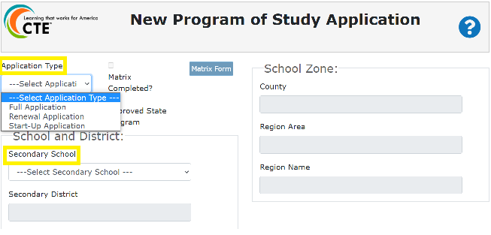
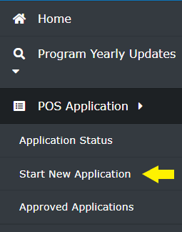
Regional Coordinators will sign into the CTE Information System through ODE District Website’s Central Login and select the Start New Application option under POS Application in the main menu. A blank Program of Study application will open and is ready to be filled out.
Select the Application Type from the drop-down: Full, Renewal, Start-up. Some application fields will change based on the application type.
Select the Secondary School from the drop-down list. After selecting the Secondary School, the Secondary District field and School Zone fields will auto-populate the appropriate information. If the application is for a school new to CTE that isn’t on the drop-down list, please contact ODE.Helpdesk@ode.oregon.gov or ODE.CTEISHelp@ode.oregon.gov requesting the specific school be updated with the CTE Site indicators in ODE’s Institution Management System. This change is necessary for the school to be included in the CTE IS.
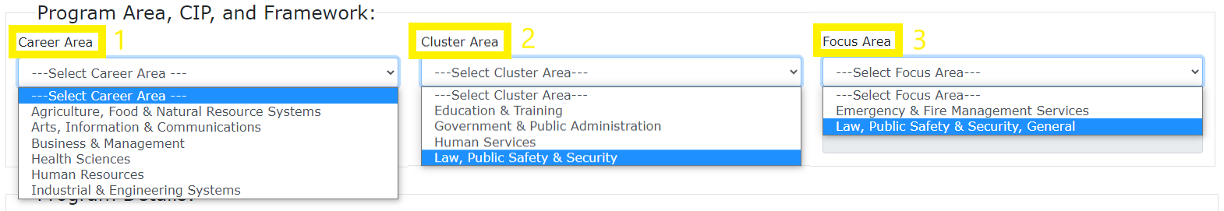
The Program Area, CIP, and Framework section fields are filled out sequentially; first, select the Career Area, then the Cluster Area, and then the Focus Area. In designing a POS, the Focus Area is optional. However, for now, the CTE Information System requires that you identify a Focus Area. For programs that will be designed at the Cluster Level, please select the general option in the Focus Area drop down list. The Program of Study Name and Secondary CIP Code fields will auto-populate based on the Focus Area selection.
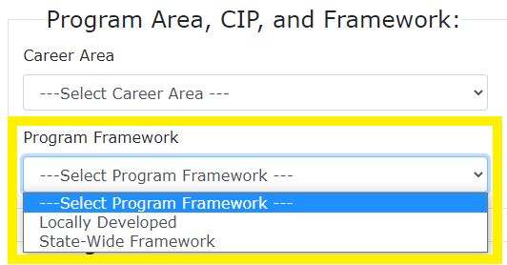
Select the Program Framework: Locally Developed or Statewide Program of Study. Select the State-Wide Framework option only if the application is for a career cluster in the following areas: Architecture & Construction; Business Management & Administration; Information & Communications; Manufacturing; Automotive & Heavy Equipment; Education and Training; Law, Public Safety & Security; and Natural Resource Systems. At this time, the Program Framework selection is informational and will not change what the system requires. As Statewide POS are developed, we plan to enhance the CTE IS to better support programs that are part of the statewide model.

Community College Grid
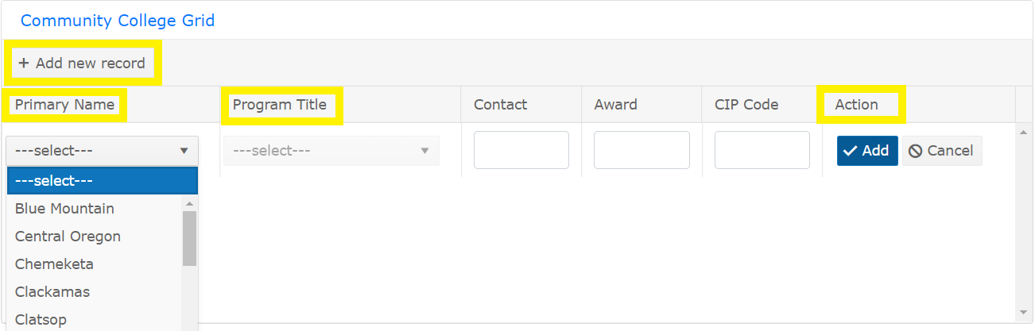
Oregon’s CTE State Plan focuses on high quality education by strengthening meaningful collaboration between secondary and postsecondary education and employers in program of study application, design, and implementation. Regional Coordinators need to select the Community College and Program Title for the aligning postsecondary program. Community College Administrator assurance fields (see below) should match the program selected.

For questions about specific CC programs available or missing in the Program Title field of the CC Grid, contact Kasena.Dailey@hecc.oregon.gov.

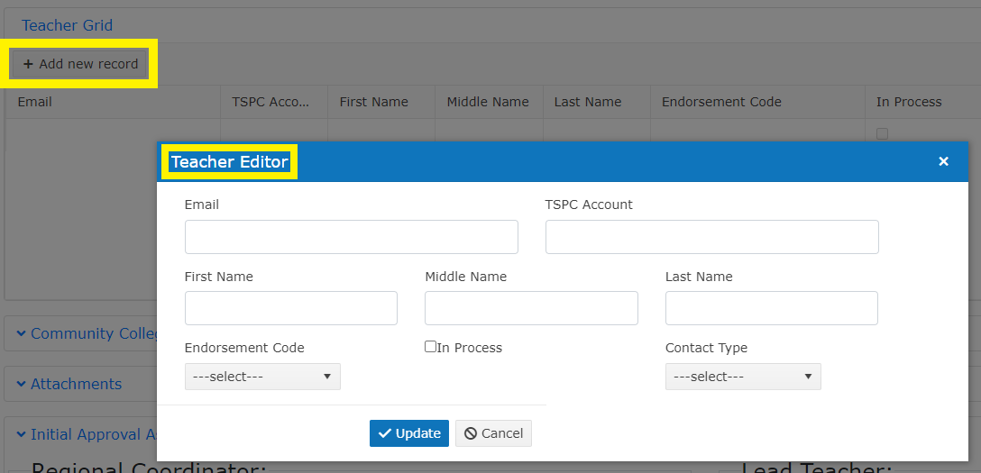
Teacher Grid
Regional Coordinators will use the Teacher Grid to add the Lead Teacher (required), Additional Teachers (optional) and any Local Admin (optional) to the program. Any Lead Teacher or Local Admin added to the Teacher Grid whose information already exists in the CTE IS Contacts will auto-populate information into the Teacher Editor box. If any of the existing contacts information needs updating, Regional Coordinators need to utilize the Contacts option in the CTE IS menu to make changes.
Anyone added to the Teacher Grid, whether Lead Teacher or Local Admin, will be notified by an automatic email from ODE Helpdesk with subject line, “School Title, Program Title – Lead Teacher Assignment,” informing the recipient that they have been assigned as the Lead Teacher or Local Administrator to a CTE Program of Study in the CTE IS. The email is generated after an application has been saved and the Teacher Grid updated.

Accessing in Progress Applications
Once any application has been saved, it is now In Progress. Regional Coordinators and Local Admin will have access to any In Progress application in their Tasks section of the CTE IS as will any Teachers, after being added to the Teacher Grid.
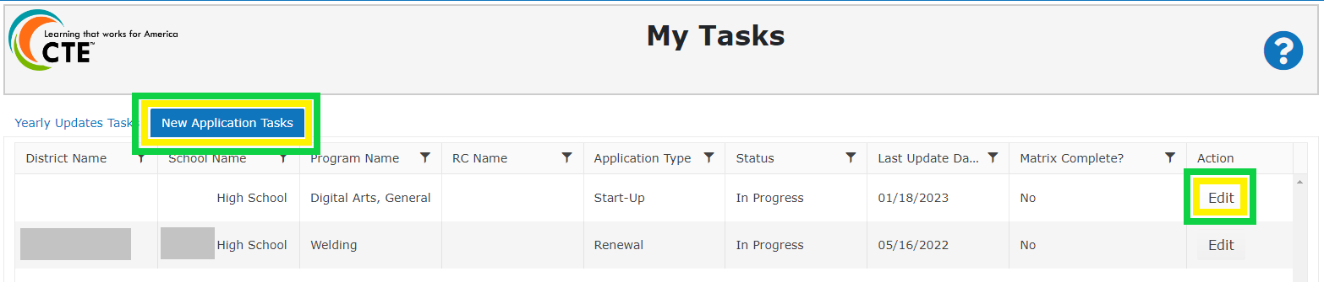
Applications can be found by clicking My Tasks in the CTE Information System menu, which will open the user’s Tasks page and display all In Progress applications. The In Progress application remains in both the Regional Coordinator and Lead Teacher/Local Admin Tasks with editing abilities until the school level user submits to the Regional Coordinator.
To open the application, click the Edit button in the Action column.
When a school level user receives the email notification for the new application, they are directed to log into the ODE District website to access the CTE Information System. If the email recipient is new to the CTE Information System, they will first need to contact their District Security Administrator to be granted access to the CTE Information System for Inset School Title. It is very important that Lead Teachers/Local Admin have permission to the CTE IS set up accurately or they will not be able to access their application information. For additional guidance on user roles, please contact ODE.CTEISHelp@ode.oregon.gov.
Once a Lead Teacher/Local Admin has access to an In Progress application, they can choose to address the Matrix first or the fields on the application page; however, it’s important to remember to Save Progress at the bottom of the application before opening the Matrix form or leaving the application page. Failing to Save Progress between screens will remove any information entered in the Additional Components of a High Quality Program of Study or Comments boxes by Lead Teacher/Local Admin.

Lead Teacher/Local Admin or Regional Coordinator Tasks

Additional Components of a High quality program of Study
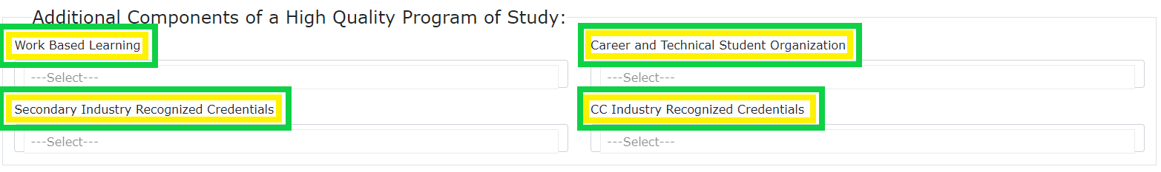
In the Additional Components of a High Quality Program of Study section, the four fields (Work-Based Learning, Career and Technical Student Organization, Secondary Industry Recognized Credentials, and CC Industry Recognized Credentials) can be selected by either the Regional Coordinator or the Lead Teacher/Local Admin. Regional Coordinators can select options when filling out the other fields and then Lead Teacher/Local Admin can adjust or the Lead Teacher/Local Admin can be responsible for selecting items from the drop down boxes with Regional Coordinators reviewing the entries.
To see the list of options for each multi-select box, click in the selection box, and a drop-down list will expand. Programs should select each item that applies from the drop-down list.
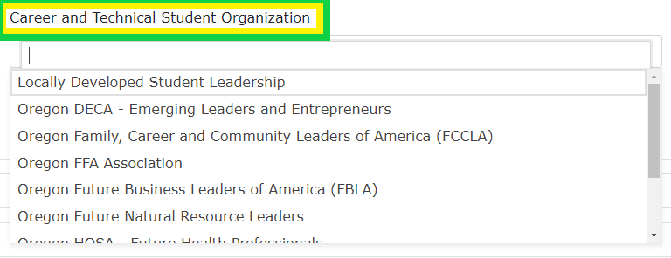
Student leadership opportunities are a required element of CTE Programs of Study. If a CTSO is not part of a program, please select the “Locally Developed Student Leadership” option in the Career and Technical Student Organization drop-down and briefly describe how the program offers student leadership opportunities in the Student Supports Service comment box.
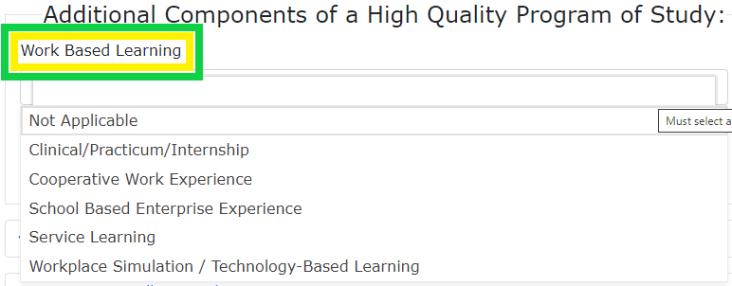
The Secondary Industry Recognized Credentials drop down list includes the complete list of approved IRCs in Oregon. The current list of approved IRCs with their unique IRC codes can be found here on the CTE Industry Recognized Credentials page; it is listed as the IRC Look-Up Table. Please use this list to verify that the IRC has been approved or if a request needs to be made for approval.
The Work Based Learning drop-down lists the identified CTE work-based learning experience types. Definitions on the WBL types can be found in the Perkins V Work-Based Learning Handbook. New programs of study must have work-based learning experiences in place. At this time, WBL is only listed on the Full/Renewal Applications.
If an Industry Recognized Credential (IRC) or Career and Technical Student Organization (CTSO) that is utilized by the school is missing from the drop-down list, please contact ODE.CTEISHelp@ode.oregon.gov or the Career Area Specialist.

Comments Section
Regional Coordinators and Lead Teacher/Local Admin both have the ability to add information to the Comments section. Until the application matrix is completed and submitted to the RC, the Comments boxes are editable by either the Lead Teacher/Local Admin or RC; however, once the matrix is submitted, only an RC has the ability to add/change/edit the Comments boxes. These boxes have a 4,000 character limit. A new full application requires information for Student Supports Services, Accountability and Evaluation, and Professional Development; a renewal application requires only the Student Supports Services information, and a start-up application doesn’t require information for any of the elements. As comments are made in the Information System, this is an opportunity to ensure responses are aligned to Level 3 or above on the CTE Program of Study Quality Rubric.
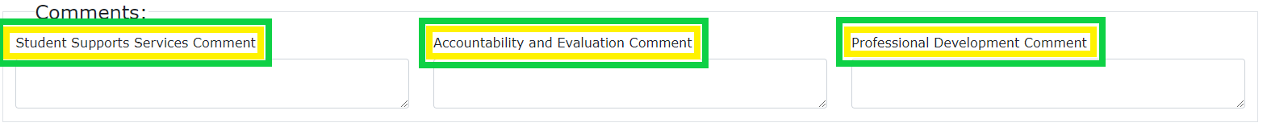
Student Supports Services Box: In addition to complying with Civil Rights regulations, student support services should provide informative guidance about CTE programs and career pathways, along with specific supports to assist students in progressing through a CTE Program of Study. In the comment box below, please explain or provide examples of how the POS addresses Student Support elements using the examples below as a guide:
- Marketing materials for recruitment of nontraditional students to CTE programs
- Skill inventories used to guide course/CTE POS selection
- Documents illustrating relation to Oregon Diploma requirements
- Help in meeting Diploma Requirements (e.g., Extended Application)
- Counseling and guidance materials
- Utilization of CTSO or Leadership opportunities to support students
- Some Examples from postsecondary partners
  - recruitment and support of nontraditional CTE students, displaced homemakers, and other special population students
  - advising and tutoring practices and procedures

Accountability and Evaluation Box: Accountability and Evaluation are core elements of Perkins eligibility. In the comments box below, please provide a short explanation describing how each of the following elements are addressed:
- Local Needs Assessment review
  - Perkins data reports (90% reports)
  - Planning to achieve equity and serve historically and currently marginalized students
- Advisory Committee/Industry Partner input
- CTE Program of Study Quality Rubric utilization in program review and improvement planning
- Work-Based Learning offerings
- Industry Recognized Credentials (if offered)
Professional Development Box: Ongoing professional development and continuous program improvement are important components of a High Quality POS. Please provide two long-term professional development goals (covering the four-year cycle) related to the implementation of the program of study. Using the HQPOS rubric as context, evidence of the professional development goals should include:
- Secondary and postsecondary engagement
- Identification of whether goals are discrete institutional goals or shared partnership/regional goals
- Explanation of how the professional development activities are designed to improve the instructional delivery within this POS
- Connection to local/regional needs assessment
- Assurance of equity focus

Completing the Matrix Form
The Matrix Form serves two important functions: one programmatic and one data related. Lead Teachers should utilize the matrix form to show the depth (sequence of non-duplicative courses that progress from introductory to advanced content) of their program by adding course information for the CTE Program of Study. Based on the career cluster and/or focus area of the application, the Matrix Form will populate with the correct Oregon Knowledge and Skill Statements. The Knowledge and Skill Statements include 1) cross-cutting employability knowledge and skills, 2) cross-cutting career cluster knowledge and skills, and 3) focus area knowledge and skills. All programs (statewide and locally developed) currently going through the renewal cycle will be expected to transition to the new Oregon Knowledge and Skill Statements by 2024. All CTE Programs of Study are required to provide students with the full range of knowledge and skill statements over the course of the high school and community college program.
The Knowledge and Skill Statements are required to be taught; however, the checkboxes crosswalking the skill statements to courses are not required fields.
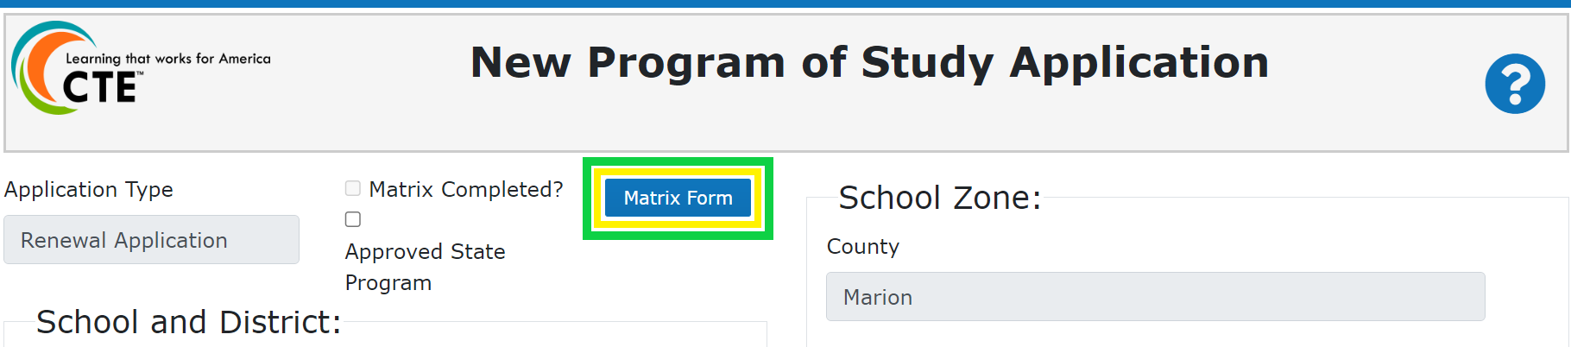
CTE courses entered into the Matrix Form also serve as validation for all CTE course records submitted to ODE during the CTE Course collection completed by secondary schools each spring. The course records inform all state and federal reporting done by ODE.
Each course entered into the Matrix Form has six required fields and one optional field. Having a copy of the CTE course information from a school’s Student Information System prior to beginning the matrix will make completing the matrix much simpler for the Lead Teacher/Local Admin.
When the Lead Teacher/Local Admin is ready to start adding courses to the Matrix Form, select the Add Course button.
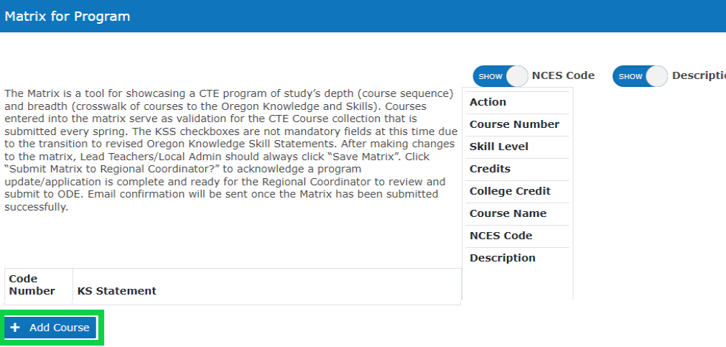
The required fields for adding a course to the matrix include:
- Course Number: Must match the course number assigned in the school's student information system.
- Skill Level: Introductory, Intermediate, or Advanced (See the CTE Policy Guidebook, pg. 110, for definitions).
- Credits: Total credit amount students are awarded if they receive a passing grade in the course.
- Course Name: Should match the student course handbook.
- NCES Code: Select the code that matches the NCES code assigned in the school’s student information system that best fits the content being taught. See the Course to Endorsement Catalog for questions about NCES codes.
- Course Description: Should match the student course handbook. If course is part of a year-long course divided by unique course codes for each term, the description should indicate which term it’s for.

The optional field for adding a course to the matrix:
College credits while in high school (dual credit): Check this box if a course articulates with a course from the postsecondary institution or is taught in partnership with a postsecondary institution and students may receive credits at both high school and college.
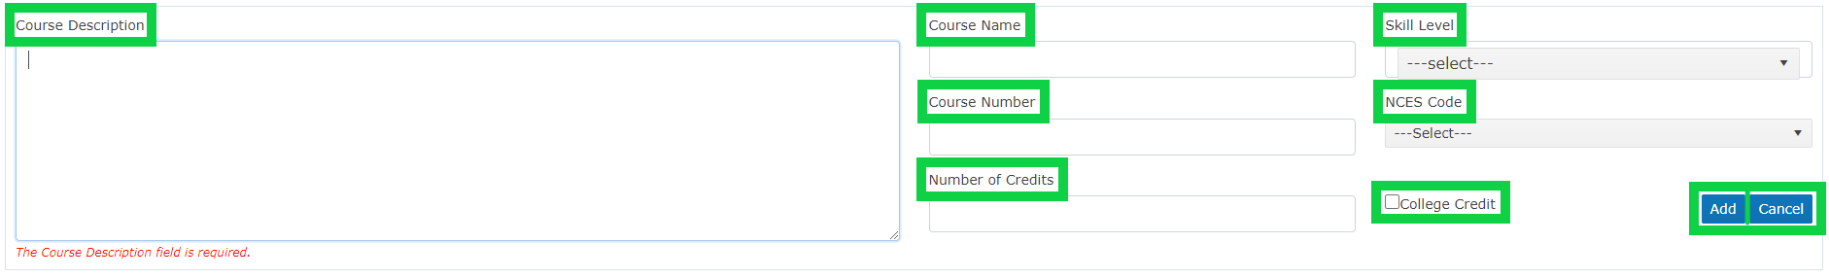
The Lead Teacher/Local Admin must fill out the required fields for each course addition and check the Dual Credit box if appropriate; once all the information is entered, click the Add button. The Cancel button will close the add course fields without saving any entered information. Repeat the process until all the courses offered within the program of study have been added to the matrix.
Once the Lead Teacher/Local Admin has finished adding the courses in their program of study to the Matrix Form, click the Save Matrix button. The Matrix Form should be saved any time the school level user needs to leave the matrix form or In Progress application to ensure changes are saved.
Before clicking Submit Matrix to Regional Coordinators, school level users should review the following required fields to ensure complete information is provided for a full program of study application:
- Work-based learning opportunities
- Industry Recognized Credentials
- Student Leadership Opportunities
- Community College Alignment
- Student Support Services
- Accountability and Evaluation Information
- Professional Development
- Assurances
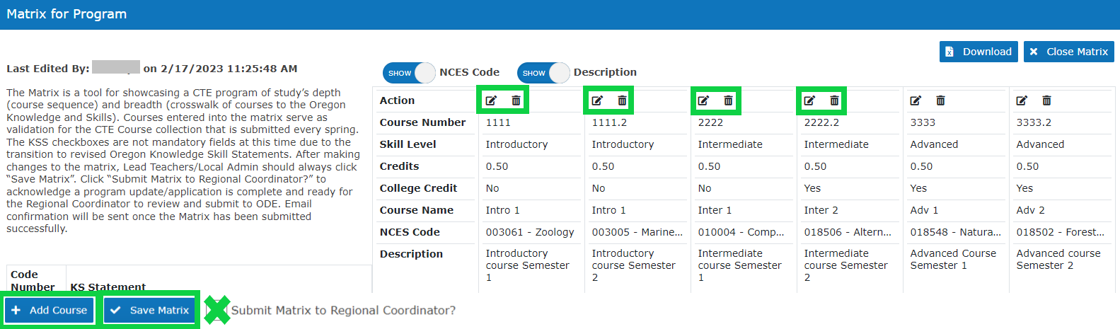
When a Lead Teacher/Local Admin has completed their application, it needs to be submitted to the Regional Coordinator for review and eventually submission to ODE. Submitting the application to the Regional Coordinator happens in the Matrix Forms by a Lead Teacher/Local Admin clicking the Submit Matrix to Regional Coordinator checkbox.
When the application is submitted to the Regional Coordinator, an automatic email from ODE Helpdesk with subject line, “School Title, Program Title – Matrix Complete,” is generated to inform Regional Coordinators that there is an application awaiting their review. At this time the application status moves from In Progress to Submitted to Regional Coordinator. Lead Teachers/Local Admin will no longer have editing access to the application or see it listed in their Tasks; however, if a user wanted to check on the status of an application at any time they can go to the POS Application option of the CTE IS menu and select Application Status to see their applications.

Completing the Initial Approval Assurances
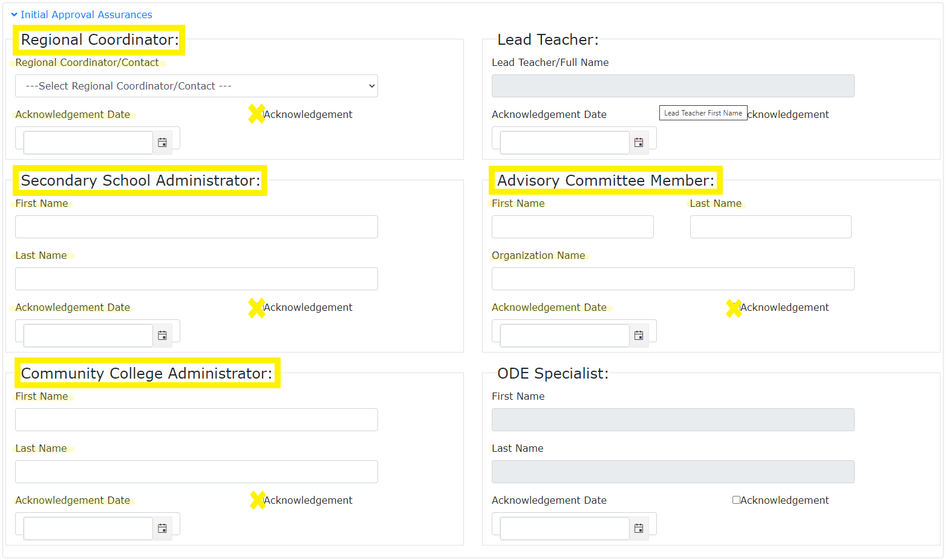
The Initial Approval Assurances section is to be completed by the Regional Coordinator. The process for gathering signatures or tracking assurances from partners is up to each Regional Coordinator. ODE does not require proof of signed assurances to be submitted. Regional Coordinators will enter the following information:
- Regional Coordinator Name
- Secondary School Administrator Name
- Advisory Committee Member Name and Organization Name (committee chair is preferred)
- Community College Administrator Name
- Acknowledgement dates for all
- Check Acknowledgement boxes for all
Some assurance fields are grayed out because they do not need to be filled out manually. The Lead Teacher assurance fields auto fill when an application’s matrix is marked as complete and submitted to the Regional Coordinator.

Application Submission
After the Lead Teacher/Local Admin has completed the matrix and clicked the submit Matrix to Regional Coordinator button, only Regional Coordinators will have the In Progress application in their tasks and have editing access to some fields. At this time, the Regional Coordinator can review the application submitted to them for accuracy and completeness. If the application is ready to be submitted to the ODE Content Area Specialist, they can click “Submit Application.” Once the application has been submitted to ODE, it will no longer be visible in the Regional Coordinator’s Tasks but the application can still be viewed status at any time if a user goes to the POS Application option of the CTE IS menu and selects Application Status. Applications that have been submitted to ODE are listed under the Under Review tab of Application Status.
When the application is submitted, an automatic email from ODE Helpdesk will go out to anyone listed on the teacher grid, as well as the Regional Coordinator and the Education Specialist, with the subject line, “School Title, Program Title – Submitted to ODE.”

For Technical Assistance with the Application: Please contact ODE.CTEISHelp@ode.oregon.gov

The CTE brand logo, brand positioning, theme, and brand extensions are the property of NASDCTEc.

