A Guide for Secondary CTE Program Applications
CTE Program Application Final Deadline – June 30th
INTRODUCTION
This guide is a resource for secondary schools and Regional Coordinators with completing Oregon’s Career and Technical Education (CTE) Program Application. The CTE program application is the last part of the more extensive program design process intended to help Oregon high schools and community colleges support and prepare students with industry-based technical and academic knowledge and skills needed for success in secondary and postsecondary education, and high-wage/in-demand careers.
Applications initiated by a Regional Coordinator on July 1st and submitted to ODE by June 30th of the current school year will be approved before August 15th (08/15) by the ODE Content Specialist for the next school year.

CTE STATEWIDE RENEWAL SCHEDULE 2
CTE PROGRAM OVERVIEW 3
CTE PROGRAM DESIGN 3
CTE PROGRAM OF STUDY DEVELOPMENT 3
STATEWIDE PROGRAM OF STUDY MODELS 4
CTE PROGRAM RENEWALS 5
COMPLETING THE CTE PROGRAM APPLICATION 5
CTE PROGRAM APPLICATION TYPES AND REQUIREMENTS 5
Renewal Application 5
Start-Up Application 6
Full Application 6
INITIATING A CTE PROGRAM APPLICATIONS 6
Start-up and Full Application Types 7
Renewal Application Type 9
VIEWING IN-PROGRESS APPLICATIONS 11
CTE PROGRAM APPLICATION SECTIONS 11
Program Details (Start-up Application Only) 11
Teacher Grid 12
Community College Grid 13
Additional Components of a High Quality Program of Study 14
Components of a High Quality Program of Study 15
Attachments 17
Initial Approval Assurances 18
THE MATRIX FORM 19
APPLICATION SUBMISSION 22
RESOURCE LINKS: 24
APPENDIX 25
DECISION COMMENTS BOX 25
CTE GUIDANCE FOR NCES COURSE CODE UTILIZATION 25

CTE STATEWIDE RENEWAL SCHEDULE
Career Clusters | Expiration Date | Application Due By
Hospitality, Tourism & Culinary**  Arts, A/V & Communications**  Marketing**  Engineering Technology** | June 2024* | June 2024
Human Services  Government & Public Administration  Finance  Health Sciences  Agriculture & Food Systems | June 2025* | June 2025
Architecture & Construction  Business Management & Administration  Information & Communications  Manufacturing | June 2026* | June 2026
Automotive & Heavy Equipment  Education & Training  Law, Public Safety & Security  Natural Resource Systems | June 2027* | June 2027
* Regardless of a program of study’s expiration date at initial approval, all Statewide and Locally Developed CTE Programs of Study will renew on schedule with the statewide renewal cycle for its associated Career Cluster.
**All programs (statewide and locally developed) currently going through the renewal cycle will be expected to transition to the new Oregon Knowledge and Skill Statements by 2025.

CTE PROGRAM OVERVIEW

CTE PROGRAM DESIGN
In Oregon, the CTE Program of Study is the cornerstone of CTE programming. In the Perkins V Act, the term “program of study” means a coordinated, non-duplicative sequence of academic and technical content at the secondary and postsecondary level that
- incorporates challenging state academic standards;
- addresses both academic and technical knowledge and skills, including employability skills;
- is aligned with the needs of industries in the economy of the state, region, Tribal Community or local area;
- progresses in specificity from a broad overview at the Career Cluster level, to occupation-specific instruction at the Focus Area level;
- has multiple entry and exit points; and
- culminates in the attainment of a recognized postsecondary credential and/or degree.
Oregon achieves the federal definition of High Quality Programs of Study (HQPOS) by requiring six (6) core elements in all state approved POS. The elements of a High Quality Program of Study include:
- Standards and Content
- Alignment and Articulation
- Accountability and Evaluation
- Student Support Services
- Professional Development
- Access and Equity

CTE PROGRAM OF STUDY DEVELOPMENT
ALL CTE POS undergo essentially the same process for development and implementation:
- Partners identify labor market needs based on advisory group recommendations and the local needs assessments.
- Partners determine whether adopting Oregon’s CTE Statewide Framework works for their community.
- The teacher and CC Instructor work together with the partners to help outline how the program will meet the six required POS elements. This work includes determining how CTE Programs of Study will provide students with the full range of knowledge and skill sets over the course of the high school and community college program.
- Once a program has been designed and developed and is ready to go through ODE’s program approval process, the Regional Coordinator (RC) initiates the application.
- Teachers and Regional Coordinators will work together to complete and submit the program application to ODE.
- ODE Content Specialists review and approve every CTE program application submitted to ODE. The applications are approved for one to four years, based on the statewide career cluster renewal schedule.
- Secondary Teachers/CC instructors–with the help and guidance of industry partners and advisors, Regional Coordinators and CTE Deans, other administrators, parents, students, and colleagues–implement the CTE POS with fidelity.
During the design process, partners of the CTE POS must determine whether the design will follow the template for a CTE Statewide Program of Study–including one or more of the indicated Focus Areas specified in each Career Cluster–or be a locally developed program of study.
CTE PROGRAM OF STUDY TYPES
Statewide Program of Study | Locally Developed Program of Study
- Industry engagement across the state  - Statewide PLC  - Statewide Advisory Committee formed in support of local/regional partnerships (TBD)  - Program of Study Frameworks  - WBL resources shared statewide (TBD)  - Student Leadership opportunities developed collaboratively statewide (TBD)  - If applicable, Industry Recognized Credentials identified and agreed upon statewide (TBD) | - Local industry engagement  - Regional PLC  - Local partnerships/advisories  - Beyond Employability Skills and the Career-area Cluster, program content developed that aligns with local needs.  - Local WBL resources created  - Student leadership opportunities developed locally  - If applicable, aligned Industry Recognized Credentials identified and incorporated
For more information on CTE program design and development, please refer to the CTE Policy Guidebook, starting on page 25.

STATEWIDE PROGRAM OF STUDY MODELS
In 2021, ODE embarked on creating standardized CTE Programs of Study beyond the existing Agriculture Science & Technology (2011) and Natural Resource/Forestry (2016) program areas. The initial phase to create CTE Statewide Frameworks for Oregon’s CTE Career Clusters is based on statewide labor market information for high-wage, in-demand occupations and will be complete in 2025; however, the effort to build robust Statewide POS models will be a continuous process. They are intended to ensure equitable CTE program quality across the state, more substantial support for CTE educators, collegial engagement between high school teachers and community college partners, more consistent connections to college credit, simplified advising and recruitment, and better alignment with postsecondary programs.
The new Statewide CTE Program of Study Frameworks provide updated Knowledge and Skill Sets to inform CTE program development in each Career Cluster. The updated Knowledge and Skill Sets include 1) employability knowledge and skills, 2) Career Cluster knowledge and skills, and 3) Focus Area knowledge and skills. Within each Career Cluster, CTE Programs of Study may be offered at the Cluster or Focus Area level. Cluster-level programs of study offer students in high schools a broad overview of careers in the field, along with skills valued by all industry partners. Focus Area programs of study offer students more occupationally specific training that may lead to industry recognized certificates and degrees.
With the adoption of Statewide Programs of Study, currently approved programs may decide to change their program focus area for better alignment with the updated focus area options and revised knowledge and skill sets. Focus area changes should only be made during the first cycle of renewals.
If an established program has decided to change its focus area at the time of renewal, please notify ODE to ensure the change is captured correctly for program continuity.

CTE PROGRAM RENEWALS
State approved CTE programs of study are assessed through a renewal process every one to four years. The intent of POS renewal is to review how program offerings are still aligning with labor market needs; meeting the state defined criteria for size, scope, and quality; addressing the required six (6) elements of a POS; and continuously improve CTE offerings using the HQPOS rubric. Regional Coordinators in each region lead District Administrators, CTE teachers, CC instructors, and industry partners through a program of study evaluation and planning for program improvements to be submitted to ODE through the program renewal process.
The CTE Program of Study Quality Rubric is a tool to help educators and administrators evaluate their CTE POS during program renewal and to create goals for continuous program improvement. The rubric delves deeper into the six (6) required elements of a High Quality Program of Study (HQPOS). Each element is presented with a set of criteria and performance levels that are aligned with the Oregon Equity Lens, CTE Program Size, Scope, and Quality, and the Work-Based Learning Rubric. For additional information on using the HQPOS rubric, please see the Quick Guide to Using the HQPOS Rubric.

COMPLETING THE CTE PROGRAM APPLICATION
All new and renewal applications must be initiated by a Regional Coordinator. There is only one application form, regardless of whether it is being filled out for a renewal, start-up, or full program of study; however, there is a slight variation of the application fields based on the selected Application Type (Full, Start-Up, or Renewal). Follow the steps below to start and complete any CTE program application for submission to ODE.
The CTE program application process must be completed in ODE’s CTE Information System. School districts must work together with their local CTE Regional Coordinators when they are ready to start the application process for any CTE program. They offer a wealth of knowledge and experience with POS development and the application process.
To help identify the application fields to be completed by Regional Coordinators and/or school level users, the screenshots below are color-coded as follows;
- Fields highlighted in yellow apply only to Regional Coordinators
- Fields highlighted in green apply to Lead Teacher/Local Admin

CTE PROGRAM APPLICATION TYPES AND REQUIREMENTS

Renewal Application for a Program of Study
Based in federal Perkins Act legislation, a CTE POS is a state-approved, non-duplicative sequence of academic and technical content that spans secondary and postsecondary educations. CTE Programs of Study lead to an industry recognized credential, postsecondary certificate of completion, or a degree. CTE programs of study feature contextualized and hands-on courses, with a minimum of three, non-duplicative high school credits (beginning in 2023-2024) aligned to a postsecondary certificate or degree program of at least 36 credits.
For state approval, schools must align CTE programming with labor market needs, meet criteria for program size, scope, and quality and meet all six elements of a CTE POS (as discussed in the 2023-2024 CTE Policy Guidebook).
The following sections of Renewal Applications are required to be filled out prior to submitting the application to ODE for review: School and District, Program Area, CIP and Framework, Course Matrix Form, Additional Components of a High Quality Program of Study, Teacher Grid, Community College Grid, Components of a High Quality Program of Study Comments and the Initial Approval Assurances. All CTE POS in Oregon must include at least three, non-duplicative CTE high school credits on the matrix form.
Together these sections demonstrate and provide the necessary evidence on how a POS is meeting required elements.

Start-Up Application
A Start-Up CTE Program is an intentional sequence of secondary CTE courses leading to the development of a full CTE POS. The Start-Up phase of a CTE Program may last up to three years, building to a full CTE POS meeting size, scope, and quality requirements.
For state approval, start-up applications do not have to provide evidence that a start-up program will meet all six required elements or size, scope, and quality of a CTE POS.
The following information is not required to be filled out for a CTE Start-up Application, but ODE encourages inclusion of the information if the program components are already established: Additional Components of a High Quality Program of Study section, Community College Grid, Teacher Grid, or Initial Approval Assurances for Advisory Committee Member and Community College Administrator.
One course is required on the CTE Start-up Application Matrix Form. A course may be identified as a CTE class if it includes instruction addressing skills from the Oregon Skill Sets and is included within a state approved CTE program.
Perkins federal funding may be used for some of the start-up costs associated with the development toward a full CTE POS. The start-up application does require an estimated Cost to Start up Program and the Expected Use of Allowed Perkins Start-up Dollars.

Full Application for a New Program of Study
Based in federal Perkins Act legislation, a CTE POS is a state-approved, non-duplicative sequence of academic and technical content that spans secondary and postsecondary educations. CTE Programs of Study lead to an industry recognized credential, postsecondary certificate of completion, or a degree. CTE programs of study feature contextualized and hands-on courses, with a minimum of three, non-duplicative high school credits (beginning in 2023-2024) aligned to a postsecondary certificate or degree program of at least 36 credits.
For state approval, schools must align CTE programming with labor market needs, meet criteria for program size, scope, and quality and meet all six elements of a CTE POS (as discussed in the 2023-2024 CTE Policy Guidebook).
The following sections of Full Applications are required to be filled out prior to submitting the application to ODE for review: School and District, Program Area, CIP and Framework, Course Matrix Form, Additional Components of a High Quality Program of Study, Teacher Grid, Community College Grid, Components of a High Quality Program of Study Comments and the Initial Approval Assurances. All CTE POS in Oregon must include at least three, non-duplicative CTE high school credits on the matrix form.
Together these sections demonstrate and provide the necessary evidence on how a POS is meeting required elements.

INITIATING A CTE PROGRAM APPLICATIONS

Start-up and Full Application Types
- To initiate a CTE program application, Regional Coordinators (RC) must sign into the CTE Information System (IS) through ODE District Website’s Central Login.
  - If you do not have a Password or are unable to log-in, please reach out to the District Security Administrator for the institution.
  - If you do not know the District Security Administrator, please contact the district office, or use the District Security Administrator Lookup on ODE’s District website.
- Select the CTE Information System for the appropriate institution you’d like to log in under from the list of applications.
  - RCs should always select the CTE Information System ESD or CC option for best system functionality.
- Click POS Application>Start New Application in the vertical, black menu bar on the left side of the screen to open a blank CTE program application or Click the green Start POS Application box on the CTE IS home screen
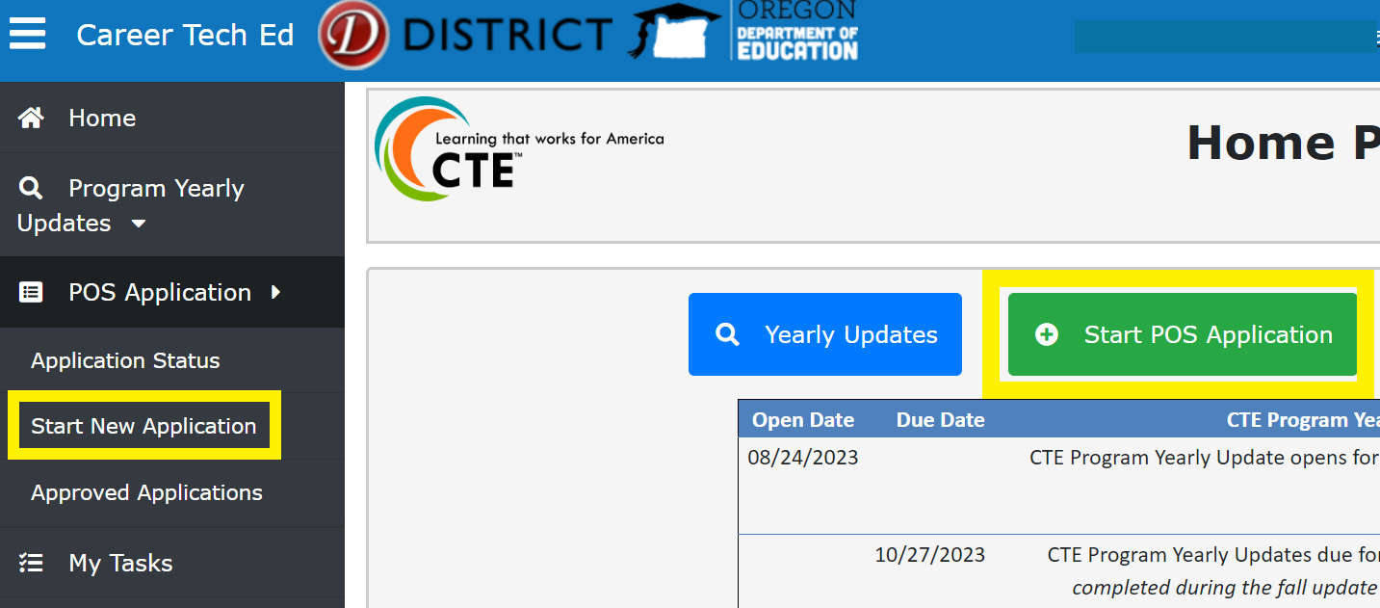
- Using the Application Type field, select which type of application is being initiated with the drop down menu.
  - If the application type is Full or Start-up, the next step will be selecting the school where the CTE program will be housed. Follow the directions below.
  - If the application type is Renewal, skip to the Renewal Application Type section of the guidance on page 9.
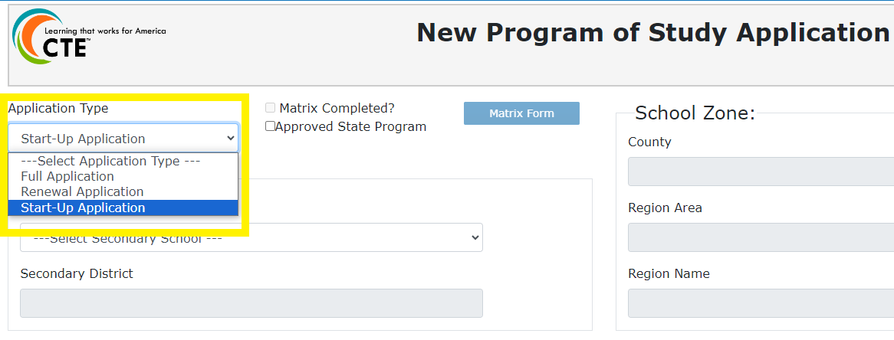

Secondary CTE Site Selection
- Select the school title from the Secondary School field drop down list.
  - The drop-down list includes CTE sites that are part of the institution a RC is logged into the CTE IS under.
    - 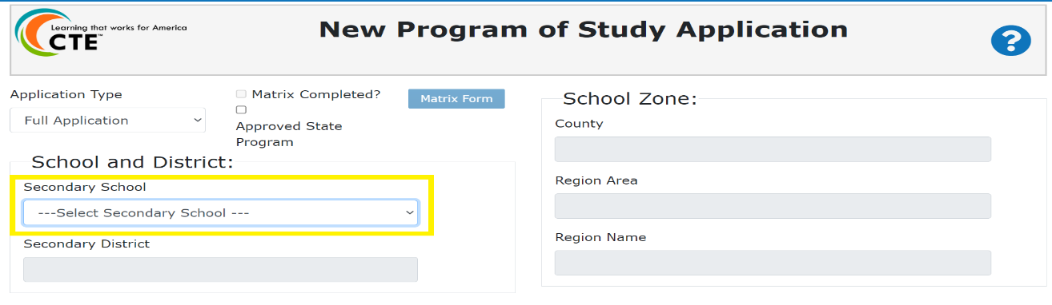For example, School 12 in Region 12A and part of Region AB. When the RC logs into the CTE IS under Region AB, School 12 will be listed in the drop down. If the RC logs into the CTE IS under District 85, School 12 will not be listed in the drop down.
  - If the application is for a school new to CTE that isn’t on the drop-down list, please contact ODE.CTEISHelp@ode.oregon.gov requesting the institution be updated to a CTE site in ODE’s Institution Management System. This change is necessary for the school to be included in the CTE IS. All institution details are fed to the CTE IS from the Institution Management System.
- After selecting the Secondary School, the Secondary District field and School Zone fields will auto-populate the appropriate information.

Program Area, CIP and Framework Section
The Program Area, CIP, and Framework section fields are filled out sequentially. In designing a POS, the Focus Area is optional. However, for now, the CTE Information System requires that you identify a Focus Area.
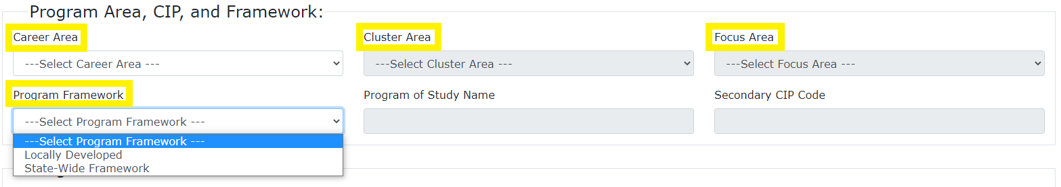
- Select the Career Learning Area from the Career Area field drop down list.
- Select the Career Cluster from the Cluster Area field drop down list.
  - For programs that will be designed at the Cluster Level (except Arts, A/V Technology and Communications), please select the general option in the Focus Area drop down list.
- Select the Focus Area from the Focus Area field drop down list.
  - The Program of Study Name and Secondary CIP Code fields will auto-populate based on the Focus Area selection.
  - Once the application is approved the Focus Area and Secondary CIP code cannot be changed.
- Select whether the program will be Locally Developed or part of the Statewide POS model from the Program Framework field drop down list.
  - Select the State-Wide Framework option only if the application is for a career cluster in the following areas: Arts, A/V Technology and Communications; Engineering Technology; Hospitality, Tourism and Recreation; Marketing; Architecture & Construction; Business Management & Administration; Information & Communications; Manufacturing; Automotive & Heavy Equipment; Education and Training; Law, Public Safety & Security; and Natural Resource Systems.
  - At this time, the Program Framework selection is informational and will not change what the system requires. As Statewide POS development continues, ODE will enhance the application process to better support programs that are part of the statewide model.
- Click the Save Progress button at the button of the program page to save the newly initiated application.

Renewal Application Type
When the selected application type is “Renewal Application”, RCs will have the ability to import some of the existing CTE program and course data from the currently approved program. Regional Coordinators should be aware that not every section from the approved program is copied over to the renewal application. The sections that are copied over can be edited within the same parameters of all application types.
Contacts from the Teacher Grid are not copied onto renewal applications. Lead Teachers, Additional Teachers and Local Admin will need to be added to the teacher grid when Regional Coordinators are ready for them to begin working on the application. When the contacts are added to the Teacher Grid a system generated email is sent letting the recipients know a renewal application is in process.
With the adoption of a Statewide Programs of Study, renewing CTE programs may decide to change their program focus area to better align with the updated focus area options and revised knowledge and skill sets.
Changing an approved program’s focus area also changes the associated CIP code and leads to an interruption in the program’s data accumulation. ODE will maintain historical information for data tracking purposes for approved programs that change focus areas at the time of renewal; however, if approved programs change focus areas outside of renewal and/or after the Statewide Program of Study adoption, they will be considered new programs and data accumulation will start over.
Upon selecting Renewal Application as the Application Type there will be a pop-up box titled Programs Due for Renewal. The pop-up window lists all currently approved programs with expiration dates for June 30th of the current school year, specific to the institution a RC is logged into the CTE IS under.
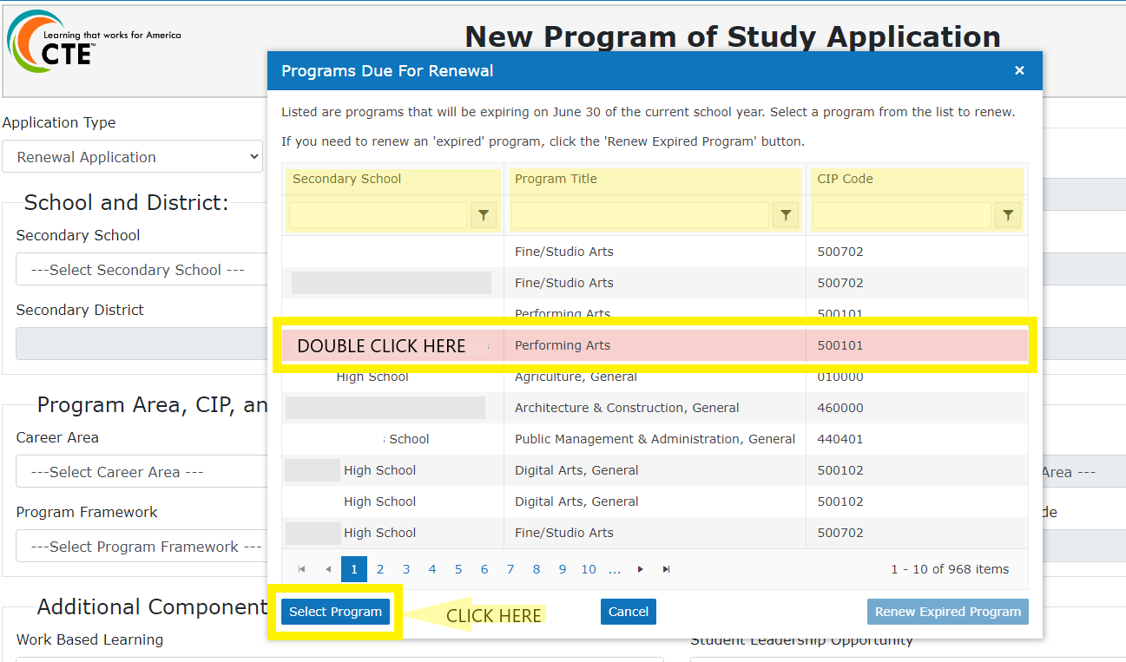
- Find the desired CTE program in the Program Due For Renewal list pop-up window.
- Click on the program line and then the Select Program box or double click on the line to import the program information to the application.
  - After a program is selected there will be a green message that the approved program’s data was imported to the renewal application successfully.
  - Once the program information has successfully copied to the application, RCs need to continue the regular application process.
- Click the Save Progress button at the button of the program page to save the newly initiated application.
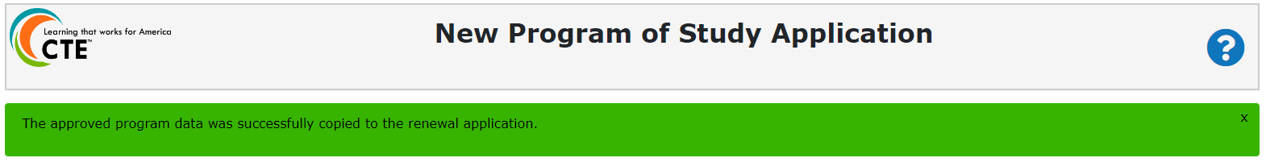
If a renewal application needs to be created for a program that has already expired, the Regional Coordinator must select Renew Expired Program at the bottom of the pop-up box. No previous program information will be copied to the renewal application.
Initiating a renewal application with this process will not remove that program from being listed in the pop-up box. Regional Coordinators should make sure not to initiate multiple renewal applications for the same program.

VIEWING IN-PROGRESS APPLICATIONS
After an application has been saved by the Regional Coordinator, it is an “In Progress” application.
- Regional Coordinators and Local Admin roles can view all “In Progress” applications (specific to the institution(s) they’ve logged into the CTE IS under).
- Lead/Additional Teachers can view all “In Progress” applications (specific to the institution(s) they’ve logged into the CTE IS under) after being added to the Teacher Grid by the Regional Coordinator.
  - When a school level user (Lead/Additional Teacher or Local Admin) is added to an application’s teacher grid, an automated email notification is sent to the new contact directing them to log into ODE’s District website to access the CTE Information System.
  - If the email recipient is new to the CTE Information System, they will first need to contact their District Security Administrator to be granted access to the CTE Information System for Inset School Title.
  - It is very important that Lead Teachers/Local Admin have permission to the CTE IS set up accurately or they will not be able to access their application information. For additional guidance on user roles, please visit the CTE Information System Roles and Access document.
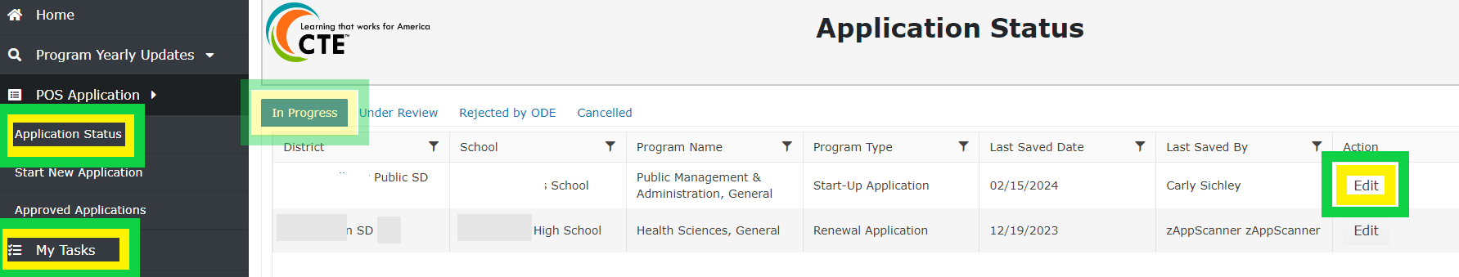
- Select POS Application> Application Status in the Main Menu and click edit on the application’s line to open the application.
- Or select My Tasks in the Main Menu and click edit on the application’s line to open the application.
- “In Progress” applications remain in both the RCs and school level users My Tasks with editing abilities until the application is submitted to the Regional Coordinator.

CTE PROGRAM APPLICATION SECTIONS

Program Details (Start-up Application Only)
The Program Details Section of the Startup Applications is where expected startup costs for the CTE program are provided. The local educational agency has the obligation and responsibility for providing the base level program. Perkins resources are used to enhance the POS and take the program to the next level. To the best extent possible, identify resources that will be utilized to establish the program start-up costs and source of funds (community, CTE revitalization, High School Success, general fund and/or Perkins). Explicitly identify where the Perkins resources will be utilized. Typically, for a CTE POS in start-up mode, investments are guided toward professional development or specialty equipment.
- Cost to Start-up Program - provide the dollar amount the school district is expecting to spend to start the CTE program.
- Expected Use of Allowed Perkins Start-up Dollars - provide a dollar amount the district plans to spend for startup costs
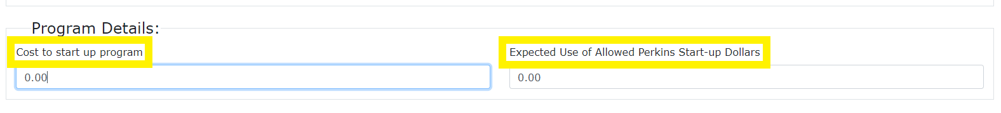

Teacher Grid
CTE program contacts are added to the application using the Teacher Grid. Only Regional Coordinators can add the Lead Teachers (required), Additional Teachers (optional) and any Local Admin (optional) to a CTE application. Until a Lead Teacher or Additional Teacher are added to the Teacher Grid, the user will not have access to the newly initiated application after logging into the CTE IS.
- Click the add new record button. A pop-up box titled Teacher Editor will appear on the screen.
  - Once a program contact is added to the Teacher Grid, whether Lead Teacher, Additional Teacher or Local Admin, they will be notified by an automatic email from ODE Helpdesk with subject line, “School Title, Program Title – Lead Teacher Assignment,” informing the recipient that they have been assigned to a CTE Program in the CTE IS. The email is generated after an application has been both saved, and the Teacher Grid updated.
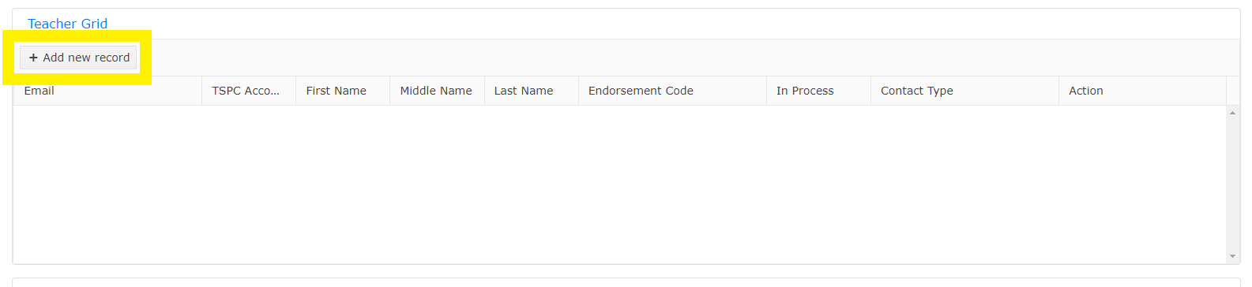
- Input the contacts email first.
  - If the contact already exists as a program contact in the CTE IS, the TSPC Account, First Name and Last Name fields will populate based on the email entered. If the email does not exist in the CTE IS, the remaining fields will need to be filled out.
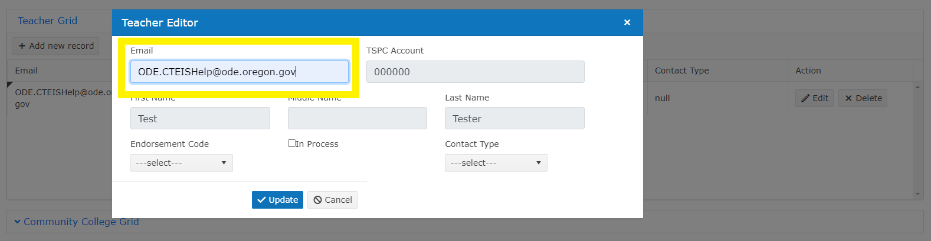
- Input the TSPC Account number for Lead Teacher and Additional Teacher contacts. Local Admin contacts do not need to have a TSPC Account number entered.
- Input the First Name and Last Name of the program contact.
- Select the Endorsement Type for Lead Teacher and any Additional Teacher contacts in the drop down. Local Admin contacts do not need to have an Endorsement Type entered.
- Check the In Process box if Endorsement Type being added for the contact is currently in process with either ODE or TSPC.
- Select the Contact Type (Lead Teacher, Additional Teacher, Local Admin) for the program contact being entered into the Teacher Grid.
- Click the Update button to save the program contact information.

Updating Contact Details
When existing program contact information is no longer accurate, RCs need to update the details, not create a new contact record. Existing contacts email, TSPC account number, and name can be edited in the Contacts section of the Main Menu. Updating the information in Contacts ensures that every CTE program in connection to the Teacher/Admin, also gets updated and decreases duplicate contact entries in the CTE IS.
- Click Contacts in the main menu of the CTE IS.
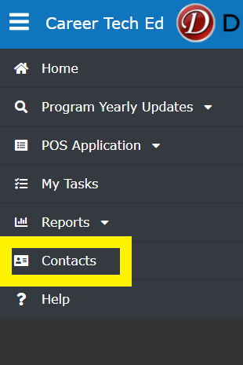
- Click Last Name to sort the contacts alphabetically by last name. Search through the contacts until the desired one is located.
- Click Edit on the contact’s record. This will enable the contacts information to be edited.
- Click Update after edits have been made to save the changes.
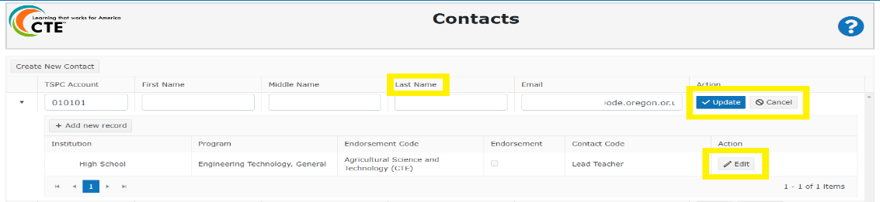
- Once the changes have been saved, the corrected contact information will reflect in the application’s Teacher Grid.

Community College Grid
Oregon’s CTE State Plan focuses on high quality education by strengthening meaningful collaboration between secondary and postsecondary education and employers in a program of study application, design, and implementation. Aligning postsecondary program information is added to the secondary program by the Regional Coordinator role using the Community College Grid.
- Click Community College Grid to expand the Community College Grid and add alignment information.
- Click the Add new record button to display the selection fields for Primary Name and Program Title.
- Select the aligning CC name in the Primary Name drop down.
  - After the CC name is selected, the Program Title field is enabled.
- Select the aligning CC program title in the Program Title drop down.
  - The Contact, Award and CIP Code fields will populate based on the selected CC Program Title.
- Click the Add button to save the aligning program’s information.
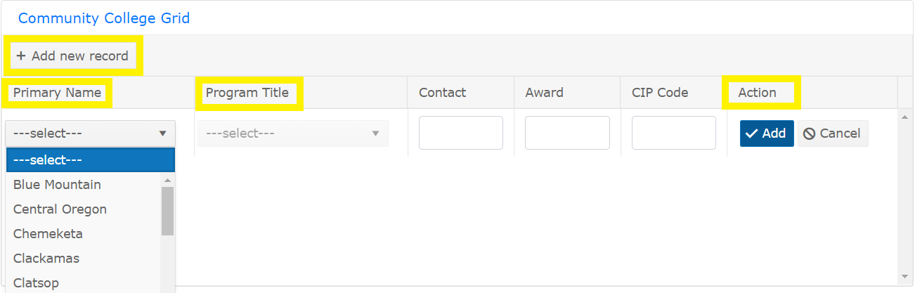
The Community College program offerings available in the Community College Grid are provided to ODE by a HECC/CCWD report. For questions about specific CC programs available or missing in the Program Title field of the CC Grid, contact Kasena.Dailey@hecc.oregon.gov.
Community College Administrator assurance fields (see Initial Approval Assurances section below) should match the program selected.

Additional Components of a High Quality Program of Study
The Additional Components of a High Quality Program of Study section is where program offerings are provided for Work-based Learning, Student Leadership Opportunity, and Industry Recognized Credentials. The four application fields (Work-Based Learning, Student Leadership Opportunity, Secondary Industry Recognized Credentials, and CC Industry Recognized Credentials) in this section can be filled out by either a School Level User or RC. School Level Users can edit the section until the application has been submitted to the RC and RCs can edit the section until they’ve submitted the application to ODE.
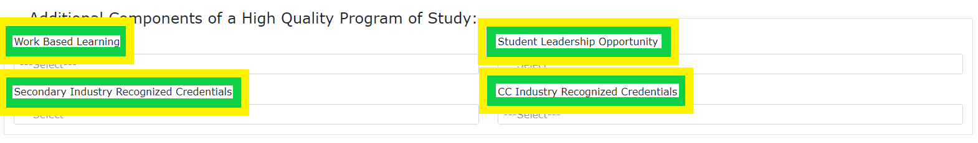
- Click in any of the four boxes to see the list of options for each multi-select box, click in the box, and a drop-down list will expand. Programs should select all that apply from the drop-down list.
Work-based Learning is a critical bridge that connects the classroom to the world of work and helps learners make informed decisions about their educational and career goals. Please select any of the work-based learning opportunities from the drop down that will be offered to students participating in the CTE Program of Study.
Student leadership opportunities are a required element of CTE Programs of Study. Please select the Career and Technical Skills Organization or “Locally Developed Student Leadership” option from the drop down that is associated with the CTE Program. CTE Programs that select the “Locally Developed Student Leadership” need to describe how the student leadership opportunities offered in the Student Supports Service comment box.
The current list of approved IRCs can be found here on the CTE Industry Recognized Credentials page; it is listed as the IRC Look-Up Table. Please use this list to verify that the IRC has been approved or if a request needs to be made for approval.
If an Industry Recognized Credential (IRC) or Career and Technical Student Organization (CTSO) that is utilized by the school is missing from the drop-down list, please check the ODE website for the lists of CTSOs of the IRC Look-Up Table.

Components of a High Quality Program of Study
The Components of a High Quality Program of Study section is where programs provide details on some of the required elements. The comment box fields (Student Supports Services, Continuous Program Improvement Goal, Accountability and Evaluation, and Professional Development) in this section can be filled out by either a School Level User or RC. School Level Users can edit the section until the application has been submitted to the RC and RCs can edit the section until they’ve submitted the application to ODE. A new full application requires information for Student Supports Services, Accountability and Evaluation, and Professional Development; a renewal application requires only the Student Supports Services information, and a start-up application doesn’t require information for any of the elements. As comments are made in the Information System, this is an opportunity to ensure responses are aligned to Level 3 or above on the CTE Program of Study Quality Rubric.
These boxes have a 4,000 character limit. Additional information can be provided for the elements by uploading a document to the Attachments section of the application.
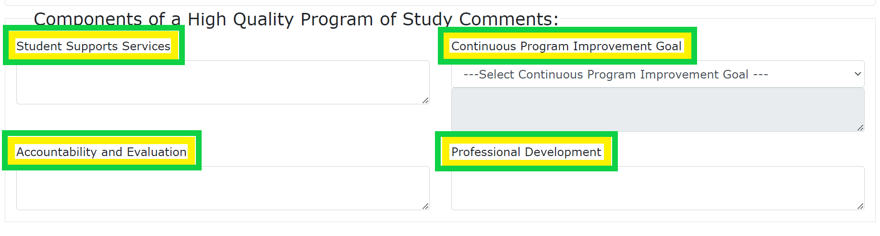
Student Supports Services Box: In addition to complying with Civil Rights regulations, student support services should provide informative guidance about CTE programs and career pathways, along with specific supports to assist students in progressing through a CTE Program of Study. Using the comment box, explain or provide examples of how the POS addresses Student Support elements using the examples below as a guide:
- Marketing materials for recruitment of nontraditional students to CTE programs
- Skill inventories used to guide course/CTE POS selection
- Documents illustrating relation to Oregon Diploma requirements
- Help in meeting Diploma Requirements (e.g., Extended Application)
- Counseling and guidance materials
- Utilization of CTSO or Leadership opportunities to support students
- Some Examples from postsecondary partners
  - recruitment and support of nontraditional CTE students, displaced homemakers, and other special population students
  - advising and tutoring practices and procedures
Accountability and Evaluation Box: Accountability and Evaluation are core elements of Perkins eligibility. Using the comment box, provide an explanation describing how each of the following elements are addressed:
- Local Needs Assessment review
  - Perkins data reports (90% reports)
  - Planning to achieve equity and serve historically and currently marginalized students
- Advisory Committee/Industry Partner input
- CTE Program of Study Quality Rubric utilization in program review and improvement planning
- Work-Based Learning offerings
- Industry Recognized Credentials (if offered)
Professional Development Box: Ongoing professional development is an important component of a High Quality POS. Using the comment box, provide two long-term professional development goals (covering the 4-year cycle) related to the implementation of the program of study. Using the HQPOS rubric as context, evidence of the professional development goals should include:
- Secondary and postsecondary engagement
- Identification of whether goals are discrete institutional goals or shared partnership/regional goals
- Explanation of how the professional development activities are designed to improve the instructional delivery within this POS
- Connection to local/regional needs assessment
- Assurance of equity focus
Continuous Program Improvement Box (Renewal Application Only): Ongoing continuous program improvement goals are an important component of a High Quality POS. On the renewal application, select the element area a program has decided to focus their continuous improvement efforts on and provide the continuous improvement goal(s) in the comment box. Using the HQPOS rubric as context, evidence of the continuous improvement goals could include and are not limited to:
- Annual POS review by the Advisory Committee
- Data review, analysis and goal setting tied to performance outcomes
- Use of a construct from the HQPOS Rubric in program planning
- Professional development planning tied to collective program evaluation (data, Advisory Committee, HQPOS, local needs assessment, diversity, equity, inclusion, and etc.)
- Specific efforts of the SD, college and/or CTE region as it relates to continuous improvement
- Completed professional development efforts
- Future professional development efforts

Attachments
Supplemental application files can be uploaded to any application using the Attachments Section. Attached documents can downloaded by school level users, RCs, and ODE Content Specialists. Any supporting documentation provided during the application process will remain available for the life of a program unless removed.
- Click Attachments to add or view a document.
- Click the Add new document button.
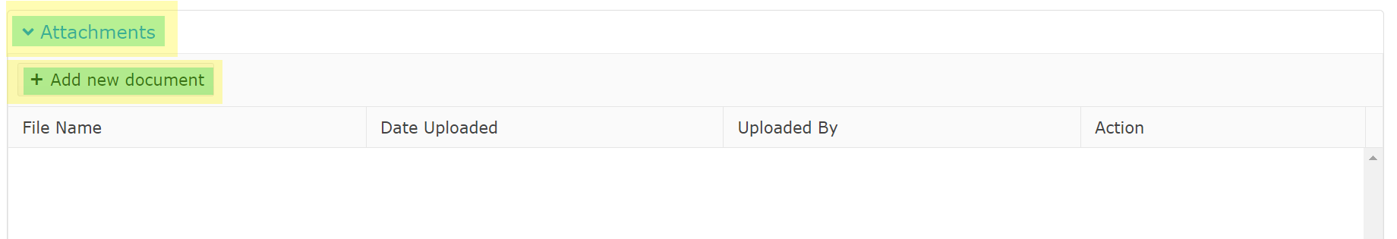
- Click the Select Files button to browse and open the file or drag and drop the file from the desktop.
  - Repeat this process until all desired documents are selected.
- Click the Upload button.
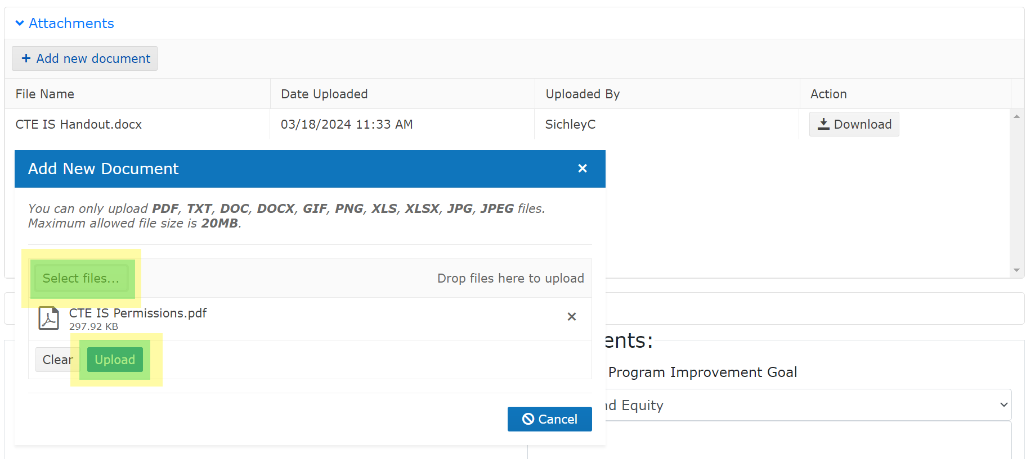
- Uploaded documents will display in the Attachments section with the File Name, Uploaded Date and who it was Uploaded by.
  - An uploaded document can be downloaded by any user with permissions to the application.

Initial Approval Assurances
The Initial Approval Assurances section must be completed prior to submitting any application to ODE. This section of the application is the Certification of Assurances for a CTE program application. ODE does not require proof of signed assurances to be submitted at this time. At the end of this guidance document (page 27) is a Certification of Assurances template that RCs can use for gathering actual signatures if desired. If signatures are gathered, they can be uploaded to the Attachments section of the CTE IS application for tracking purposes.
For 2023-24 Regional Coordinators must provide the Initial Approval Assurance details to any application (submission of assurances signature page is not required for 2023-24). By providing this information, Regional Coordinators are verifying that the program partners have agreed to the following things,
- Regional Coordinator Name, Acknowledgement, Acknowledgement Date - Recommend program for state approval (Perkins Eligible)
- Secondary School Administrator Name, Acknowledgement, Acknowledgement Date - Have reviewed this program application document for clarity, completeness and adherence to program quality standards and support its approval. The secondary school administrator agrees that the CTE program area requirements for secondary CTE programs, including appropriate CTE certification for teachers, the rules and regulations for Public Law 109-270, and the requirements contained in the Oregon State Plan for Career and Technical Education will be complied with in the operation of the CTE programs and services offered by the district or through contract between the district and other agencies, institutions, or individuals. The secondary school administrator agrees to furnish CTE program data as requested by the Oregon Department of Education.
- Advisory Committee Member Name, Organization Name (committee chair is preferred), Local/Regional Advisory Committee, Acknowledgement, Acknowledgement Date - The program advisory committee has been involved in the design and development of this program.
- Community College Administrator Name, Acknowledgement, Acknowledgement Date - The specific community college(s) has been involved in the design and development of this CTE program of study and agrees to continue collaboration (collegial professional development), meeting all six (6) core elements, especially alignment and articulation.
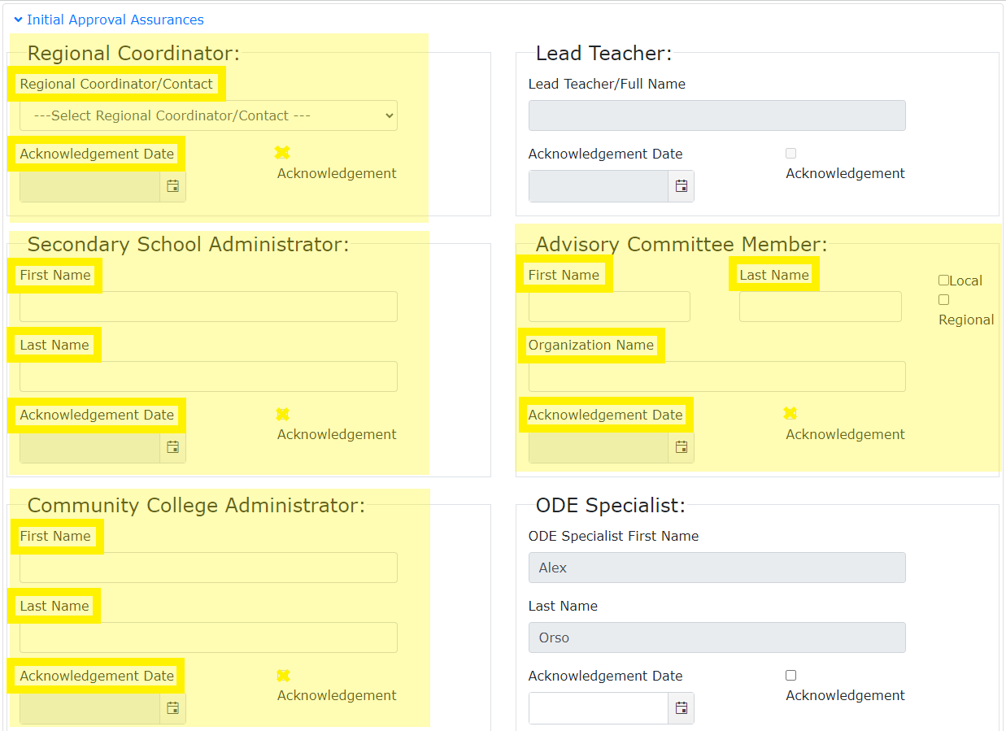
Some assurance fields are grayed out because they do not need to be filled out manually by the Regional Coordinator. The Lead Teacher assurance fields auto fill when an application’s matrix is marked as complete and submitted to the Regional Coordinator and the ODE Content Specialist will provide the acknowledgement and date of their approval upon final state approval of the application.

THE MATRIX FORM
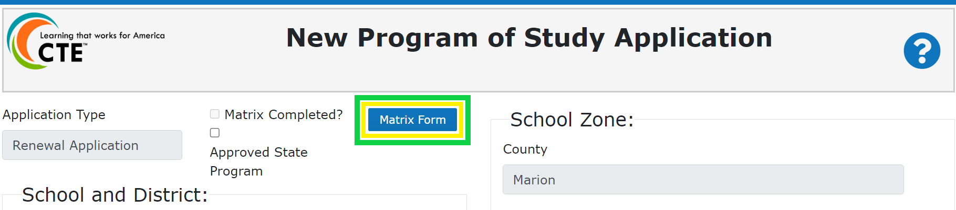
Every application must complete a Matrix Form. The Matrix Form serves two important functions: one programmatic and one data related. Lead Teachers should utilize the matrix form to show the depth (sequence of non-duplicative courses that progress from introductory to advanced content) of their program by adding course information for the CTE Program of Study.
The checkboxes that were historically used to crosswalk the Knowledge and Skill Statements to each course are no longer part of the Matrix Form. The crosswalk was optional for the last few years during the revision of Oregon’s Skill Sets and has now been removed. ODE is working with a group of CTE partners to rethink and revise how they support CTE Program of Study quality and ensure that educators are providing students with opportunities to learn and develop the full range of skills and knowledge in their CTE Program of Study courses.
All CTE Programs of Study are required to provide students with the full range of knowledge and skill statements over the course of the high school and community college program. The Knowledge and Skill Sets include 1) cross-cutting employability knowledge and skills, 2) cross-cutting career cluster knowledge and skills, and 3) focus area knowledge and skills. All programs (statewide and locally developed) currently going through the renewal cycle will be expected to transition to the new Oregon Knowledge and Skill Statements by 2025.
CTE courses added to the Matrix Form also serve as validation for all CTE course records submitted to ODE during the CTE Course collection completed by secondary schools each spring. Institution reported course records inform all state and federal reporting done by ODE.
Completing the Matrix Form
All CTE IS users with access to the application can view the Matrix Form, but an application’s matrix must be completed by a School Level User. Every application is required to have a matrix form filled out prior to submission. Start-up applications require only one course on the matrix form and Full/Renewal applications require three (3) nonduplicative credits worth of courses.
Having the course information from the Student Information System readily available will make completing the matrix form much simpler for the school level user. Courses are added individually to the matrix form and each course has eight (8) data fields.
- Click Matrix Form at the top of the application to open the Matrix Form.
  - Start-up and Full Application types will start with a blank matrix form.
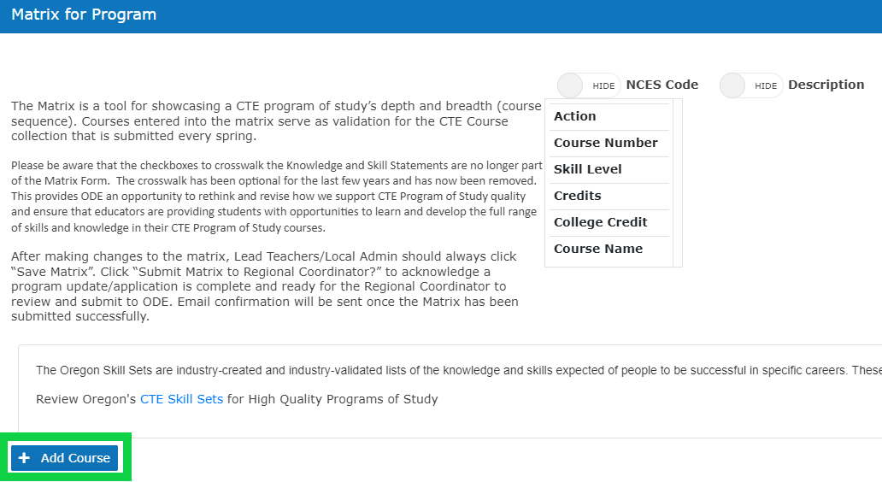
  - If a renewal application had the information imported from the approved program, the CTE courses will populate on the application’s matrix form. Populated courses must be reviewed for accuracy and district changes.
- Click the Add Course button. The course fields will open at the bottom of the matrix form.
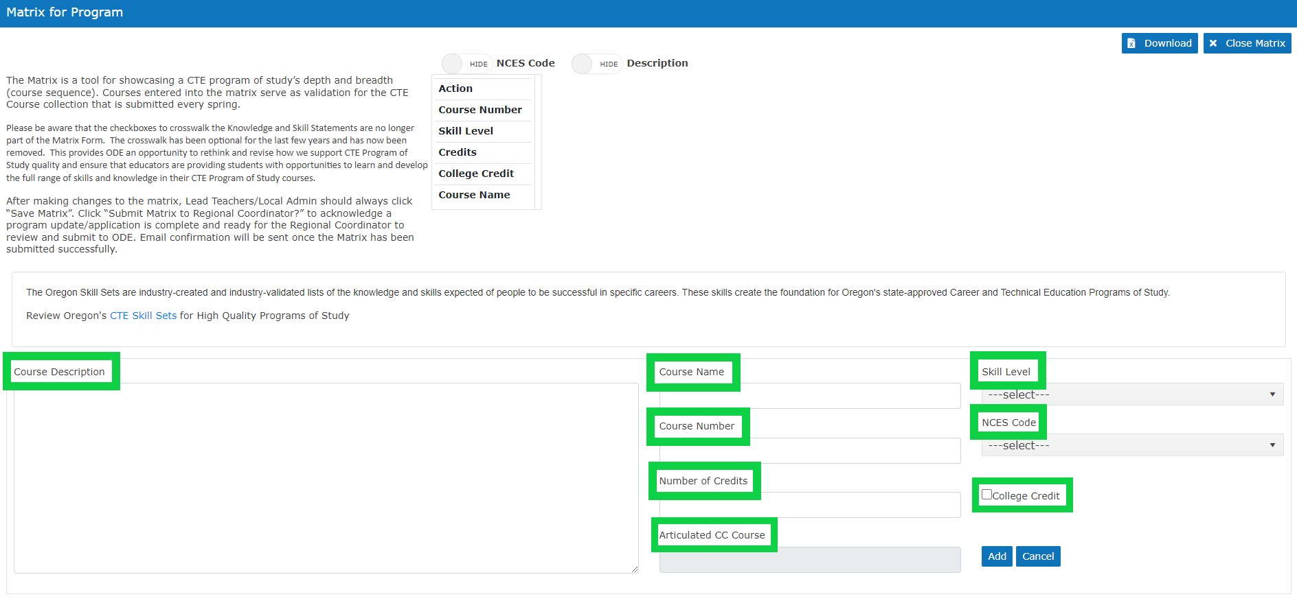
Each course added to the matrix form must include the following details:
- Course Number (required): Must match the course number assigned in the school's student information system.
  - CTE sites have complete autonomy over their course numbering design.
- Skill Level (required): Introductory, Intermediate, or Advanced (See the CTE Policy Guidebook, pg. 109, for definitions).
  - Course sequence should show a progression from Intro to Advanced
- Credits (required): Credit amount students are awarded if they receive a passing grade in the course.
  - CTE data are calculated and compiled for state and federal reporting based on the Oregon Diploma and Modified Diploma requirement of 24 credits to graduate (ORS 329.451). When divided, the 24 credits equate to learners earning an average of 0.5 credits a semester or 0.34 credits a trimester awarded at successful completion of a course.
- Course Name (required): Should match the student course handbook.
- NCES Code (required): Select the code that matches the NCES code assigned in the school’s student information system that best fits the content being taught. See the Course to Endorsement Catalog for questions about NCES codes.
- Course Description (required): Should match what is in the student course handbook.
  - Year-long courses should indicate here first or second semester if different semesters/trimesters have unique course codes.
  - If the course is awarding graduation credit (science, math, language arts, and etc) and/or accelerated college credit. Indicate that the CTE content within the course is connected to the respective academic standards that allows for graduation credit and/or college credit to be awarded.
- College credits while in high school (dual credit) (optional): Check this box if a course articulates with a course from the postsecondary institution or is taught in partnership with a postsecondary institution and students may receive credits at both high school and college.
- Articulated CC Course (optional): Enter the course information at the postsecondary institution that articulates with the secondary course.
  - If the CC Credits box is checked, this field is enabled.

- Each required field for the course needs to be filled out by the School Level User.
- Click the Add button once all the information is entered to save the course information.
  - The Cancel button will close the add course fields without saving any entered information. Repeat the process until all the courses offered within the program of study have been added to the matrix.
After a course is added to the matrix form, it can be edited if needed. School level users should pay particular attention to the accuracy of populated courses on renewal applications in case changes are needed.
- To edit or remove a course, click the Edit or Delete buttons above the specific course in the Action row near the top of the Matrix Form. The course fields will open at the bottom of the matrix form.
- Edit necessary field(s)
- Click the Update button once the information is entered to save the updated course information.
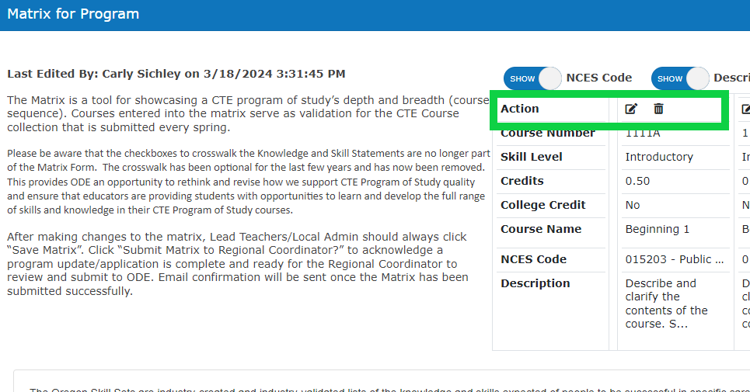
- Follow steps 43 through 48 until all courses are added to the Matrix Form

APPLICATION SUBMISSION
When a School Level User has completed their application, it needs to be submitted to the RC. The RC will review the application and either return it to the school for additional edits or submit it to ODE.
Before submitting the matrix, School Level Users should review the following required fields to ensure complete information is provided for full/renewal applications:
- Work-based learning opportunities
- Industry Recognized Credentials
- Student Leadership Opportunities
- Community College Alignment
- Student Support Services
- Accountability and Evaluation Information
- Professional Development
- Assurances

- To submit the application to the RC, click the Submit Matrix to Regional Coordinator checkbox.
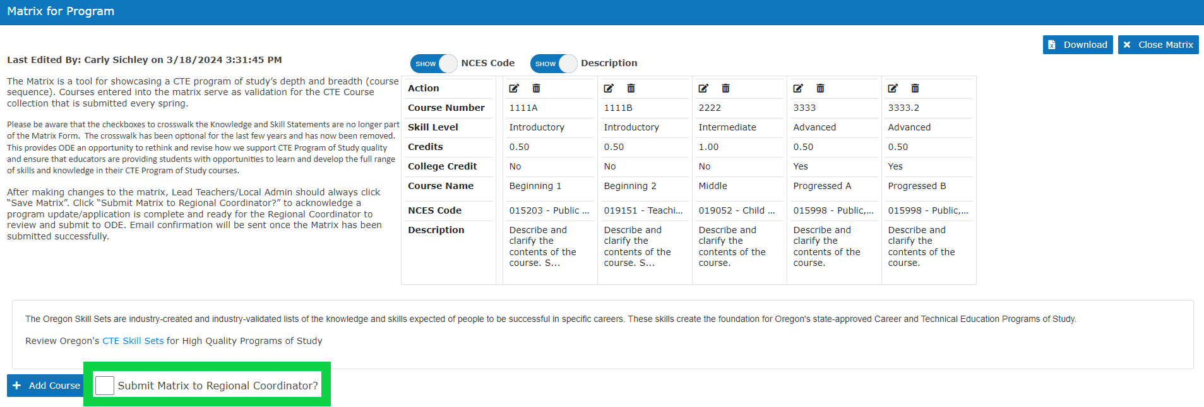
  - When the application is submitted to the RC, an automatic email from ODE Helpdesk with subject line, “School Title, Program Title – Matrix Complete,” is generated to inform RCs that there is an application awaiting their review and School Level Users that their tasks are complete unless otherwise notified.
  - After the School Level User has submitted the application to the RC, they will no longer have the application in their Tasks or have editing access to the application.

Regional Coordinators will see the application in their tasks and have editing access to some fields. At this time, the RC can look over and make sure the information is all there; if the application is ready, click “Submit Application.'' Once the application has been submitted to ODE, it will leave the RC’s My Tasks and they will no longer have edit access to the application. When the application is submitted, an automatic email from ODE Helpdesk will go out to anyone listed on the teacher grid, as well as the Regional Coordinator and the Education Specialist, with the subject line, “School Title, Program Title – Submitted to ODE”.
Applications that have been submitted to ODE are still available to School Level Users and RC’s in POS Application>Application Status. The application can be viewed in the Under Review tab of the Application Status page.
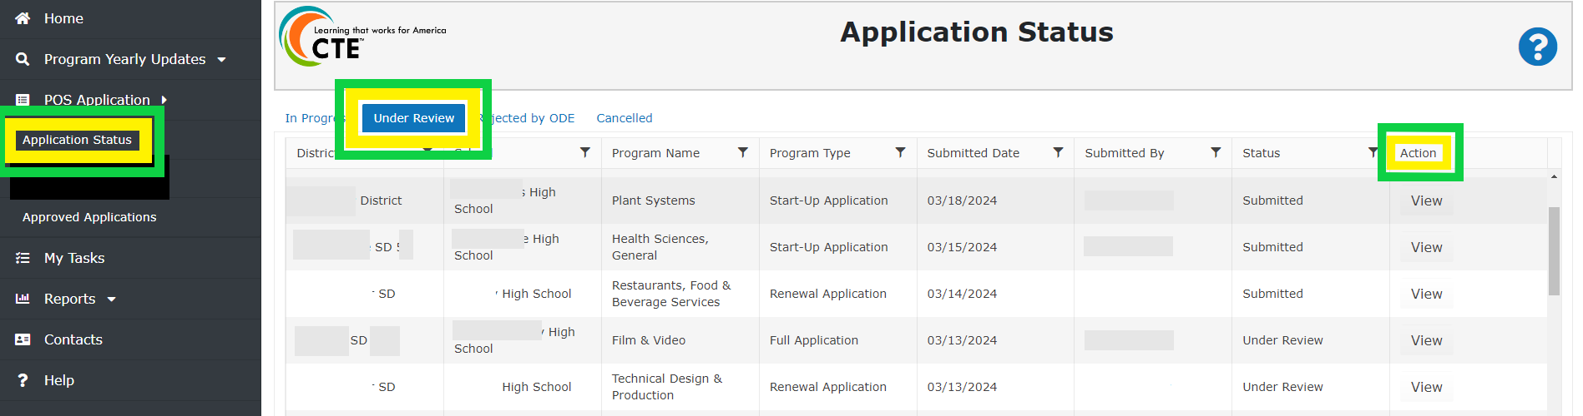Applications in Under Review will have one of two statuses, Submitted or Under Review. The Submitted Status indicates that the application was submitted but hasn’t had any review yet and Under Review indicates that the Content Specialist has started their initial review.
When an application is approved by the ODE Content Specialist, an automatic email from ODE Helpdesk will go out to anyone listed on the teacher grid, as well as the Regional Coordinator and the Education Specialist, with the subject line, “School Title, Program Title – CTE Application Approved”. The approved application will always be available for viewing in Approved Applications of the main CTE IS menu. All CTE program applications submitted by June 30th will be approved by August 15th. New/Start-up/Renewed programs approved during by the August 15th deadline will first display as an approved program on the last Thursday of August in both the CTE IS and Approved CTE Programs report.

For Technical Assistance of the Application: Please contact ODE.CTEISHelp@ode.oregon.gov

RESOURCE LINKS:
ODE CTE Program Application Resources
CTE Policy Guidebook 2023-2024
CTE Oregon Skill Sets : High Quality Programs of Study
NCES Course to Endorsement Catalogue
Oregon Department of Education : Career and Technical Student Organizations
Oregon CTE Organization Chart 2023.xlsx

APPENDIX

DECISION COMMENTS BOX
The Decision Comments box is used to share information during the application process. When an application is submitted to ODE, sent back for revision by Regional Coordinators or ODE Content Specialists, or approved, comments can be provided. Any explanations of immediate or long-term changes should be listed here as documentation during the application process. Comments made in the Decision Comment box are public record and will remain available until a new application is submitted for the approved program in one to four years.
Type any notes/comments into the box right before submission/rejection. Submission or Rejection of the application will save the comment and the comment will be included in the system generated email. The most recent comments are listed in the Decision Comments box. Previously comments made by Regional Coordinators and Content Specialists are listed below. To review a previous comment in its entirety, click the View button in the specific comments row.
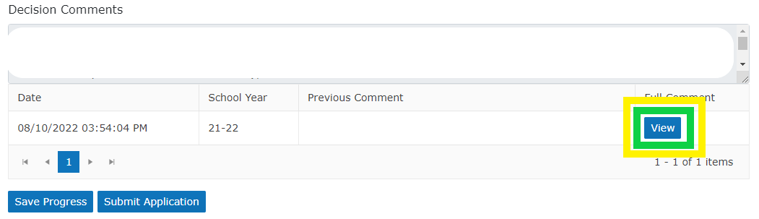

CTE GUIDANCE FOR NCES COURSE CODE UTILIZATION
It is expected that all courses connected to a CTE Program of Study be tied to the NCES course codes listed within the respective CTE content area and/or instructional focus and be taught by a teacher with the appropriate CTE endorsement. There may be instances that a “non-CTE NCES codes” could be utilized within a CTE Program of Study. The “non-CTE NCES codes” are the exception and not the rule within CTE programming.
As a teacher, administrator, Regional Coordinator, or Advisory Committee is considering the inclusion or addition of a “non-CTE courses” it is important to communicate the intent, logic model and sequencing of courses that supports the rationale to include the course(s) in a CTE Program of Study. Some CTE Programs of Study have a natural connection to the student learning outcomes of a non-CTE course. A technical approach to environmental science for the Natural Resources Program of Study and anatomy and physiology within the Health Occupations Program of Study are examples of where a non-CTE course could be appropriate for a CTE Program of Study. Yet, a biology course that is a school district requirement, cannot be included within an Agriculture Science and Technology CTE Program of Study. As a rule of thumb, any course that is required to be taken by all students cannot be included within a CTE Program of Study. In cases where non-CTE NCES courses are being included within a CTE Program of Study, explicit examples must be provided to show how the student learning outcomes are connected to the CTE Skillset that the Program of Study is built upon.
OAR 584-230-0020 authorizes a teacher for instructional assignments within the scope of the approved CTE endorsement, as determined by NCES course codes. OAR (584-210-01700) provides guidance for educator mis-assignment allowing teachers on unrestricted licenses to teach in an out-of-field subject-matter endorsement not to exceed 10 hours per week. Per OAR (584-210-0160) this provision does not apply to teaching assignments in ODE approved CTE Programs. EXAMPLE: An advanced math teacher without a CTE endorsement teaching mechanical engineering in an ODE-approved CTE program would require a LCA for the CTE endorsement. As with considering the inclusion or addition of a “non-CTE course” it is important to communicate the intent and rationale for including a non-CTE licensed teacher in an approved CTE program of study.
School systems are encouraged to reach out to Carly Sichley carly.sichley@state.or.us and the respective CTE Content Education Specialist with specific questions related to the non-CTE course and content area. There may be a delay / time lag in getting a non-CTE course approved in the Program of Study due to the updates required within the data system.
The following links provide the context for awarding “academic credit” / graduation credit for CTE courses. The Oregon State Board of Education has acknowledged and approved the awarding of “Applied Academic Credit for CTE courses”.
Applied Academics
- Oregon Applied Academic Project Final Report
- Applied Academic Case Study Summary Report
- Applied Academics Brief
- Applied Academic Guidelines

Office of Educational Improvement and Innovation  Public Service Building  255 Capitol Street NE  Salem, OR 97310 | Oregon Department of  Community Colleges and  Workforce Development
CTE Program Certification of Assurance
For 2023-24 Regional Coordinators must provide the Initial Approval Assurance details to any CTE program application in the CTE Information System. By providing this information, Regional Coordinators are verifying that the program partners have agreed to the items below. After filling in all the appropriate fields of this form, Regional Coordinators can collect signatures either electronically or on a printed copy. Gathered signatures can be uploaded to the CTE application for tracking purposes and should match all names provided in the Initial Approval Assurances section of CTE programs.

CTE Program Title:
Secondary School Name:
Name of Community College:
SECONDARY LOCAL SUPPORT and CERTIFICATE OF ASSURANCE | Have reviewed this program application document for clarity, completeness and adherence to program quality standards and support its approval. The secondary school administrator agrees that the CTE program area requirements for secondary CTE programs, including appropriate CTE certification for teachers, the rules and regulations for Public Law 109-270, and the requirements contained in the Oregon State Plan for Career and Technical Education will be complied with in the operation of the CTE programs and services offered by the district or through contract between the district and other agencies, institutions or individuals. The secondary school administrator agrees to furnish CTE program data as requested by the Oregon Department of Education.
Secondary School District Administrator Signature |  | Date:
Lead Teacher Signature |  | Date:

ADVISORY COMMITTEE SUPPORT and CERTIFICATE OF ASSURANCE | The Advisory Committee has been involved in the design and development of this program.
Advisory Committee Signature |  | Date:

POST-SECONDARY LOCAL SUPPORT AND CERTIFICATE OF ASSURANCE | The specific community college(s) has been involved in the design and development of this CTE program of study and agrees to continue collaboration (collegial professional development), meeting all six (6) core elements, especially alignment and articulation.
Community College Administrator’s Signature |  | Date:

CTE REGIONAL COORDINATOR | Recommend program for state approval (Perkins Eligible)
CTE Regional Coordinator Signature |  | Date:

