A Guide for using the
CTE Program of Study Application
2020 Version
This Guide is for use through June 30, 2020
Application deadlines for 2020:
April 30 - Early Bird (for ODE action before summer break)
June 30 - Final deadline

Background
T

his guide for filling out the Oregon Career and Technical Education (CTE) Program of Study (CTE POS) Application is intended to give participants in the application process some guidance on how to take on the CTE POS process and complete the appropriate elements in the application before submitting it to the Oregon Department of Education (ODE). It is expected that every POS component institution taking on this process will undergo unique processes to self-evaluate, plan, and record their particular CTE POS adventure. This guide is meant only as an initial source for answering anticipated questions that might arise. The Guide begins with a brief description of CTE Programs of Study as designed in Oregon, and then gets into the specific requirements for completing the application. Schools are encouraged to start the process with their CTE Regional Coordinator (secondary) or CTE Dean (community college). These folks have a wealth of experience with the process and will be able to help you avoid common pitfalls, as well as provide insight and access to possible sources of information and other resources.

The CTE POS approval process is intended to help Oregon high schools and community colleges support and prepare students in the acquisition of demanding, industry-based technical and academic knowledge and skills needed for success in high school and post-secondary preparation, and for success in demand-driven careers. While student success in their chosen career path is the true measure of program effectiveness and quality, the CTE Program of Study approval process provides an external measurement of a CTE program’s readiness and sustainability, quality, and continuous improvement process. Program status will be identified according to the 2008-2019 Perkins IV Secondary CTE Program Requirement and Funding Matrix illustrated on page 4 in this document. Additionally for more information, there is a Question & Answer document at the end of this Guide.

The Fundamental Fund Facts

- The approval of a CTE Program of Study (POS) is the eligibility threshold for school districts and colleges to access Perkins federal funds that supplement, but do not supplant, local CTE funding.
- Perkins funds are to be used to enhance and improve student performance in CTE Programs of Study.
- With an approved CTE POS, a school district/community college may access Perkins funds to support those approved CTE Programs of Study.
- For approval of new (never before offered) CTE programs, institutions must present the online New Program application, with the documented support of a Regional Coordinator or college CTE Dean, to the Oregon Department of Education for consideration before limited Perkins funds can be spent on the program.

The Structure of a CTE Program of Study
Post-secondary Component
CTE Programs of Study
Core Elements:
Standards & Content
Alignment & Articulation
Accountability & Assessment
Student Support Services
Professional Development

Secondary Component

- Component
Postsecondary Componen

- A CTE Program of Study is comprised of a secondary component and a post-secondary component leading to a post-secondary certificate of completion, a degree, or an industry-recognized credential.
- CTE Programs of Study must lead to occupations in high demand, high wage career areas (as listed at Regional High Demand, High Wage Occupations).
- The secondary component and post-secondary component may be approved separately or jointly. Separate approval must explicitly show the alignment of standards across the two educational levels.
- Courses within a CTE Program of Study must be based on, and aligned with, industry-validated technical and academic standards.
- CTE Program of Study content standards and assessment strategies must be validated by local or regional employers or industry groups.

CTE Program of Study Core Elements: Purpose
- Provide cornerstones for quality career and technical education program design
- Contribute to the systemic development, evaluation and continuous improvement of programs
- Ensure opportunities for students to engage in standards-based, industry-validated curriculum, instruction, and assessment
- Ensure a program is of sufficient size, scope and quality to serve the needs of the students
- Provide students quality learning experiences that lead to the attainment of academic and technical standards, high school diploma requirements and preparation for post-secondary opportunities.
- Promote—where possible—a consistent process for regional or statewide program approval, program evaluation, and overall continuous improvement.

Program Design and Development—A summary

CTE Program of Study approval is the process for determining a program’s ability to establish and sustain the CTE Program of Study Core Elements and the ability to provide students with the necessary skills for entry to a post-secondary opportunity. The process is also a vehicle for identifying program quality, continuous improvement and possible technical assistance needs. CTE Program of Study approval establishes eligibility for Perkins federal funds to supplement local funding. To attain a CTE Program of Study approval, a program must have documented implementation evidence for each of the Core Elements’ Indicators. (See the 2008-2019 Perkins IV Secondary CTE Program Requirement and Funding Matrix on page 4 of this document.) New programs (never before offered) desiring to access Perkins Funds must receive authorization to apply from the local or regional Perkins Eligible Entity and the Oregon Department of Education. NEW programs are required to be ready for full implementation in 3 years. For more information, contact your Regional Coordinator (CTE Regional Coordinator List).

Local Evaluation Process Using the Readiness and Sustainability Evaluation Tool
Schools seeking CTE Program of Study approval will conduct an assessment to determine a program’s readiness for approval and sustainability. The CTE Program of Study Readiness and Sustainability Evaluation Tool (included in this document) identifies the required Core Elements and the indicators that further define each element. The readiness evaluation is meant to be an honest local self-assessment of a program’s implementation status. It is not expected that every applicant will meet all indicators, but where there are indicators that are not being met, it is expected the application will detail how the component institutions will work to meet the indicator through professional development or continued program design.

The evaluation process should be conducted in collaboration with all teachers contributing to the CTE program of study, both secondary and post-secondary, administrators and a CTE Regional Coordinator. At least one employer or industry member of a CTE program of study advisory committee member must be involved in the application process.

Required application forms and resources are available electronically and can be downloaded from the ODE web site at: CTE Program of Study Approval/Renewal

End of Background Section

2008-2019 Secondary CTE Program Requirement and Funding Matrix
CTE Program Requirements | CTE Program of Study (CTE POS)  Perkins-Eligible | State Recognized (CTESRP)  CTE Program³ | Local CTE Electives
- CTE Foundation Criteria  - Minimum CTE Course¹ offering: 2 credits  - Aligned to high wage, high demand career pathways (see ODE org chart)  - Aligned to industry recognized skill standards (see Oregon Skill Sets)  - Equitable access  - Continuous improvement | All Criteria Required  (Only CTE Courses¹ are included for Perkins expenditures and CTE reporting) | All Criteria Required  (Only CTE Courses¹ are included for CTE reporting) | Equitable access required  Remaining criteria: Optional  (The definition of a CTE Course¹ is provided below as a guide for course design.)
- CTE Program of Study 5 Core Elements Criteria:  - Standards & Content  - Alignment & Articulation  - Accountability & Assessment  - Student Support Services  - Professional Development | All Core Elements and Indicators Required | Selected Core Element Indicators Required:  (From the CTE Readiness Evaluation & Sustainability Tool (pp.7-13))  #1A,C,D,E (p.9); #2A,D (p.10);  #3A,D (p.11);  #4A, B,C (p. 12) | Not required  (The definition of a CTE Course is provided below as a guide)¹
- ODE approval process  - CTE POS Application Resources | Required: ODE Approval  CTE Program of Study Approval  (All POS Elements met)  CTE POS application | Required: ODE Recognition  Modified Approval  (Not all POS Elements met)  CTE POS application | Not required
- Annual updates to all CTE programs to reconcile local and state records, and/or sustain Perkins eligibility and CTE teacher licensure [CTE Program Update] | Required | Required | Not required
- Renewal following published renewal cycle (usually, 4-year cycle) | Required | Required | Not required
- Annual submission of CTE Course Enrollment and CTE Student Data Collections for state and Perkins accountability | Required | Required | Not required
- Address All Aspects of an Industry⁴ | Required | Not required (but recommended) | Not required
- Exposure to state and/or federal accountability sanctions | Required | Yes | Not required
- Meets CTE Diploma Requirements | Required | Yes | Yes
- Teacher Licensure/CTE Endorsement | Licensed Teacher Required  CTE Endorsement Required  [TSPC licensed teacher with appropriate CTE endorsement aligned with approved CTE program of study] | Licensed Teacher Required  CTE Endorsement Optional²  [TSPC requires evidence of an ODE-recognized CTE program for a CTE license or endorsement.] | Licensed Teacher Required  [Does not need to meet TSPC requirements for CTE license or endorsement]
- Funding Support | Perkins Federal Funds, as well as State & Local Funds | State and Local Funds | State and Local Funds

Footnotes -
¹ – See CTE Course definition below
² - Some courses require a CTE Endorsement; check with NCES codes: List of NCES Codes
³ - To start or maintain an FFA Chapter, an agriculture program must be Perkins eligible (CTE POS), or be a State Recognized Program (CTE SRP) meeting additional Perkins CTE Program of Study indicators from the CTE Readiness Evaluation & Sustainability Tool (pp.7-13): #1B; and # 2C; and maintain a Licensed Teacher with a CTE Endorsement in Agriculture.
⁴ – All Aspects of an Industry—see definition below

Definitions:

CTE Course: A course may be identified as a Career and Technical Education Course, and may be included as a CTE Course in a CTE POS, an initial Start-Up CTE POS, or a CTE SRP, if it includes the following elements:
- Contextual instruction focused within a specific career pathway environment
- Career pathway specific technical content -and/or-
Academic content taught in career focused context(s)
- Contextual instruction of career pathway specific workplace readiness skills, which may include:
  - Communication
  - Teamwork
  - Problem solving/critical thinking
  - Personal management
  - Career management and life-long learning
- Hands-on instruction and application by students of acquired career pathway knowledge and skills
- Instruction related to at least one of the nine “All Aspects of an Industry” (taught with a career pathway focus):
  - Business planning
  - Management
  - Health, safety and the workplace environment
  - Community issues
  - Principles of Technology
  - Personal work habits
  - Technology production skills
  - Labor
  - Finance
- Any course included as a course in a CTE POS or a SRP POS must be taught by a CTE certified teacher and must include instruction that addresses the skill set identified for that program as evidenced by a skills-to-course matrix or other ODE acceptable method.

Workplace Readiness Skills: The skills common to industry and education environments that are necessary for success and advancement in industry or education programs. These may include:
- Communication
- Teamwork
- Problem solving/critical thinking
- Personal management
- Career management and life-long learning

All Aspects of an Industry: These are the nine aspects of industry that were identified for Perkins III and are expected to be part of the scope and sequence of a Perkins IV CTE Program of Study. They include:
- Business planning
- Management
- Health, safety and the workplace environment
- Community issues
- Principles of Technology
- Personal work habits
- Technology production skills
- Labor
- Finance

.

CTE Program of Study Approval Process

Program Design:

Industry Standards

1. Local CTE Programs of Study applications are intended to be developed around at least one complete Career Cluster skill set as identified on the Oregon Skill Sets website, or a comparable industry validated skill set. An application may be for a CTE Program of Study based on a Career Cluster level skill set, or may include additional skill standards for one or more Focus Areas. For example, a Finance CTE POS may be developed at the Finance Cluster level only; or it may have one or more additional Focus Areas including 1) Banking and Related Services; 2) Business Financial Management; 3) Financial and Investment Planning, Insurance Services, or Business Financial Management and Accounting. A close review of Classification of Instructional Programs codes (CIP Code) may help determine which skill sets to select for the POS, based on intended focus of the program. (Community college program components are approved through a separate process with the Office of Community Colleges and Workforce Development (CCWD) and are approved using 6 digits, while the secondary component will usually be approved using a 4 digit CIP code.)

All the Right People

2. Ideally, applicants will work with their Regional Coordinator, the community college CTE Dean or other college representatives, local CTE administrators, business and industry partners, assessment and data people, career content teachers at both the secondary and the post-secondary level, and core academic content partners to evaluate the needs and desires for the program design. The Certificate of Assurances in the Application has a place for several of these partners to sign. Make sure all partners have the opportunity to contribute to the program design and operation.

Planning, Collaboration, Self-Evaluation and Design—the CTE POS Process
3. Gather input from all CTE POS partners to self-evaluate your current program, plan collaboratively for the future, and identify needs:
- Use the Readiness and Sustainability Evaluation Tool (below, starting on page 7) to work with all partners to design your CTE Program of Study. You will use much of the information from that tool to complete the Application.
- Develop all five elements required for complete CTE POS Applications.

Program Application:

Processing the Applicaton

4. Applicants work with a Regional Coordinator to complete and submit a CTE Program of Study Application, including Certificate of Assurances signed by all parties indicated.

Submit the CTE POS application and required documentation to your local CTE Regional Coordinator

The CTE Regional Coordinator will visit with the teacher(s) and administrator(s) to:

Verify the CTE program of study application materials for accuracy and authenticity, advisory committee involvement and

Make initial determination on the approval status for the CTE program of study, suggest improvements, refinements or technical assistance

Notify the applicant of CTE Program of Study field approval recommendation, and

Forward field approved program application and materials to ODE through SmartSheets

ODE will review the CTE Program of Study application, including all attachments

If the submitted program application is incomplete or does not provide evidence of readiness and sustainability, the application will be returned to the applicant and the CTE Regional Coordinator specifying what information is needed before the application process can move forward.

The CTE Regional Coordinator will work directly with the applying program to address any issues or concerns relating to the application.

Final CTE Program of Study approval will be determined by ODE staff

For details of the submission process, see page 6

Final Submission

Submission Process

Instructions

CTE Teacher: Submit complete electronic application materials to your CTE Regional Coordinator.
Regional Coordinator: Submit all POS applications to ODE using the SmartSheet® process described below.

Regional Coordinators will submit complete electronic copies of the application materials through uploads to SmartSheets® by following this procedure:
- [It is recommended that you create a folder on your computer using the name of the secondary school, the name of the Program of Study, whether it is a full or renewal application, and the year of submission, e.g., “BeavervilleHSAccountingFull2020.” This way, you will have an “original” in case you need that for some reason.}
- Place all the teacher’s POS application materials in your folder, using consistent names for each file. For example:
  - *1_BeavervilleHSAcctgFullPOSApp2020.doc (Please include the Word® version of the application)
  - *2_BeavervilleHSAcctg2020Assurances.pdf
  - *3_BeavervilleHS_LBCCAcctg2020Matrix.xls (Please include all courses in the matrix, secondary and postsecondary)
  - BeavertonHSAcctg2020RoadMap
  - BeavertonHSAcctg2020StudSuprtSrvs
  - LBCCAcctg2020StudSuprtSrvs
  - LinnCountyLMI_Data (proof of high wage, high demand)
  - List of advisory members, letters of support, etc., all files identified properly
(*The numbering on the titles for the first three documents listed above helps the ODE specialist review the application, and helps ODE staff properly process the completed application.)
- Create a SmartSheet record for the POS application and supporting materials.
- Open the attachments dialogue box and upload all the files from your folder to the attachment box.
- Each application needs to include a completed Assurance page with all signatures included on one form—please, no duplicate pages with partial signatures.
- For Regional Programs of Study, however, each secondary institution will need to have its own application documents, which includes a copy of the Application, the school specific Matrix, and the school specific Assurance page. (Suggestion: for Regional applications, please secure Community College signatures first, then photocopy for each secondary partner and acquire secondary signatures.)

DEADLINE for submission: June 30, 2020

(You may delete this page before submitting this application.)

CTE Programs of Study

Readiness & Sustainability Evaluation Tool

- This Readiness and Sustainability Tool is the basis for the Oregon Career and Technical Education Program of Study Application (CTE POS), and much of what you gather here will be needed to complete that application.
- Please use this tool for self-evaluation and planning as you develop your CTE POS in conjunction with your CTE POS partners at partner institutions.
- Hint: You can copy information from the “Areas of Strength” box and the “Priority Concerns” box at the end of each Element section in this Evaluation Tool and paste it into each appropriate “Comments Box” in the Application.

(This Evaluation Tool should be used to help gather the information needed for the actual CTE Program of Study application—however, this tool is for development/workshop purposes only and will not be submitted with the application.)

The Readiness and Sustainability Evaluation Tool:

Self-Evaluation Worksheet:

Use this part of the Readiness and Sustainability Evaluation Tool to prepare for filling out the CTE POS Application
- These are the same checkboxes as are on the Application. If you are unable to check a box, please be prepared to explain why in the appropriate Comments Box on the Application.
- Answering the “Areas of Strength” and “Priority Concerns” questions in this worksheet will also give you information to put in the Comments Box in each section of the Application.
- Please note: there are questions in the “Strengths” and “Priority Concerns” sections specifically for the Secondary partner, and questions specifically for the Post-Secondary Partner; PLEASE ADDRESS ALL ISSUES FROM BOTH PARTNERS’ PERSPECTIVE
- Use links to web documents or attachments (as addenda to the application) to document products that already exist that demonstrate work you have done or are planning to do as you develop this CTE POS.
  - Addenda protocols:
    - Create a subfolder for each Element for which you are attaching files
    - Label each folder for that Element (e.g., Element1, Element2, etc.)
    - Name files clearly to identify what element and criteria they address
    - Place files in appropriate folders before submitting application

Getting started with your self-evaluation:

CTE POS Design Elements: General directions (from the CTE POS Application, page 4)

GENERAL DIRECTIONS FOR COMPLETING THIS ELEMENTS SECTIONS:
- In the first part of each Element section, click on each checkbox for criteria that applies to your Program of Study
- For those criteria that don’t apply at this time, explain in the Comments box at the end of the section how you will address those criteria before the program is up for revision (POSs are usually approved for four years)
- In the second part of each Element section, there is the expandable space provided for Comments, as mentioned above. Use this box to explain missing check marks in the criteria statements above, point out strengths of your program, or identify special circumstances you need to have considered during ODE review of this application
- If you already have documents or files that help demonstrate the strength of each Element, simply attach those documents or files in an Addendum folder when submitting this application, rather than write lengthy responses in the Comment box. (Consult the Guide to Using the Oregon CTE Program of Study Application 2020 for details about how to use Addenda if submitting supporting documents or files.)

Element 1: Standards & Content
Standards and Content are the foundational elements for designing Perkins-eligible Programs of Study

This POS design includes:

A. Relevant, rigorous technical skill standards-based content, including or aligned with challenging academic standards
B. Shared secondary and post-secondary technical content which incorporates the knowledge and skills identified in the Oregon Skill Sets or other industry-based standards, which are validated through national and state employer input
C. Sufficient size, scope and sequence to include curriculum and instruction leading to student attainment of academic and technical knowledge and skills for high school graduation, college entry, and careers within high wage, high demand fields
D. A systemic approach to instructional delivery of academic and technical knowledge and skills where student performance is demonstrated through valid and reliable technical skill assessments (TSA) aligned to industry standards
E. A plan for continuous improvement of program design and instructional delivery that provides the opportunity for each CTE POS student to:
Meet diploma requirements, post-secondary entry requirements, and/or certificate/degree requirements
Demonstrate mastery of academic and technical content that is aligned with industry standards
Apply learning through authentic experiences
Develop skills and build confidence to compete in high wage, high skill, and/or high demand occupations.

Meets all Standards and Content requirements for Perkins Eligible CTE Program of Study [EACH indicator has documented evidence of full implementation.]
Areas of Strength | Priority Concerns/Challenges
- What is working well in your partnership with other educational institutions comprising this Program of Study as you identify and implement Skill Sets/Industry Standards? (Requires both a secondary and post-secondary response in the Application.)  - What’s working well with your particular component that is worth keeping?  - What goals do you have to sustain and improve your program?  - What strategies will you use to reach your goals?  - How will you know if you are successful?  Standards & Content  Identify strengths here... | - What concerns and challenges are you facing as you work with your partners on developing this Program of Study as you identify and implement Skill Sets/Industry Standards? (Requires both a secondary and post-secondary response in the Application.)  - What will be new or needs to be revised?  - What strategies will you use to address identified priority concerns?  - What are the indicators you will use to measure your improvement?  - How will you know if you are successful? And when?  Standards & Content  Identify concerns and challenges here...

Element 2: Alignment and Articulation
Alignment and Articulation are key to getting Program of Study partners working together to build career pathways for CTE students

The alignment of this POS includes:

A. A unified, cohesive sequence of content among secondary and post-secondary partners contained in a non-duplicative sequence
of courses or learning experiences.
B. Alignment of content between secondary and post-secondary education partners may include course articulation or other ways to
acquire post-secondary education credits (e.g. Oregon’s Credit for Proficiency, Dual Credit, Oregon Transfer credit, etc.).
C. Articulation agreements are developed, implemented and supported at the institutional level to ensure long-term sustainability
and cross-sector cooperation.
E. Based on the program design and instructional plan, each student will:
Continually progress in knowledge and skills when ready;
Earn high school or college credit based on performance; and
Make the connection between educational preparation and entry into a career.

Areas of Strength | Priority Concerns/Action Challenges
- What is working well in your partnership with other educational institutions comprising this Program of Study as you work out issues around Alignment and Articulation? (Requires both a secondary and post-secondary response in the Application.)  - What is working well in your partnership with other educational institutions comprising this Program of Study as you identify and implement Skill Sets/Industry Standards? (Requires both a secondary and post-secondary response.)  - What’s working well that is worth keeping?  - What goals do you have to sustain and improve your program?  - What strategies will you use to reach your goals?  - How will you know if you are successful?  Alignment & Articulation  Identify strengths here... | - What is working well in your partnership with other educational institutions comprising this Program of Study as you work with Alignment and Articulation issues? (Requires both a secondary and post-secondary response.)  - What will be new or needs to be revised?  - What strategies will you use to address identified priority concerns?  - What are the indicators you will use to measure your improvement?  - How will you know if you are successful? And when?  Alignment & Articulation  Identify concerns and challenges here...

Element 3: Accountability & Assessment
Accountability and Evaluation are core elements for Perkins eligibility—they provide data illustrating the value of CTE to students’ future plans

In this POS design:

A. Business, community and education partners (specifically, an Advisory Committee) participate in CTE Program of Study design and development, including:
Assistance in evaluating program vision, goals and priorities
Validation of industry skill standards for curriculum content and technical skill assessment, where appropriate
Participation in the CTE teacher recruitment, instructor appraisal process, and ongoing faculty professional development
B. Performance will be measured against the Perkins-required performance measures as described in Perkins IV Measurement Definitions identified in Oregon’s State Plan (re: Data Collection)
C. Perkins performance data is used for data-driven, CTE program of study design and improvement decisions
D. Students have the opportunity to learn in a contextual career related environment that allows them to:
Monitor their own progress through their demonstration of attaining technical and academic skill standards
Demonstrate their technical and academic proficiency in meaningful ways
Adapt their program to meet personal goals based on industry requirements and performance outcomes

Meets all requirements for Perkins Eligible CTE Program of Study [EACH indicator has documented evidence of full implementation.]
Areas of Strength | Priority Concerns/Challenges
- What is working well in your partnership with other educational institutions comprising this Program of Study as you identify and implement Technical Skill Assessments? (Requires both a secondary and post-secondary response in the Application.)  - What is working well in your partnership with other educational institutions comprising this Program of Study as you work our reporting issues? (Requires both a secondary and post-secondary response in the Application.)  - How have you and your other institutional partners comprising this Program of Study used student data in your planning and decisionmaking? (Requires both a secondary and post-secondary response in the Application.)  - What’s working well that is worth keeping?  - What goals do you have to sustain and improve your program?  Accountability & Assessment  Identify strengths here... | - What Technical Skill Assessment issues are most pressing in your POS development?  - What will be new or needs to be revised?  - What strategies will you use to address identified priority concerns?  - What are the indicators you will use to measure your improvement?  - How will you know if you are successful? And when?  Accountability & Assessment  Identify concerns and challenges here...

Element 4: Student Support Services
Student Support Services include the ways that all students are made aware of the career and education opportunities available in the CTE career Pathway that is the focus of this POS.

In this POS design:

A. All CTE students will have informational guidance support and advising to assist them in progressing through a CTE program of study in an efficient and seamless manner (e.g. Career Pathway Templates, Education Plan and Profile, POS visual guides, Career Information System, etc.).
B. Each student will be able to:
Identify the career path options he/she can follow to a chosen career;
Receive consistent and informed messages about career and possible financial options for post-secondary education;
Take ownership of their education through maintaining a current education plan;
C. Compliance is evident with Federal regulations, including Title VI- Civil Rights Act of 1964; Title IX – Education Amendments of 1972; Section 504 of the Rehabilitation Act of 1973; Vocational Education Programs Guidelines for Eliminating Discrimination and Denial of Services on the Basis of Race, Color, Sex, Religion, National Origin, Age or Disability; Title II of the Americans with Disabilities Acts of 1990; therefore, this POS provides:
Appropriate access for all students, including non-traditional and special populations.
A non-biased and non-discriminating learning environment (with respect to race, color, national origin, gender and disability status).
Program facilities with physical access and instruction that accommodates students with disabilities, including various learning styles (e.g. the use of visual, auditory, tactile, and kinesthetic teaching methods, and other appropriate forms of instruction).
Responsiveness to the needs of students for whom English is a second language.
D. Opportunities for structured student leadership are a program component and integrated into CTE POS instruction. This POS integrates either:
1) One of the state chartered CTSO’s: DECA, FBLA, FCCLA, FFA, FNRL, HOSA, SkillsUSA, or TSA, or
2) Another local or national organization that meets the criteria listed in the ODE Student Leadership criteria document.
- The locally developed student organization or experience provides leadership development opportunities that meet the following expectations (see details in linked document above):
Context related instruction, career development and practical assessment
Community-based learning experiences
Organizational management and administrative experiences

Meets all requirements for Perkins Eligible CTE Program of Study [EACH indicator has documented evidence of full implementation.]
Areas of Strength | Priority Concerns/Challenges
Secondary Partners:  - How will this POS help students meet graduation requirements, including Education Plan and Profile, Extended Application, Career Related Learning Experience, etc?  - How will this POS help meet academic needs through focused work with applied academics?  - What guidance and counseling efforts are in place to help students develop along a career pathway?  - How will this POS address non-traditional students develop in this career area?  Post-secondary Partners:  - How will you work with recruiting and providing services for non-traditional, displaced homemakers, and other special population students for this specific POS?  - How will you provide advising and tutoring services to students in this POS?  Student Support Services  Identify strengths here... | - What shared recruitment and student service issues exist between partner institutions?  - How might your POS partners help move students more effectively and consistently along this career pathway? (Retention and completion)  - What will be new or needs to be revised?  - What strategies will you use to address identified priority concerns?  - What are the indicators you will use to measure your improvement?  - How will you know if you are successful? And when?  Student Support Services  Identify concerns and challenges here...

Element 5: Professional Development
Professional Development for POS teachers should be designed on the needs identified by data, and should focus on continuous improvement of student opportunities within this POS.

The planned professional development for this POS will:

A. Help teachers and administrators develop and improve standards-based curriculum and learning experiences that promote the integration of coherent and challenging academic content and industry-based technical standards, including opportunities for the appropriate academic and CTE instructors to jointly develop and implement classroom-based curriculum and instructional strategies.
B. Include professional development that is high quality, sustained, intensive, and focused on instruction designed to increase the academic knowledge and understanding of industry standards
C. Encourage applied learning methodology that contributes to the academic and CTE knowledge of the student
D. Provide research and training opportunities that help teachers develop appropriate and useful assessment tools and strategies.
E. Provide training and guidance geared to help improve instructional delivery methodology that helps improve student performance and skill acquisition, particularly skills needed to work with and improve instruction for special populations.
F. Assist teachers in accessing and utilizing CTE accountability data, student achievement data, and data from assessments

Meets all requirements for Perkins Eligible CTE Program of Study [EACH indicator has documented evidence of full implementation.]
Areas of Strength | Priority Concerns/Challenges
- What shared professional development opportunities exist around this Program of Study?  - What’s working well that is worth keeping?  - What goals do you have to sustain and improve your program?  - What strategies will you use to reach your goals?  - How will you know if you are successful?  Student Support Services  Identify strengths here... | - What are the gaps and issues that both partners share regarding professional development that may impede growth of this POS?  - What will be new or needs to be revised?  - What strategies will you use to address identified priority concerns?  - What are the indicators you will use to measure your improvement?  - How will you know if you are successful? And when?  Student Support Services  Identify concerns and challenges here...

End of Self Evaluation Worksheet
Instructions for Completing the CTE POS Application:

Page 1: Instructions for completing the Program Identification section:

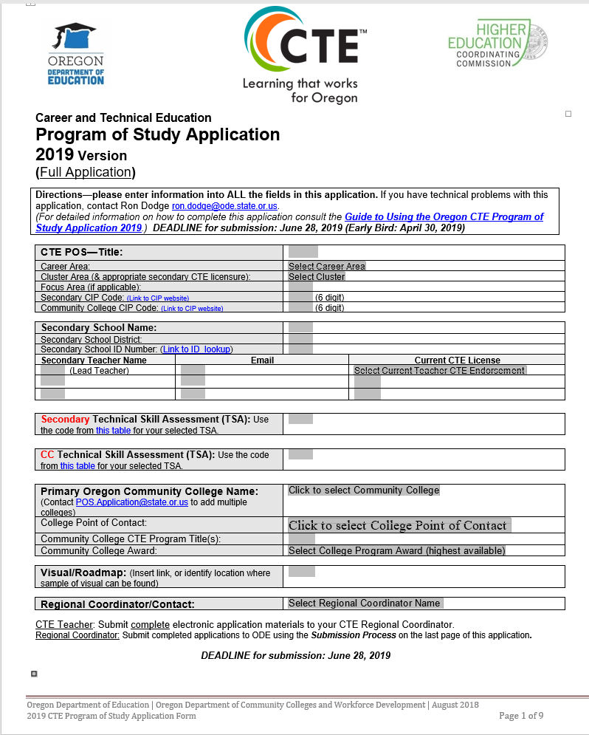

- Please complete all fields of this front page. This information feeds our CTE POS database, and missing information slows the approval process.
- Grey fields require keying-in of information
- Grey fields with black letters also have little arrows indicating Pull-Down Menus. You must select choices from those Pull-Down Menus.
- The CTE POS Title is the title shared between the partner institutions. The POS Title should reflect the Skill Set identified. ODE data reporting to the USDOE will be by Skill Set Cluster title—your aligning POS Titles to those Cluster titles is preferable.
- Please take care when identifying and aligning CIP codes. Please use the official CIP Code Titles

Page 2: Instructions for completing Skills-to-Courses Matrix:

- Identify all courses to be included in the secondary component and give a brief course description; these courses are only those courses in which the teacher will teach with intent and purpose the identified skill set; please complete all information for each course
- Identify the courses in which the student has had the opportunity to learn those skills from the identified skill set for which the teacher will assess with the Technical Skill Assessment (TSA—Y or N?)
- Identify any secondary courses that are eligible for college credit for the student and select the name of the community college that articulates that credit; please complete the college information for those articulated CC courses in a separate column on the matrix.

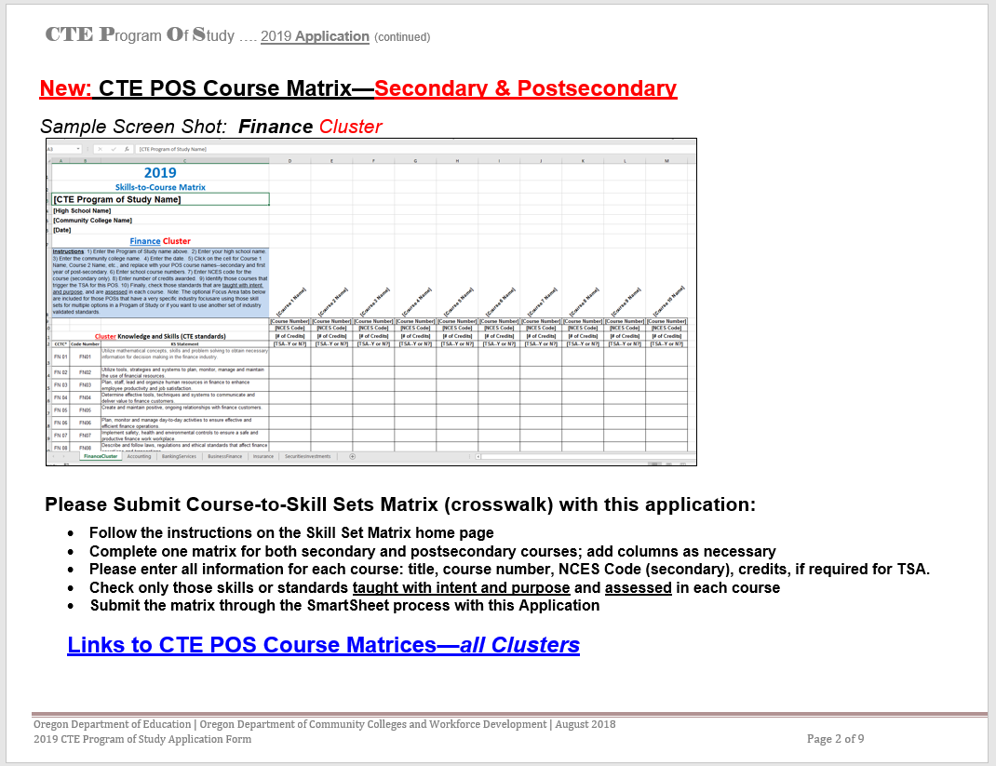

Page 3 (and following): Instructions for completing the five Element sections:

- Read each statement and check those that apply (most boxes should be checked in order to for the application to be approved)
- Those boxes that are not checked should be explained in the Comments Box that follows
- The Comments Box should also be used to address those questions listed above each Box. If you have documents that answer those questions, simply attach them to the application when submitting.

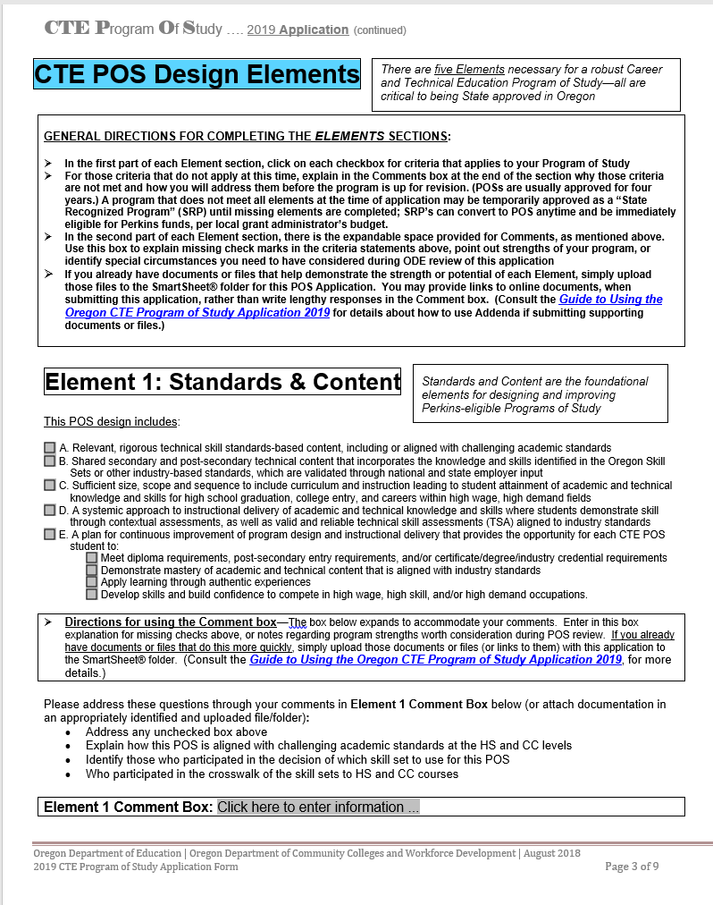

Page 8: Instructions for completing the Certificate of Assurance page:

- Be sure all fields are filled in before printing this page for gathering signatures.
  - Be sure CTE POS name is the same as the title on the first page
  - Enter secondary school name and local administrator name
    - For Regional or Statewide applications, add additional lines for each secondary school or community college (Contact or Kenzie Mozejko (503) 947-5636 for help)
    - Add additional lines for administrators
  - Enter community college name and cc administrator name
  - Enter Advisory Committee member’s name (committee chair is preferred)
  - Enter all dates
- Print and acquire signatures
  - For Regional or Statewide applications, get college(s) signatures first
  - Then make copies for each secondary school to sign
- Scan completed Certificate of Assurances page(s) and add to file before sending to ODE.
  - All signatures MUST be on one document, except for Regional and Statewide applications
  - For Regional or Statewide applications, there should be a copy of the completed Certificate of Assurance page for each secondary school included with the application; ODE recognizes regional and statewide components as individual programs at each secondary school for reporting and licensure purposes, so an individual folder is established for each school.

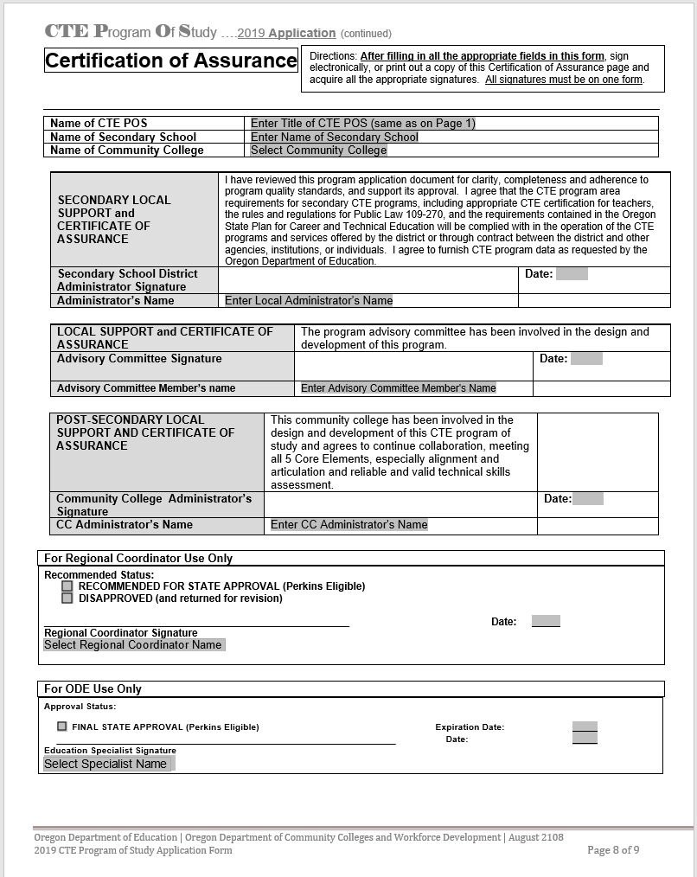

Summary of Documentation for Application Submission

The following is a compiled list from the Element sections of the Application:

Element One—Standards and Content
- Identify technical skill standards/skill sets (in the matrix exercise below); (Performance Indicators not necessary for this exercise)
- Standards-to-course crosswalk/mapping—Please use the Excel spreadsheets posted online at (Skill Set Matrices Page ), or use one you’ve created locally to crosswalk the identified Skill Set against the listed courses. All courses identified in the secondary and postsecondary course lists on pages 2 and 3 must be included.
Element 2—Alignment and Articulation
- Provide evidence of real partnerships and institutional collaboration
- Articulation agreement(s) between secondary and post-secondary institutions
- Provide a CTE POS visual (road map, diagram, chart of courses through college) showing courses and activities available at secondary, multiple entry points at post-secondary, multiple exit points and bridged pathway options, as appropriate; CTE POS visual should illustrate clearly for student, the pathway focus of CTE POS, as well as options related to the CTE POS—(Note: If you have included a hyperlink to these visuals on Page 1 of this application, you do not need to include a copy in an Addendum)
Element 3—Accountability and Assessment
- Identify technical skill assessment(s) to be used with this CTE POS (on Page 1)
Element 4—Student Support Services
- Include examples (documents, other evidence) of Comprehensive Guidance and Counseling that students will receive. This documentation may include:
- Marketing materials for recruitment of non-traditional students to CTE courses
- Tools or skill inventories used to guide course/CTE POS selection
- Secondary partner: Documents illustrating relation to Oregon Diploma requirements:
* Academic applications (Extended Application)
* Education Plan and Profile
* Essential Skills
* Counseling and Guidance materials
- Post-secondary partner: Documents illustrating
* Recruitment and servicing of non-traditional CTE students, displaced homemakers, and other special
population students
*Advising and tutoring practices and procedures
Element 5—Professional Development
- Evidence of the Professional Development plan in place for the development and advancement of this POS; requires a secondary and post-secondary response
- Give samples of your regional and local professional development planning documents , both as discreet institutions and as partner institutions; explain how the professional development activities are designed to improve the instructional delivery within this POS
- Include relevant regional and local professional development budget items and considerations, especially jointly funded activities

For Technical Assistance: FIRST, contact your CTE Regional Coordinator (CTE Regional Coordinator List)

Submission Process

Instructions

CTE Teacher: Submit complete electronic application materials to your CTE Regional Coordinator.
Regional Coordinator: Submit all POS applications to ODE using the SmartSheet® process described below.

Regional Coordinators will submit complete electronic copies of the application materials through uploads to SmartSheets® by following this procedure:
- [It is recommended that you create a folder on your computer using the name of the secondary school, the name of the Program of Study, whether it is a full or renewal application, and the year of submission, e.g., “BeavervilleHSAccountingFull2020.” This way, you will have an “original” in case you need that for some reason.}
- Place all the teacher’s POS application materials in your folder, using consistent names for each file. For example:
  - *1_BeavervilleHSAcctgFullPOSApp2020.doc (Please include the Word® version of the application)
  - *2_BeavervilleHSAcctg2020Assurances.pdf
  - *3_BeavervilleHS_LBCCAcctg2020Matrix.xls (Please include all courses in the matrix, secondary and postsecondary)
  - BeavertonHSAcctg2020RoadMap
  - BeavertonHSAcctg2020StudSuprtSrvs
  - LBCCAcctg2020StudSuprtSrvs
  - LinnCountyLMI_Data (proof of high wage, high demand)
  - List of advisory members, letters of support, etc., all files identified properly
(*The numbering on the titles for the first three documents listed above helps the ODE specialist review the application, and helps ODE staff properly process the completed application.)
- Create a SmartSheet record for the POS application and supporting materials.
- Open the attachments dialogue box and upload all the files from your folder to the attachment box.
- Each application needs to include a completed Assurance page with all signatures included on one form—please, no duplicate pages with partial signatures.
- For Regional Programs of Study, however, each secondary institution will need to have its own application documents, which includes a copy of the Application, the school specific Matrix, and the school specific Assurance page. (Suggestion: for Regional applications, please secure Community College signatures first, then photocopy for each secondary partner and acquire secondary signatures.)

DEADLINE for submission: June 30, 2020

(You may delete this page before submitting this application.)

