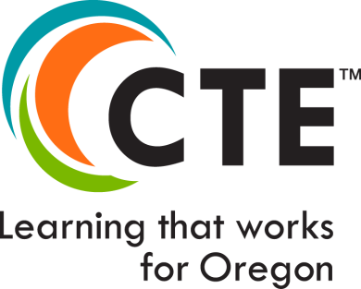

Career and Technical Education

Program of Study Application

2019 Version

(Full Application)

Directions—please enter information into ALL the fields in this application. If you have technical problems with this application, contact Ron Dodge ron.dodge@ode.state.or.us.
(For detailed information on how to complete this application consult the Guide to Using the Oregon CTE Program of Study Application 2019.) DEADLINE for submission: June 28, 2019 (Early Bird: April 30, 2019)

CTE POS—Title:
Career Area:
Cluster Area (& appropriate secondary CTE licensure):
Focus Area (if applicable):
Secondary CIP Code: (Link to CIP website) | (6 digit)
Community College CIP Code: (Link to CIP website) | (6 digit)

Secondary School Name:
Secondary School District:
Secondary School ID Number: (Link to ID lookup)
Secondary Teacher Name | Email |  | Current CTE License
(Lead Teacher)

Secondary Technical Skill Assessment (TSA): Use the code from this table for your selected TSA.

CC Technical Skill Assessment (TSA): Use the code from this table for your selected TSA.

Primary Oregon Community College Name: (Contact POS.Application@state.or.us to add multiple colleges)
College Point of Contact:
Community College CTE Program Title(s):
Community College Award:

Visual/Roadmap: (Insert link, or identify location where sample of visual can be found)

Regional Coordinator/Contact:
CTE Teacher: Submit complete electronic application materials to your CTE Regional Coordinator.
Regional Coordinator: Submit completed applications to ODE using the Submission Process on the last page of this application.

DEADLINE for submission: June 28, 2019

New: CTE POS Course Matrix—Secondary & Postsecondary

Sample Screen Shot: Finance Cluster
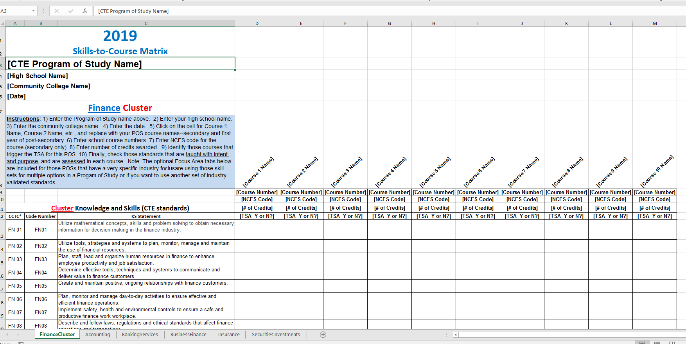

Please Submit Course-to-Skill Sets Matrix (crosswalk) with this application:
- Follow the instructions on the Skill Set Matrix home page
- Complete one matrix for both secondary and postsecondary courses; add columns as necessary
- Please enter all information for each course: title, course number, NCES Code (secondary), credits, if required for TSA.
- Check only those skills or standards taught with intent and purpose and assessed in each course
- Submit the matrix through the SmartSheet process with this Application

Link to CTE POS Course Matrices—all Clusters

CTE POS Design Elements
There are five Elements necessary for a robust Career and Technical Education Program of Study—all are critical to being State approved in Oregon

GENERAL DIRECTIONS FOR COMPLETING THE ELEMENTS SECTIONS:
- In the first part of each Element section, click on each checkbox for criteria that applies to your Program of Study
- For those criteria that do not apply at this time, explain in the Comments box at the end of the section why those criteria are not met and how you will address them before the program is up for revision. (POSs are usually approved for four years.) A program that does not meet all elements at the time of application may be temporarily approved as a “State Recognized Program” (SRP) until missing elements are completed; SRP’s can convert to POS anytime and be immediately eligible for Perkins funds, per local grant administrator’s budget.
- In the second part of each Element section, there is the expandable space provided for Comments, as mentioned above. Use this box to explain missing check marks in the criteria statements above, point out strengths of your program, or identify special circumstances you need to have considered during ODE review of this application
- If you already have documents or files that help demonstrate the strength or potential of each Element, simply upload those files to the SmartSheet® folder for this POS Application. You may provide links to online documents, when submitting this application, rather than write lengthy responses in the Comment box. (Consult the Guide to Using the Oregon CTE Program of Study Application 2019 for details about how to use Addenda if submitting supporting documents or files.)

Element 1: Standards & Content
Standards and Content are the foundational elements for designing and improving Perkins-eligible Programs of Study

This POS design includes:

A. Relevant, rigorous technical skill standards-based content, including or aligned with challenging academic standards
B. Shared secondary and post-secondary technical content that incorporates the knowledge and skills identified in the Oregon Skill Sets or other industry-based standards, which are validated through national and state employer input
C. Sufficient size, scope and sequence to include curriculum and instruction leading to student attainment of academic and technical knowledge and skills for high school graduation, college entry, and careers within high wage, high demand fields
D. A systemic approach to instructional delivery of academic and technical knowledge and skills where students demonstrate skill through contextual assessments, as well as valid and reliable technical skill assessments (TSA) aligned to industry standards
E. A plan for continuous improvement of program design and instructional delivery that provides the opportunity for each CTE POS student to:
Meet diploma requirements, post-secondary entry requirements, and/or certificate/degree/industry credential requirements
Demonstrate mastery of academic and technical content that is aligned with industry standards
Apply learning through authentic experiences
Develop skills and build confidence to compete in high wage, high skill, and/or high demand occupations.

- Directions for using the Comment box—The box below expands to accommodate your comments. Enter in this box explanation for missing checks above, or notes regarding program strengths worth consideration during POS review. If you already have documents or files that do this more quickly, simply upload those documents or files (or links to them) with this application to the SmartSheet® folder. (Consult the Guide to Using the Oregon CTE Program of Study Application 2019, for more details.)

Please address these questions through your comments in Element 1 Comment Box below (or attach documentation in an appropriately identified and uploaded file/folder):
- Address any unchecked box above
- Explain how this POS is aligned with challenging academic standards at the HS and CC levels
- Identify those who participated in the decision of which skill set to use for this POS
- Who participated in the crosswalk of the skill sets to HS and CC courses

Element 1 Comment Box: Click here to enter information ...

Element 2: Alignment and Articulation
Alignment and Articulation are key to help Program of Study partners work together to build career pathways for CTE students

The alignment of this POS includes:

A. A unified, cohesive sequence of content among secondary and post-secondary partners contained in a non-duplicative sequence
of courses or learning experiences.
B. Alignment of content between secondary and post-secondary education partners may include course articulation or other ways
students can acquire post-secondary education credits (e.g. Credit for Proficiency, Dual Credit, Oregon Transfer credit, etc.).
C. Articulation agreements are developed, implemented and supported at the institutional level to ensure long-term sustainability
and cross-sector cooperation.
D. Based on the program design and instructional plan, each student will:
Continually progress in knowledge and skills when ready;
Earn high school or college credit based on performance; and
Make the connection between educational preparation and entry into a career.

- Directions for using the Comment box—The box below expands to accommodate your comments. Enter in this box explanation for missing checks above, or notes regarding program strengths worth consideration during POS review. If you already have documents or files that do this more quickly, simply upload those documents or files (or links to them) with this application to the SmartSheet® folder. (Consult the Guide to Using the Oregon CTE Program of Study Application 2019, for more details.)

Please address these questions through your comments in Element 2 Comment Box below (or attach documentation in an appropriately identified and uploaded file/folder):

Address any unchecked box above

Briefly describe the level of alignment and/or articulation that exists for this POS (you may also identify non-Perkins eligible alignments that exist with private schools, universities, etc.)

Briefly describe the alignment and/or articulation activities that have occurred, and who participated from HS and CC levels

Element 2 Comment Box: Click here to enter information ...

Element 3: Accountability & Evaluation
Accountability and Evaluation are core elements for Perkins eligibility—they provide data illustrating the value of CTE to students’ college/career plans

In this POS design:

A. Performance will be measured against the Perkins-required performance measures as described in Perkins IV Measurement Definitions identified in Oregon’s State Plan (re: Data Collection)
B. Business, community and education partners (specifically, an Advisory Committee) participate in CTE Program of Study design, development, and evaluation, including:
Assistance in evaluating program vision, goals and priorities
Validation of industry skill standards for curriculum content and technical skill assessment, where appropriate
Participation in the CTE teacher recruitment, instructor appraisal process, and ongoing faculty professional development
C. Perkins performance data is used for data-driven, CTE program of study design and improvement decisions
D. Students have the opportunity to learn in a contextual career related environment that allows them to:
Monitor their own progress through their demonstration of attaining technical and academic skill standards
Demonstrate their technical and academic proficiency in meaningful ways, e.g., Technical Skill Assessment, industry credential, etc.
Adapt their program to meet personal goals based on industry requirements and performance outcomes

- Directions for using the Comment box—The box below expands to accommodate your comments. Enter in this box explanation for missing checks above, or notes regarding program strengths worth consideration during POS review. If you already have documents or files that do this more quickly, simply upload those documents or files (or links to them) with this application to the SmartSheet® folder. (Consult the Guide to Using the Oregon CTE Program of Study Application 2019, for more details.)

Please address these questions through your comments in Element 3 Comment Box below (or attach documentation in an appropriately identified and uploaded file/folder):

Address any unchecked box above
- Identify the data used in designing this POS, and the effect that the data had on the design
- Identify the members of the Business Advisory Committee
- How will the POS be evaluated, and by whom?
- How will you know if the POS is successful?
- What process will you use to decide any changes that need to occur because of the POS evaluation?
- Required: List the TSA(s) code used for this POS on Page 1 (ODE approved list)

Element 3 Comment Box: Click here to enter information ...

Element 4: Student Support Services
Student Support Services include the ways that all students are made aware of the career and education opportunities available in the CTE career Pathway that is the focus of this POS.

In this POS design:

A. All CTE students will have informational guidance support and advising to assist them in progressing through a CTE program of study in an efficient and seamless manner (e.g. Career Pathway Templates and/or Roadmaps, Education Plan and Profile, POS visual guides, Career Information System, etc.).
B. Each student will be able to:
Identify the career path options he/she can follow to a chosen career;
Receive consistent and informed messages about career and possible financial options for post-secondary education;
Take ownership of their education through maintaining a current education plan;
C. Compliance is evident with Federal regulations, including Title VI- Civil Rights Act of 1964; Title IX – Education Amendments of 1972; Section 504 of the Rehabilitation Act of 1973; Vocational Education Programs Guidelines for Eliminating Discrimination and Denial of Services on the Basis of Race, Color, Sex, Religion, National Origin, Age or Disability; Title II of the Americans with Disabilities Acts of 1990; therefore, this POS provides:
Appropriate access for all students, including non-traditional and special populations.
A non-biased and non-discriminating learning environment (with respect to race, color, national origin, gender and disability status).
Program facilities with physical access and instruction that accommodates students with disabilities, including various learning styles (e.g. the use of visual, auditory, tactile, and kinesthetic teaching methods, and other appropriate forms of instruction).
Responsiveness to the needs of students for whom English is a second language.
D. Opportunities for structured student leadership are a program component and integrated into CTE POS instruction. This POS integrates either:
1) One of the state chartered CTSO’s: DECA, FBLA, FCCLA, FFA, FNRL, HOSA, SkillsUSA,
TSA —or—
2) Another local or national organization that meets the criteria listed in the ODE Student Leadership criteria document.
- The locally developed student organization or experience provides leadership development opportunities that meet the following expectations (see details in linked document above):
Context related instruction, career development, and practical assessment
Community-based learning experiences
Organizational management and administrative experiences

- Directions for using the Comment box—The box below expands to accommodate your comments. Enter in this box explanation for missing checks above, or notes regarding program strengths worth consideration during POS review. If you already have documents or files that do this more quickly, simply upload those documents or files (or links to them) with this application to the SmartSheet® folder. (Consult the Guide to Using the Oregon CTE Program of Study Application 2019, for more details.)

Please address these questions through your comments in Element 4 Comment Box below (or attach documentation in an appropriately identified and uploaded file/folder):

Address any unchecked box above
- Briefly describe the POS-specific student support services that HS and CC students will receive in this POS that will support their success in the courses
- How will those student support services help inform and prepare HS and CC students for their next educational and career steps?
- Briefly describe the specific efforts that will be made to recruit all types of students into this POS (both HS and CC levels)
- Briefly describe any student leadership opportunities that will be available for both HS and CC

Element 4 Comment Box: Click here to enter information ...

Element 5: Professional Development
Professional Development for POS teachers should be designed on the needs identified by data, and should focus on continuous improvement of student opportunities within this POS.

The planned professional development for this POS will:

A. Connect to teacher effectiveness evaluations.
B. Help teachers and administrators develop and improve standards-based curriculum and learning experiences that promote the integration of coherent and challenging academic content and industry-based technical standards, including opportunities for the appropriate academic and CTE instructors to jointly develop and implement classroom-based curriculum and instructional strategies.
C. Include professional development that is high quality, sustained, intensive, and focused on instruction designed to increase the academic knowledge and understanding of industry standards
D. Encourage applied learning methodology that contributes to the academic and CTE knowledge of the student
E. Provide research and training opportunities that help teachers develop appropriate and useful assessment tools and strategies.
F. Provide training and guidance geared to help improve instructional delivery methodology that helps improve student performance and skill acquisition, particularly skills needed to work with and improve instruction for special populations.
G. Assist teachers in accessing and utilizing CTE accountability data, student achievement data, and data from assessments

- Directions for using the Comment box—The box below expands to accommodate your comments. Enter in this box explanation for missing checks above, or notes regarding program strengths worth consideration during POS review. If you already have documents or files that do this more quickly, simply upload those documents or files (or links to them) with this application to the SmartSheet® folder. (Consult the Guide to Using the Oregon CTE Program of Study Application 2019, for more details.)

Please address these questions through your comments in Element 5 Comment Box below (or attach documentation in an appropriately identified and uploaded file/folder):
- Address any unchecked box above
- Briefly describe how PD will be planned and implemented, based on the needs of this POS
- Briefly describe any planned joint PD ventures for HS and CC teachers, as well as regional trainings

Element 5 Comment Box: Click here to enter information ...

CTE Teacher: Submit complete electronic application materials to your CTE Regional Coordinator.
Regional Coordinator: Submit completed applications to ODE using the Submission Process on the last page of this application.

DEADLINE for submission: June 28, 2019
Certification of Assurance
Directions: After filling in all the appropriate fields in this form, sign electronically, or print out a copy of this Certification of Assurance page and acquire all the appropriate signatures. All signatures must be on one form.

Name of CTE POS | Enter Title of CTE POS (same as on Page 1)
Name of Secondary School | Enter Name of Secondary School
Name of Community College

SECONDARY LOCAL SUPPORT and CERTIFICATE OF ASSURANCE | I have reviewed this program application document for clarity, completeness and adherence to program quality standards, and support its approval. I agree that the CTE program area requirements for secondary CTE programs, including appropriate CTE certification for teachers, the rules and regulations for Public Law 109-270, and the requirements contained in the Oregon State Plan for Career and Technical Education will be complied with in the operation of the CTE programs and services offered by the district or through contract between the district and other agencies, institutions, or individuals. I agree to furnish CTE program data as requested by the Oregon Department of Education.
Secondary School District Administrator Signature |  | Date:
Administrator’s Name | Enter Local Administrator’s Name

LOCAL SUPPORT and CERTIFICATE OF ASSURANCE | The program advisory committee has been involved in the design and development of this program.
Advisory Committee Signature |  | Date:
Advisory Committee Member’s name | Enter Advisory Committee Member's Name

POST-SECONDARY LOCAL SUPPORT AND CERTIFICATE OF ASSURANCE | This community college has been involved in the design and development of this CTE program of study and agrees to continue collaboration, meeting all 5 Core Elements, especially alignment and articulation and reliable and valid technical skills assessment.
Community College Administrator’s Signature |  | Date:
CC Administrator’s Name | Enter CC Administrator's Name

For Regional Coordinator Use Only
Recommended Status:
RECOMMENDED FOR STATE APPROVAL (Perkins Eligible)
DISAPPROVED (and returned for revision)

______________________________________________________ Date:
Regional Coordinator Signature

For ODE Use Only
Approval Status:

FINAL STATE APPROVAL (Perkins Eligible) Expiration Date:
______________________________________________________ Date:
Education Specialist Signature

. Final Submission

Submission Process

New instructions this year--2019!

Instructions

CTE Teacher: Submit complete electronic application materials to your CTE Regional Coordinator.
Regional Coordinator: Submit all POS applications to ODE using the SmartSheet® process described below.

Regional Coordinators will submit complete electronic copies of the application materials through uploads to SmartSheets® by following this procedure:
- [It is recommended that you create a folder on your computer using the name of the secondary school, the name of the Program of Study, whether it is a full or renewal application, and the year of submission, e.g., “BeavervilleHSAccountingFull2019.” This way, you will have an “original” in case you need that for some reason.}
- Place all the teacher’s POS application materials in your folder, using consistent names for each file. For example:
  - *1_BeavervilleHSAcctgFullPOSApp2019.doc (Please include the Word® version of the application)
  - *2_BeavervilleHSAcctg2019Assurances.pdf
  - *3_BeavervilleHS_LBCCAcctg2019Matrix.xls (Please include all courses in the matrix, secondary and postsecondary)
  - BeavertonHSAcctg2019RoadMap
  - BeavertonHSAcctg2019StudSuprtSrvs
  - LBCCAcctg2019StudSuprtSrvs
  - LinnCountyLMI_Data (proof of high wage, high demand)
  - List of advisory members, letters of support, etc., all files identified properly
(*The numbering on the titles for the first three documents listed above helps the ODE specialist review the application, and helps ODE staff properly process the completed application.)
- Create a SmartSheet® record for the POS application and supporting materials.
- Open the attachments dialogue box and upload all the files from your folder to the attachment box.
- Each application needs to include a completed Assurance page with all signatures included on one form—please, no duplicate pages with partial signatures.
- For Regional Programs of Study, however, each secondary institution will need to have its own application documents, which includes a copy of the Application, the school specific Matrix, and the school specific Assurance page. (Suggestion: for Regional applications, please secure Community College signatures first, then photocopy for each secondary partner and acquire secondary signatures.)

- DEADLINE for submission: June 28, 2019

- Early Bird deadline (assures feedback before teachers leave for summer): April 30, 2019

(You may delete this page before submitting this application.)

The CTE brand logo, brand-positioning, theme, and brand extensions are the property of NASDCTEc

