Career and Technical Education

Program of Study Renewal

2019 Version

Step 1 –ODE specialists will review POS Renewal Applications based on course information contained in the Course-to-Standards Matrix,
so please be sure those matrices are complete and accurate.)
Step 2 – Complete this 2019 CTE POS Renewal form (make sure all items are complete)
- Program ID Page (Page 1 of this Form) complete
- Provide a link to Career Pathway visual (on Page 1 below)
- Complete CTE Course-to-Standards Crosswalk Matrix (use one of the ODE Cluster templates, or a similar local form); attach matrix to this 2019 CTE POS Renewal form
- Indicate on the Matrix (above) those courses that trigger the Technical Skill Assessment(s); identify the TSA on Page 1 of this 2019 CTE POS Renewal form
- Enclose evidence of Student Support Services that are specific to this CTE POS (see next page)
- Print out Assurances page, secure signatures, and scan as attachment to this 2019 CTE POS Renewal form
Step 3 – Submit this 2019 CTE POS Renewal form and attachments to your Regional Coordinator for field approval
Step 3 – CTE Regional Coordinator: Review and field approve appropriately completed 2019 CTE POS Renewal form and attachments
Step 5 – Submit appropriately completed and field approved 2019 CTE POS Renewal form using SmartSheet® process described on last page of this application.
DEADLINE: June 28, 2019.

CTE POS—Title:
Career Area:
Cluster Area (and CTE licensure)
Focus Area (if applicable):
Secondary CIP Code: (Link to CIP website) | (6 digit)
Community College CIP Code: (Link to CIP website) | (6 digit)

Secondary School Name:
Secondary School District:
Secondary School ID Number: (Link to ID lookup)
Secondary Teacher Name: | Email |  | Current CTE License

CC Technical Skill Assessment (TSA): Use the code from this table for your selected TSA.

Secondary Technical Skill Assessment (TSA): Use the code from this table for your selected TSA.

Primary Oregon Community College Name: (Contact POS.Application@state.or.us to add multiple colleges)
College Point of Contact:
Community College CTE Program Title:
Community College Award:

Visual/Roadmap: (Insert link, or identify location where sample of visual can be found)

Regional Coordinator/Contact:

Student Support Services

Directions:
- Complete the Expectations section below as evidence of the secondary (Sec) and postsecondary (Psec) Student Support Services that you provide specifically for students studying in this CTE Program of Study - and/or -
- Enclose (as links in the Comments box below or as attachments) documents that demonstrate Student Support Services that you provide specifically for students studying in this CTE Program of Study (both Sec and Psec)

Expectations
Check the applicable boxes below that indicate the Student Support Services you provide for students studying in this CTE Program of Study. (Boxes not checked should be explained in the Comments box below.)

Sec | Psec | Student Service Provided
 |  | Students receive information, guidance, and/or counseling specific to this CTE Program of Study, including career and job market information, and college program information.
 |  | Students participate in CTE POS specific career related learning experiences or related work experience.
 |  | Students’ education planning is developed around information specific to this CTE Program of Study.
 |  | Extended application projects or capstone experiences are developed within the context of this CTE Program of Study.
 |  | Written information is provided to all students in this CTE Program of Study informing them of available articulated college (or university) credits, dual credit, expanded options, scholarships, and other postsecondary opportunities.
 |  | Efforts are made to provide information to students who are considered non-traditional by gender to the occupations resulting from this CTE Program of Study.
 |  | Access and recruitment to courses in this CTE POS are provided for all students including, but not limited to all Oregon and federal protected classes.
 |  | Accommodations are made to assure students with special needs can participate in this CTE POS.
 |  | Assistance is provided for students wishing to participate in this CTE POS for whom English is not their native language.

Evidence
During an ODE/CCWD audit, you may be asked for documentation or evidence of meeting the expectations listed above. Indicate where documentation may be found by providing links in the Comments box below, or by describing where documentation is kept, or by attaching documents to this 2019 CTE POS Renewal form.

Sec | Psec | Evidence/documentation location (check those that apply)
 |  | Links to documentation are included in Comments box below
 |  | Description of where documentation can be found is included in Comments box below
 |  | Actual Student Support Services documents are attached to this 2019 CTE POS Renewal form

Comments:
(In the box below, please: 1) include links to any online documentation; 2) please include identification of the Technical Skill Assessment(s) (TSA) identified for this CTE POS—secondary and postsecondary; 3) finally, use this comment box to explain missing checkboxes from the Expectations matrix above.)

Enter comments here

New: CTE POS Course Matrix—Secondary & Postsecondary

Sample Screen Shot: Finance Cluster
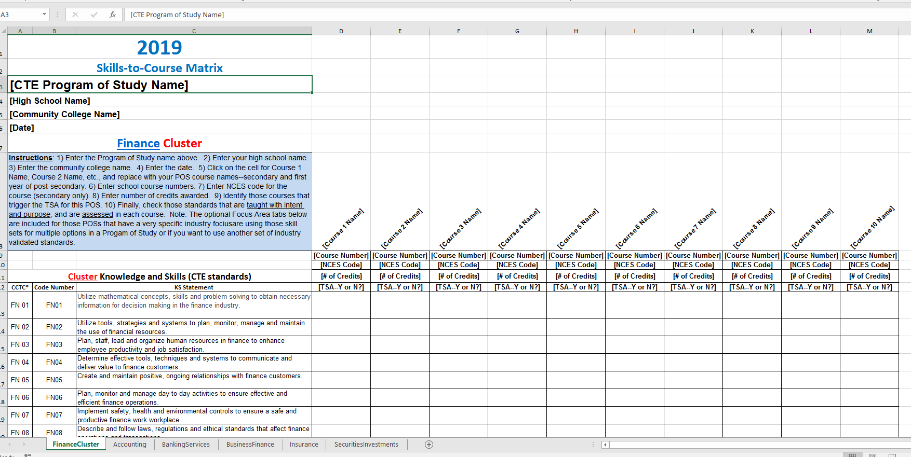

Please Submit Course-to-Skill Sets Matrix (crosswalk) with this application:
- Follow the instructions on the Skill Set Matrix home page
- Complete one matrix for both secondary and postsecondary courses; add columns as necessary
- Please enter all information for each course: title, course number, NCES Code (secondary), credits, required for TSA?
- Check only those skills or standards taught with intent and purpose and assessed in each course
- Submit the matrix through the SmartSheet process with this Application

Links to CTE POS Course Matrices—all Clusters

Certification of Assurance
Directions: After filling in all the appropriate fields in this form, print out a copy of this Certification of Assurance page and acquire all the appropriate signatures. All signatures must be on one form. Submit signed Assurance form through SmartSheet® process described below.

Name of CTE POS | Enter Title of CTE POS (same as on Page 1)
Name of Secondary School | Enter Name of Secondary School
Name of Community College

SECONDARY LOCAL SUPPORT and CERTIFICATE OF ASSURANCE | I have reviewed this program application document for clarity, completeness and adherence to program quality standards, and support its approval. I agree that the CTE program area requirements for secondary CTE programs, including appropriate CTE certification for teachers, the rules and regulations for Public Law 109-270, and the requirements contained in the Oregon State Plan for Career and Technical Education will be complied with in the operation of the CTE programs and services offered by the district or through contract between the district and other agencies, institutions, or individuals. I agree to furnish CTE program data as requested by the Oregon Department of Education.
Secondary School District Administrator Signature |  | Date:
Administrator’s Name | Enter Local Administrator’s Name

LOCAL SUPPORT and CERTIFICATE OF ASSURANCE | The program advisory committee has been involved in the design and development of this program.
Advisory Committee Signature |  | Date:
Advisory Committee Member’s name | Enter Advisory Committee Member's Name

POST-SECONDARY LOCAL SUPPORT AND CERTIFICATE OF ASSURANCE | This community college has been involved in the design and development of this CTE program of study and agrees to continue collaboration meeting all 5 Core Elements, especially alignment and articulation and reliable and valid technical skills assessment.
Community College Administrator’s Signature |  | Date:
CC Administrator’s Name | Enter CC Administrator's Name

For Regional Coordinator Use Only
Recommended Status:
RECOMMENDED FOR STATE APPROVAL (Perkins Eligible)
DISAPPROVED (and returned for revision)

______________________________________________________ Date:
Regional Coordinator Signature

For ODE/OCCWD Use Only
Approval Status:

FINAL STATE APPROVAL (Perkins Eligible) Expiration Date:

______________________________________________________ Date:
Education Specialist Signature

Final Submission

Submission Process

New instructions this year--2019!

CTE Teacher: Submit complete electronic application materials to your CTE Regional Coordinator.
Regional Coordinator: Submit all POS applications to ODE using the SmartSheet® process described below.

Regional Coordinators will submit complete electronic copies of the application materials through uploads to SmartSheets® by following this procedure:
- [It is recommended that you create a folder on your computer using the name of the secondary school, the name of the Program of Study, whether it is a full or renewal application, and the year of submission, e.g., “BeavervilleHSAccountingFull2019.” This way, you will have an “original” in case you need that for some reason.}
- Place all the teacher’s POS application materials in your folder, using consistent names for each file. For example:
  - *1_BeavervilleHSAcctgFullPOSApp2019.doc (Please include the Word® version of the application)
  - *2_BeavervilleHSAcctg2019Assurances.pdf
  - *3_BeavervilleHS_LBCCAcctg2019Matrix.xls (Please include all courses in the matrix, secondary and postsecondary)
  - BeavertonHSAcctg2019RoadMap
  - BeavertonHSAcctg2019StudSuprtSrvs
  - LBCCAcctg2019StudSuprtSrvs
  - LinnCountyLMI_Data (proof of high wage, high demand)
  - List of advisory members, letters of support, etc., all files identified properly
(*The numbering on the titles for the first three documents listed above helps the ODE specialist review the application, and helps ODE staff properly process the completed application.)
- Create a SmartSheet record for the POS application and supporting materials.
- Open the attachments dialogue box and upload all the files from your folder to the attachment box.
- Each application needs to include a completed Assurance page with all signatures included on one form—please, no duplicate pages with partial signatures.
- For Regional Programs of Study, however, each secondary institution will need to have its own application documents, which includes a copy of the Application, the school specific Matrix, and the school specific Assurance page. (Suggestion: for Regional applications, please secure Community College signatures first, then photocopy for each secondary partner and acquire secondary signatures.)

- DEADLINE for submission: June 28, 2019
- Early Bird deadline (assures feedback before teachers leave for summer): April 30, 2019

Checklist before submitting:

All items on Page 1 of this form have been completed
The Career Pathway Map/Visual link has been included on Page 1, (showing both secondary and postsecondary partners)
The course-to-standards matrix for this CTE POS has been completed and attached
All courses that trigger the Technical Skill Assessment have been identified in the course-to-standards matrix
All student support services expectations (Page 2) have been addressed and any documentation has been linked or attached
Assurances document has been properly completed, signed, and attached and/or faxed

(You may delete this page before submitting this application.)

The CTE brand logo, brand-positioning, theme, and brand extensions are the property of Advance CTE

