Quick Guide for using the High Quality CTE Program of Study
(HQ POS) Rubric
Purpose of the HQ POS Rubric
Career and Technical Education (CTE) Programs of Study (POS) are designed to help students prepare for future careers, including additional schooling, training, and industry experience that would help the student best prepare for that future. The High Quality Program of Study (HQPOS) Rubric is a tool to be used by educators and administrators to assess existing CTE POS in order to create goals for continuous program improvement to heighten the student experience. CTE Programs, in collaboration with the local CTE Regional Coordinator, are expected to self-evaluate and continuously improve over the four year period of the program approval. Based on the self-evaluation, programs should set long and short term goals that address areas needing improvement. The intent is that this tool will be used for the CTE Program of Study Renewal as well as to inform the Local and Regional Needs Assessment sections dealing with CTE Program Quality required by Perkins V.
There are ten elements in the High Quality Program of Study Rubric. Those ten elements are cross walked to the five Elements of a CTE Program of Study and performance levels are aligned with the Oregon Equity Lens, Program Size, Scope, and Quality and the Work-Based Learning Rubric. For more background information, please consult section five of the CTE Policy Guidebook
Important Points to Ponder When Utilizing the HQPOS Rubric
- It is NOT intended that each CTE POS focus on ALL elements of this rubric each time the program self-evaluates; the goal, rather, should be to maintain those elements the CTE POS has addressed well, but plan strategies that will help improve areas that need improvement
- It is NOT intended that a self-evaluating CTE POS meet a “4” on all elements in the rubric. Circumstances change, and a program’s ability to address each element in the rubric will ebb and flow over time; again, maintaining ground gained should be part of the continuous improvement effort. In general, Level 3 of the HQPOS rubric aligns with the definition for size, scope, and quality of a CTE Program of Study.
- It IS intended that a CTE POS will use the rubric—especially relevant elements of the rubric based on local circumstances—to help evaluate program success, future planning and goal setting for the CTE POS
- ODE is NOT currently expecting evidence of a program’s use of this rubric, especially in those years when renewal is not required; however, a local program may use information from the rubric to communicate with educational partners, business and industry partners, district personnel, community interests, and ODE to communicate the strength, growth and needs of the CTE POS. As program process and statewide programs are implemented there could be change to the expectations on rubric usage.
Cycle of Use: High Quality Program of Study Rubric

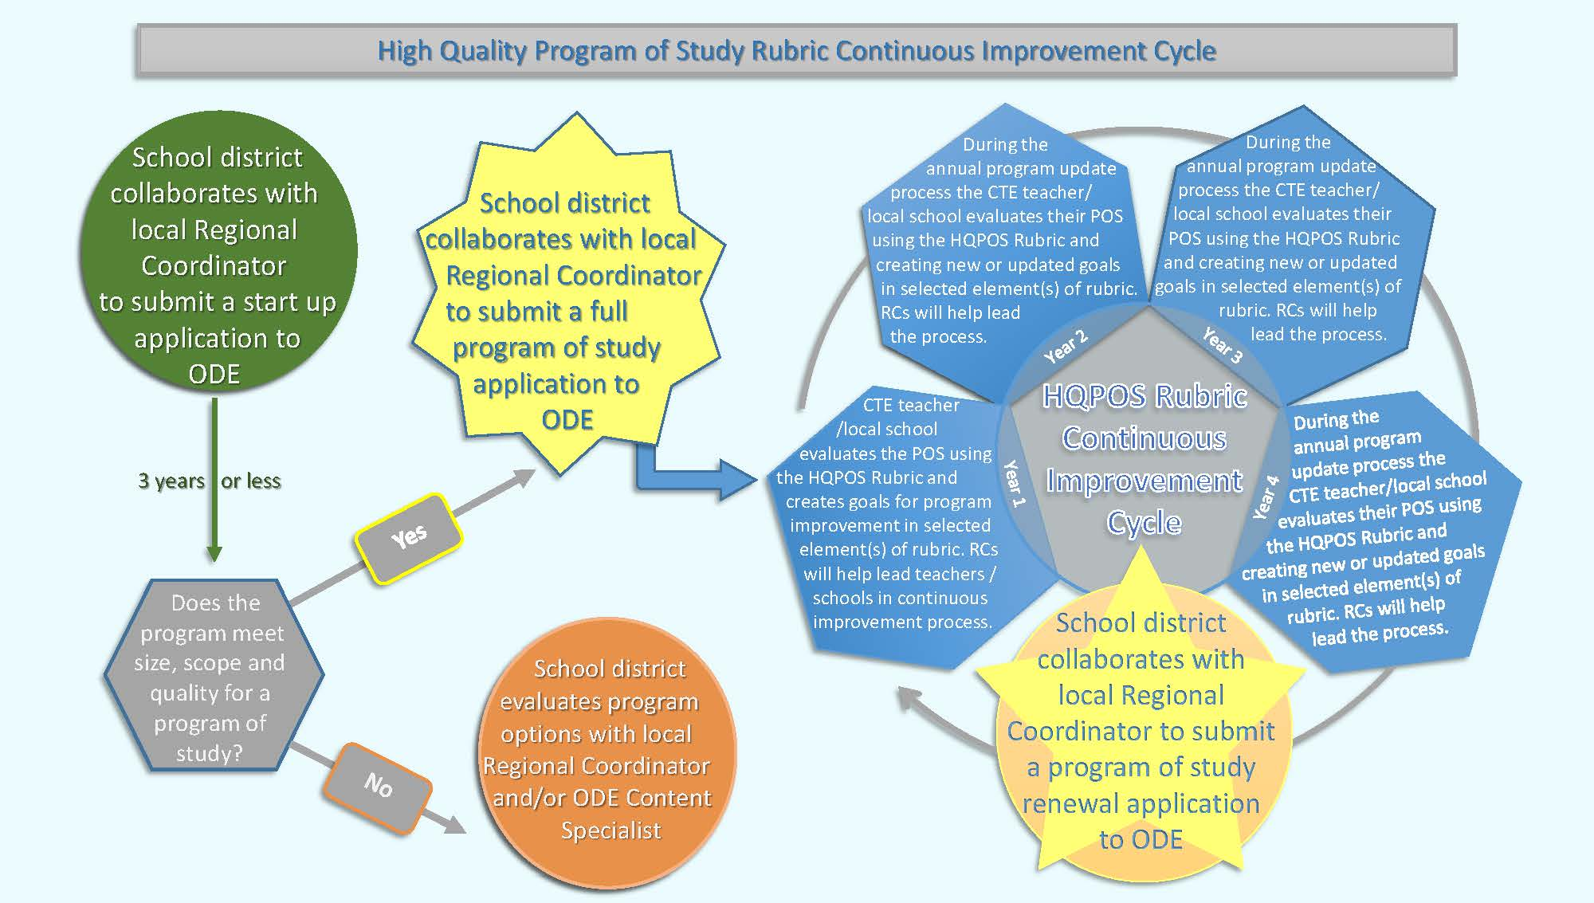

Elements of the HQ POS Rubric
Below are the ten elements of the HQPOS Rubric with their connection to the POS core element and descriptions. Each element listed includes an overarching explanation of what goals should be focused on when this element is selected for continuous improvement of the program.
HQ POS Rubric Element (POS Core Element) | HQ POS Element Overview
1. Access and Equity (Access and Equity) - Provides all students and their families with appropriate knowledge and experiences to help make informed education and career decisions. | HQPOS positively impacts the whole school population, providing the opportunity for all students to have access and inclusion in all opportunities. The HQPOS positively impacts the community demographic and helps promote equal access and inclusion for all. The HQPOS helps eliminate opportunity gaps and barriers that exist in schools and communities.
2. Rigorous Integrated Content (Standards and Content) - Appropriately licensed secondary teachers, and postsecondary instructors meeting institution requirements* integrate rigorous technical and academic content. | Quality CTE instruction is applied learning in the context of the career field of the Career Cluster. Students learn how the technical skills of the POS’s Skill Set are used in the field, but moreover, they learn how the academic skills required for success in the field are used throughout the career area.
3. Engaged Learning (Standards and Content) – Engages students through instructional strategies that are relevant, authentic, and meet the needs and interests of all students | Students have repeated opportunities to learn through hands-on experiences in venues that replicate the real workplace specific to that career. Students work with experienced adults to learn skills and demonstrate their proficiency with those skills.
4. Coherent Curriculum (Standards and Content) - Aligns to industry-identified standards and sequenced to prepare students for their next steps. | Curriculum has a scope and sequence that aligns to industry standards and leads to an industry recognized credential. Students are able to earn three or more high school credits, some or all of which are linked to college credit. High schools and community colleges work together to assure smooth, seamless transitions for students between components of the program and into industry.
5. Partnerships (Alignment and Articulation) - Actively engages employer and educator partners to develop, enhance, and support the CTE program in a manner that is sustainable. | Partnerships with industry are an integral part of the high quality program, wherein partners have a role in design, implementation, evaluation, and continuous improvement of the program. Activities that engage partners should include participation with both secondary and postsecondary partners.
6. Credentials (Alignment and Articulation) – Links instruction to meaningful college credit or industry credentials that can lead to high wage and high demand occupations. | Students have the ability to earn industry recognized credentials that help them obtain employment and advance readily in their chosen career field.
7. Facilities and Equipment (Alignment and Articulation) – Provides students with safe access to facilities and equipment that are appropriate to the type of instruction and reflect workforce needs. | Students have access to cutting edge technology, industry level equipment, materials, and processes. Facilities and equipment are kept current and prepare students to have skills to operate and process in state-of-the-art workplace environments.
8. Continuous Improvement (Accountability and Evaluation) – Revises the program of study based on student performance, economic demand, and employer requirements | Student data are collected yearly and are analyzed by the design team for program success and program planning. Data are shared with students, staff, parents, and the public to gain awareness and support of the CTE POS.
9. Career Connected Learning (Student Support Services) - Provides quality, accurate and timely information and support that will help students identify, pursue, transition, and complete pathways to future careers. Career Connected Learning should include activities and opportunities within the four domains of: Awareness, Exploration, Preparation and Training. | Students are made aware of the plethora of careers that exist in our economy. They learn what it takes to be prepared to enter those careers with the knowledge and skills to be successful. They actively participate in the design and implementation of their career journey through the development of Education and Career Plans. Students involve multiple adults, including parents, teachers, business partners, counselors, and others in designing and implementing their education and career plans.
10. Professional Development (Professional Development) – Promotes instructor professional growth that aligns with long-term program goals. | Professional development plans of CTE instructors are tied closely to the needs of the HQPOS, encouraging innovation and continuous improvement. Plans are linked to improved and innovative teaching methods, exposure to and use of cutting edge technology, and acquiring and implementing robust curriculum and materials.

Coming Soon
This Quick Guide is only a temporary placeholder for a more robust Guide that ODE will add to their page of CTE POS Resources after gathering more input from districts and CTE regions, as well as from the initial programs involved in the Statewide Programs of Study development. That Guide will address individual elements of the rubric, offering more detailed help and insight for each of the elements.
For further information or support please contact the following:
Your local Regional Coordinator | From ODE: Carly Sichley or Ron Dodge | From CCWD: KC Andrews

