Department of  Office of Educational Improvement and Innovation  Public Service Building  255 Capitol Street NE  Salem, OR 97310-0203  503-947-5600  Fax 503-378-5156  CTE page on ODE Website |  | 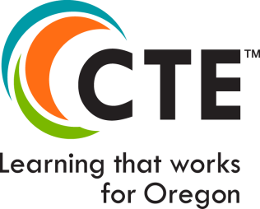
Start-Up CTE Program of Study Application
(HSS/BM 98 Eligibility/Perkins (30%) Eligibility)
2019 Version

This application is required for all Start-Up CTE Programs of Study. There are two parts to this application. An approved Start-Up CTE POS application makes the courses in this POS eligible for partial (up to 30% of start-up costs) Perkins funding and High School Success (HSS…BM98) funds.

Part 1 – Must be completed for all Start-Up CTE Programs of Study, even if they are being developed exclusively with local funds. This application will place the program in ODE’s list of pending CTE Programs of Study. If the program is not completed within the identified time, it will be removed from that list and a new application must be submitted.

Part 2 – Must be completed for all new CTE Programs of Study where Perkins funds or HSS funds are being requested to develop either the secondary or postsecondary component of the program. If the program is not completed within the identified time, it will be removed from the list of pending CTE Programs of Study and ODE may request return of Perkins funds used to develop the program.

PART 1 – Must be completed by secondary and postsecondary partners

CTE Program of Study—General Information
Proposed Title of Program of Study
Secondary CIP Code: (Link to CIP website) | (6 digit)
Community College CIP Code: (Link to CIP website) | (6 digit)
Career Cluster
Focus Area (if applicable)

Secondary School Name:
Secondary School ID Number: (Link to ID lookup)
Secondary Teacher Name
Secondary Teacher Licensure

Oregon Community College Name:
Community College Award:
Program Contact Name:
Department, division, etc.:
Phone: | Email :

Regional Coordinator/Contact:

2019 Course-To-Standards Matrix (Crosswalks)

ODE will need a list of courses that will comprise this POS, and on which the school may spend Perkins funds and report data. It is also important to see which industry standards (from the Oregon Skill Sets or another acceptable set of industry standards) are taught in each course, in order to see that all expected standards will be taught with intent and purpose, and assessed, in the courses of this POS. It is likewise important that redundant or irrelevant courses are not being included and funded with federal funds.

Please use the appropriate Skill Set Course-to-Standards matrix from the hyperlinks below to map the skills from the selected Skill Set to the POS courses, and include the completed matrix in the SmartSheet folder with this application.

(For detailed information on how to complete a Course-To-Standards matrix, consult the Guide to Using the Oregon CTE Program of Study Application 2019, as well as the Instructions on each version of the Skill Sets below.)

Agriculture, Food & Natural Resource System
- Agriculture, Food & Natural Resource System

Arts, Information & Communications
- Arts, AV Tech Communication
- Information and Communication Tech
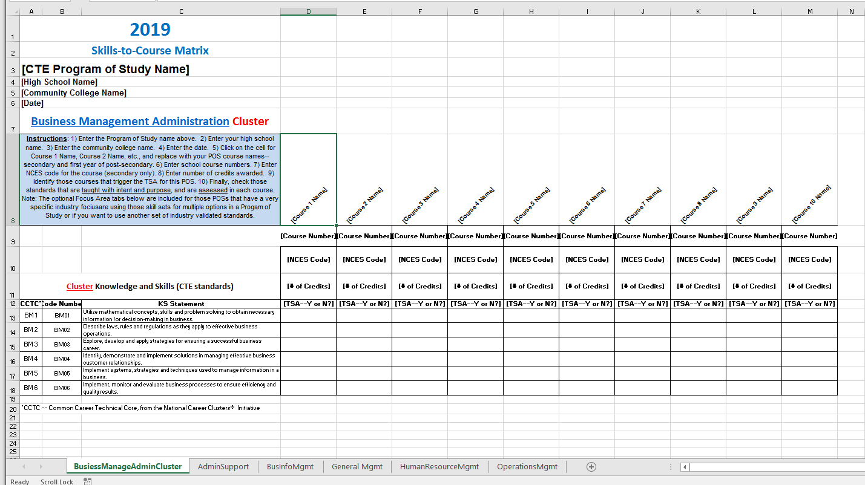

Business & Management
- Business and Management, Admin
- Finance
- Hospitality, Tourism & Recreation
- Marketing

Health Sciences
- Health Sciences

Human Resources
- Education and Training
- Government, Public Admin
Example Course-To-Standards Matrix
- Human Services
- Law, Public Safety, Security

Industrial and Engineering Systems
- Architecture & Construction
- Manufacturing
- Engineering Technology
- Transportation, Distribution & Logistics
- Automotive & Heavy Equipment

PART 2 – This documentation must be submitted by the secondary and postsecondary components if Perkins funds will be requested for the development of the CTE POS.

Important: To be eligible for Perkins POS development funds, a program component:
- Must not have existed in the school or college within the last three years
- Must be designed to meet local demand for High Demand/High Wage careers
- Must have at least 70% resource support from the local district or community college

Attachments:

- Short-term Budget – Attach a detailed proposed budget for development of the CTE Program of Study during the first year. Include all resources that will be used. **

- Long-term Budget – Identify the estimated total funds that will be used to support the continued development of the program during years two and three. **

- Plan – Provide brief bulleted list of planned activities that will move the development of the program to a CTE Program of study over a period of no more than three years. This list should address all core elements of a CTE Program of Study: 1) content and standards, 2) alignment and articulation, 3) assessment and evaluation, 4) student support services, and 5) professional development.

- Sustainability – Briefly describe how this program will be sustained once it has been approved. Please include a description of the planned use of Perkins funds for enhancement of student learning opportunities.

** As a rule, Perkins grant funds can be used for only 30% of the development costs. Perkins funds may only be used for allowable costs. See FAQ for more information.

Assurances
(Proposed Joint Submission Date must be within 3 years of application)
Name of School
Name of Program
Proposed Joint Submission Date: deadline for secondary and postsecondary components
Signatures: By signing below, the appropriate representatives agree to work collaboratively to create the above CTE Program of Study within the timeline identified by the Proposed Joint Submission Date above.

ODE must approve the use of Perkins funds to develop new Programs of Study that are not on our current list of approved CTE programs. ODE will only consider doing so if 1) the new program has not been offered in the secondary school or community college over the past 3 years, 2) it meets a high wage, high demand economic/workforce need (as identified by the Oregon Department of Labor), and 3) it has financial support from the district or community college.

If this request to start up a new CTE POS is approved, the program must become a CTE Program of Study within no more than three years, and Perkins funds can be used to support no more than 30% of program development costs.

If the program does not become a CTE Program of Study in the approved time, all Perkins funds used to support that development may be required to be returned.

Secondary Administrator |  | Date:
Postsecondary Administrator |  | Date:
Regional Coordinator |  | Date:

FOR ODE USE ONLY
Approval Status: | Approved Not Approved
ODE Specialist | ___________________________  Printed Name | _______________________________  Signature | _________  Date:

Attachments:

Attach documentation of labor market need for each new component of the CTE Program of Study:

- Post-secondary component: Attach a copy of recent LMI (within last 3 years). If information is older than 3 years, submit new data which can be found at Quality Info: Labor Market Information website .

- Secondary component: Attach a letter of support written and signed by members of a local industry advisory committee, or signed by a shared secondary-postsecondary advisory committee.

The CTE brand logo, brand-positioning, theme, and brand extensions are the property of NASDCTEc

