WorkKeys Assessments, what does it mean for your students?

Improve Graduation Rates!
• • •
- ECCO 4J High School increased graduation rates by over 30%!

- Proficiency Sound Assessments

- Enables students to see a reason to take coursework seriously
- Much more than just another assessment

- Engages and connects students to real life work scenarios and skills needed

- Improve students’ success in entry-level jobs by providing employers with concrete docu-mentation of skills needed

ACT WorkKeys Assessments and Your School
Job Growers Incorporated

There are a total of three WorkKeys assessments, two of which help meet the essential skills requirements for High School graduation: reading for information and applied math. The third assessment is locating information and completes the requirement needed to earn the National Career Readiness Certificate (NCRC).

What is a National Career Readiness Certificate (NCRC) and what does it evaluate?
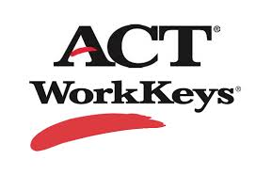
The National Career Readiness Certificate (NCRC) was developed by ACT and is an industry-recognized, nationally normed, evidence-based credential that certifies essential skills needed for workplace success. The three WorkKeys assessments evaluate many skills including: problem solving, critical thinking, reading and using work-related text, applying mathematical reasoning to work-related problems, locating, synthesizing, and applying information presented graphically. Individuals can earn the NCRC by taking the following three WorkKeys assessments, and scoring a level bronze or higher:
The Oregon NCRC Delivers Immediate Benefits to Your Students, Your School & Your Community
- Applied Mathematics
- Locating Information
- Reading for Information

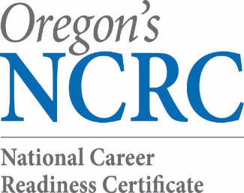
Strategic Partnerships
Success in Oregon is about community-based workforce partnerships that involve vital roles for industry, individuals, policy makers, educators, and economic developers.

- INDUSTRY identifies the foundational skills they need for a productive workforce;
- INDIVIDUALS can understand what skills are required by employers;
- POLICY MAKERS can consistently measure the skills gap across the state;
- EDUCATORS have tools to close the skills gap;
- ECONOMIC DEVELOPERS have a reporting tool to market their workforce and recruit employers.

All of Oregon’s 36 counties are actively pursuing their county CWRC certification. As of August 8, 2014, Oregon has issued a total of 34,608 over 1,828 employers have signed a letter of support saying they would prefer the NCRC for job applicants.

Education Partners – Why do we care?
Education plays a crucial role in helping a region close skill gaps that prevent people from getting a job and put existing jobs at risk. Education helps create competitive advantage for individuals through increased skills. The NCRC validates these skills and a learner’s readiness for work. For some students it can mean the difference between graduating and dropping out.
The NCRC certification means:
- K12 public education can utilize the NCRC to demonstrate work readiness for graduates.
- A gold-level NCRC satisfies high-school graduation requirements for reading and math.
- Career Technical Education Centers are closely-aligned with local businesses and help people gain the skills, technical knowledge, academic foundation, and real-world experience they needed prepare for high-skill, high-demand, and high-wage careers.
- GED/Adult Basic Education can help fast-track the career pathway for adults returning to the workforce. An NCRC could be the gateway to college for those who earn a GED.

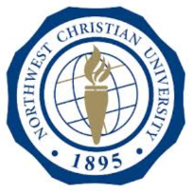
The American Council on Education (ACE) Recommendation Service (CREDIT) connects workplace learning with colleges and universities by helping adults gain access to academic credit for formal courses and examinations taken outside the traditional classroom. ACE has endorsed the NCRC at the silver and gold level as a certificate that qualifies for up to three college credits in critical thinking. As of Fall of 2014, Northwest Christian University (NCU) will award 3 college credits for the NCRC! In addition, six of the seventeen community colleges are pursuing college credit for the NCRC.
Contact Us:
Kurt Shovlin @ kshovlin@worksystem.org Multnomah, Washington 503.4787368
Sherri Stratton @ sherries@jobcouncil.org Josephine, Jackson 541-682-7224
Aurora King @ aurorak@jobcouncil.org Josephine, Jackson 541-842-2582
Jennifer Senner @ jsenner@jobgrowers.com Yamhill, Polk, Marion 503-798-4153
Bridget Dazey @ bridget.dazey@wicco.org Clackamas 503-657-1727
Peter Svendsen @ psvendsen@communityservices.us Linn, Benton, Lincoln 541-758-2633
Sue Thompson @ SueThompson@laneworkkforce.org Lane 541-4255-8116
Amy Gibbs @ amy@tocowa.org TOC-OWA (all other counties) 541.928.0241 ext210
Jennifer King @ king_j@4j.lane.edu Lane- ECCO High School 541-463-3930
Blanca Hawkins @ Blanca.Hawkins@state.or.us Statewide 503-947-1521
Visit Us at : http://www.oregonworkready.com/

J

“ACE is committed to the national goal of boosting the number of adults with college degrees. ACE credit recommendations help millions of adult learners, including veterans and active duty military, gain credits and earn postsecondary credentials,” said Patricia Book, ACE’s assistant vice president for lifelong learning. “We are pleased to recommend that members of ACE’s College and University Network award credit hours to individuals who have completed specific levels of the ACT National Career Readiness Certificate.”

