Process to Request a

Charter School Waiver

Published September 2024


Table of Contents
Authority 3
Waiver Request Process 3
2025 Process Timeline 5
Letter of Acknowledgement or Support from Sponsor 6
Understanding Equity 7
Historically Underserved Populations in Oregon 9
Data collection and review process 10
Equity Lens Questions for Waiver Requests 10
2025 Charter School Waiver Request Form 14

Authority
In Oregon, all charter schools are public. They must be open to all students, adhere to state and federal regulations, and cannot charge tuition or fees. However, charter schools are granted some flexibility from some laws that apply to traditional public schools. In addition to these flexibilities, charter schools can request further exemptions from certain laws in ORS Chapter 338. By approval from the State Board of Education, charter schools in Oregon can request waivers if these waivers promote the ideas of equity and choice to families who may otherwise not have access to these charter schools.

What gives the State Board of Education authority to grant waivers?
ORS 338.025
1. The State Board of Education may adopt any rules necessary for the implementation of this chapter. The rules shall follow the intent of this chapter.
2. Upon application by a public charter school, the State Board of Education may grant a waiver of any provision of this chapter if the waiver promotes the development of programs by providers, enhances the equitable access by underserved families to the public education of their choice, extends the equitable access to public support by all students or permits high quality programs of unusual cost. The State Board of Education may not waive any appeal provision in this chapter or any provision under ORS 338.115.

Waiver Request Process

Twice a year, the State Board of Education will hear requests for charter school waivers and make decisions about whether to approve the waivers. In order for a public charter school to submit a waiver request to the State Board of Education, the public charter school must participate in required technical assistance provided by the Oregon Department of Education. The Department will evaluate each waiver request and the public charter school will be provided the opportunity to respond to the Department’s questions and revise the waiver require prior to submitting the request to the State Board. Once the waiver request has been formally submitted to the State Board, it will be heard at least twice before a decision is rendered. The public charter school will be invited to respond to the Board’s questions and provide additional information between the first and second hearing. After the Board has issued a decision, the public charter school may implement the approved waiver or will be eligible to submit a revised request in the future.

The Oregon Department of Education will make available a webinar for schools seeking waiver requests. This webinar will:

- outline the type of information ODE looks for in waiver requests,
- expand on equity so everyone is thinking about this topic in a similar way, and
- provide tips on data collection

This webinar will be available via a trackable login system, and schools seeking waivers must watch this webinar and provide proof.

Once schools understand how the Department looks at equity, schools will need to begin collecting relevant data for their waiver. The webinar will give more specifics on data information, but think about whom this waiver might affect.
- If you’re looking to allow teachers’ children to bypass the lottery system for enrollment, think about how that may affect enrollment. You’ll have fewer spots open for the lottery system, there may be unintended changes to the student population of your school, and more of your students may come from more educated families.
- If you’re looking to exempt your school from providing transportation to students, think about how that decision may affect enrollment. Even if none of your current students need transportation, this decision could deter families from lower socioeconomic backgrounds from applying to your school.
- If you’re looking to have more flexibility with teacher qualifications, schools need to consider what alternative qualifications will be required. There might be a need to provide ongoing professional learning. The school will need to make a compelling case that this will support recruiting and retaining teachers who mirror the demographics of the students, or other program-specific justifications that will support students who would benefit from the program.

After schools watched the webinar, collected their data, and completed the form, they’re ready to submit their waiver requests to the Department.

Rather than allowing schools to submit waivers throughout the year, schools will have a deadline for submitting waiver requests. This deadline will exist to allow the State Board of Education to devote time to charter school waivers. Doing so will promote efficiency in the Institutions while also promoting predictability for schools and families.

The State Board will also have a deadline for approving/denying waivers. Approved waivers may be implemented at the State Board’s discretion. Schools whose waiver request are denied will receive an explanation for the decision and will have to wait until the next school year to submit a new waiver request. To resubmit their waiver, schools must address all the issues outlined by the State Board.

Letter of Acknowledgement or Support from Sponsor
Each charter school shall include a letter from their sponsor acknowledging the waiver request and indicating whether or not they are supportive of the request.

2025 Process Timeline

January 16, 2025 9:00 AM – 10:00 AM
Technical assistance webinar will be made available by ODE for charter schools seeking waivers. Please Register for the webinar.

February 28, 2025
Deadline for submitting waiver requests. No other waivers will be considered after this day for 2025. Submit via email to: Christen.Kelly@ode.oregon.gov

March 14, 2025 10:00 AM – 12:00 PM
The Department will conduct an internal review hearing for all waiver requests prior to drafting recommendations for the State Board of Education. Charter school leaders are invited to attend the hearing to present the waiver request and answer questions.

March 28, 2025
Deadline for submitting additional information following the review hearing.

April 10, 2025
The State Board will have a first read on all charter school waiver requests. Charter schools are invited to attend the State Board meeting to respond to the State Board’s questions. State Board agendas and materials are available here.

May 2, 2025
Deadline for submitting additional information following the first read at State Board meeting.

May 15, 2025
The State Board will make a final decision on all charter school waiver requests. Charter schools are invited to attend the meeting. State Board agendas and materials are available here.

Understanding Equity

The statute allowing waivers, ORS 338.025, primarily exists so schools can promote equity in education. Unfortunately, neither the Department of Education nor the State Board of Education gives schools much guidance on how to think about equity in education. The Department adopted what is known as an equity lens to help schools think about equity. These questions were adapted from the Racial Equity Impact Assessment Toolkit published by Race Forward Center for Racial Justice Innovation.
Equity Lens Questions
- Who are the racial or ethnic and underserved groups affected? What is the potential impact of the waiver and educational opportunity for these groups?
- Does the decision being made ignore or worsen existing disparities or produce other unintended consequences? Does this decision have an impact on eliminating the opportunity gap?
- Are there barriers to more equitable access to these groups to the public education of their choice? (e.g. mandated, political, emotional, financial, programmatic, or managerial)
- How has the public charter school intentionally involved stakeholders who are also members of these groups within their community?
- How will the public charter school modify or enhance its school to ensure each learner and the school’s community’s individual and cultural needs are met?
- How is the public charter school collecting data on race, ethnicity, and native language relating to the educational goals for the school and waiver under consideration?
- What is the public charter school’s commitment to professional learning for equity? What resources is the public charter school allocating for training in culturally responsive instruction and board governance?

Schools may sometimes overlook these equity questions because charter school officials do not think their waivers hinder equity or they have not looked into their data and practices with equity in mind.

For example, some schools try to opt out of providing transportation for their students. If none of their current students need transportation, why should they have to provide it?

Other schools want their teachers’ children to bypass the lottery system for admission to their schools. They’re not directly denying admission to other students based on race or sexual orientation. How could this be considered inequity?

Part of the reason schools may find this information irrelevant when submitting waiver requests is a fundamental misunderstanding of equity. Some educators may think equity and equality are interchangeable. While the ideas are similar and promoting equality is desirable, equality is not the same as equity.

Equity differs from equality in the fact that it is not “need-blind.” Rather, equity is targeting underserved populations and diverting resources to those populations.
Equality vs. Equity
Equality: Diverting the same amount of resources to everyone. Often ignores the history of marginalized groups.
Equity: Diverting resources to those who need them. Acknowledges how systemic oppression passes between generations.
Equity is taking steps necessary to ensure everyone is on the same playing field. Equity may not ensure an equal outcome, but it does strive to give equal opportunities.
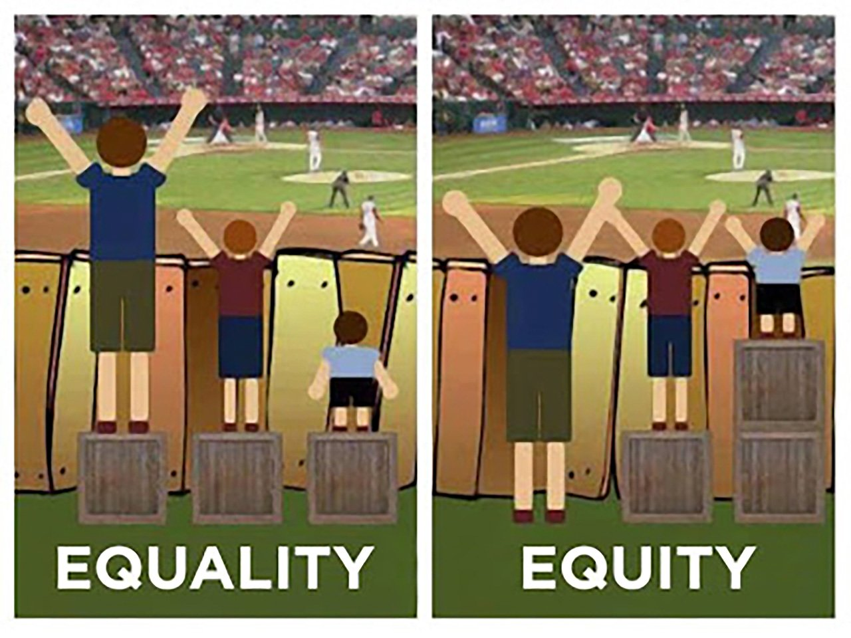
This photo demonstrates equity. In the first image, all observers have the same box to stand on. However, the observers are all different heights, so only two of the three can see over the fence. In the second image, the boxes are stacked according to the height of each observer so each person can see over the fence. The shortest gets two boxes, the middle gets one, and the tallest does not need a box. It is not equal, but it is equitable because everyone has a chance to see the game.

In the same way, Oregon’s education system prioritizes equity so that all Oregonians have the same likelihood of succeeding in school and in their future. You can access the Equity Resources Guide for additional information on education equity.

Historically Underserved Populations in Oregon

When engaging with Oregon’s equity lens, many schools may ask “Who are underserved populations in Oregon?” Generally, the following groups may be considered underserved populations for the purposes of your waiver request:

1. Communities of color: Oftentimes, segregation and racial discrimination is thought to be an issue confined to the South. However, both the United States and Oregon have a history of systemically oppressing communities of color. Black Americans were not allowed in Oregon until 1926, and Oregon did not ratify the 15th Amendment until as late as 1959. Mexican Americans, Latinos, Native Americans, Chinese Americans, Japanese Americans, and other Asian Americans faced systemic discrimination in Oregon well into the 20th century. While Oregon has taken strides to correct its racist history, the effects of systemic oppression still linger to this day.

To learn more about Oregon’s often untold racial history, explore the Timeline of Oregon and U.S. Racial, Immigration, and Education History published by the Center for Education Equity.

2. First-generation college students: According to the latest data from the American Community Survey, about 24 percent of Oregon’s adult population do not have schooling beyond a high school diploma. Another 10 percent have less than a high school diploma. About 31 percent of Oregon’s adult population holds a bachelor’s degree or higher. Families without college degrees may not have the resources to assist their children with school. They may also work longer or more irregular hours, meaning they don’t have the time necessary to help with homework or studying. Students from these backgrounds may need additional class time, and they may benefit from the smaller class sizes that many charter schools provide.

3. Low-income families: With Oregon’s rising cost of living, some families have to forego what other families might consider necessities: reliable transportation, annual vacations, access to nutritional food, affordable healthcare, vision care, or access to dental care may be out of reach to some families. Some low-income families may rely on schools to provide breakfast and lunch for their children; other families may not have the means to pay for school fees or possible field trip fees. Without a reliable bus system, many low-income students may not have the ability to go to school regularly.

4. LGBTQ2SIA+ Youth: About 68 percent of LGBTQ2SIA+ students feel unsafe at their school because of their sexual orientation, gender expression, or identity. Most queer and transgender students will forego school functions or extracurricular activities because they feel unsafe. Of the LGBTQ2SIA+ youth surveyed, 83.4% report hearing homophobic or transphobic remarks. Additionally, 58.0% of students reported hearing homophobic remarks from their teachers or other school staff, and 72.0% of students reported hearing negative remarks about gender expression from teachers or other school staff. These students are unique because, unlike communities of color or low-income families, many LGBTQ2SIA+ students do not have people in their homes that share their identity. Further, some students may not be out or open about their sexual orientation or gender identity, meaning faculty and other students do not know when they are saying homophobic or transphobic things in front of queer and transgender students.

The 2021 National School Climate Survey by GLSEN provides information on the experiences of lesbian, gay, bisexual, transgender, and queer youth in our nation’s schools. Read it here.

5. Students with Special Education Needs: Students in Oregon who need special support to be successful in education represent a little over 13% of public school students. Often families who were dissatisfied with the services and support received in their neighborhood school seek other public school options including public charter schools. Over the years, students and advocates have had to change laws and practices to ensure all students receive an appropriate education program in the least restrictive environment.

6. Emerging bilingual students: Students whose families speak another language at home, migrant students, immigrant students, or first-generation American students may have language barriers, making school more difficult for them than other students. As a result, they may need different support and resources to ensure they can access learning.

7. Rural students: Oregon is unique in that it has the 26th largest metropolitan area in the country, Portland, and it has about 98,236 square miles of mostly remote, rural, and suburban land. The urban/rural divide in Oregon is stark, and the needs of the Portland metro area may differ significantly from rural areas. Chronic absenteeism, long commutes, and inaccessibility to the Internet are all issues facing rural communities.

This list is not all-encompassing, but it should be a guide to help schools understand the unique needs and challenges facing certain groups, and it should also show how the action or inaction of schools can adversely impact certain groups.

Intersectionality: By now, you may have noticed that some of these groups may overlap! For example, many families without college degrees are low-income, and many emerging bilingual students belong to communities of color. This intersection of race, gender, nationality, etc. is called “intersectionality,” and it adds an extra layer to Oregon’s equity lens. For example, asking for a waiver so that your school does not have to provide transportation can negatively affect low-income students, but it could also negatively impact many rural students or communities of color. When requesting a waiver, think about how it can impact multiple groups at a time.

Data collection and review process
Beginning with the 2019-2020 academic year, all schools will need to include a process for collecting data on how their proposed waiver has impacted the following:
- Equitable access for families: What was the racial/ethnic makeup, gender composition, social class structure, emerging bilingual student population, and LGBTQIA+ student composition of the student population before the waiver went into effect? How has the composition changed after the waiver went into effect?
- Equitable makeup of staff/faculty: What was the racial/ethnic makeup, gender composition, social class structure, emerging bilingual staff/faculty population, and LGBTQIA+ staff/faculty composition of the staff/faculty population before the waiver went into effect? How has the composition changed after the waiver went into effect?
- Teaching style: Have teaching styles changed since the waiver went into effect? How?
- Accommodations: How has the waiver affected how staff/faculty accommodate students?
- Student outcomes: Keeping in mind Oregon’s protected classes as outlined in ORS 659A.403, what was the student population’s educational outcomes before the waiver went into effect? What were the outcomes after the waiver went into effect?
- Other data: Schools may submit additional data relevant to the waiver.

When submitting a waiver request or providing data for ODE, using visuals such as charts and tables could be useful. However, numbers alone are not the only way to gather data. Talking to community members, teachers, students, or families could also be considered data if the information provided is relevant.

When submitting waiver requests, ODE will, per legislative and policy mandates, adhere to an equity lens. To assist schools in using an equity lens, ODE has compiled these guidelines and examples to help schools think about and answer the equity questions.

While these guidelines are not all-encompassing, they should be broad enough for schools to understand the goals and objectives of the equity lens.

Equity Questions for Waiver Requests

1. Who are the racial/ethnic and underserved groups affected? What is the potential impact of the resource allocation and strategic investment on these groups?
Take a look at the communities to which your school caters.
- Do your students all come from similar neighborhoods and backgrounds, or are their backgrounds more diverse?
- By applying for this waiver, could potential students from underserved families be denied access to your school in favor of potential students from more privileged backgrounds?

If your waiver increases diversity in your school (racial, ethnic, socioeconomic, or other), proceed to question two.

If your waiver, intentionally or not, could take spots away from underserved groups, please rewrite your waiver to address the adverse impacts.

If you are unable to rewrite your waiver to address the issue of underserved groups, please provide justification for not prioritizing underserved groups.
If you need assistance determining which groups are considered “underserved,” look at page 8 of this document! It may be helpful to jumpstart your thought process. If you are still unsure, refer back to the mandatory webinar (or call ODE, we can point you in the right direction).

2. Does the decision being made ignore or worsen existing disparities or produce other unintended consequences? What is the impact on eliminating the opportunity gap?

- Are certain groups of students meeting benchmarks more quickly than other students?
- Does your school enroll diverse student groups or largely only students from one population?
- Does your school have any students from a less privileged socioeconomic status?

If you believe your waiver could diversify your school or assist students from historically underserved backgrounds, proceed to question three.

If your waiver could possibly make your school less diverse, please rewrite your waiver request so that students from historically underserved backgrounds are neither implicitly nor explicitly adversely impacted.

If you are unable to rewrite your waiver request, please provide justification for not prioritizing equity.
For example, many charter schools request waivers so that teachers’ children have priority in the lottery process. This type of waiver can have the unintended consequence of making schools whiter than the district as a whole. If this is the case, schools may need to devise a plan to balance out their potential racial disparities.
It could also unintentionally shape the student body so that school children come from families more educated than the overall districts. If this is the case, schools may need to devise a plan to balance the socioeconomic disparities.
ODE encourages schools to take innovative approaches to combat inequity. Some straightforward approaches could include: increasing enrollment, diversifying the teacher population, or ensuring some demographics are given a preference using a weighted lottery process.

3. What are the barriers to more equitable outcomes? (E.g. mandated, political, emotional, financial, programmatic or managerial)
Review your waiver request. If your waiver increases equity in ways not addressed above, please list any and all barriers your waiver may help to overcome. If your waiver increases inequity in ways not addressed above, please list any and all barriers that may result along with plans to overcome these barriers (or justification for ignoring said barriers).
For example, some schools request to be exempt from Oregon’s rule requiring schools to provide transportation to students. How might this exemption hinder students currently enrolled? How might this exemption prohibit certain groups of students from enrolling in the future?
If you’re a school that cannot provide transportation for students directly, what are some other ways you could ensure students reliable transportation? Could you share transportation with nearby schools? Is your school in a community with reliable public transportation?

4. How have you intentionally involved stakeholders who are also members of the communities affected by the waiver request? How do present your information in questions (1), (2) and (3) to these stakeholders?
Please provide a list of the groups you are classifying as stakeholders. How often have you met with these groups, and what was their input?

Are there any groups you would like to have involved in this plan but couldn’t? Why or why not? What input would you have liked to have gotten from those groups?

How have stakeholders responded to your waiver request and the information in questions (1), (2), and (3)?

5. How will you modify or enhance your strategies to ensure each students’ and communities’ individual and cultural needs are met?
Take a look at the demographics in your school. Your waiver may alter your schools demographics by either diversifying or homogenizing your student population. Either way, your student population may look different and may have different needs than before the waiver request went through. Please provide your plan to integrate your potential new student population into your broader student population. Further, please provide a plan to adapt your school to the new student population.

6. How are you collecting data on race, ethnicity, and native language?
Think about your students, teachers, families, and other relevant stakeholders. When you talk to them for their input on your waiver, are you keeping track of their race? Ethnicity? Native language?

For collecting data, ODE encourages the use of percentages and raw numbers, but we’re also interested in what your stakeholders say.

When you talk to your stakeholders, keep track of common themes (such as words, phrases, and ideas) that your stakeholders say. Do your historically underserved stakeholders provide input that differs from your more affluent stakeholders? Are all of your stakeholders, regardless of demographics, providing the same input? Make note of it!

7. What is your commitment to P-20 professional learning for equity? What resources are you allocating for training in culturally responsive instruction?
Please include a list of professional learning opportunities that your staff and board have participated in and/or are scheduled to attend. You can provide a budget narrative with details on individual financial investments including how many people from your school participated. Or, you can produce a budget and chart to provide the details.

If you have not invested in professional learning for equity and culturally responsive practices, will you be allocating resources in the future? If yes, what are your plans? If no, please provide a justification for not allocating resources toward learning for equity and culturally responsive practices.

2025 Charter School Waiver Request Form
Charter School Overview
Category | Your Response
Charter School Name | [response]
Address | [response]
Administrator Name | [response]
Contact Information | [response]
School District | [response]
Year School Opened | [response]
Current Charter Contract Dates (Start and End Date) | [response]
Brief description of your charter school’s educational model (max 500 characters) | [response]
Waiver Request Summary
What statute would you like the State Board to waive? | [response]
Please summarize the waiver request (max 500 characters) | [response]

Waiver Request Detail
1. Who are the racial/ethnic and underserved groups affected? What is the potential impact of the resource allocation and strategic investment to these groups?
[response]
2. Does the decision being made ignore or worsen existing disparities or produce other unintended consequences? What is the impact on eliminating the opportunity gap?
[response]
3. What are the barriers to more equitable outcomes? (E.g. mandated, political, emotional, financial, programmatic or managerial)
[response]
4. How have you intentionally involved stakeholders who are also members of the communities affected by the waiver request? How do present your information in questions (1), (2) and (3) to these stakeholders?
[response]

5. How will you modify or enhance your strategies to ensure each students’ and communities’ individual and cultural needs are met?
[response]
6. How are you collecting data on race, ethnicity, and native language?
[response]
7. What is your commitment to P-20 professional learning for equity? What resources are you allocating for training in culturally responsive instruction?
[response]

Data Collection
All charter schools with approved waivers will be required to report the impact of the wavier annually to the State Board. What is the charter school’s plan for collecting data on how the proposed waiver will impact students and the quality of education? The plan must minimally include disaggregated data by student demographics and stakeholder engagement.
[response]
Sponsor Acknowledgment
The State Board is interested to understand the charter school sponsor’s position on the waiver request. Please include evidence that the sponsor acknowledges being notified of the waiver request and whether or not the sponsor is in favor of the request.
[ ] Included as separate attachment

