Process to Request a single School Age SSID Number
- Access your applications list from the ODE District site at https://odedistrict.oregon.gov/Pages/default.aspx. The Login web application link is located in the center of the page.
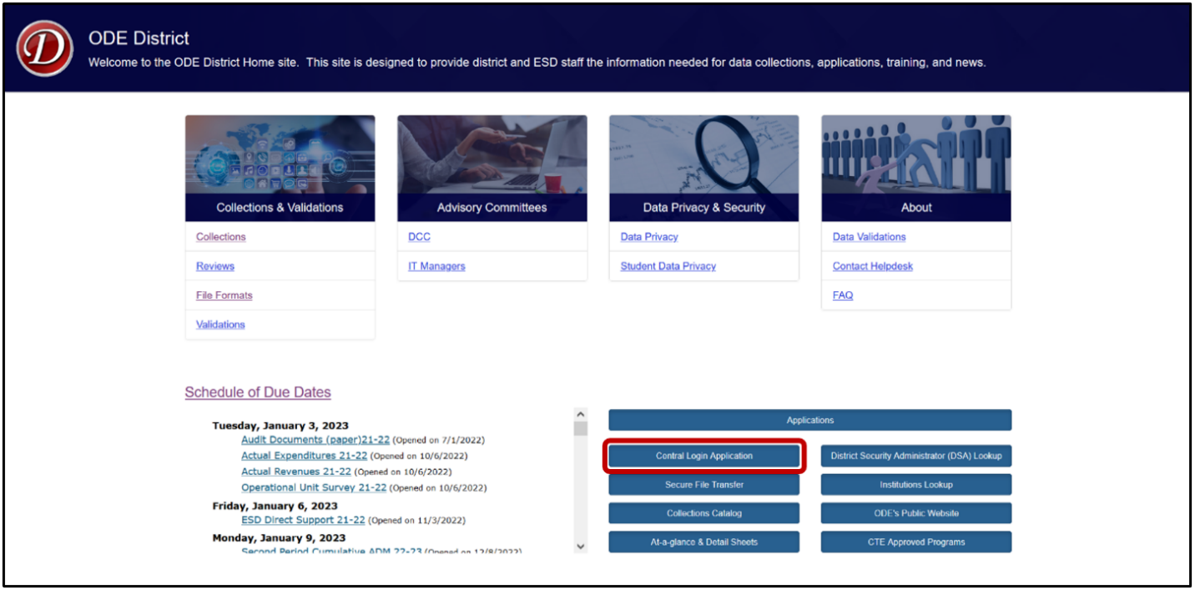
- Login to the District website by entering your User Name and Password, then press enter or click on the Login button.
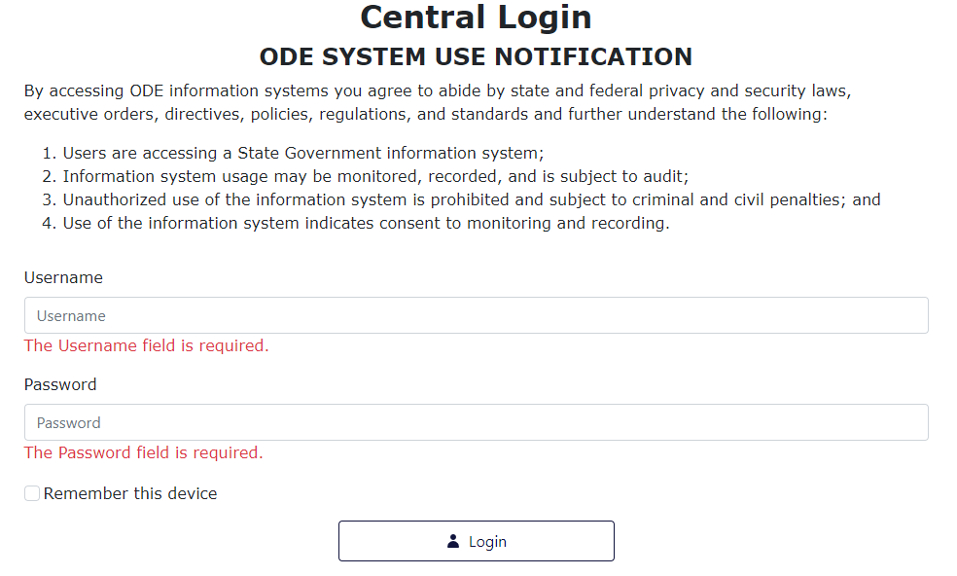
- From the Applications list, click on Consolidated Collections. District users will see their district name listed in place of Oregon Department of Education.
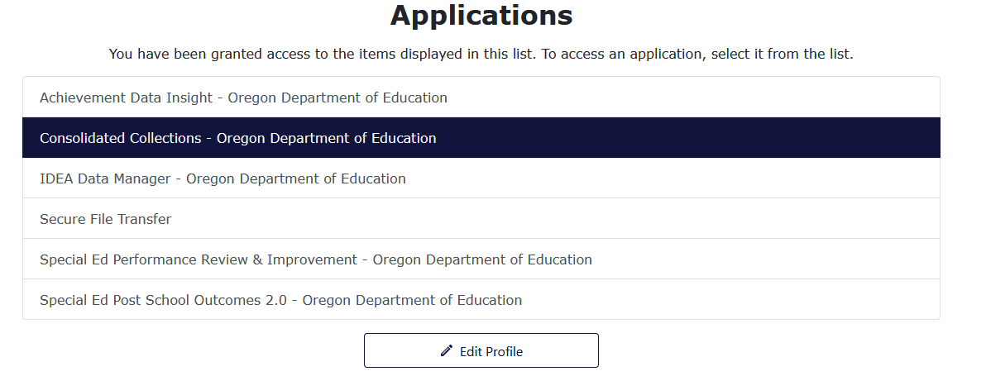
Note: If Consolidated Collections is not an option in your Applications list, please contact your District Security Administrator for access.
- From the main Consolidated Collection page, hover your mouse over the Student Collections menu option.
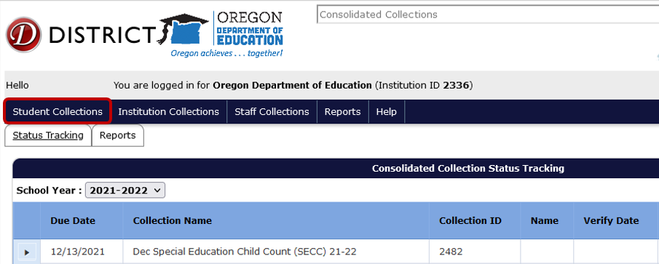
- From the drop menu, hover your mouse over SSID (Secure Student ID) System.
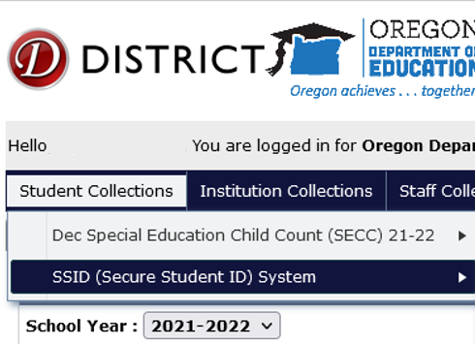
- From the fly out menu, hover your mouse over Data Submission.
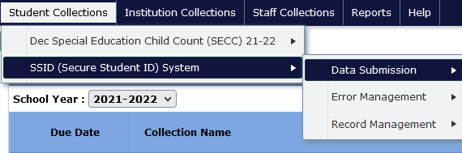
- Then from the final fly out menu, click on Web Submission.
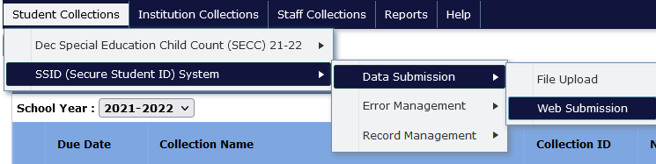
5. On the Web Submission screen, enter the applicable information for each field and click Search.
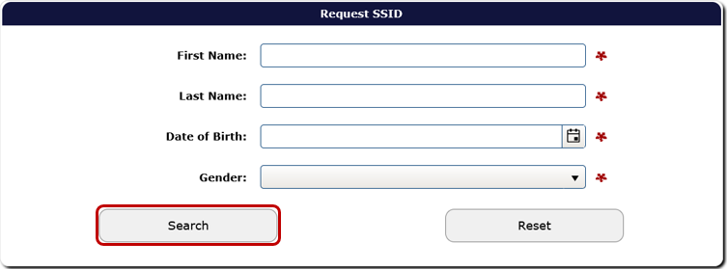
The system will generate a list of records. Select the applicable record and retrieve the SSID number. Be thorough in checking existing SSID numbers for possible matches. Creating a new SSID number for a student who was already assigned one causes problems with data submissions later.
If there is not a match, enter the child’s information in the fields provided and click Save when finished. A new SSID number will be created for the student. If required student demographic fields are empty, the system will highlight them with a red outline.
