ODE Help Desk & Data Security and Privacy Overview

# Contact Information

ODE Helpdesk ODE.[Helpdesk](mailto:ODE.Helpdesk@ode.state.or.us)@ode.state.or.us (503) 947-5715

# Services

ODE Help Desk can

* Provide technical assistance with how to submit your data
* Check to see if your data has submitted
* Provide assistance with questions about access rights and permissions

ODE Help Desk can not

* Submit your data for you
* Make changes to your data
* Answer content area questions

# Help Desk vs. Data Team – who to call?

| Question | Answer |
| --- | --- |
| How to report a student? | Data Team |
| Why won’t my data submit? | Data Team (will refer to HelpDesk if needed) |
| Audit/Error Corrections? | Data Team |
| How can I get a new user added? | ODE Help Desk |

# ODE Help Desk: What to Expect

When you call or email ODE Help Desk, the best way to contact the ODE Help Desk is at [ODE.helpdesk@state.or.us](mailto:ODE.helpdesk@state.or.us) or (503) 947-5715.

# Data Security and Privacy

The student data that you collect, handle, and submit is protected student data governed by:

* [Family Educational Rights and Privacy Act](https://www2.ed.gov/policy/gen/reg/ferpa/index.html) (FERPA) ([34 CFR Part 99](https://www.ecfr.gov/current/title-34/subtitle-A/part-99))
* [Oregon Identity Theft Protection Act](https://dfr.oregon.gov/business/Documents/4117.pdf)
* And in some cases, the Health Insurance Portability and Accountability Act (HIPAA), such as the transfer of records between agencies

**Consequences: Loss of protected data can have financial impact to your school, district, or ESD, including fines and cost of remediation!**

# Student Data Security: Handle With Care

Basic tips to protect student level data

1. Use Secure File Transfer. Never send information that would identify an individual student via email, not even to the ODE Help Desk or a member of the Data Team. Emails sent to and from the ODE are considered public record.
   1. In order to provide information to ODE, it is advisable to send only the student’s SSID number
   2. **Never** send student’s name, birth date, telephone number, grade or anything else that could be used to identify a specific student.
   3. On ODE’s [Secure File Transfer](https://district.ode.state.or.us/apps/xfers/) users can send secure documents to ODE Staff.
2. Never share your username and password
   1. You are responsible for everything done in the system using your username and password
   2. Avoid storing your password in an obvious place (desk drawers, under keyboards, sticky notes on monitors are all bad places to store passwords)
3. Use a Passphrase instead of a Password
   1. Passphrases are sentences you can remember and include spaces and punctuation.
   2. Example: Trust the force, Luke!
   3. Example: Scotty, beam us up.
4. Lock your computer monitor (Window key +L) when you leave your desk
   1. Avoid leaving your monitor open and unattended
5. Never store or transport student data on an unencrypted thumb drive/flash drive
   1. Portable drives are one of the biggest risk factors for losing large volumes of data

| A solid red triangle with a white exclamation point in the center. | **The privacy and security of student data depends upon you.**  People are the most important part of information security | A solid red triangle with a white exclamation point in the center. |
| --- | --- | --- |

# ODE Policies

[Handling Confidential Information](https://odemail.sharepoint.com/sites/PoliciesProcedures/Shared%20Documents/Forms/AllItems.aspx?id=%2Fsites%2FPoliciesProcedures%2FShared%20Documents%2F581%2D101%20Handling%20Confidential%20Information%20Policy%2Epdf&parent=%2Fsites%2FPoliciesProcedures%2FShared%20Documents)

[Information Asset Classification](https://odedistrict.oregon.gov/DataPrivacySecurity/Documents/Information%20Asset%20Classification.pdf)

# Information Security Questions

Contact ODE Chief Information Security Officer and Team at [ODE.Infosec@ode.state.or.us](mailto:ODE.Infosec@ode.state.or.us).

# Secure File Transfer

To send personally identifiable information to ODE staff, use Secure File Transfer. Go to the [District Home page](https://odedistrict.oregon.gov/Pages/default.aspx), and in the center right-hand side beneath Applications, select Secure File Transfer.

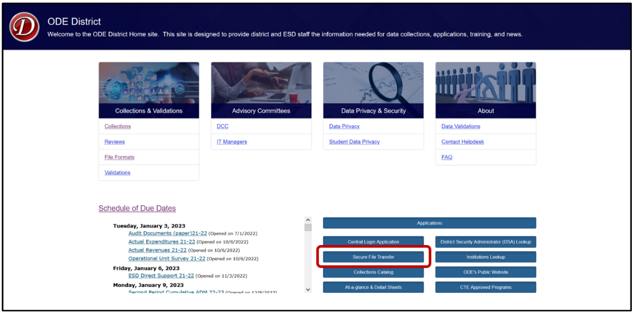

On the Secure File Transfer page, select the desired email(s) from the ODE Email List on the left. Users can select one email at-a-time, or by holding the Ctrl key, users can select multiple emails at once. Once selected, they will highlight in a blue hue.

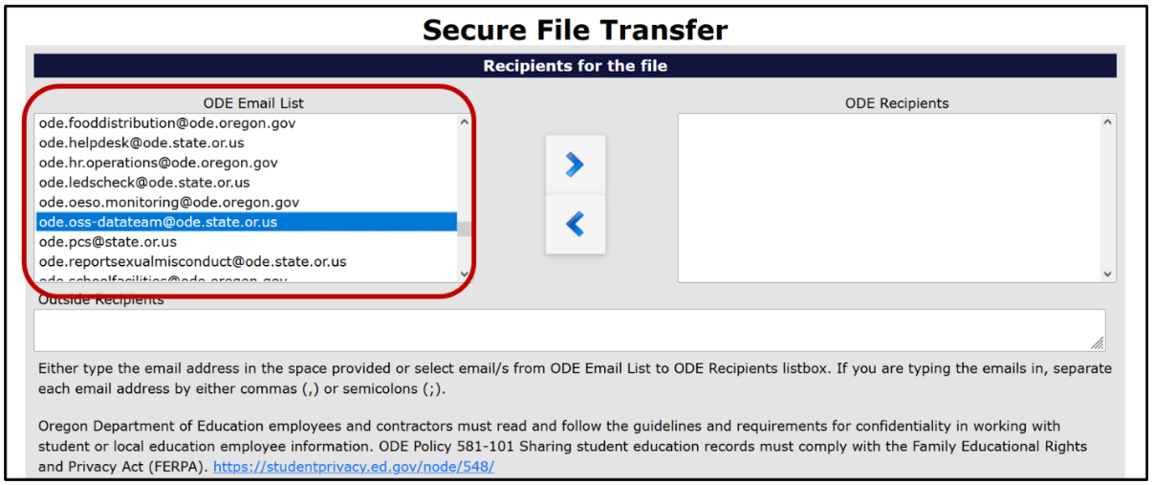

Once users select their desired ODE email(s), they can add them to the ODE Recipients list by selecting the right pointing arrow in the center of the application page.

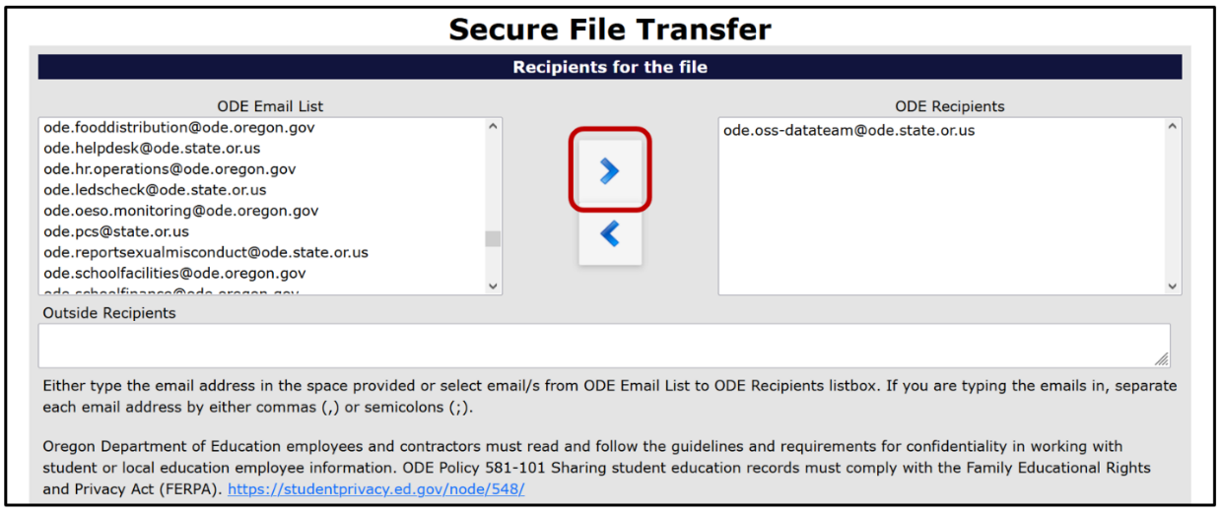

If the wrong email was added to the ODE Recipients list, users can select the incorrect email(s) in the ODE Recipients column and then select the left pointing arrow to remove them.

If an intended recipient is not found in the ODE Email list, or to send to a non-ODE employee, users can write their email into the Outside Recipients textbox. **Warning:** emails written in this textbox require commas (,) or semicolons (;) to separate them. The system will read emails not separated in this manner as one singular email.

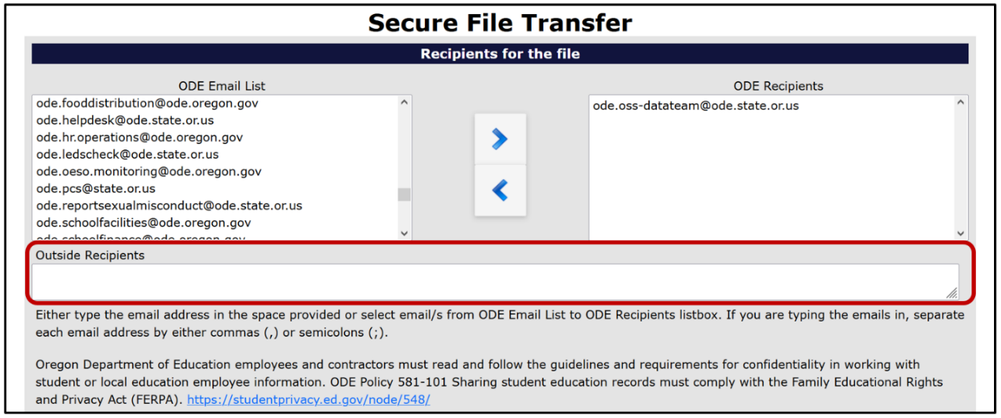

With all recipients selected, users must type their email address into the “Enter your email address” textbox.

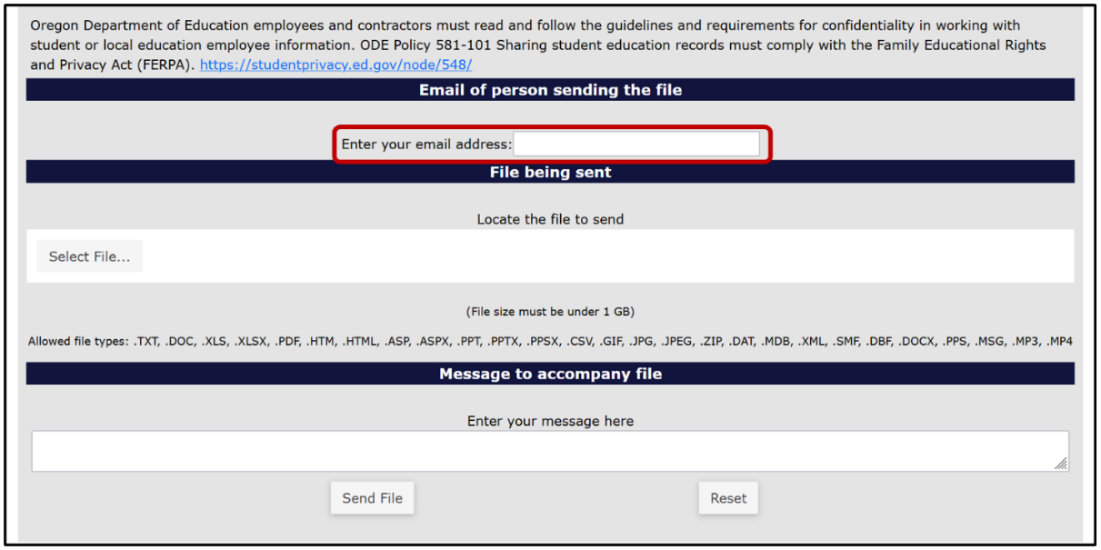

To add the file to be sent, select the Select File button.

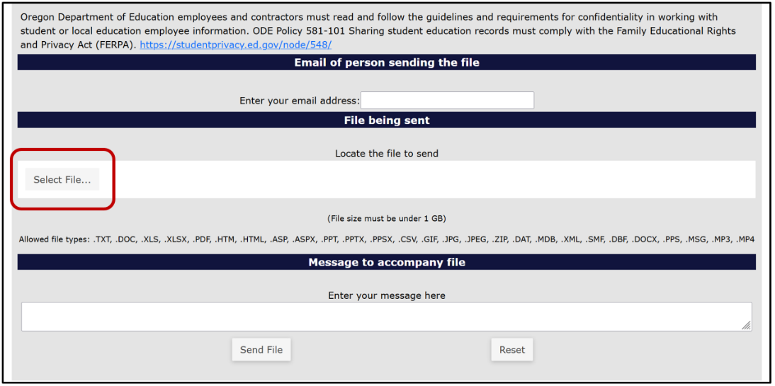

Find the desired file and select it. To select the file there are two methods. For the first method, users select the desired file, and then select the Open button in the window. For the second method, users double click the desired file.

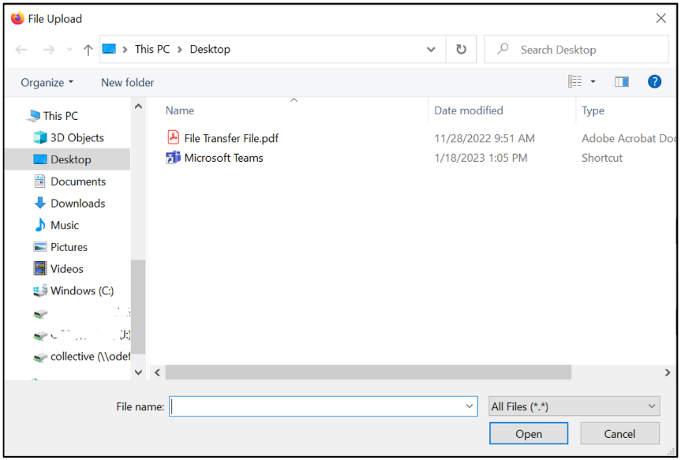

Users can type a message at the bottom of the page to add context and or anything else necessary for the recipients to know. This section is best thought of as the body of an email.

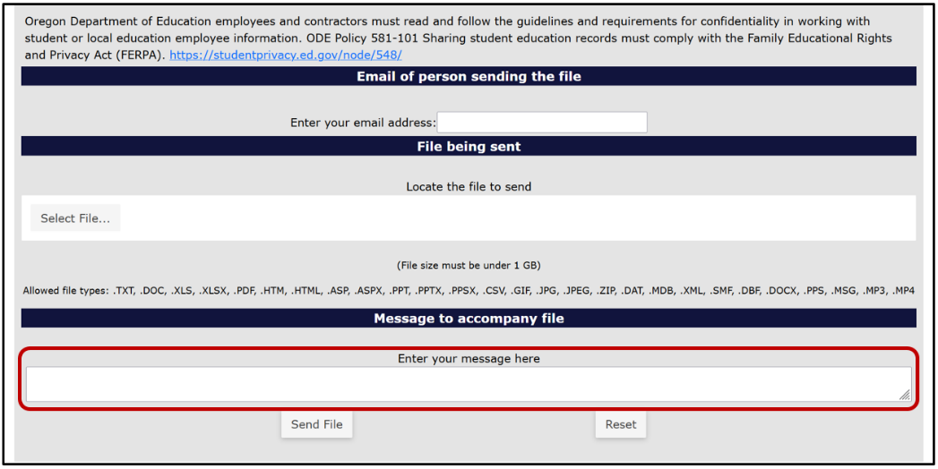

Finally, to send the file, select the Send File button at the bottom of the webpage.

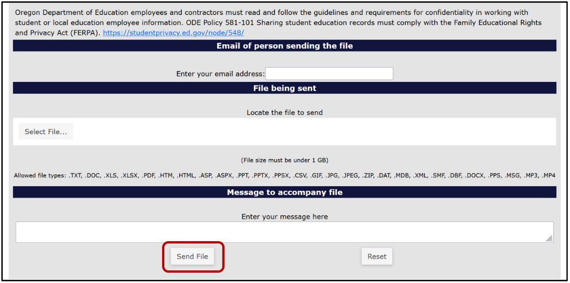

The recipient will receive an email with a web link. This link will take the recipient to a Secure File Transfer page on the ODE District website. They will enter their email address, the same address the user selected, and click the Submit Email Address button. The page will generate a Download button for the recipient to click, which downloads a zip file of the document the user sent.