Process to Request a School Age SSID Number on an Individual Basis
- Open Internet Explorer and enter the address for the district web site.
  - https://district.ode.state.or.us/home/
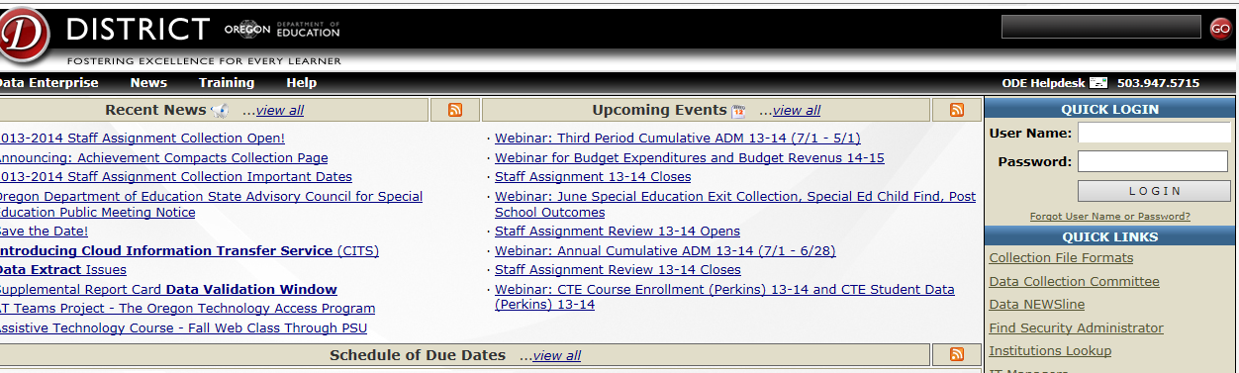
- Enter the District website by entering your User Name and Password in to the Quick Login area, then press enter or click on the Login button.
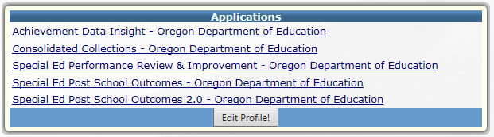
- From the list of ‘Applications’, click on Consolidated Collections – Oregon Department of Education.

Note: If Consolidated Collections is not an option in your list of Applications, please contact your network administrator for access.
- From the main Consolidated Collection page, hover your mouse cursor over the Student Collections menu option.
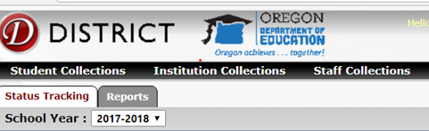
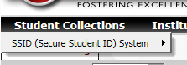
- Then hover your mouse cursor over SSID (Secure Student ID) System.

- Then hover your mouse over Data Submission.
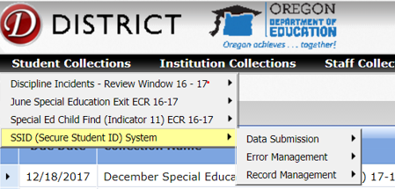

- Then click on Web Submission.
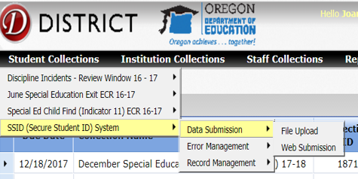
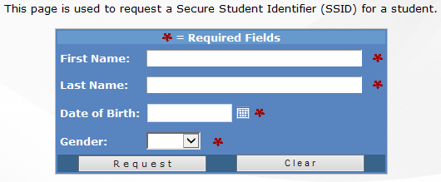
5. On the Web Submission entry screen, fill in all fields with the correct information and click Request.

If a list appears after clicking on Request, select the child from the list and retrieve the SSID number. Be thorough in checking existing SSID numbers for possible matches. Creating a new SSID number for a student who was already assigned one causes problems with data submissions later.
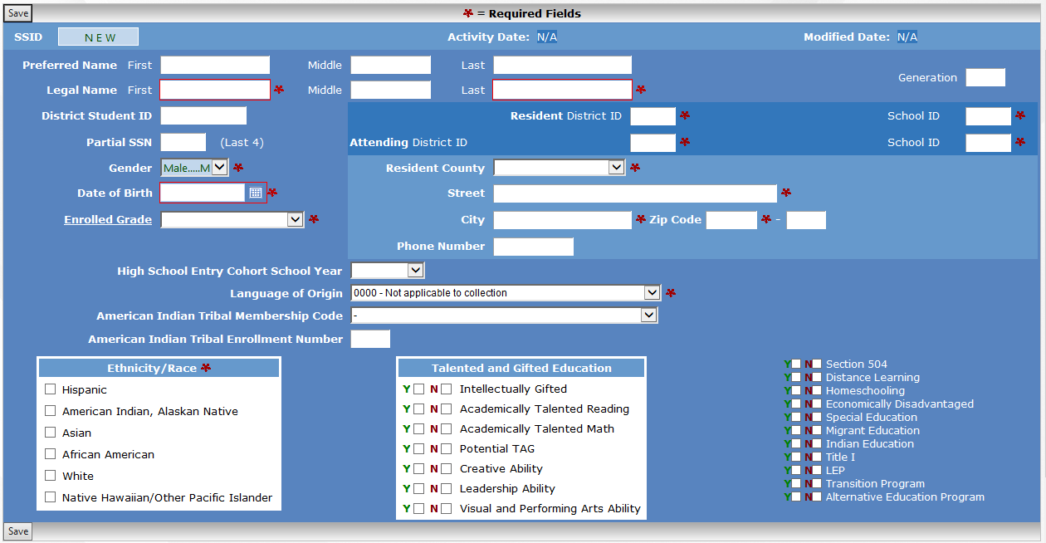
If there is not a match, enter the child’s information in the fields provided and click save when finished.
A new SSID number will be created for the student.

