Instructions for Completing the Indistar Division 22 Assurances Form for 2017-2018

(Due February 15, 2019)

Start by logging into Indistar at www.Indistar.org in your web browser. Your login information is available from your district security administrator. Enter your district Indistar login and password in the boxes at the top right corner of the screen.

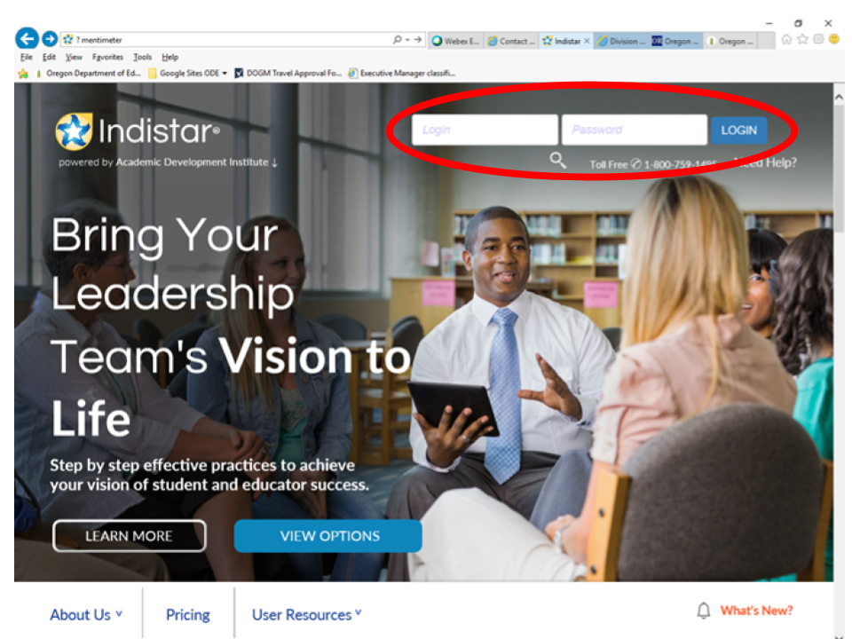
The form is found under “Complete Forms” on the Indistar Dashboard. Scroll down to and click on “Division 22 Assurances.” Directions are available on this tab and are repeated on the form.
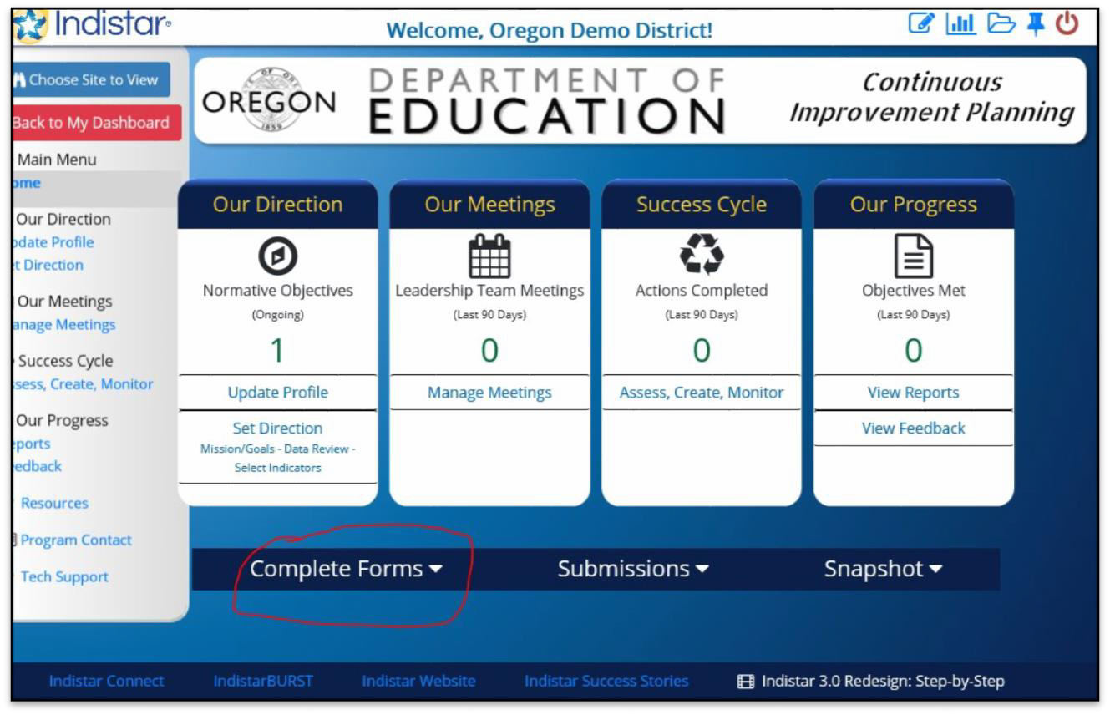

Complete the form

- Most questions are check boxes or fill-ins.
- You may complete the form in multiple sessions. You should save your work at the end of each session (use the “Save” button at the end of the form).
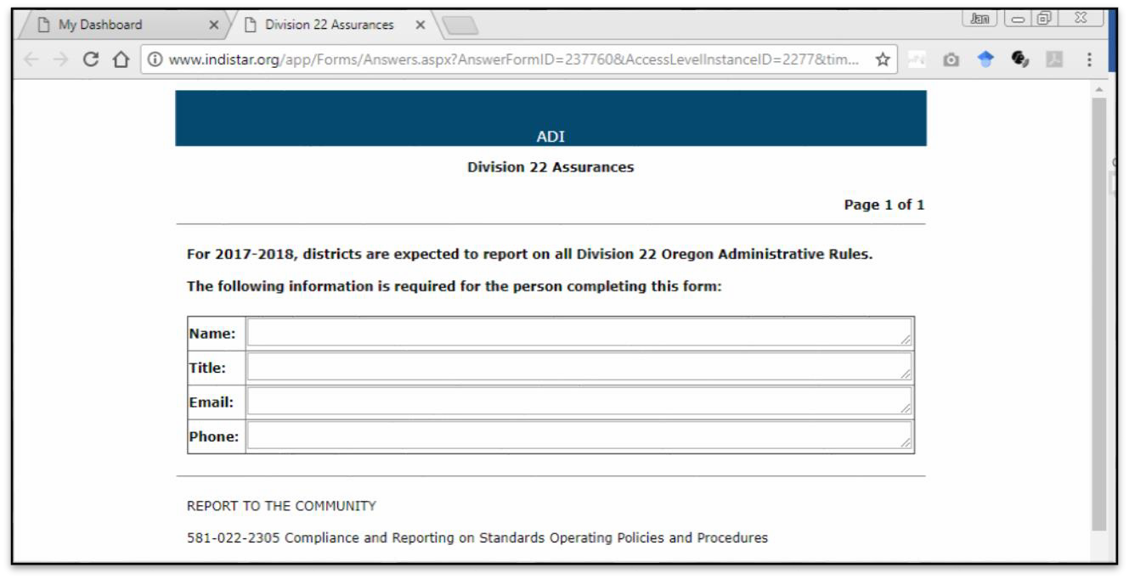

Upload the additional documents, marking the appropriate box on the form when you are done.

When the form is complete, click the “Save and Preview” button at the end of the form to review your work before you submit the form. Once reviewed, “close” the document.

Submit the form using the “submit” button under the “Submissions” tab.

A PDF document with the submission date will appear. You will also receive an e-mail message telling you that you have successfully submitted your Assurances to ODE with an attached copy.
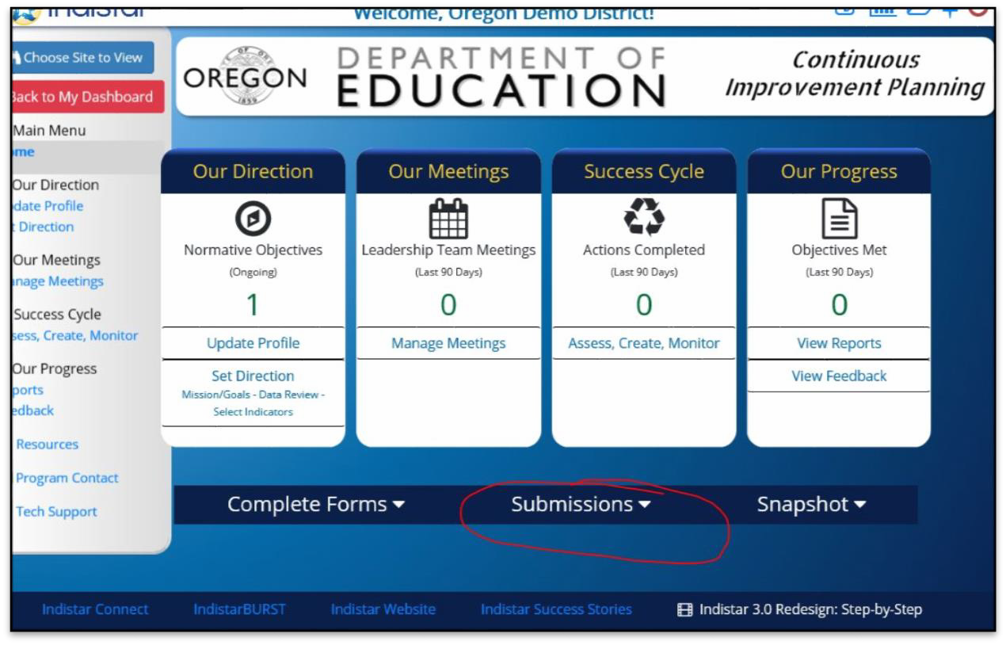

If you have questions, please contact the ODE Helpdesk, at ODEHelpdesk@state.or.us or
call (503) 947-5772.

