Arts Learning Family Letter Template

Arts Learning Family Letter Template Instructions:

Utilize a copy of this template to communicate to families about arts learning experiences in the classroom. This template can be filled out by educators and shared or completed with students as a reflection activity to share with their family. It can be shared electronically or printed off for students to fill out in class.

If possible, share an artifact, photo, or performance from the process attached with the document, on a classroom website, or in a classroom newsletter to supplement this communication tool. Before sharing with families, we recommend that the classroom letter is translated into the home languages of students in the classroom.

Communicating the Benefits of Arts Education provides additional information around the benefits of arts education and communications strategies and tools for arts programs.

Read the Communicating the Benefits of Arts Education Resource

Arts Learning Family Letter Template

Dear [ ],

Today we engaged in arts learning during a lesson about [content theme]. We worked with [arts learning experience].

We learned [lesson objectives]

We created [process and/or product]

We shared our learning by [performance/assessment/reflection protocol]

At home, you could [extended learning activity] to deepen learning around this content and share this experience with family.

Ask [student name] about [student’s personal interest in project]!

[insert link to student photo, performance, or artifact if possible]

Thank you for supporting arts learning for your student!

Sincerely,

[Teacher signature]

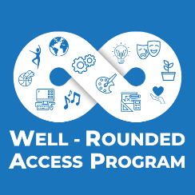
This work is funded by the Expanding Access to Well-Rounded Courses Grant, a 5 year, 9.8 million dollar Federal grant that ODE received from the US Department of Education in 2020. The Arts Access Toolkit is a portion of the work of the Well-Rounded Access Program, along with supporting access projects for courses in the arts and STEAM across the state. Over time, the Well-Rounded Access Program team hopes to continue to develop and refine this resource with the collaboration of administrators and educators statewide. If districts or schools have additional resources, examples or success stories to contribute, please contact the Well-Rounded Access Program team at ODE.WRCoursesGrant@ode.state.or.us.

