**The Oregon Department of Education’s Response**

**To Recommendations 1 and 2**

**The Oregon Secretary of State’s Audit 2019-01**

**January 2019**

**Oregon Department of Education**

**Portland Public Schools**

**ODE and PPS Must Do More to Monitor Spending and Address Systemic Obstacles to Student Performance, Particularly at Struggling Schools**

**Revised December 2020**

This page intentional left blank

**Table of Contents**

Executive Summary 5

Introduction 7

Potential K-12 Savings Areas 8

Spending Trends 8

Spending Pattern Differences Among School Districts 10

A Deeper Analysis 18

Are variations in the spending patterns related to student outcomes? 25

A Tool for School Districts 26

Appendix A: High School Graduation Rate Regression Results 27

**List of Exhibits**

Exhibit 1: Share of Operating Expenditures by Function 9

Exhibit 2: Distribution of School Districts by Size 10

Exhibit 3: Share of Operating Expenditures by District Size 11

Exhibit 4: Distribution of School Districts by Locale 12

Exhibit 5: Share of Operating Expenditures by District Locale 13

Exhibit 6: Distribution of School Districts by ELL Percent 13

Exhibit 7: Share of Operating Expenditures by Percent ELL Students 14

Exhibit 8: Distribution of School Districts by Economically Disadvantage Percent 15

Exhibit 9: Share of Operating Expenditures by Percent Economically Disadvantaged

Students 15

Exhibit 10: Distribution of School Districts by Teacher Salary Range 16

Exhibit 11: Share of Operating Expenditures by Teacher Salary Range 16

Exhibit 12: Median Class Size by Teacher Salary Range 17

Exhibit 13: Regression of Factors Associated with Share of Operating Expenditures 19

Exhibit 14: Summary of Estimated Impact of Spending Shares on High School

Graduation Rates 25

This page intentionally left blank

**Executive Summary**

In Audit Report 2019-01, released in January 2019, the Oregon Secretary of State’s Audits Division recommended that the Oregon Department of Education (ODE) evaluate potential cost savings areas and the spending trends of Oregon’s school districts[1]. They also recommended that ODE provide tools and templates to help districts benchmark spending against peer districts, and provide guidance on best-practice options for directing more money to the classroom.

In this report, the Department of Education evaluates the spending patterns of Oregon’s school districts to determine if the characteristics of districts and the students they serve influence the way the districts allocate resources to different uses. We then use the lessons of that analysis to see if those spending patterns are associated with student outcomes as measured by graduation rates.

**Key Findings**

1. Over time, state-level shares of total operating expenditure that Oregon’s school districts spend in various categories have been very stable, with Instruction remaining between 59 percent and 60 percent of the total for more than a decade. The category with the most variation—Student Support—also stayed in a very narrow range—from 5.7 percent to 7.1 percent.
2. Variation among districts, however, is much larger, and this provides an opportunity to use district-level data to evaluate how allocating spending to different categories might increase efficiency and improve student outcomes.
3. There are economies of scale in certain activities, such as District Administration, Business Services, Operations & Maintenance, and Transportation. That means larger districts can perform these activities at a lower per student cost than smaller districts.
4. Allocating a higher share of spending to Instruction is associated with higher graduation rates, so districts should strive to spend a larger share on Instruction by working to become more efficient—and spending less—in other categories. To the extent that districts currently allocate resources to Instruction based on class size targets or fixed ratios of staff to students, they may be missing opportunities to improve student outcomes by re-allocating resources to Instruction from non-instructional activities.
5. Specifically, we find that spending more on Instruction by reducing spending on Instructional Staff Support, Business Services, and Central Activities has the potential to increase high school graduation rates. We estimate that reallocating the shares spent by one percentage point in each of those three categories to Instruction can raise graduation rates between 3 and 4 percentage points.
6. Teacher salaries vary considerably across the state, ranging from around $40,000 in small, rural districts to nearly $80,000 in districts in the Portland metropolitan area. This represents a problem of a different nature than the effective use of resources by individual school districts. While effective resource use is something each individual district can work to improve, the variation in salary costs across the state creates inequities among districts that will require state-level action to remedy. Because Oregon’s K-12 funding system does not adjust for salary variation across the state, districts in high salary labor markets have lower purchasing power than districts in lower salary labor markets. One result is dramatic differences in average class sizes, with the lowest salary districts at just above 19 and the highest salary districts at more than 26.

The 28 school districts with average salaries above $65,000 serve 57 percent of all students in Oregon and even larger shares of historically underserved students: 86 percent of African American students; 80 percent of Native Hawaiian/Alaska Native students; 69 percent of English Language Learners; and 60 percent of Hispanic students. Without a mechanism to adjust for these large salary variations, the inequities in student outcomes for large numbers of Oregon’s historically underserved students are likely to persist.

**Recommendations**

1. While the savings may be relatively small, districts should continue to pursue cost-saving strategies such as forming consortia and working with their Education Service Districts to purchase supplies and other inputs in larger quantities to get lower prices. For small districts, purchasing services such as technology, special education services, and professional development rather than trying to perform those services themselves can be cheaper as well. This is a way for smaller districts to capture some of the economies of scale for certain activities that larger districts already achieve.
2. Districts should work to identify ways to allocate more resources to Instruction by becoming more efficient in other activities that less directly contribute to student learning. Our analysis shows that those activities are Instructional Staff Support, Business Services, and Central Services. This recommendation does not necessarily mean districts should cut necessary activities, but rather should look for efficiencies so that the resources saved can be used for classroom instruction and other activities more directly related to student learning.
3. Districts should use the Comparison Tool created by ODE to compare their spending patterns to those of similar districts. By making these comparisons, districts can learn from one another about how to become more efficient and which categories of spending are associated with better student outcomes. In making these comparisons, districts should compare themselves to other districts of roughly the same size. Our analysis shows that district size impacts spending patterns, so districts have the most to learn from other districts of the same size. The Comparison Tool is on the Department of Education’s website [here](https://www.oregon.gov/ode/schools-and-districts/grants/Pages/K-12-School-Funding-Information.aspx).
4. The Oregon Legislature should consider adding a mechanism to adjust for the wide variation in salaries around the state. Oregon makes this type of adjustment in its minimum wage—paying a higher wage in areas with a higher cost of living—and that logic should apply to funding schools as well. A mechanism to compensate for salary variation can help to equalize the purchasing power across school districts, giving high-salary districts the same ability as lower-salary districts to effectively serve their students.

**Introduction**

Oregon’s 197 school districts vary tremendously in size, location, student demographics, and local culture. In serving the needs of their students, the ways Oregon’s school districts use their resources are likely to vary as well. To better understand this variation, and to learn how school districts might be able to allocate their resources differently to better serve their students, the Audits Division of the Oregon Secretary of State’s Office made a series of recommendations to the Oregon Department of Education. The first two recommendations address issues of potential savings areas and school district spending trends.

Recommendation 1: Evaluate potential K-12 savings areas and spending trends, including an analysis of classroom spending compared to other spending. Share the analysis publicly, and work with the Quality Education Commission to include the analysis in the Commission’s public report.

Recommendation 2: Provide tools and templates to help districts regularly benchmark spending against peers, and provide guidance on best-practice options for directing more money to the classroom.

**Potential K-12 Savings Areas**

For this analysis, ODE defines “savings” as getting the same outcomes with lower spending, or getting better outcomes with the same level of spending.

Savings can be achieved primarily in three ways:

1) Getting lower prices for inputs of the same quality.

2) Becoming more efficient at what you are already doing.

3) Doing things differently in a way that results in better outcomes.

The Secretary of State’s first audit recommendation is that the Department of Education “Evaluate potential K-12 savings areas and spending trends, including an analysis of classroom spending compared to other spending,” indicating that the Department should focus on how districts allocate their resources to different spending categories. In other words, determine if there is potential for improving student outcomes by re-allocating resources from low-productivity uses to higher-productivity uses. This involves districts being innovative at **doing things differently** to improve the quality of learning and increase student outcomes and the equity of student experiences and educational results.

**Getting Lower Prices for Inputs**

On the input price side, the options for realizing substantial savings are limited: districts can work together to get better prices and achieve efficiencies through economies of scale in purchasing—perhaps through ESDs; being more careful in contract negotiations to avoid paying too much; and paying attention to seasonal price variations for items like fuel and other supplies, etc. School districts’ biggest cost is labor, and there are few options for reducing labor costs beyond becoming more efficient so that fewer staff are needed, or trying to reduce salaries, which may make it harder to attract high quality staff.

**Becoming More Efficient at What You are Already Doing**

While it may be useful to conduct performance audits of Oregon school districts to determine if there are inefficiencies in their day to day operations, such audits are labor intensive and are, therefore, very expensive. While conducting performance audits for each of Oregon’s school districts is outside the scope of the Secretary of State’s Audits Division’s recommendations to ODE, the Audits Division might consider asking the legislature to provide funding for performance audits of school districts.

**Doing Things Differently**

The approach the Department of Education adopted for this evaluation comes from an analysis of district spending patterns and their relationship to student outcomes. By observing variations in spending patterns and student outcomes, while taking into account external factors that are outside of district control, ODE was able to identify which spending categories are associated with better student outcomes and which categories are not. With this information, school districts can devise strategies to move resources from “low-productivity” spending categories to “high-productivity” categories.

This approach has the advantage that it can be done with data that ODE already collects and does not require the large expense of conducting individual district performance audits. It also has the advantage of allowing us to compare districts to one another to see how similar or different their spending patterns are, allowing districts to learn from each other. And finally, this approach has the advantage of estimating the impact of different spending patterns on student outcomes, something that individual district performance audits cannot do.

While the evaluation of spending patterns cannot answer all of a district’s questions about how to become more efficient with their resources, it is an important first step. It can provide districts with evidence, based on the data of all of Oregon’s school districts, of where to find resources (the unproductive spending categories) that can be shifted to the more productive categories. The accompanying data tool, which allows districts to easily compare their spending patterns with those of similar districts, can be the basis of conversations among districts to learn from one another about how to more efficiently use their resources.

**Spending Trends**

To better understand how school districts allocate resources to different activities and uses, ODE looked at trends over time in spending by category for all districts combined. Exhibit 1 shows that the share of spending in various categories has been remarkably stable over time, even during economic downturns when revenue fell. Spending on instruction, the largest category, ranged from a low of 59.0 percent in 2007-08 to a high of 60.0 percent in 2017-18—almost no variation at all. The category with the most variation, student support, ranged from 5.7 percent in 2007-08 to 7.1 percent in 2018-19—still not much variation.

**Exhibit 1: Share of Operating Expenditures by Function, 2007-08 to 2018-19**

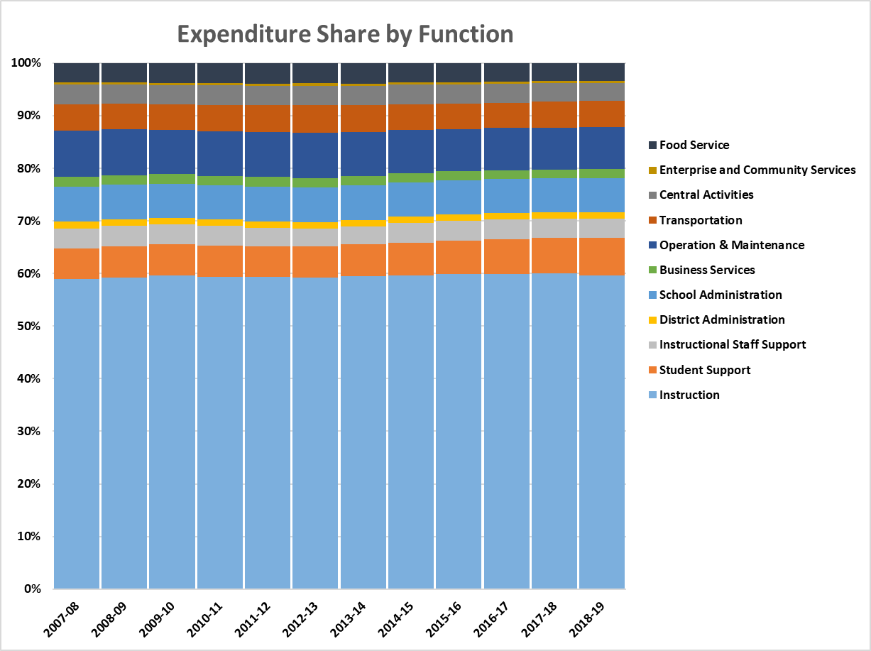

The stability of spending by function category over time at the state level provides few insights about the factors that influence spending patterns. The share of spending on Instruction ranged from a low of 59.0 percent in 2007-08 to a high of 60.0 percent in 2017-18. The category with the largest variation—Student Support—varied from 5.7 percent in 2007-08 to 7.1 percent in 2018-19. This lack of variation over time means that data at the state level simply cannot shed light on the impacts that differences in spending patterns might have on student outcomes.

Looking at how spending patterns vary among school districts, on the other hand, can give us much more information about the factors that influence how spending varies across different spending categories. That’s because the wide variation in district circumstances, such as size, demographics, etc. are associated with the allocation of much different levels of resources for different uses to serve the specific needs of students in each district. In addition, factors such as economies of scale and variation in input prices (e.g., teacher and other staff salaries) can have a large impact on how much each district must spend in various categories.

**Spending Pattern Differences Among School Districts**

To better understand the factors that influence how school districts allocate spending to different uses, and the impact that those spending patterns have on student outcomes, we perform the analysis in two steps. First, we evaluate what district characteristics are associated with shares of spending in different categories, and second, we evaluate how different spending patterns may have different impacts on student outcomes.

A number of factors can affect the share of total spending that a district allocates to various activities such as instruction, student support, administration, transportation, and others. The Department of Education’s analysis explored these factors. Guided by lessons from an initial descriptive analysis, ODE did a deeper analysis using district-level data to better understand the factors associated with variations among districts in expenditures by category. The analysis found that district size is associated with the share spent on district administration and centralized activities—smaller districts spend a larger share—indicating there are economies of scale for certain district-wide functions. Certain other costs, such as transportation, are influenced by district size and by location. Rural districts, which also tend to be small, spend the most on transportation because of their large geographic size and low student population densities, requiring long trips. Exhibit 2 shows the size distribution of districts in Oregon, along with the average spending per student, in the 2018-19 school year. The considerably higher spending per student in the Small and Very Small categories is the result of added revenue provided by the Small School Correction, which provides more funding to districts with small schools.

**Exhibit 2: Distribution of School Districts by Size, 2018-19**

This table shows the number of school districts, the number of students, and the average operating expenditures per student for the districts in 6 size categories, ranging from Very Small (less than 250 students) to Very Large (30,000 or more students).

Exhibit 3 shows the distribution of spending across spending categories broken down by the district size categories described above.

**Exhibit 3: Share of Operating Expenditures by District Size, 2018-19**

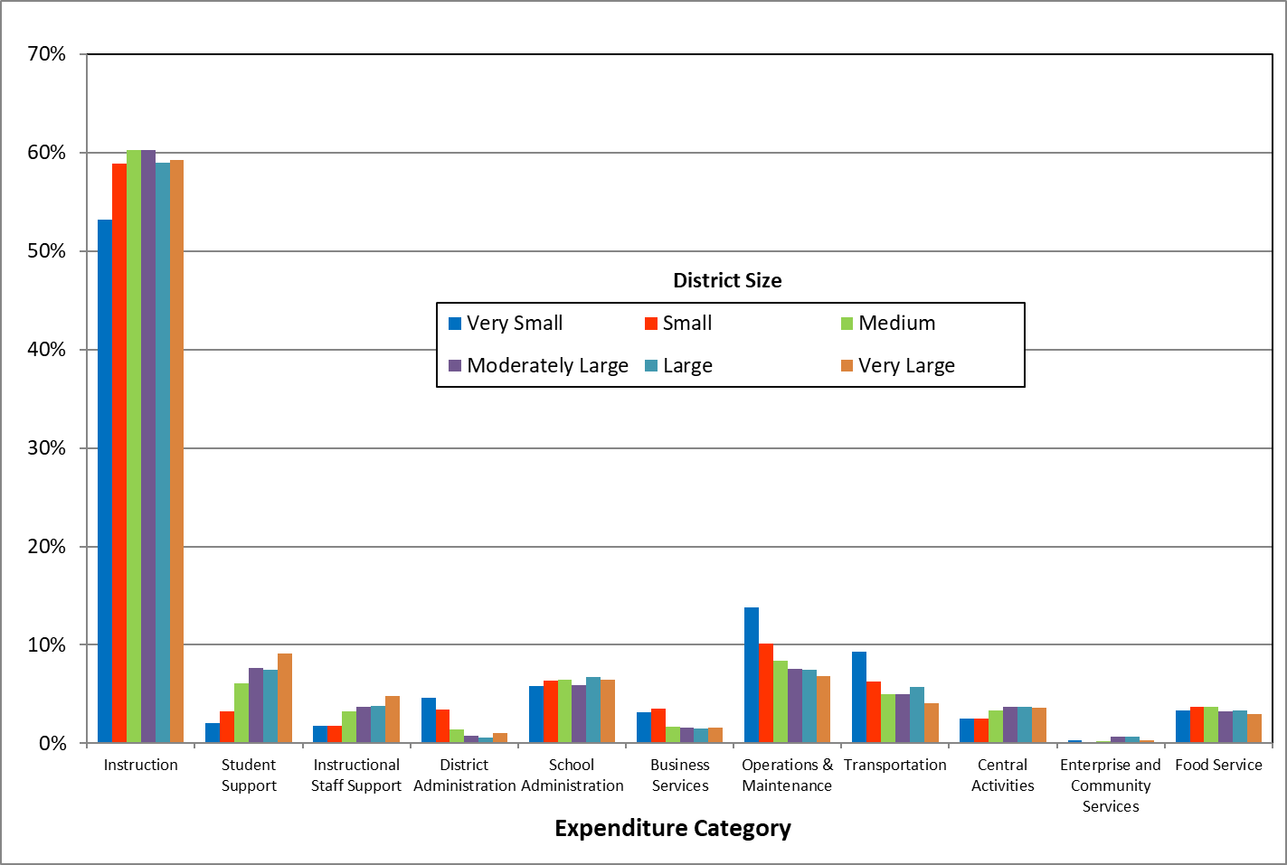

Some key relationships jump out:

* Instruction is by far the largest spending category. The smallest districts spend the lowest share on instruction, but these districts also have considerably higher funding per student (Exhibit 2) because of the added funding they receive from the Small School Correction.[2] Although the smallest districts spend the smallest share on Instruction, they spend the largest dollar amount per student.
* In some spending categories, the share spent falls as districts get larger, suggesting that in those categories there are economies of scale—certain activities can be performed at a lower cost as district size gets bigger. The categories that stand out are District Administration, Business Services, Operations & Maintenance, and Transportation. For Operations & Maintenance and Transportation the economies of scale appear to be present over the entire range of district sizes. In contrast, for District Administration and Business services the economies of scale are substantially diminished for districts larger than the Medium size category.
* For two spending categories—Student Support and Instructional Staff Support—the share rises as districts get larger.
* For the remaining spending categories, district size does not appear to have much impact on the share of total spending devoted to that category.

Exhibit 4 shows the number of school districts and students across geographic categories known as “locales,” which are designed to capture the distinctions between urban and rural areas. In the exhibit we display data for the four major locales defined by the National Center for Education Statistics (NCES).[3] The exhibit shows that more half of Oregon’s 197 school districts are in Rural areas, but those districts serve less than 10% of all K-12 students. In contrast, the 13 districts in the City category (6.6% of all districts) serve more than 40% of all students.

**Exhibit 4: Distribution of School Districts by Locale, 2018-19**

This table shows the number of districts, the number of students, the share of total enrollment, and the average operating expenditures per student for districts in four geographic locale categories: Rural, Town, Suburb, and City.

Because locales are fairly strongly correlated with district size—with smaller districts in Rural and Town areas and larger ones in Suburban and City areas—the distribution of spending across locale categories shown in Exhibit 5 is similar to distribution by district size shown in Exhibit 3.

**Exhibit 5: Share of Operating Expenditures by District Locale 2018-19**

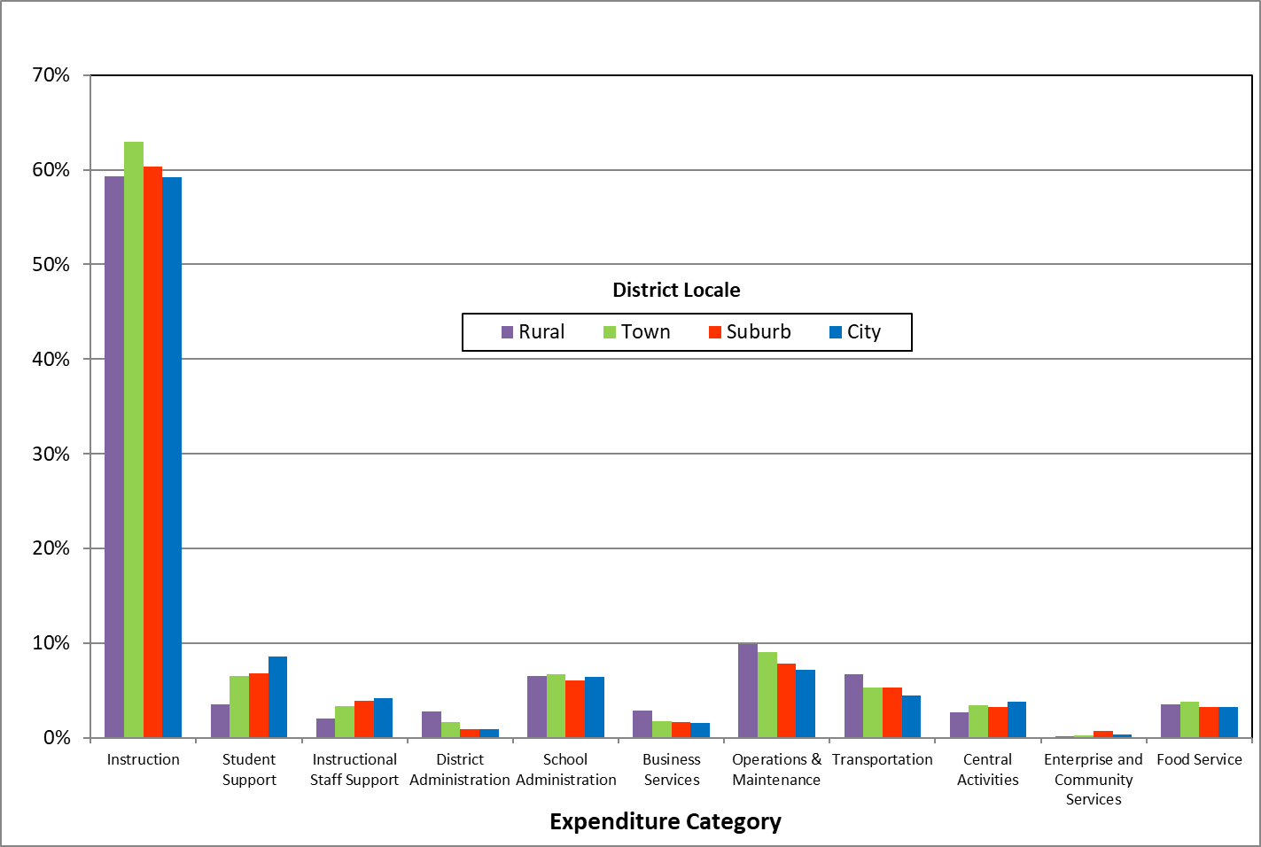

More than a quarter of all Oregon school districts don’t have any students identified as English Language Learners (ELL). Those districts are all quite small, with more than half of them having fewer than 200 students and together accounting for less than 2 percent of all K-12 students in the state. Nearly two thirds of all ELL students are in districts whose ELL students make up less than 10 percent of their total students. Exhibit 6 shows this distribution.

**Exhibit 6: Distribution of School Districts by ELL Percent, 2018-19**

This table shows the number of districts, the number of students, the share of total enrollment, and the average operating expenditures per student for districts in six categories based on the percentage of a district's enrollment that is English Language Learners. The categorises rage from Zero to 20% or Higher.

Exhibit 7 shows that districts with the highest share of ELL students spend a smaller share on Instruction than other districts, but those same districts spend a larger share on Student Support Services. In the other spending categories, there is no consistent relationship between expenditure shares and the share of students who are English Language Learners.

**Exhibit 7: Share of Operating Expenditures by Percent ELL Students, 2018-19**

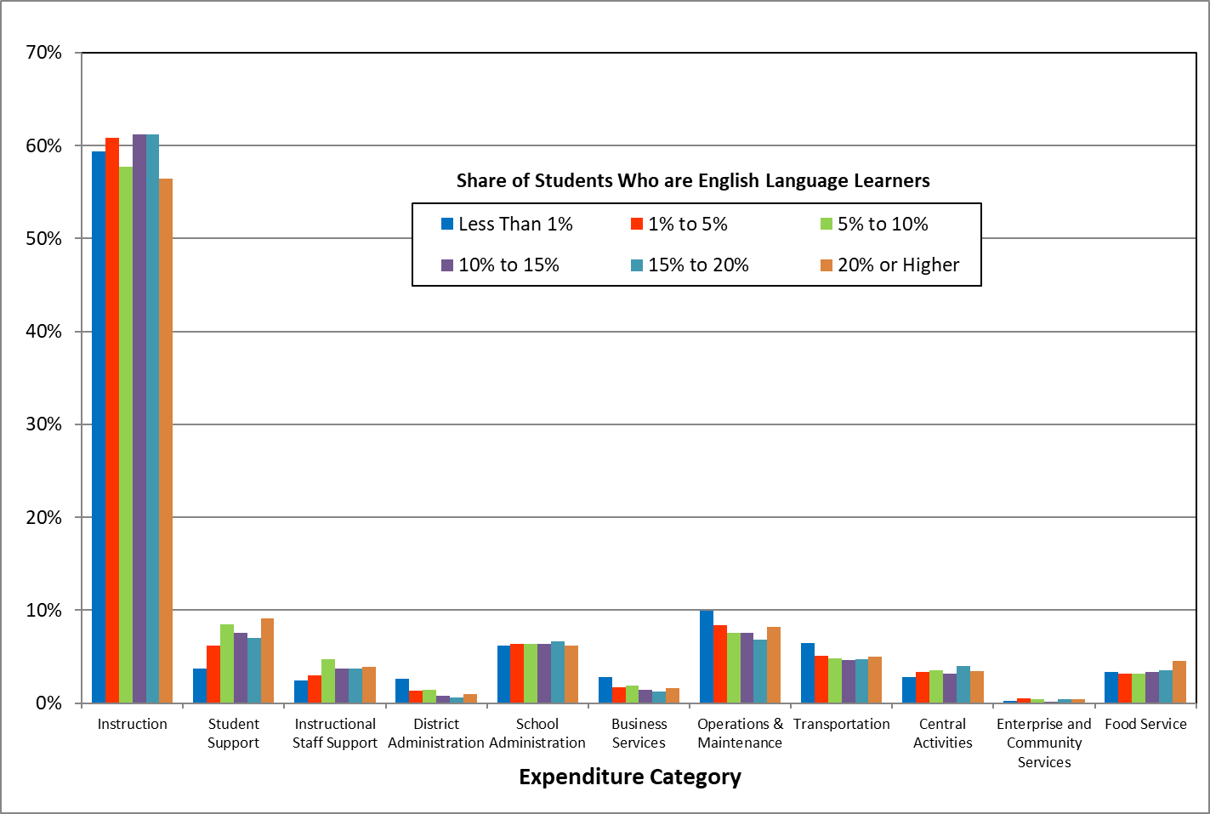

Exhibit 8 shows the number of districts and students across categories of districts’ shares of students who are economically disadvantaged, defined as the students qualifying for free or reduced price lunches under the U.S. Department of Agriculture’s School Lunch Program. More than 68 percent of all districts, and more than 61 percent of all students, attend districts where over 40% students are economically disadvantaged. Figure 9 shows that there is no clear relationship between the share of students who are economically disadvantaged and the share of operating expenditures allocated to different uses. The one exception is the share spent on food service, which is what we would expect.

**Exhibit 8: Distribution of School Districts by Economically Disadvantaged Percent, 2018-19**

This table shows the number of districts, the number of students, the share of total enrollment, and the average operating expenditures per student for districts in five categories based on the percentage of a district's enrollment that is economically disadvantaged students The categories range from Less Than 20% to 80% or Higher.

**Exhibit 9: Share of Operating Expenditures by Percent Economically Disadvantaged Students, 2018-19**

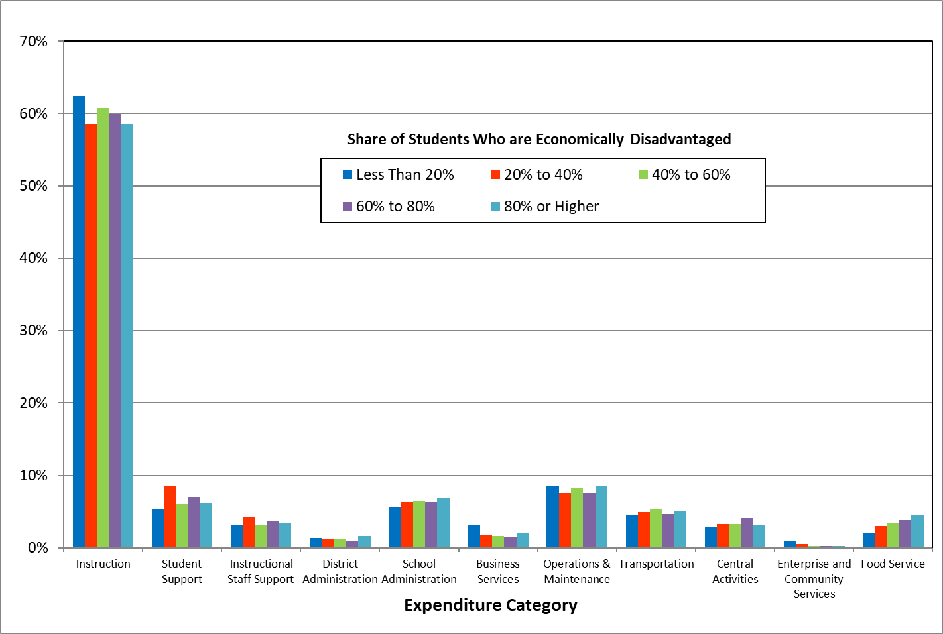

Exhibit 10 shows the number of districts and students by teacher salary levels. With the statewide average teacher salary level at $65,019, the table shows that only 18 districts 9 percent) have average salaries above the statewide average, but more than 57 percent of students attend those 18 districts. This shows clearly that larger districts tend to pay higher salaries than smaller districts, but because Oregon’s small districts are located primarily in rural areas, the observed salary differences are more likely a result of the labor market and cost of living differences between rural and urban areas.

**Exhibit 10: Distribution of School Districts by Teacher Salary Range, 2018-19**

This table shows the number of districts, the number of students, the share of total enrollment, and the average operating expenditures per student for districts in six categories based on teacher average salaries. The categories range from Less Than $50,000 to $70,000 and Higher.

**Exhibit 11: Share of Operating Expenditures by Teacher Salary Range, 2018-19**

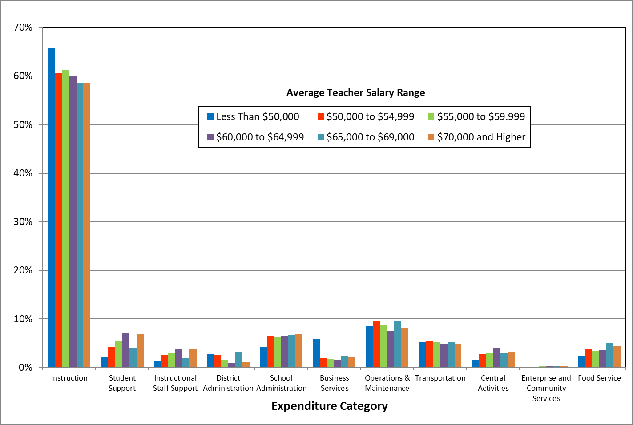

It may seem counter-intuitive that districts with lower teacher salary levels spend a larger share on Instruction, but the reason becomes clear when you look at Exhibit 12. It shows that median class sizes are considerably higher in districts with higher teacher salaries. The high salary districts are concentrated in larger school districts which tend to be in larger cities and suburbs, with lower salaries being more common in smaller districts that are primarily in smaller towns and rural areas. The higher salaries that districts in larger urban and suburban districts must pay their teachers (and other staff) mean they do not have sufficient resources to have the smaller class sizes that lower-salary districts can offer.

**Exhibit 12: Median Class Size by Teacher Salary range, 2018-19**

This table shows the number of districts, the number of students, the average salary, and the median class size for districts in six categories based on teacher average salaries. The categories range from Less Than $50,000 to $70,000 and Higher.

The wide variation in salaries across school districts in Oregon shown in Exhibit 12—ranging from around $40,000 in some small, rural districts to nearly $80,000 in districts in the Portland metropolitan area—means the higher-salary districts have much lower purchasing power, leaving them at a distinct disadvantage in serving their students compared to low and moderate salary districts.

These large salaries variations, and the associated higher class sizes, represents a potentially serious inequity in Oregon’s K-12 funding system. The 28 school districts with average salaries above $65,000 serve 57 percent of all students in Oregon and even larger shares of African American students (86%), Native Hawaiian/Alaska Native students (80%), English Language Learners (69%), and Hispanic students (60%). While this issue needs further exploration, these large salary variations, for which Oregon’s K-12 funding system does not compensate high-salary districts, may be resulting in continuing inequities for large numbers of Oregon’s historically underserved students.

**A Deeper Analysis**

The graphs above provide an initial look at the relationship between spending patterns and various district characteristics. The graphs, however, look at only one characteristic at a time (district size, the share of students who are English Language Learners, etc.). A more in-depth analysis that looks at multiple district characteristics at the same time can help identify which of the district characteristics have the most influence on spending patterns.

**Regression Model Results**

Exhibit 13 on the following page shows the results of a set of statistical regressions where we regressed the expenditure shares of districts, for each of eight key expenditure categories, against a set of independent variables associated with differences in district characteristics that might affect allocative decisions. These characteristics

**Exhibit 13: Regression of Factors Associated with Share of Operating Expenditures, 2018-19**



include per-pupil expenditures, district enrollment (Fall Membership), self-contained median class size, average teacher salary, the length of the school year (days in session), NCES locale code classification status (Rural, Suburb, Town or City), district size, demographic student group shares, and other student group shares.

Expenditures used in this analysis were classified according to the requirements in the 2018 Program Budgeting and Accounting Manual for School Districts and Education Service Districts in Oregon[4]. These requirements define a common set of expenditure classifications so that the data for all of Oregon’s school districts are comparable. However, because of differences in the expenditure reporting requirements for charter schools, in our analysis we excluded the expenditures districts made for charter schools (expenditure function 1280). We also excluded students enrolled in these charter schools from the calculation of enrollment, per-pupil expenditures, and all student group shares.

To avoid doubly counting expenditures, we excluded expenditures with object codes in the 370 group. This group is designed to track tuition payments from one district to another in cases where a student transfers to another district under a contract between the two districts. These expenditures do not reflect the purchase of educational goods or services but are merely an accounting method for documenting transfer payments from one district to another.

To restrict the analysis of expenditures to only those used for providing current educational services to students, and not for revenues such as bond funds earmarked for capital acquisition or debt service, we include only those expenditures which were financed by revenues in the General Fund, Special Revenue Funds, and Enterprise Funds. This definition of expenditure is most commonly referred to as ‘Operating Expenditures”. We excluded expenditures from the Debt Service Funds, Capital Projects Funds, Internal Service Funds, and Trust and Agency Funds. This set of restrictions allow us to meaningfully analyze only those differences in expenditure allocations that may measurably impact student outcomes.

**Instructional Expenditures**

Increases in total per-pupil expenditures within a district are statistically significantly correlated with a reduction in the share of expenditures allocated to Instruction. This is consistent with the idea that instructional resources are allocated to schools in a fixed proportion to enrollment in order to achieve metrics such as target class sizes or staffing ratios[5]. When school districts have additional funding beyond what is required to achieve these targeted metrics, the tendency to spend it on non-instructional activities implies that revenue-constrained districts may have been making allocative decisions to preserve instructional expenditures at the expense of non-instructional activities, and that additional funding is used to restore these activities.

Increases in enrollment within a district are statistically significantly correlated with a reduction in the share of expenditures allocated to Instruction. This may be because increases in enrollment that do not significantly negatively impact the class size or staffing ratio targets selected by districts enough to trigger the hiring of additional instructional resources can lead to additional students being spread across teachers and classrooms, slightly increasing enrollment at no additional financial cost to the district. These effects may be more likely in the smallest districts, where very small class sizes can be increased considerably without requiring additional staff.

Increases in median class size within a district are weakly statistically correlated with reductions in the share of expenditures allocated to Instruction. This may be because districts facing the marginal decision to add teachers may opt to increase class size instead, at no additional cost to the district, and opt to use the avoided costs of hiring additional instructional resources for non-instructional purposes. Again, this is more likely to occur in smaller districts with small class sizes.

Increases in the level of average teacher salaries are statistically significantly correlated with increases in the share of expenditures allocated to Instruction. The small magnitude of this effect may indicate that districts that face higher than average teacher wages may make decisions that reduce the quantity of teachers they hire to offset the cost impact of higher teacher wages, such as increasing class sizes or utilizing relatively more instructional assistants or paraprofessionals in lieu of fully accredited teachers. As Exhibit 12 above shows, there is a strong positive correlation between teacher salary levels and median class sizes. As we discussed above, Oregon’s school funding system does not account for the variation in salaries around the state, creating a funding inequity across school districts.

Districts classified as Rural, Suburban, or Town districts appear to spend a lower share on instructional activities than City districts, although this difference is weakly statistically significant for Town districts.[6] The differences may arise because the unavoidable fixed facility and maintenance costs of operating school districts that districts must incur are comparable to the costs that larger districts must incur yet must be spread across a smaller number of students. This may create an additional budget constraint on small districts that larger districts do not face that forces smaller districts to reduce the share they have remaining to allocate to Instruction. It may also be possible for large school districts to coordinate the hiring and scheduling of less-used instructional resources between groups of schools, while smaller districts may lack the ability to effectively coordinate between groups of schools, either due to geographical remoteness, or to the fact that there are too few schools (or solitary schools) within the district.

Very Small, Small, Medium, Moderately Large, and Large Districts also appear to spend lower shares on instructional activities than Very Large districts with 30,000 students or more; however, this difference is only statistically significant for Medium, Moderately Large, and Large Districts.[7] This negative impact relative to districts in the Very large category may be related to economies of scale. Because the largest districts are able to spend less on categories such as District Administration, Operations and Maintenance, and Transportation, they free up more resources for Instruction.

**Student Support Expenditures**

Increases in total per-pupil expenditures within a district are statistically significantly correlated with increases in the share of expenditures allocated to Student Support Services. If districts make the decision to allocate instructional resources to schools in proportion to enrollment in order to achieve target class sizes, then additional per-pupil funding beyond what is required to achieve those targets enables districts to allocate relatively more to non-instructional activities, such as Student Support Services.

Increases in enrollment within a district are statistically significantly correlated with an increase in the share of expenditures allocated to Student Support Services. This suggests that, for small changes in enrollment, districts make decisions indicating that they perceive the value from altering instructional expenditures to reduce class sizes to be less than the value of providing additional non-instructional resources to students.

Increases in the level of average teacher salaries are statistically significantly correlated with a reduction in the share of expenditures a district allocates to Student Support Services. This may indicate that some districts that face higher wages and do not choose to counteract this by increasing class sizes or employing alternative staffing resources to supplant teaching staff are left with a relative smaller fraction of their total revenues to allocate to non-instructional activities.

Districts classified as Town districts spend a statistically significantly higher share on Student Support Services than City districts. The share for Suburban districts is also higher, but is not statistically significant, and the share for Rural districts is lower, but it also is not statistically significant.

Very Small, Small, Medium, Moderately Large, and Large Districts also appear to spend lower shares on Student Support Services activities than Very Large districts with 30,000 students or more students. This difference is strongly statistically significant for Small, Medium, Moderately Large, and Large Districts and weakly significant for Very Small districts. The weaker result among Very Small districts may again be due to districts that receive the Small School Correction gaining additional funding that enables them to make different allocative decisions than their peers that do not receive the Small School Correction.

**Instructional Staff Support Expenditures**

Increases in total per-pupil expenditures within a district are statistically significantly correlated with increases in the share of expenditures allocated to Instructional Staff Support Services.

Increases in enrollment within a district are statistically significantly correlated with increases in the share of expenditures allocated to Instructional Staff Support Services.

Districts classified as Suburban or Town districts spend a statistically significantly higher share of their expenditures on Instructional Staff Support Services than City districts. Rural districts also appear to spend a higher share although this effect is not statistically significant.

Increases in the share of Special Education Students are statistically significantly correlated with a decrease in the share which districts allocate to Instructional Staff Support. This appears inconsistent with the fact that additional weighting provided for Special Education Students in the Oregon’s school funding formula allocates additional funding to districts for the higher costs of educating Special Education Students. Because many Special Education Students require services from non-instructional staff such as physical and occupational therapists, speech pathologists, audiologist, nurses, and other staff, it may be that spending on those staff “crowd out” spending for Instructional Staff Support. If this is the case, it suggests that the added 0.5 weight in the school funding formula for Special Education Students may not be sufficient to fund services for Special Education Students without reducing funding for other activities, or that the 11% cap on the share of a districts students who can receive the extra 0.5 weight for Special Education Students is too low.

**District Administration Expenditures**

Increases in enrollment within a district are statistically significantly correlated with decreases in the share of expenditures allocated to District Administration. Because centralized administrative activities have a fixed cost component, this negative relationship suggests there are economies of scale in District Administration.

Very Small, Small, Medium, Moderately Large, and Large districts allocate lower shares to District Administration than Very Large Districts (the base category), with a high level of statistical significance. This suggests that the very largest districts or more difficult and require more resources to run than smaller districts.

Increases in the share of economically disadvantaged students are statistically significantly correlated with reductions in the share districts allocate to District Administration. It’s not clear why having more economically disadvantaged students would be associated with centralized administrative costs, but it may be partially driven by a correlation between this student group’s enrollment share and district size.

**School Administration Expenditures**

Rural districts are estimated to spend a statistically significantly higher share on School Administration than City districts. Given that our model has already accounted for variations in district size, this finding suggests that there may be economies of scale for administration at the school level—that is, administrative activities become more efficient as school size increases. Rural schools tend to be smaller than schools in Towns, Suburbs, and Cities, so the fixed administrative costs at small, Rural schools—primarily the principal and other administrative staff—cost proportionally more in Rural schools than they do in non-Rural locations.

Districts with small schools that are relatively close to each other may be able to share school administration resources, effectively leveraging school site proximity to buy a fraction of a school administrator. Rural districts, in contrast, are more likely to have geographically remote schools which are unable to effectively share school administration resources between facilities. These factors may combine to prohibit Rural districts from taking advantage of the economies of scale in School Administration that less rural or remote districts are able to achieve.

**Business Services Expenditures**

Increases in enrollment within a district are statistically significantly correlated with a reduction in the share of expenditures on Business Services. As with District Administration, this suggests there are economies of scale in Business Services, with larger districts able to perform these services more efficiently than smaller districts. The negative coefficients that decline at larger district sizes (in absolute terms) indicate that the economies of scale diminish as district size increases.

**Operation and Maintenance Expenditures**

Increases in total per-pupil expenditures within a district are statistically significantly correlated with higher shares of expenditure allocated to Operation and Maintenance. This suggests higher funding allows districts to devote more resources to maintaining their buildings, something that is often deferred when resources are inadequate

Increases in average teacher salaries in a district are statistically significantly correlated with reductions in the share of Operations and Maintenance expenditures allocated by a district.

There is a negative relationship between district enrollment and the share spent on Operations and Maintenance, indicating that economies of scale may be present in this activity as well, but the relationship is not statistically significant.

**Central Activities Expenditures**

Increases in enrollment within a district are statistically significantly correlated with increases in the share of expenditures districts allocate to Central Activities. These activities include technology and information services, statistical services, research and development, human resource services, etc. The positive relationship between district size and the share spent on these services may be a result of smaller districts receiving such services from their Education Service District (ESD) while larger districts perform these services themselves. The relationship is particularly strong for Medium and Moderately Large sized districts.

Increases in the average actual teacher salary in a district are statistically significantly correlated with reductions in the share of expenditures districts allocate to Central Activities.

Districts classified as Rural, Suburban or Town are statistically significantly predicted to allocate lower shares of expenditures to Central Activities than districts classified as City districts.

**Are variations spending patterns related to student outcomes?**

The goal of the spending pattern analysis summarized above is to determine how district characteristics influence how they allocate spending to different activities. Now we turn our attention to whether those spending patterns have an impact on student outcomes. That is, can spending the same amount of money, but in different ways, achieve better results for students?

The Department of Education used the results of their spending pattern analysis to evaluate whether or not variations in spending patterns are systematically associated with student outcomes, using high school graduation as their student outcome measure. Using a multivariate linear regression model, we estimated the relationship between high school graduation rates and the shares of spending in various categories. Using this type of model allows us to take into account other factors that influence graduation rates so that we are able to isolate the impacts of spending patterns. These other factors include district spending levels, district size, district location (City, Suburb, Town, and Rural), student demographics, and the share of students who are low income, English language learners, and special education.

Exhibit 14 summarizes the results of the regression equation for just the spending share variables. We present the full regression results, showing the relationship to high school graduation of the spending share variables and all of the control variables, in Appendix A.

**Exhibit 14: Summary of Estimated Impact of Spending Shares on High School Graduation Rates, 2018-19**

This table shows the estimated impact on high school graduation rates of spending more or less ins certain spending categories.  The based category is Instruction.

Focusing on the factors that have a statistically significant relationship with high school graduation, we see that a one percentage point reduction of the share of total operating spending devoted to Instructional Staff Support activities, and raising the share to Instruction by one percentage point, will result in an estimated increase in the graduation rate by 1.29 percentage points.

Similarly, reducing the share spent on Business Services by one percentage point and devoting those resources to Instruction is predicted to raise the graduation rate by 1.07 percentage points. For Central Activities, we predict a shift of a one percentage point share of total spending to Instruction will increase the graduation rate 1.19 percentage points.

These findings suggest that districts may be able to improve student outcomes by reallocating resources, where possible, toward instruction and student support activities and away from activities that are more administrative in nature. In particular, shifting spending to Instruction from administrative and support activities that are less directly related to student learning has the potential to improve student outcomes.

To assist districts in evaluating how they allocate resources to different activities, the Department of Education has developed a tool that allows districts to compare their resource allocations to those of similar districts. The hope is that similar districts can learn from one another how to better use their resources.

**A Tool for School Districts**

The analysis of how spending patterns are related to student outcomes may be of use to school districts in making budgeting and spending decisions. The analysis shows, for example, that districts that spend a higher share of their resources on classroom instruction get better student outcomes. With this knowledge, a district that currently spends less on instruction than other districts in similar circumstances may be able learn from the other districts how to find savings in the non-instructional areas.

The tool developed by the Department of Education provides the information that districts need to make such comparisons. The tool provides, for each school district in the state, expenditure data in a range of categories. This information, along with demographic and student performance data, will allow districts to compare themselves with their peer districts and quickly see how different spending patterns may be related to different outcomes. Perhaps more importantly, it may generate conversations among school districts so they can share knowledge about what seems to be effective and what doesn’t.

In making these comparisons, districts should compare themselves to other districts of roughly the same size. Our analysis shows that district size impacts spending patterns, so districts have the most to learn from other districts of the same size.

The tool is available for download on the Department of Education’s website [here.](https://www.oregon.gov/ode/schools-and-districts/grants/Pages/K-12-School-Funding-Information.aspx)

**Appendix—High School Graduation Rate Regression Results**

This table shows the detailed results of the the regression equation that was estimated to identify the factors that are associeated with high school graduation rates.

1. Oregon Secretary of State’s Office, “ODE and PPS Must Do More to Monitor Spending and Address Systemic Obstacles to Student Performance, Particularly at Struggling Schools”, Audit Report 2019-01, January 2019
2. ORS 327.077
3. https://nces.ed.gov/programs/edge/Geographic/SchoolLocations
4. The current version of this document is available from [the ODE website](https://www.oregon.gov/ode/schools-and-districts/grants/Pages/Financial-Budgeting-and-Accounting.aspx).
5. This appears to be how many districts make their budgetary decisions regarding the level of instructional staff they hire. For example, “In elementary, middle and K-8 schools, staff will be allocated based on the number of classes required by grade level or subject based on the projected enrollment in those grade levels. Previously, the FTE allocation was allocated on a ratio of projected enrollment for the entire school. This change will ensure that each grade level has the necessary number of teachers. High school FTE allocation will continue to be based on a ratio, but all high schools will start with a minimum base number of FTE, to ensure adequate staffing at under-enrolled and small schools and ensure students receive instruction in core academic and state mandated courses.” Approved Budget For the fiscal year 2018/19, School District No. 1J, Multnomah County, Oregon Portland Public Schools, p.28; See also “Increase the staffing ratio in grades 3-12 by two, for a staffing ratio of 31:1 (loss of 37.5 licensed full-time equivalent (FTE) positions; add back 6 FTE in hot spots for a net loss of 31.5 FTE)” Adopted Budget For Fiscal Year 2019-20, Hillsboro School District 1J, p. 3.
6. City districts are the base category, so the impacts of the other geographic locale categories are relative to districts in the City category.
7. Very Large districts are the base category, so the impacts of the other size categories are relative to districts in the Very Large category.