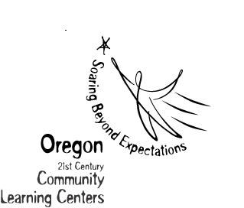21st Century Community Learning Centers

Applicant and Partner Commitment Form
Attachment C

Applicant Signature:

Print Name:

Organization:

Address:

Phone Number: |  |  | Fax Number:
E-Mail:

All Partners in the 21st CCLC need to be listed here.
Indicate if the commitment the partner is providing is (1) on a contract or is (2) an in-kind service
Partner Signature: |  |  | Description of Commitment:
Print Name:

Organization:

Address:

Phone Number: | Fax Number:
E-Mail:

Partner Signature: |  |  | Description of Commitment:
Print Name:

Organization:

Address:

Phone Number: |  | Fax Number:
E-Mail:

(If more space is needed to list partners, please include additional copies of this chart.)

