Coronavirus Aid, Relief, and Economic Security (CARES) ACT
Elementary and Secondary Education Relief (ESSER) ACTIVITIES

The following topics must be discussed during the ongoing consultation process; check to indicate that the topic has been discussed.

Education Stabilization Relief Fund (18003):

- Any activity authorized by the ESEA of 1965, including the Native Hawaiian Education Act and the Alaska Native Educational Equity, Support, and Assistance Act (20 U.S.C. 6301 et seq.), the Individuals with Disabilities Education Act (20 U.S.C. 1400 et seq.) (‘‘IDEA’’), the Adult Education and Family Literacy Act (20 U.S.C. 1400 et seq.), the Carl D. Perkins Career and Technical Education Act of 2006 (20 U.S.C. 2301 et seq.) (‘‘the Perkins Act’’), or subtitle B of title VII of the McKinney-Vento Homeless Assistance Act (42 U.S.C. 11431 et seq.).

- (Coordination of preparedness and response efforts of local educational agencies with State, local, Tribal, and territorial public health departments, and other relevant agencies, to improve coordinated responses among such entities to prevent, prepare for, and respond to coronavirus.

- Providing principals and others school leaders with the resources necessary to address the needs of their individual schools.

- Activities to address the unique needs of low-income children or students, children with disabilities, English learners, racial and ethnic minorities, students experiencing homelessness, and foster care youth, including how outreach and service delivery will meet the needs of each population.

- Developing and implementing procedures and systems to improve the preparedness and response efforts of local educational agencies.

- Training and professional development for staff of the local educational agency on sanitation and minimizing the spread of infectious diseases.

- Purchasing supplies to sanitize and clean the facilities of a local educational agency, including buildings operated by such agency.

- Planning for and coordinating during long-term closures, including for how to provide meals to eligible students, how to provide technology for online learning to all students, how to provide guidance for carrying out requirements under the Individuals with Disabilities Education Act (20 U.S.C. 1401 et seq.) and how to ensure other educational services can continue to be provided consistent with all Federal, State, and local requirements.

- Purchasing educational technology (including hardware, software, and connectivity) for students who are served by the local educational agency that aids in regular and substantive educational interaction between students and their classroom instructors, including low-income students and students with disabilities, which may include assistive technology or adaptive equipment.

- Providing mental health services and supports.

- Planning and implementing activities related to summer learning and supplemental afterschool programs, including providing classroom instruction or online learning during the summer months and addressing the needs of low income students, students with disabilities, English learners, migrant students, students experiencing homelessness, and children in foster care.

- Other activities that are necessary to maintain the operation of and continuity of services in local educational agencies and continuing to employ existing staff of the local educational agency.

The list of suggestions below are not exhaustive. All CARES Act applications are subject to final review and approval through the Oregon Department of Education application process and must adhere to state and local COVID-19 restrictions.
Consider both short-term and long-term needs in budget planning.
- Funding does not have to be used at only Title I served schools nor for only Title I eligible students.
- Activities allowed under any federal education grant such as IDEA, Title I, Title II, Title III, Title IV, 21st Century Community Learning Centers, Perkins, or McKinney-Vento, are allowed under CARES.
- Non-public school Activities must be non-ideological, secular, and neutral in nature.
- Fiscal rules of EDGAR and OMB apply as any other federal fund.

Application Categories | Examples of Applications
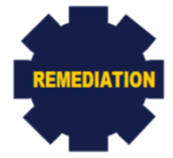 | - Activities to address gaps in learning that occurred due to school disruptions  - Summer School  - Funding can be used to support your local 21st Century Community Learning Centers Program activities  - Staff and curriculum resources to start the school year early, lengthen the school day, or year  - Additional teachers to provide intensive support once school has started  - Additional support for students most in need, including students with disabilities, English learners, foster, homeless, migrant, low-income, etc.
- Additional devices
- WiFi/Internet connectivity
- Learning management systems
- Professional development for educators to deliver eLearning
- Offline course/material curation
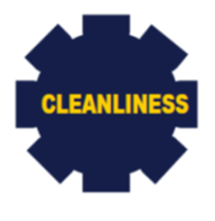 | - Additional Processional cleaning of schools to prepare for student return or maintain student and staff safety once buildings are open  - Personal protective equipment (PPE)  - Cleaning Supplies
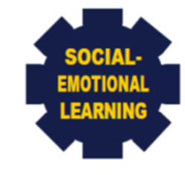 | - Additional funding of mental health partners for additional services to students (including students who do not have insurance or do not qualify for current services  - Funding of support group for educators  - Professional development on trauma responsive practices  - Online platform for a social-emotional learning universal screener  - Source of Strength, Hope Squad, etc., for student peer groups and support  - Mental Health First Aid training, including coverage for substitutes  - Increase EAP programming for educators to care for COVID-19 related trauma
Graphics and Examples Provided by:
The Indiana Department of Education

