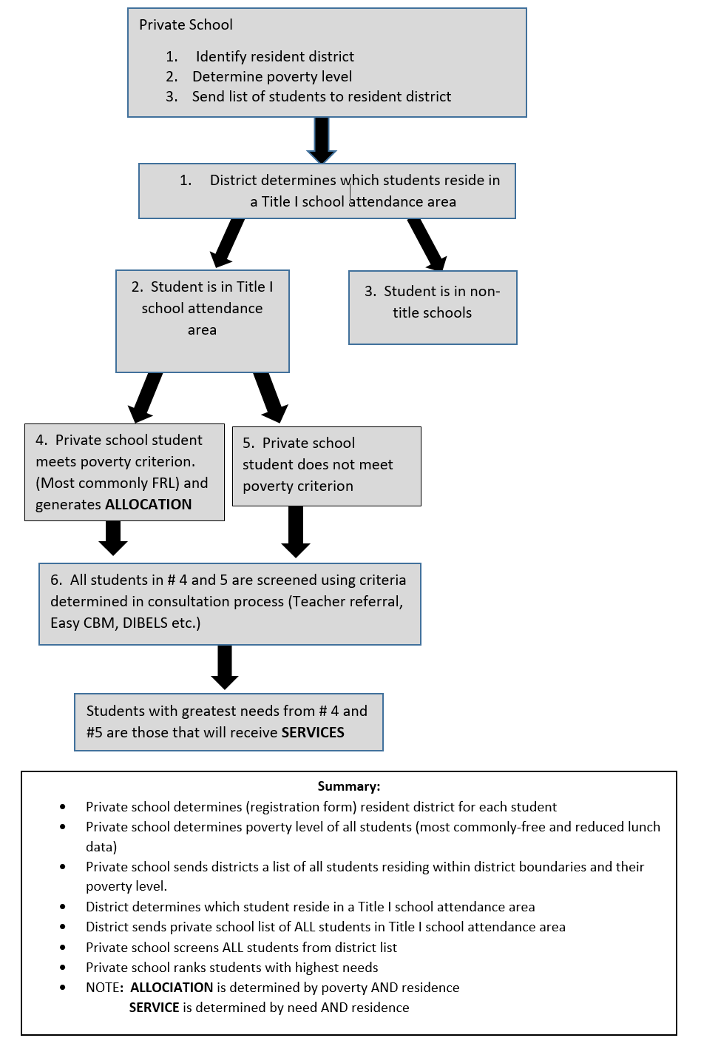
Title I Equitable Services: Process for Determining ALLOCATION and SERVICE

