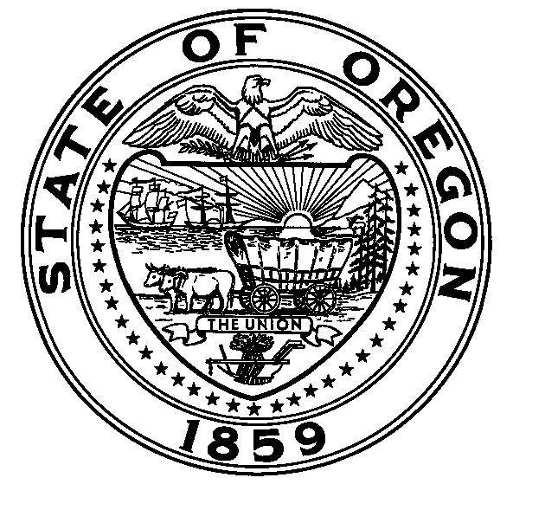
NCLB Title Program Monitoring
Parent Survey Questions

District Name: Oregon Department of Education

Instructions: Circle the answer that best expresses your opinion. If you have children in different schools, please fill out a separate form for each school.
- The kind of school my child attends is:
Elementary School | Intermediate School |  | Middle School |  | High School |  | Charter School
- I feel welcome at my child’s school.
Strongly agree | Mostly agree |  | Agree |  | Slightly disagree |  | Strongly disagree
- I am encouraged to participate in decision making at my child’s school.
Strongly agree | Mostly agree |  | Agree |  | Slightly disagree |  | Strongly disagree
- I can easily arrange a meeting with my child’s teacher[s].
Strongly agree | Mostly agree |  | Agree |  | Slightly disagree |  | Strongly disagree
- I receive written communication in a language I can understand.
Strongly agree | Mostly agree |  | Agree |  | Slightly disagree |  | Strongly disagree
- I have no concerns about the Title 1 services my child is receiving.
Strongly agree | Mostly agree |  | Agree |  | Slightly disagree |  | Strongly disagree
- I was notified that my child is receiving Title program services.
Yes |  | No |  |  |  | N/A
- During this year, my child told me that she/he was harassed at school.
Yes |  |  |  | No
- Name two things you like best about your school’s programs/activities for your child.
a. |  |  |  | b.
- Name two ways you would like the school to involve you more in your child’s education.
a. |  |  |  | b.
- Write any other comments you would like to make about your child’s education/school. Please continue on the back if you need more room to write your comments.

Thank you for taking the time to complete this survey. Your responses will add to the picture of the district we formed during our monitoring visit. Your ideas and opinions are valued by the Oregon Department of Education.

