The purpose of this document is to assist districts/schools with their 2019-20 Spring EL Collection submission. Each district will have a spreadsheet with up to six (6) separate worksheets. Not every district will have all six (6) worksheets. If your district does not have one of the worksheets, it means your district was not identified as needing to review data for that topic.

Please note – Due to 3rd period ADM not being collected this school year, ODE staff are using 2nd period ADM. The end date for 2nd period ADM is 01/01/2020. ODE staff encourage districts to carefully check each record to ensure all ELs are reported accurately during this COVID-19 Pandemic.
__________________________________________________________________________________________

Worksheet Tab 1: EL Record Counts - Every district has this tab
Districts with a zero in columns (d, e, f, or g) have these columns highlighted.
This is a count of all submitted records to the Spring EL Collection. These counts are provided merely as a double check for you. It is irregular for a district to have a zero count in columns d, e, f, or g. If this is the case for your district, please confirm this data.

Included:
- Count of all records submitted – column c
- Count of all 3H records (tested but found not eligible for EL support) – column d
- Count of all 5F (former ELs) – column e
- Count of all 5M (monitored ELs ) – column f
- Count of number of students with exit date – column g

Worksheet 2: In ADM not in EL (Not every district will have this tab)
This means the student has an ADM program type 02 code in 2nd period ADM, but either is missing from the Spring EL Collection or has a Record Type in the Spring EL Collection that is not eligible to receive ADM program type 02 (4N, 4O, 4P, 3H, 2J, 5M, or 5F).

This worksheet uses 2nd period ADM (2019-20) and compares to the Spring EL Collection. Students listed on this worksheet have an ADM program type 02 in 2nd period ADM, but were not submitted as an EL, eligible to receive ADM program type 02, in the 2019-20 Spring EL Collection.

What to do:
- Steps to address the review of this data:
- First identify if each student is an EL – sometimes students on monitor status are accidently coded with a program type 02 ADM code.
  - If the student is not an EL (or is in monitor status), the program type 02 ADM code will need to be removed. Please contact the ADM data owner for assistance in updating this record.
  - If the student is an EL, then check that the student is receiving ELD services – sometimes ELs with a waiver for service (Program code beginning with the number 4) are accidently coded with a program type 02 ADM code.
    - If the student is an EL with a waiver for service, then the program type 02 ADM code will need to be removed. Please contact the ADM data owner for assistance in updating this record.
    - If the student is an EL who recently has a waiver and the ADM Program Type 02 has an end date that matches the time the student received EL Program instructional time.
    - If the student is an EL and is receiving service, add the student to the EL data collection prior to the review window close date (June 22, 2020).

Worksheet 3: In EL not in ADM (Not every district will have this tab)
This worksheet highlights students reported to the Spring EL Collection as receiving ELD services, but ODE did not find a corresponding ADM program type 02 code for the student in 2nd Period ADM.

What to do:
- This list is a heads-up to the district that the district may be eligible to claim EL weighted funding for this student.
  - Any changes would need to be made in the ADM collections.
  - Please contact the ADM data owner for assistance with these records.
- First check the ADM enrollment date
  - If the student enrolled after the 2nd period ADM end date and the student will be included in annual ADM this record is OK.

Worksheet Tab 4: Missing 5M/5F records –only districts with missing student records will have this sheet
(Not every district will have this tab)
This is a list of all of the students ODE found reported to your district’s 2nd period ADM, who have a prior EL record in a previous EL data collection. ODE staff use the EL Spring Data Collection to calculate the outcomes of current, monitored, and former ELs in ODE reports.

What to do:
- Please add any missing records into the Spring EL data collection.
- Use column I to determine student status (EL Exit Date).
  - What code to use?
    - Exited in 18-19 school year – 5M(monitored) program codes 60, 60
    - Exited in 17-18 school year – 5M(monitored) program codes 61,61
    - Exited in 16-17 school year – 5M(monitored) program codes 62, 62
    - Exited in 15-16 school year – 5M(monitored) program codes 63, 63
    - Exited in 14-15 or any school year prior to 14-15 – 5F(Former)
    - ODE staff have put in the EL status in column K to assist districts
- Review the EL Student History if you need a language of origin other than English (see steps below).

Worksheet Tab 5: EL Records with Unusual Language Codes (Not every district will have this tab)
This worksheet identifies students reported to the Spring 19-20 EL Data collection with a language of origin code that seems improbable. ODE is required to report all the languages to the US Dept. of Education, the languages listed for these students were identified as improbable or unusual.

What to do:
- Please review these student records to identify appropriate language of origin.
- Update language or origin code as necessary.

Worksheet Tab 6: 2-J Student Records (Not every district will have this tab)
This worksheet identifies students reported to the Spring 19-20 EL Data collection with an EL Record Type Code 2-J (Potential EL). This record type code is only to be used for students enrolling with a disability who could not participate in the identification screener due to the screener not being accessible for the student.

If a student enrolled in the district during the COVID-19 Pandemic and could not participate in the ELPA screener, this student should have an EL Record Type Code of SE (State of Emergency).

What to do:
- Please check all students included on this sheet.
- Determine if they are a 2-J (Potential EL with a disability that precluded identification screening), or if the student enrolled during the COVID-19 Pandemic and could not be given the identification screener.
  - Modify records if necessary

If you have any question, please email Kim Miller, kim.a.miller@ode.state.or.us. Additional EL information is located in the EL Collection reports tab “EL Student History Report”. This report will provide you with history EL records for all students enrolled in your district. The steps to download the EL Student History Report follow.

___________________________________________________________________________________________

EL History Report Steps:

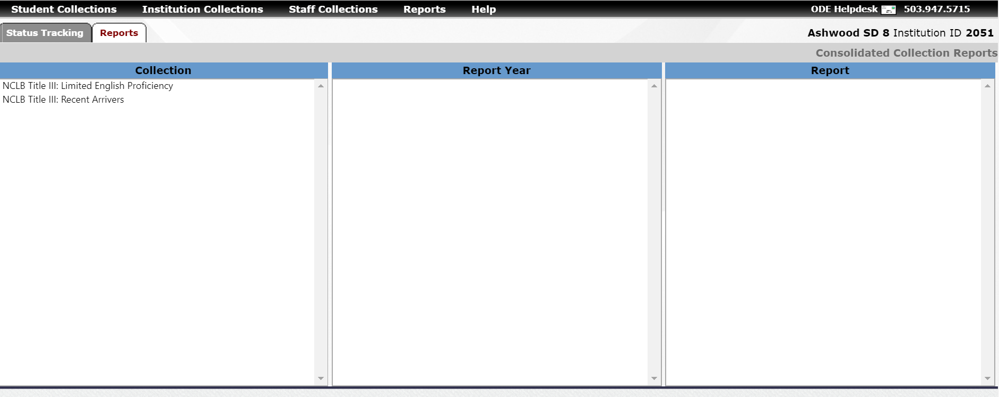

2.
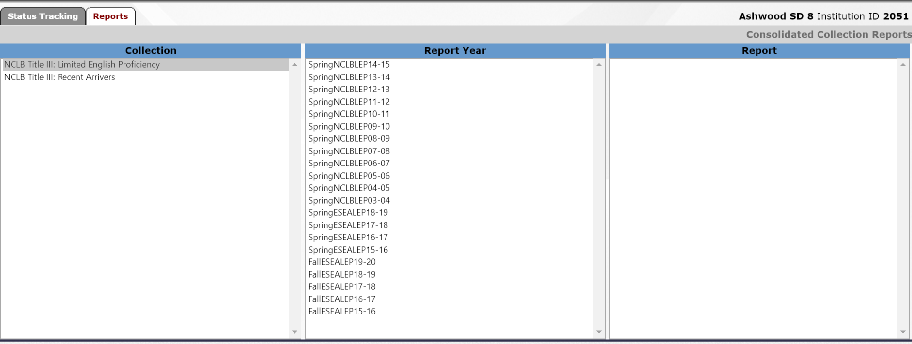
3.
