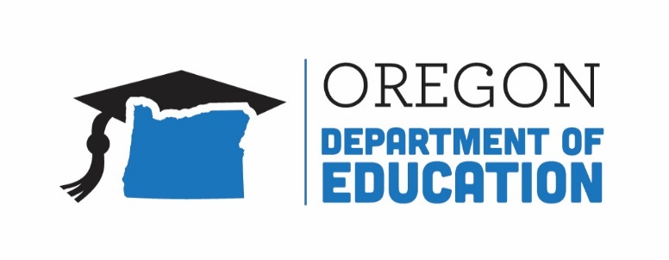
Oregon achieves . . . together!

Title IA Committee of Practitioners (CoPs) Webinar

Wednesday, May 2, 2018
1:30-2:30 PM
ODE Studio B, Salem, OR

Agenda

1:30 PM Welcome & Introductions (Lisa)

1:35 PM Approve Revised Bylaws (Lisa)

1:40 PM Title IV-A Student Support and Academic Achievement Grant
Updates and Discussion (Raquel and Melinda)

2:00 PM Comprehensive Needs Assessment
Updates and Discussion (Shawna)

2:20 PM Agenda Items from Committee for Next Meeting (Lisa)

