Consolidated Collections

Student Collections - SSID

User GuidE

May 4, 2015

ODE Service Desk
(503) 947-5715 - ODEHelpdesk@state.or.us

Table of Contents
Consolidated Collections 1
Student Collections 1
SSID 1
User Guide 1
Table of Contents 2
How to Use This Document 4
Purpose 5
Navigation 7
Data Submission 8
Submission Preparation 9
SSID Submission Flow 10
Submitting Data 11
File Upload 13
Web Submission 14
Student Collections: SSID 14
Error Management 16
Review Queue 16
Review Email 16
Review Errors 17
Housekeeping 19
Download Errors 20
Review Suggestions 21
Resolve Duplicates 22
Record Management 24
Student Lookup & Record Maintenance 24
Student Lookup & Record Maintenance: Student Collections 24
Production Download 27
Student Collections: SSID 27
Review History / Review Merge History 29
Appendix A: Preparing CSV Data Files 30
Overview 30
Production Download 30
Update the Data 33
Save and Submit the File 33
Appendix C: Common Tasks 34
Appendix D: Record Maintenance: Editing Student Demographic Information 36
Appendix E: SSID Matching Algorithm 38
Appendix F: Search Specifications 39
Appendix G: Resources / Tools 41
Revision History 42
Troubleshooting 43

How to Use This Document
Return to Table of Contents
The information in this user guide, as outlined in the Table of Contents, is divided into sections corresponding to the functions within the Consolidated Collections\SSID application. There are three major menu options in each student collection: Data Submission, Error Management, and Record Management.
- Read and understand the instructions for Data Submission, Error Management, and Record Management before attempting to use the application.
- Reports and Help sections are menu options available in the Consolidated Collections application which are available tools for the Student Collections.
- The appendices provide specific information such as, preparing a CSV data file and collection-specific instructions for Student Collections. These appendices are not intended to replace the general instructions, but to supplement them; both should be read to gain maximum benefit. The collection-specific instructions are organized by student collection, function, and reference links.
- Refer to the “Table of Contents” to find instructions for a particular collection or function. Each entry is a hyperlink to the section in the document. At the top-left corner of each page is a hyperlink to return to the “Table of Contents”.
- Information and instructions for Institution Collections are provided in the Consolidated Collections Institution Collections User Guide.
- Information and instructions for Staff Collections are provided in the Consolidated Collections Staff Collections User Guide.

Purpose
The purpose of the Consolidated Collections Application is to provide a single collection mechanism and simplified method by which district users may submit and update information required by the Oregon Department of Education (ODE) for student data collections. This application provides access, for authorized users, to the following collections:
Return to Table of Contents
- Cumulative ADM
- Career and Technical Course Enrollment & Student Data
- Kindergarten Assessment Collections
- Freshman On Track
- High Cost Disability (HCD)
- Child Nutrition Direct Certification Match (NSLP)
- Discipline Incidents
- Kindergarten Assessment
- NCLB Title III - Limited English Proficiency
- NCLB Title III – Recent Arrivers
- ESEA Title X - Homeless
- Oregon Pre-Kindergarten Student
- Special Ed Child Find (Indicator 11)
- Special Ed Pre-Kindergarten Student
- Special Education Child Count (December and June)
- Secure Student Identifier (SSID)
NOTE: ODE consolidated these collections under Student Collections in Consolidated Collections. Please check the Schedule of Dues Dates at https://district.ode.state.or.us/apps/info/ for items such as, the open and close dates for a collection, contact person (data owner) and their phone and additional documents for the specific collection by clicking on its link to access its “Details” page. The documents are located under the Documents section.
  - Access to the Consolidated Collections Application is restricted to authorized users only and controlled by your District Security Administrator.
  - Use the District Security Administrator Lookup Tool to locate your District Security Administrator for help at https://district.ode.state.or.us/apps/login/searchSA.aspx.
  - Use the Central Login Application User Guide at https://district.ode.state.or.us/apps/info/docs/CentralLoginUG.pdf for more information about how to login to Central Login to access applications/collections that have been granted to a user.

Navigation
Return to Table of Contents
The navigational system consists of various options, organized by function and collection, presented in a dropdown menu bar at the top of each page and in a hierarchical list of links in the body of the main page after logging in.
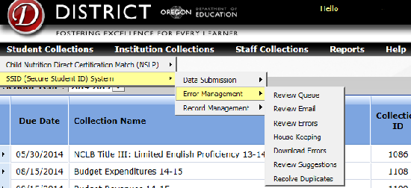
Applications: Use this menu to move among the applications to which your District Security Administrator has granted you access.
Collections: Student Collections and Institution Collections: Use these to move among the available Data Collections. After selecting a collection, the active collection is indicated in a shaded band near the top of the page.
Data Submission: Allows you to submit a .csv file or use a web application to enter the data directly.
Error Management: Allows you to review and fix issues with submissions.
Record Management: Allows you to download and to update the data after the submission has been processed. Interaction is with the data directly and not the file.
Reports: Provides Collection Summary Reports and other information for each collection.
Help: Opens the Collection Details Page for each collection. This is the location for documents, news, file definitions, reports etc.
- Not all collections are applicable / available to all institutions, and are subject to opening / closing dates. Not all functions are applicable / available under every collection. You should familiarize yourself with the navigation system and which collections / functions / options are available to you.

Once you have selected an option from the main menu, the tabs below will allow you to navigate through menus options easier and faster.
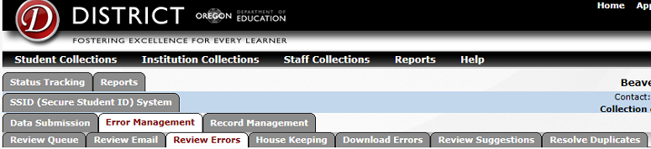

Data Submission
The Data Submission functions allow you to submit a prepared data file to the Oregon Department of Education (ODE) or to use a web interface to enter data directly. Two Data Submission options are available to most Student Collections, File Upload and Web Submission.
Return to Table of Contents

Submission Preparation

- Multiple collections cannot be combined in one submission; each collection must be submitted individually and is maintained in a separate database.
- Please note that for .csv files the top row of column headers is a required row.
- Please make sure that all student demographic data is correct and current before submitting files to ODE.
- When preparing a Comma Separated Values (CSV) file, it is crucial that you not enter commas in any of the fields. Entering a comma in any field signifies the end of that field and the beginning of the next. Unexpected commas will result in columns being shifted causing a critical error.

SSID Submission Flow
Return to Table of Contents

Submitting Data
Determine the fastest and easiest way to submit your SSID data. Here are two options:
Return to Table of Contents
Spreadsheet – Use Microsoft Excel or another spreadsheet program to create a comma-delimited (.csv) text file.
Individual Submission - Use the Web Submission and Record Maintenance options to submit data and to update SSID records individually online.

Spreadsheet
Consider using the Spreadsheet option if you have over 150 students and are not using a Macintosh (Apple) computer. Follow these steps to create your data file using a spreadsheet program:
- Do a “Production Download” in CSV format.
  - Filter by either “All Students – All Information” or “Changed Data by Date Range”.
  - Choose the file type “.csv” to download a “comma separated values” file.
  - Save the file to your computer.
  - Open the file with Microsoft Excel.
  - You may edit, add, or delete records (rows) as dictated by the particular collection for which you are submitting data.
    - Do not delete the top row of column headers; this is a required row.
    - For SSID submissions, the file should only contain currently enrolled students. Graduated students, dropouts, and transfer students should not be included in the file.
  - When you have entered all the required data into the spreadsheet, choose File -> Save As, and save the file as a “CSV (Comma delimited) (*.csv)” file.
- When preparing a Comma Separated Values (.csv) file, it is crucial that you not enter commas in any of the fields. Entering a comma in any field signifies the end of that field and the beginning of the next. Unexpected commas will result in columns being shifted causing a critical error.
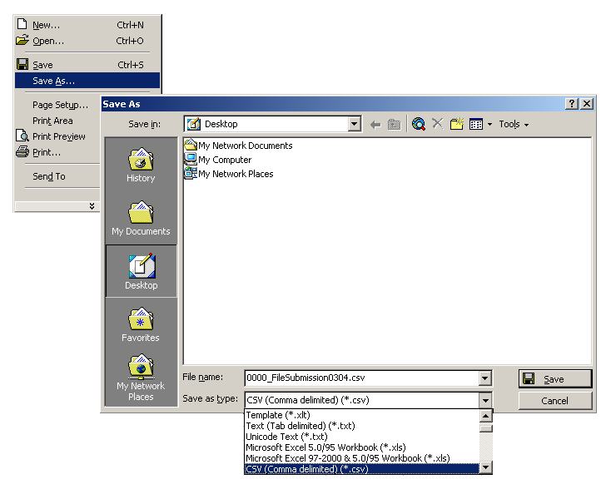
- Upload the data file you just created to ODE.
Return to Table of Contents

Individual Submission
Consider using the Individual Submission option if you have less than 150 students. Follow these guidelines when submitting your SSID data using the Individual Submission option:
- Use the Record Maintenance option, from the Record Management menu, to update records for all returning students. SSID records for all returning students must be updated with current information (i.e. Grade Level, Enrolled Institution Information, Phone Number, Address, etc.).
- Use the Web Submission option from the Data Submission menu to create, update or submit new collection data for existing students. SSID records must be updated (or created) for all new students (i.e. In-State Transfer Students, Kindergarteners or Pre-kingergarteners, New-to-State Students, etc.). The Web Submission option when selected from the Data Submission menu under SSID is used to request SSID records for new students only. Be sure and search to see if a SSID record exists for a student before requesting a new one.

File Upload
Use the File Upload option to upload a prepared Comma Separated Values (CSV) Or XML file to the Oregon Department of Education (ODE). The supported file extensions are .csv, .zip., and .xml
- Find the collection you wish to work with in the menu bar at the top of the page. Select “File Upload” from the Data Submission menu. The File Upload form is displayed.
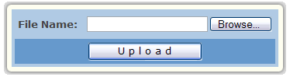
- Enter the absolute path (i.e. C:\MyDocuments\myfile.csv), or click the [Browse] button to browse to the file you wish to submit. Only one file can be uploaded at a time.
- Click the [Upload] button to submit the file.
- Do not close the browser window or move to another web page until the system updates the page with the “…The file has passed some preliminary testing...” message.
- If errors are listed under Error Info you will need to correct the errors and return to Step 1 to resubmit the file. If your file appears to be error free it will be moved to the file-processing queue. You can track its progress using Review Queue from the Error Management menu.
- You will be emailed information concerning the processing of your data. If errors are listed, proceed to the Review Errors section.
- Please note that large files may take several minutes to appear in the file-processing queue after submission.
- Upload problems such as “Request Timed Out” and “Page Cannot Be Displayed” errors may be encountered when submitting very large files. When this is the case, you may either Zip the file or divide it into two or more smaller files.
- Zipped and large files may take several minutes to process. Please wait for email confirmation of your submission, or contact the ODE Helpdesk at (503) 947-5715, before resubmitting the file or attempting to perform Error Management or Record Management.

Web Submission
Return to Table of Contents

Student Collections: SSID
Use the Web Submission option, under SSID, to request a Secure Student Identifier (SSID) for a student who has never had a SSID record created. Be sure and use Studdent Lookup and search for the student to ensure that a record does not already exist before creating a new one.
- Select “Web Submission” from the Data Submission menu.
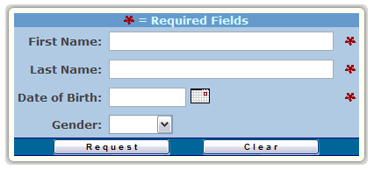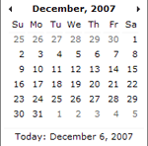
This page is used to request a Secure Student Identifier (SSID) for a student.
- Enter First Name, Last Name, Date of Birth, and Gender in the appropriate fields for the student who needs a Secure Student Identifier (SSID).
- The name fields in the search form are not case sensitive; you may use both upper and/or lower case letters.
- After all necessary data has been entered click the [Request] button.
- If there are possible matches to the data you have entered, a list will be displayed. Check each line carefully to determine if it is a match to the student for whom you wish to obtain an SSID. If one of the records matches your student, click the [Select Student] button to view the record. If none of the records match your student, click the [Add as New Student] button.
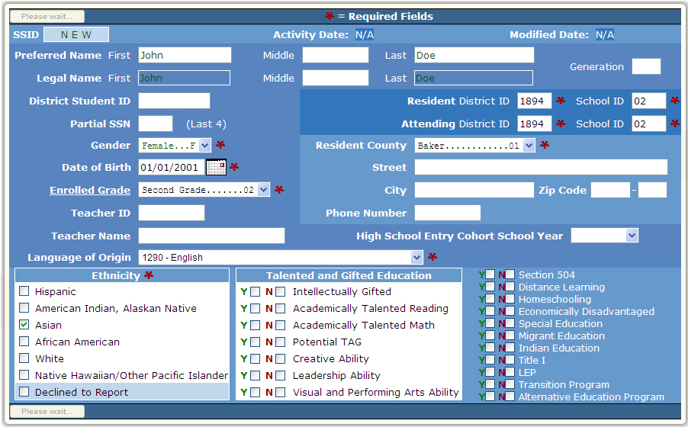

- Complete the form that is displayed with as much detail as possible. Be sure to complete all required fields marked with an asterisk (*).
Return to Table of Contents
- After all the information is entered click the [Save] button.
- The new record and SSID number will appear on the screen.
  - To create another SSID click the [Return to Web Submission Entry] button.
  - To edit this record click the [Edit Record] button.
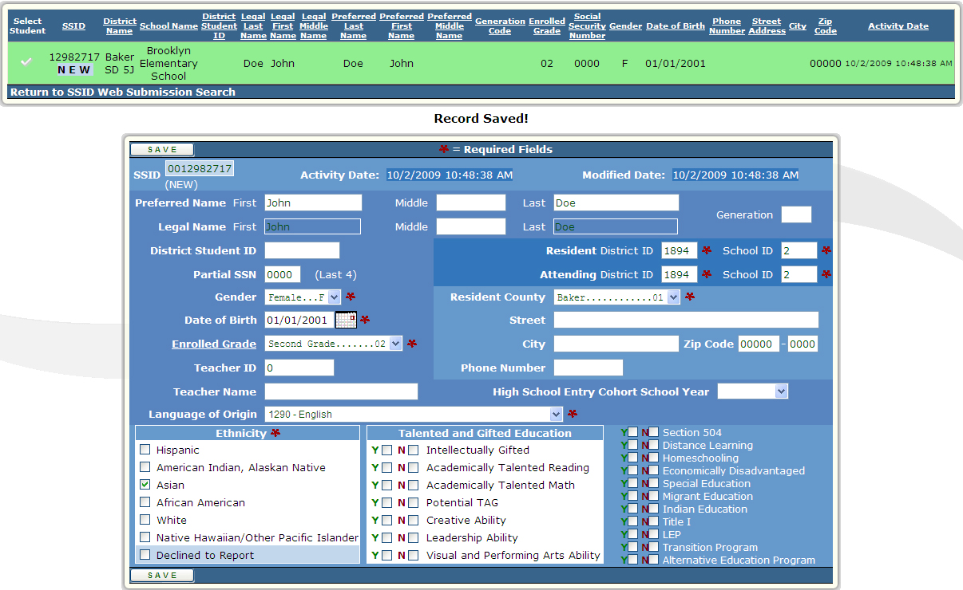
For assistance looking up an Institution ID, visit the Institution Lookup Application at: http://www.ode.state.or.us/instid. For a listing of Enrolled Grades, or Graduation Category Codes click the appropriate [List] button. Be sure to close the list window before continuing.

Error Management
Use the various options provided under the Error Management menu to review, download, and fix errors in submitted records; to view the status of files waiting to be validated/posted; review email sent regarding submitted records; review suggestions and resolve duplicate records; and to perform housekeeping. Not all Error Management options are available/applicable to every collection.
Return to Table of Contents

Review Queue
This is an informational page only. Use Review Queue to view the status of submitted files waiting to be validated/posted.
- Select “Review Queue” from the Error Management menu. The page will be displayed.
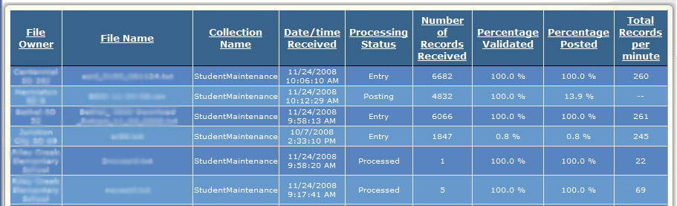

Review Email
Use the Review Email option to view email sent from ODE regarding submitted files.
- After selecting “Review Email” from the Error Management menu at the top of the page, you are presented with a list of email messages sent by the Oregon Department of Education (ODE) to the application users who have submitted files.
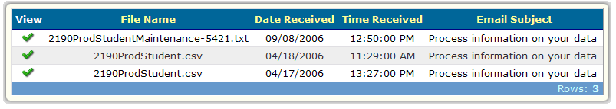
Records: 3
- Click the next to the message you want to read and it will be displayed at the bottom of the screen.
- To navigate multiple pages click the underlined numbered links at the lower left corner of the list.

Review Errors
Use the Review Errors option to view and resolve any errors that may exist in submitted files. Errors will be displayed to institutions that have an administrative relationship to the student. A user that is logged in as either a district or a school will see an error for the same student. Only records that are error free can be posted and included in the Collection. Any records still showing in Review Errors that have not been corrected online or through subsequent file uploads will not post to the collection in Record Maintenance.
Return to Table of Contents
- From the Error Management menu, click “Review Errors”. A list of errors organized by type with their counts and descriptions will be displayed on the screen.
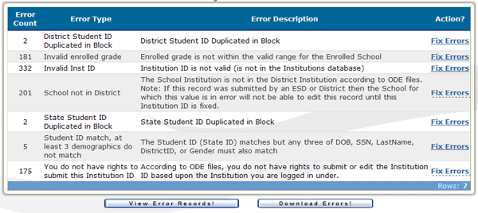
Records: 7
- To view a list of the individual error records within each of the error types, click the [View Error Records!] button at the top of the form.
- To download the errors as a .txt, .csv, or .xml file, click the [Download Errors!] button.
- Click the “Fix Errors” link corresponding to the type of error you wish to resolve.
- The Error Detail form will be displayed.
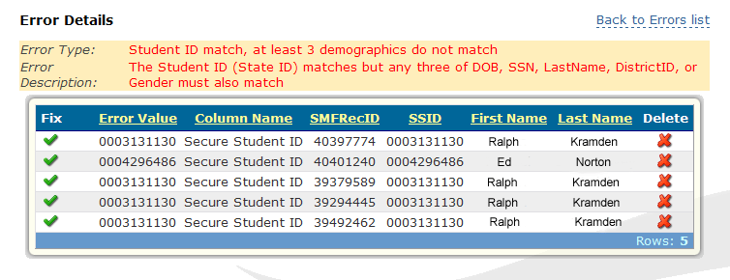
Records: 5
- Click the to fix the error. The “Error Information” form will be displayed below the list.
- Or click the to delete the error from the list.
Return to Table of Contents
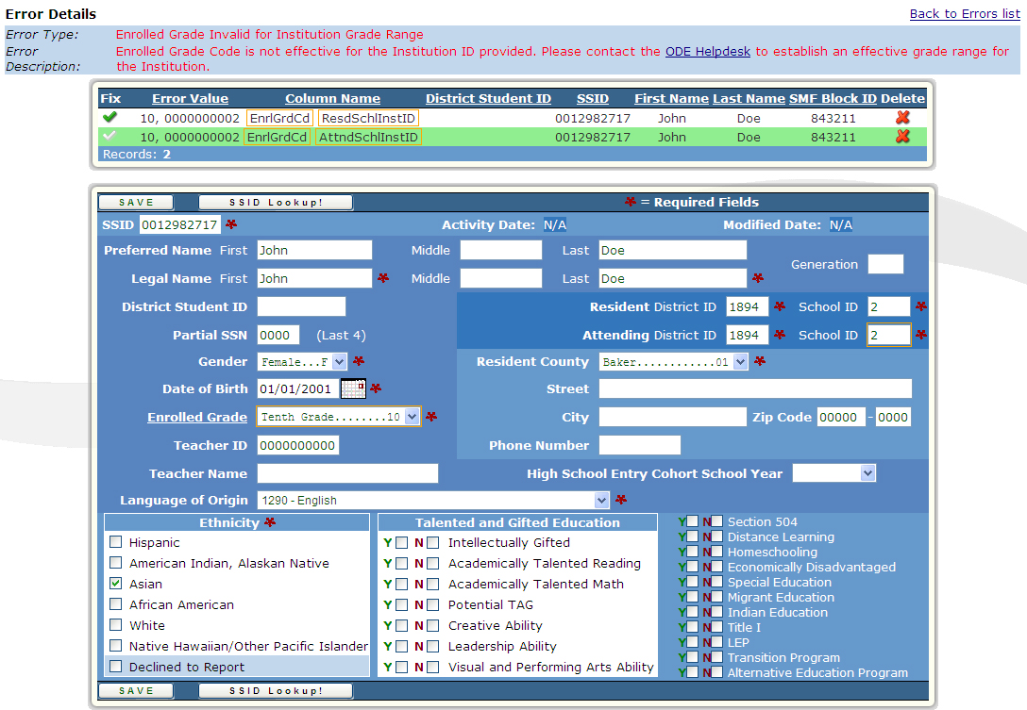
- Review the error information listed at the top of the form. Make the necessary data corrections to resolve the listed error.
- To leave without making any changes to the record, click the [Back to List!] button.
- For a listing of Enrolled Grades or Graduation Category Codes click the appropriate [List] button. Be sure to close the list window before continuing.
- Click the [Save!] button to save the changes. If all the errors have been corrected the “This Error Has Been Fixed!” and “Record Saved” messages will be displayed at the top of the form.
- Click the [Back to List] button to return to the list of errors.
- You can use Record Maintenance to verify your corrected records have posted.

Housekeeping
Use the Housekeeping option to display a list of submissions with errors, and mass-delete the non-posted records associated with a specific file submission.
Return to Table of Contents
- Choose “Housekeeping” from the Error Management menu.
- A list of submitted files will be displayed that still have associated non-posted records. If there are no files with existing error records you will receive the message: “There is no housekeeping to be done.”
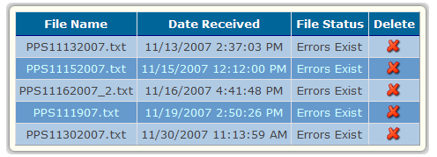
- Click the associated with the file to remove it from this list and to clear the errors associated with that file from the “Review Errors” list.
- Once a file has been deleted, it is no longer accessible for editing or correction. Any records in the file that were in error will need to be resubmitted and corrected before those records will be posted to the collection.

Download Errors
Use the Download Errors option to download errors from submitted files. The errors can be downloaded in one of two formats: a Comma Separated Values file (.csv) for a spreadsheet, or an Extensible Markup Language file (.xml) for advanced users. The files can then be corrected and resubmitted.
Return to Table of Contents
- Choose “Download Errors” from the Error Management menu. The “Download Errors – Choose File Type” form appears.
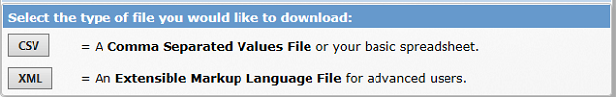
- Choose a file format for the download.
  - Choose from Comma Separated Values (.csv), and Extensible Markup Language (.xml) file types by clicking the corresponding button at the bottom of the form.
- After making your selection an email will be sent containing a link and instructions for retrieving your file.

Review Suggestions
Use the Review Suggestions option to view and resolve attempted SSID entries that do not fully match any existing student records, as per the Appendix E: SSID Matching Algorithm. Any submitted records (without SSIDs) that have potential matches to existing student records are displayed here. This option is available only under SSID.
- Select “Review Suggestions” from the Error Management menu. A list of Attempted Entries (Submitted Record) and their corresponding Possible Matches appears. Each page contains a maximum of 25 suggestions.
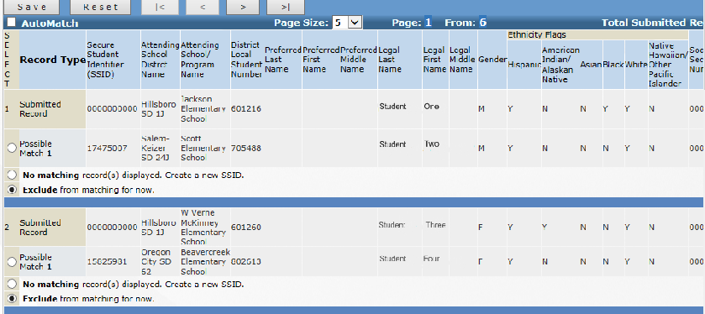
- Review each Submitted Record on the page. Compare the Submitted Record to the Possible Matches below it. Determine which, if any, of the Possible Matches is the student that matches your Submitted Record.
Return to Table of Contents
- Click the radio button next to the correct Possible Match. If none of the Possible Matches are correct, click the radio button next to No matching record(s) displayed. Create a new SSID.
- If you do not want to resolve the suggested match at this time, click the radio button next to Exclude from Matching for Now. By doing this, you will be able to resolve the selection at a later time.
- Click the [Save] button to save your selections for that page of Suggested Matches.
- Buttons have been provided above and below the list to navigate between multiple pages of suggestions.

Resolve Duplicates
Use the Resolve Duplicates option to resolve duplicate SSID records. Sometimes, for whatever reason, a student may be issued more than one SSID, or two students may have the same name, DOB, etc. When suspected duplicate records are detected they are listed on the Resolve Duplicates page. This option is available only under SSID.
- 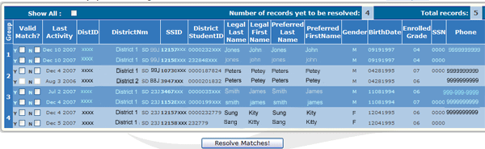Choose “Resolve Duplicates” from the Error Management menu. A list of possible duplicate records appears.
- Possible duplicate SSID records are presented in groups. Each record associated with your district or institution will be represented by an active checkbox. Records not associated with your district or institution will be represented by inactive checkboxes and may not be selected.
- Do not click the checkboxes for records you are not able to determine are or are not actually duplicate records.
- Click the "Y" checkbox for records you are able to determine are actually duplicate records.
- Click the "N" checkbox for records you are able to determine are not duplicate records.
- An automated process runs every weekend that complies of list of possible duplicates. These are sent to designated Primary Submitters for SSID so these duplicates can be resolved. (Note: the Primary Submitter role is designated by the District Security Administrator (DSA).)
- "Y" responses will result in merging records using the lowest SSID number and the most recently created data. At least two records in a group must be marked with a "Y" to result in a merged record.
Return to Table of Contents
- If one record in a group is marked with a "Y" and another record is marked with an "N", the records will not be merged, but may appear in future Resolve Duplicate lists
- A record pair with two "N" responses will result in the record not being merged and the record pair will not appear in future duplicate listings.
- Groups of records that are marked but not resolved will continue to appear in future duplicate listings for the districts that have not yet marked their records.
- To show all of the records, including the ones that have previously been resolved, click the Show All checkbox at the top of the form.
- The number of records presented per page can be controlled by using the Page Size dropdown list.
- Click the numbered links at the bottom of the form to navigate multiple pages.
- It is not necessary to click the [Resolve Matches] button at the end of each page. Clicking any of the numbered links below the list will result in the saving of all of the resolves made on each page.
- When you are through selecting matches, click the [Resolve Matches] button. The system will set the selections to Pending for the next scheduled merge process.

Record Management
Use the various options under the Record Management menu to view, download, and update data after the submission has been processed. Interaction is with the data directly and not the file.

Student Lookup & Record Maintenance
Use the Record Maintenance option to search for and to directly edit student records in the ODE database. The changes are processed and take effect immediately. The procedures for Record Maintenance vary slightly from collection to collection. The Student Lookup option returns a “read-only” version of the record and is available only under the SSID collection.

- Choose either “Student Lookup” or “Record Maintenance” from the Record Management menu. You will be presented with a page containing four search forms. You may choose to search by SSID, Institution, or Student Demographics.
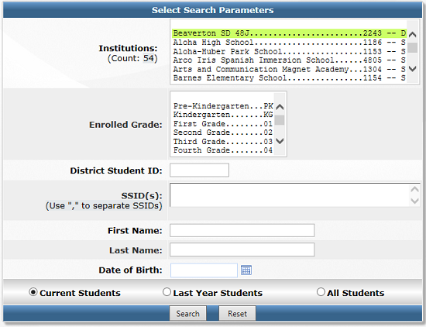
Enter enough information into your selected search form(s) to narrow the results while still finding the record(s) you need. The more you put in the search forms, the more you may eliminate the variations of spelling, etc. (searching for Johnston will also find Johnston-Smith, but searching for Johnston-Smith will not find Johnston records)
Return to Table of Contents
  - Searches performed on partially completed search forms will return larger result sets and may take longer to execute (or may even time out).
  - If you have an SSID number for an existing student, enter it in the appropriate search form.
    - When searching by SSID, if the SSID you have entered has been merged to another record you will see a message informing you that this record has been merged and is not available for editing. You will be given the current SSID, and instructions to maintain only the current record.
  - If you use the “Institution Specific Search Form”, the set of results will be limited to students enrolled in the institution for which you are logged in.
    - If you are logged in as an ESD you will have a special dropdown box from which you may select from the districts in your jurisdiction.
    - If you Un-select the “Hide Implicitly Administered Institutions” checkbox, the list of Institutions will expand to include all the institutions/programs that are administered by multiple Districts/etc.
  - If the “Student Demographic Search Form” is used, a last name or part of a last name is recommended to increase the efficiency of your search.
    - You may enter any portion of a name in the First Name or Last Name fields. For a range of names beginning with specific letters, enclose the range in brackets. For example, to return all names beginning with the letters a, b, or c, enter [a-c] in the appropriate name field.
  - The “Institution Specific” and “Student Demographic” search forms may be combined to further limit your search.
- Select the "Current Students" or the “Last Year Students” or the "All Students" radio button from the bottom of the form. Use "Current Students" to return all SSID records matching your criteria having an Activity Date after July 1 of the current school year. Use “Last Year Students” for a list of records having an Activity Date between July 1 and June 30 of the previous school year. Use "All Students" to return all SSID records matching your criteria regardless of Activity Date.
- Click the [Search] button to execute your search, or use the [Reset] button to clear all search forms for a new search.
- After clicking the [Search] button, a list of records matching your search criteria will be displayed.
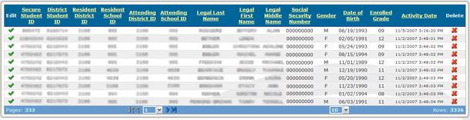Search results for Record Maintenance. Results for Student Lookup are similar.

Records: 3326
Pages: 333
Click on the associated with the record you wish to edit or view. Record Maintenance will display an editable version of the student record. Student Lookup will display a read-only version of the record. Steps 7, 8, and 9 apply only to Record Maintenance.
Return to Table of Contents
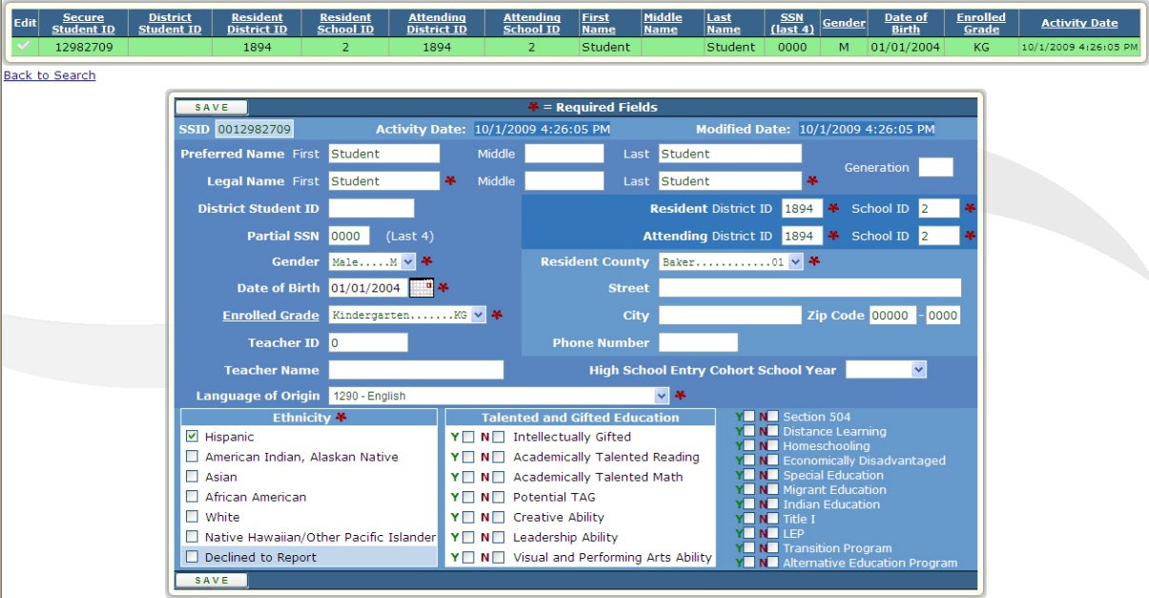
- Make any necessary changes to the record.
- Click the [Save] button to save your changes and to update the Activity Date and the Update Date of the record. To update only the Activity Date, save the record without making any changes. To discard any changes and return to the list use the [Back to List] button. To discard changes and return to the search page, click the [Back to Search] button. NOTE: For an SSID record to be “Current”, the Activity Date must be within the Current School Year.
- After making your changes and clicking the [Save] button, if you are presented with an “ERRORS FOUND!” message window, correct any errors and click the [Save] button again to record your changes. To discard any changes and return to the list use the [Back to List] button. To discard changes and return to the search page, click the [Back to Search] button.
- If the record has been merged to another, the [View Merge History] button will provide details of the merge.
Return to Table of Contents
- For assistance looking up an Institution ID, visit the Institution Lookup Application at: http://www.ode.state.or.us/instid/. For a listing of Enrolled Grades, Entry Codes, Withdrawal Codes, or Reason for Leaving Codes click the appropriate [List] button. Be sure to close the list window before continuing.

Production Download
Use the Production Download option to download data from ODE for upload into your Student Information System (SIS).

Student Collections: SSID
- Select “Production Download” from the Record Management menu. A form for selecting the type of data filter you would like to use will be displayed.
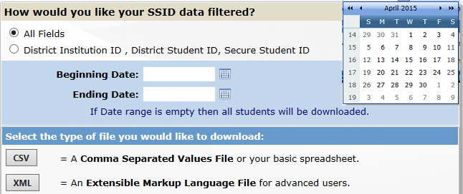
- Click on the type of filter you would like to use to filter your data. You may choose from the following filter types:
Return to Table of Contents
- All Fields All data fields for each student associated with your institution.
- District Institution ID, District Student ID, Secure Student ID Three select data fields for each student associated with your institution.
- If you are filtering by Date Range, enter a Beginning Date and an Ending Date using the dd/mm/yyyy format. SSID records with an Activity Date later than the Beginning Date and earlier than the Ending Date will be returned.
- Choose from Comma Separated Values (.csv), and Extensible Markup Language (.xml) file types by clicking the corresponding button at the bottom of the form.
- After making your selection, you will receive an email containing a link and instructions for retrieving your file.
  - Click the link and enter your email address when prompted. The File Transfer Send File page will appear.
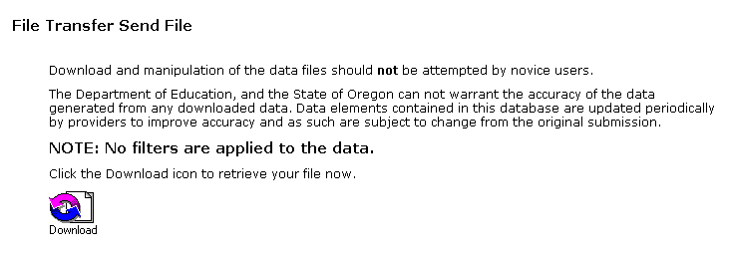
- Click the “Download” icon.
  - When the “File Download” dialog box comes up asking “Would you like to open the file or save it to your computer?” you may choose either option.
  - If you choose to save the file, save it to a meaningful location on your computer. Your Desktop or My Documents folder may be good choices.

Review History / Review Merge History
Return to Table of Contents
The “Review History” option allows you to view current student records and a history of any changes made to the records. The “Review Merge History” option provides details in the case where two SSID records have been merged into a single record.
- Choose “Review History” or “Review Merge History” from the Record Management menu from the SSID System collection under Student Collections.
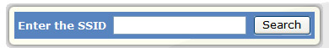
- Enter the SSID of the student record for which you wish to view the history and click the [Submit] button to view the history.
  - If you are using “Review History” and the SSID you have entered has been merged to another record you will see a message informing you that this record has been merged and is not available for editing. You will be given the current SSID, and instructed to maintain only the current record.
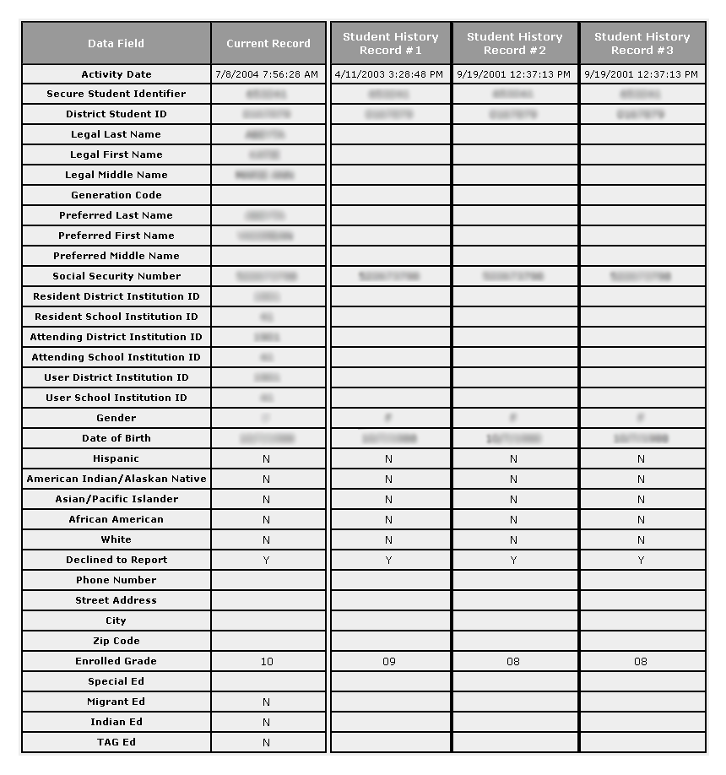

Appendix A: Preparing CSV Data Files
The instructions and information presented in this appendix can be used to produce a file, conforming to the Consolidated Collections file format, of up-to-date SSID information for your institution. This file should be maintained and submitted periodically to ODE for the open SSID collection. This file may also be submitted for any of the collections incorporated in the Consolidated Collections application by entering the required data in the fields specific to the collection for which you are submitting the file. Submitted data in fields not required by a particular collection will not be used to update SSID records or other collections.
Return to Table of Contents

Overview
- Use Production Download to download a file containing your institution’s student information for the previous year.
- Open the file with Microsoft Excel.
- Update the data.
- Save and submit the file.

Production Download
To download a file, in the correct format, containing your institution’s student information for the previous year:
- Select “Production Download” from the Record Management menu under the SSID collection. A form for selecting the type of data filter you would like to use will be displayed.
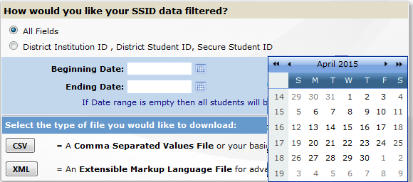
  - Choose the “All Fields” filter.
  - In Beginning Date, enter the first date of the collection year for last year, i.e. 07/01/2013.
  - Leave the ending date blank to get all the records belonging to you since the Beginning Date.
Return to Table of Contents
    - This search will return all SSID records for all students enrolled in your institution for the previous year.
- Click the [CSV] button to download the file in a Comma Separated Values (.csv) format.
- You will receive an email containing a link and instructions for retrieving your file.
  - Click the link and enter your email address when prompted. The File Transfer Send File page will appear.
- Click the “Download” icon when it appears on the screen.
  - When the “File Download” dialog box comes up asking “Would you like to open the file or save it to your computer?” you must Save the file if you may want to make any changes to the data.
  - If you choose to save the file, save it to a meaningful location on your computer. Your Desktop or My Documents folder may be good choices.
- Proceed to the next section “Update the Data”.

Update the Data
- Remove the records for any students who are no longer enrolled in your institution.
Return to Table of Contents
- Update the information for all returning students.
  - Do not delete the top column-header row.
  - Do not use commas in any of the fields.
  - Do not use “special” characters. Use only standard English characters.
- Add the information for any new students to the bottom of the list. Be sure to follow the data format of the downloaded records exactly.
- When preparing a Comma Separated Values (CSV) file, it is crucial that you not enter commas in any of the fields. Entering a comma in any field signifies the end of that field and the beginning of the next. Unexpected commas will result in columns being shifted causing a critical error upon file upload.

Save and Submit the File
- After you have entered all the required data into the spreadsheet, choose File -> Save As, and click [Save] to save the file as a “CSV (Comma delimited) (*.csv)” file.
- Click [OK] in the message box that asks if you want to save only the active sheet.
- Click [Yes] in the message box that asks if you want to keep the workbook in the CSV format.
- The file can then be submitted to ODE following the instruction for File Upload.

Appendix C: Common Tasks

Task:  Return to Table of Contents | Tool:
Enter new students into the system | - Depending on the number of new students, either prepare and submit an CSV file, leaving the SSID field blank; or use the “Web Submission” option from the Data Submission menu under SSID.
Transfer students into your school or district | - To transfer students individually use the “Record Maintenance” option from the Record Management menu under SSID. Edit the Resident and Attending District and School Institution ID fields to reflect the current Institution IDs. Any other fields, such as District Student ID, Address, etc, that need to be updated should also be updated at this time.  - To transfer multiple students you may submit a CSV file containing the updated information to ODE.
Create a file to upload | - You can do a Production Download and edit, add, or remove the appropriate records according to the collection for which you are submitting. You then save the file and submit it to ODE. More information can be found in Appendix A: Preparing CSV Data Files.
Find the SSID for an existing student | - Select the “Student Lookup” or “Record Maintenance” option from the Record Management menu under SSID. See Record Management section.
Correct / edit posted records | - Select the “Record Maintenance” option from the Record Management menu under the appropriate collection.  - To edit multiple student records you can submit a CSV file containing the new information to ODE.  - See Appendix D: Record Maintenance: Editing Student Demographic Information.
Fix error records submitted that are not posted | - Select the Review Errors or Download Errors options from the Error Management menu under SSID. If the Download Errors option is used, after receiving the download file and before uploading the corrected file, delete the file in “Housekeeping” from the Error Management menu under SSID. This will delete the error records tied to the housekeeping file. Then, resubmit the corrected file.
To Correct the Error: "You do not have rights to submit this Institution ID." | Occurs when the Attending Institution ID fields of the record list an institution that is not, or has no administrative relationship to the submitting institution.  To fix this error:  1) Select the “Review Errors” option from the Error Management menu under the collection that contains the error record.  2) At the Error Categories page, click on the “Fix Errors” link to fix the error type.  3) At the Error Details page, click on the to open the error record to fix and compare the Attending Institution ID in the error record (XXXX) to the Institution ID of your login.  4) The Attending School Institution ID in the error record must be equal to or administered by the Institution ID of your login. If you believe this is already the case then proceed to step (6), otherwise proceed to step (5).  5) Change the Attending District and Attending School Institution IDs to the correct institution IDs and verify the Resident District and Resident School IDs based on the definitions available in the Consolidated Student File Format Definition: <https://district.ode.state.or.us/forms/smf/sfda/cnsldtdfilefrmt.xls>  Keep in mind that these are both required fields and the Attending School must have an administrative relationship to the Attending District in the Institution Boundaries Database. Use the Institution ID Lookup Tool to lookup institution information: <http://www.ode.state.or.us/instid/>.  6) Click the [Save] button.  A) If there are no remaining errors for the record then “Record Saved!” messages will appear at the top of the page.  B) If the error record fails to save the “Errors – See below” message will appear at the top of the page.  7) If the correct student data has been submitted in the Attending District Institution ID and Attending School Institution ID fields and you are still unable to save the record then one of the following is possible:  A) The institution for which you are logged in is not the institution required to submit the student record.  B) A necessary administrative relationship is missing (or some similar inconsistency exists) in our Institutions Database. A current list of administrative relationships and related data may be found in the Daily Institution Database Extract file, located here: <http://www.ode.state.or.us/ftp/incoming/inst_db_extract_XL8.zip>.  Please contact the ODE Helpdesk at <ode.helpdesk@state.or.us> or 503.947.5715 if you need help or believe an institution data inconsistency exists.

Appendix D: Record Maintenance: Editing Student Demographic Information
In order for a submission to be matched to an existing student record, the SSID and three of five demographic fields must match those of an existing record on file with ODE.

Fields Used for Matching at Level 1: | Required for Record?
Secure Student Identifier (SSID) | Required
Legal Last Name | Required
Date of Birth | Required
Gender | Required
Social Security Number (SSN) (only last 4 digits) | Optional
District Student ID | Optional

If only the required matching fields are present in the record, using “Record Maintenance” to edit any of them will result in an error. If it is necessary to change or correct the data in any of the Legal Last Name, Gender, or Date of Birth fields, a Social Security Number or District Student ID must be present in the existing record. If the record does not have a value in either of these optional fields it will be necessary to temporarily assign a value to one of them in order to edit the record and still satisfy the matching criteria. The District Student ID field is preferred.
Quick Steps:
Open the SSID record in Record Maintenance, Edit
Add a District Student ID. ( any number is fine )
Save the record
Change the Last Name, or Gender, or Birth date (only one!)
Save the record
Remove the District Student ID
Save the record.

- The record in the figure below contains data in only the required fields. The fields used for matching are circled. Changing the information in any of the required fields will not leave enough information to create a match and will result in an error unless the optional field is filled and saved first.
Return to Table of Contents
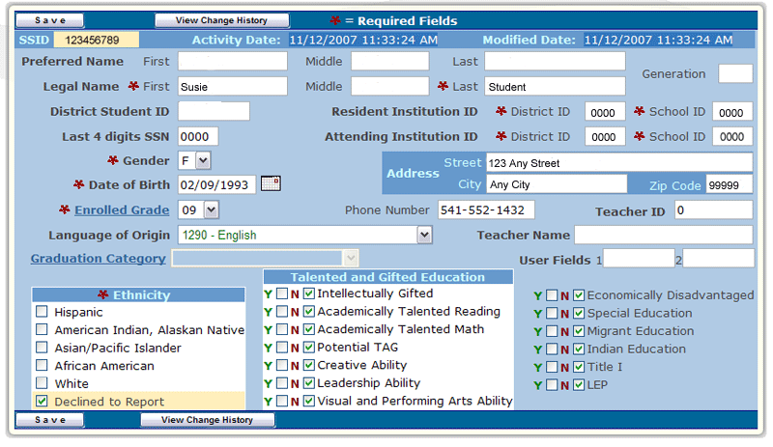
Required
Optional
- To edit any of the required student demographic fields (Legal Last Name, Date of Birth, and Gender) when only the minimum amount of information is present in the existing record:
  - Enter a number in the District Student ID field.
    - If your district does not use a District Student ID it may be necessary to make one up.
  - Click [Save] to save the record.
- The record now has information in four of the five demographic fields. Changing the information in one of them will still leave enough information to create a match.
  - Make any corrections necessary to one field at a time, clicking the [Save] button after each change to save the record.
- When you are finished correcting the record, be sure to remove the number that you put in the District Student ID field, if it is a made-up number, and click [Save] to complete the process.

Appendix E: SSID Matching Algorithm
- Each record in the uploaded file (or Online Submission) is processed individually according to the following criteria:
Return to Table of Contents
Hard Match
- Match Level 1: SSID and any three of Legal Last Name, District Student Identifier, SSN, DOB, and Gender must match.
- Match Level 2: Resident District Institution ID and District Student Identifier, plus any two of Legal Last Name, SSN, DOB, and Gender must match.
- Match Level 3: SSN, DOB, Gender, and either Legal Last Name or Preferred Last Name must match.
Suggested Matches
- Match Level 7: Resident District Institution ID, Gender, and one each from all three of the following pairs: (DOB or SSN); (Legal Last Name or Preferred Last Name); and (Legal First Name or Preferred First Name).
- Match Level 8: Gender and one each from all three of the following pairs: (DOB or SSN); (Legal Last Name or Preferred Last Name); and (Legal First Name or Preferred First Name).

- The submitted record is first processed using Match Level 1, followed by Match Level 2, and Match Level 3. If the record satisfies one of these matching requirements it is considered a Hard Match. If the submitted record is found to be a Hard Match the corresponding current SSID record will be moved into history and the submitted SSID record will be posted as the new current SSID record.
- If the submitted record does not create a Hard Match then the submitted record will be processed using Match Level 7 and Match Level 8. If the record satisfies one of these matching requirements it is considered a Suggested Match and will be posted to the Review Suggestions area. Once the match is validated in Review Suggestions area, the corresponding current SSID record will be moved into history and the submitted SSID record will be posted as the new current SSID record.
- If the submitted record does not satisfy any of the matching criteria then a new SSID record will be created from the submitted SSID record. The next available SSID number will be assigned to the new record.

Appendix F: Search Specifications
Return to Table of Contents

Search Type | Collection |  | Search Results Pool
Web Submission | SSID |  | All records in the SSID system.
 | Student Collections (except SSID) |  | If any of the SSID, First Name, Last Name or Date of Birth fields are used as search criteria the results will be from all records in the SSID system. Otherwise, the results will be from records having a Resident or Attending School Institution ID that equals or is administered by the institution ID under which the user is logged in.
Record Maintenance | SSID |  | If any of the SSID, First Name, Last Name or Date of Birth fields are used as search criteria the results will be from all records in the SSID system. Otherwise, the results will be from records having a Resident or Attending School Institution ID that equals or is administered by the institution ID under which the user is logged in.
 | Student Collections (except SSID) |  | Only records having a Resident or Attending School Institution ID that equals or is administered by the institution ID under which the user is logged in.
Production Download | SSID |  | Only records having a Resident or Attending School Institution ID that equals or is administered by the institution ID under which the user is logged in.
 | Student Collections (except SSID) |  | Only records having a Resident or Attending School Institution ID that equals or is administered by the institution ID under which the user is logged in.
Student Lookup | SSID |  | If any of the SSID, First Name, Last Name or Date of Birth fields are used as search criteria the results will be from all records in the SSID system. Otherwise, the results will be from records having a Resident or Attending School Institution ID that equals or is administered by the institution ID under which the user is logged in.
Optional Parameters (Applicable to: Web Submission, Student Lookup, & SSID–Record Maintenance)
Current Students |  | Returns results from records having an Activity Date after July 1 of the current school year.
Last Year Students |  | Except High School Completers |  | Returns results from records having an Activity Date between July 1 and June 30 of the previous school year.
 |  | High School Completers |  | Returns results from records having an Activity Date between Sep. 1 of the previous school year and August 31 of the following year.
All Students |  | Returns results from all records that are not end-dated or merged.
All searches are limited to a maximum of 5000 results except Production Download.

Appendix G: Resources / Tools
Return to Table of Contents
- Central Login Website <https://district.ode.state.or.us/search/page/?=125>
- SSID and other Consolidated Collection File Format Layouts
<https://district.ode.state.or.us/search/page/?id=185>
- Institution Lookup Application <http://www.ode.state.or.us/instid>
- Additional documentation for all applications may be found at <https://district.ode.state.or.us/apps/info/AppDocs.aspx>
- SSID System (Consolidated File Format) Details <https://district.ode.state.or.us/apps/info/DataCllctnDetail.aspx?id=128&Collection_ID=189>
- Find District Security Administrator <https://district.ode.state.or.us/apps/login/searchSA.aspx>

Revision History
Return to Table of Contents

Date | Page | Section | Description
07/14/2005 | 83 | Revision History | Added a Revision History to aid users in identifying new or clarified information.
07/14/2005 | 7 | Purpose | Revision: “This consolidation incorporates the following previously separate collections:” was changed to “This application provides access to the following collections:” Reason for revision: To clarify that the data collections associated with Consolidated Collections have not been combined into a single data collection.
07/14/2005 | N/A | N/A | The Student Collections and Institution Collections were separated to provide more concise information to users.
07/14/2005 | 53 | Student Collections: Suspensions/Expulsions/Truancy | Instructions updated.
07/14/2005 | 39 | Student Collections: High School Completers / Early Leavers | Instructions updated for both collections.
07/14/2005 | 31 | Reports | A section was added to describe the new Reports feature of the application.
07/14/2005 | 21 | Housekeeping | Added clarification to the last bulleted item that error records will need to be corrected and resubmitted after the file is deleted from Housekeeping.
08/12/2005 | 48 | Student Collections: Professional-Technical Education (Perkins) | Sections were added for the Course Submission and Student Info Submission options.
08/16/2005 | 8 | RSS Feed | Added section describing the: RSS Feed.
09/25/2005 | 22 | Review Suggestions | Updated instructions for new buttons.
09/30/2005 | 62; 63 | Fall Membership; Spring Membership | Separate instructions for each collection.
02/07/2006 | 76 | Common Tasks | Added instructions for “You do not have rights to submit this Institution ID” error.
09/25/2006 | 40; 44 | Fall Membership; Spring Membership | Moved table of data elements from Fall to Spring. Updated link to consolidated file format.
09/28/2007 |  |  | Document is in process of being updated; added watermark “BEING UPDATED!”
12/26/2007 | All | All | Sorted Collections in alphabetical order, added missing collections, removed obsolete collections, such as SET, each section updated, created hyperlinks to navigate within user guide & return to table of contents.
11/25/2008 | All | All | Added missing information from collections, Updated screenshots. Added new information regarding file uploads, file format, and tested links.
4/13/2015 | All | All | Updated, Removed non-SSID pages
5/4/2015 | All | ALL | Updated language and screenshots to match UI.
Return to Table of Contents

Troubleshooting
If you have problems with any of the processes outlined in this document, please contact the ODE Helpdesk via email at ode.helpdesk@state.or.us or phone at 503-947-5715.

