Consolidated District Performance Report

(CDPR)

Title ID: Academic Outcomes
Title ID: Programs and Facilities

User Guide

August 2025

ODE Helpdesk
503-947-5715
ode.helpdesk@ode.oregon.gov

Table of Contents
Table of Contents ii
How to Use This Document 1
Data Submission 2
Data for ESEA CDPR Title ID: Academic Outcomes 3
Data for ESEA CDPR Title ID: Programs and Facilities 7
Resources & Tools 9
Revision History 10
Troubleshooting 10

How to Use This Document
The information in this user guide, as outlined in the Table of Contents, is divided into sections corresponding to the functions within the Consolidated District Performance Report (CDPR) application. There are three major menu options in each data collection: Data Submission, Error Management, and Record Management.
- Read and understand the instructions for Data Submission, Error Management, and Record Management before attempting to use the application.
- The Help section is a menu option available in the application.
- The appendices provide specific information such as, preparing a CSV data file and collection-specific instructions for Student Collections. These appendices are not intended to replace the general instructions, but to supplement them; both should be read to gain maximum benefit. The collection-specific instructions are organized by student collection, function, and reference links.
Refer to the “Table of Contents” to find instructions for a particular collection or function. Each entry is a hyperlink to the section in the document. At the top-left corner of each page is a hyperlink to return to the “Table of Contents”.

Purpose
The purpose of the Consolidated District Performance Report Application is to provide a collection mechanism for district users to submit and update information required by the US Department of Education. This application provides access, for authorized users, to the following collections:
- ESEA CDPR Title ID: Programs and Facilities (Programs and Facilities information for students participating in programs funded by Title ID, Neglected and Delinquent funds)
- ESEA CDPR Title ID: Academic Outcomes (Academic Outcomes for students participating in programs funded by Title ID, Neglected and Delinquent funds)

NOTE: Please check the Schedule of Dues Dates for items such as, the open and close dates for a collection, contact person (data owner) and their phone and additional documents for the specific collection by clicking on its link to access its “Details” page. The documents are located under the Documents section.
- Access to the Consolidated Collections Application is restricted to authorized users only and controlled by your District Security Administrator.
- Use the District Security Administrator Lookup Tool to locate your District Security Administrator for help.
- Information about logging in to Central Login applications/collections is in the Central Login Application User Guide.

Navigation
The navigational system consists of various options, organized by function and collection, presented in a dropdown menu bar at the top of each page.
Student Collections: Provides access to collections of student data outside the scope of this documentation.
Institution Collections: Provides access to the four collections described here along with a number of other collections of institutional data.
Staff Collections: Provides access to collections of employee and staff data outside the scope of this documentation.
Reports: Provides Collection Summary Reports and other information for each collection.
Help: Opens the Collection Details Page for each collection. This is the location for documents, news, file definitions, reports etc.

Not all collections are applicable or available to all institutions, and are subject to opening/closing dates. Not all functions are applicable or available under every collection. Please familiarize yourself with the navigation system and with which collections, functions, and options are available to you.
Once you have selected an option from the main menu shown above you will notice the new menu navigation option below. Using tabs will allow you to navigate through menus options easier and faster.

Data Submission
The Data Submission functions for these collections allow you to submit data through the web interface only. Because ODE expects a single record submitted from each participating district, and because these data are not coming from the typical student database maintained by districts, staff must do direct entry into a web collection instrument.
Each collection uses an entry format similar to that shown below from the ESEA CDPR Title ID: Academic Outcomes collection. In each collection, you can find further information on each entry by pointing at the text describing the entry. This will present a small box providing a more thorough description.
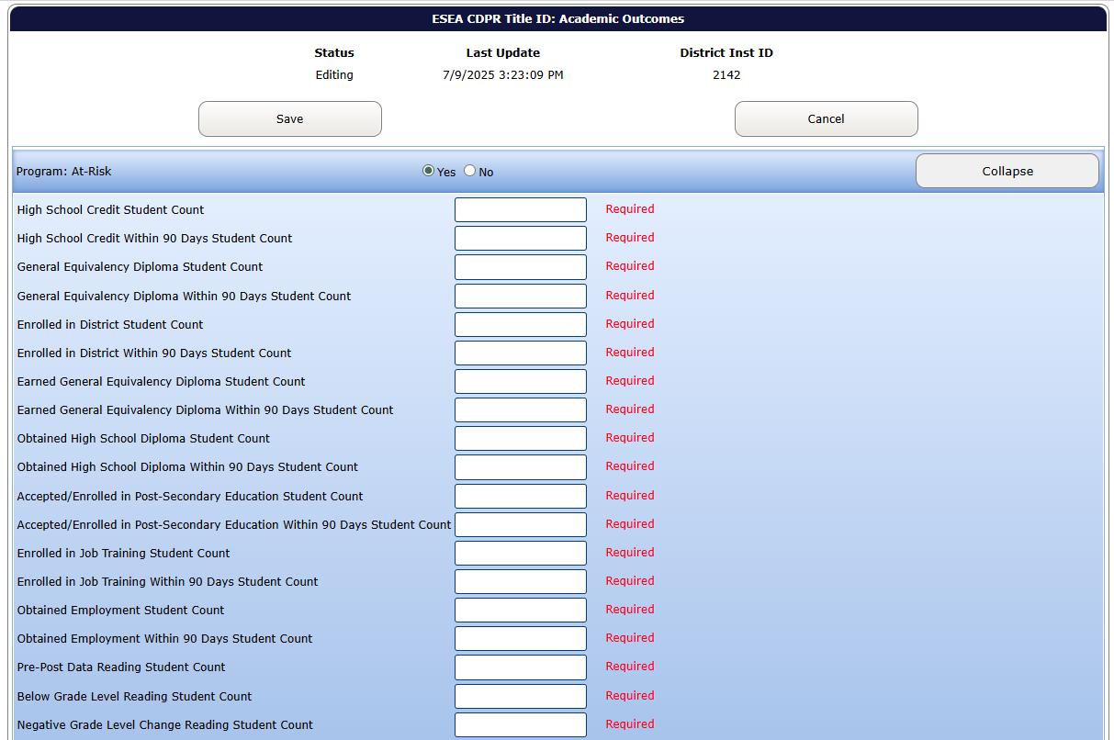

Data for ESEA CDPR Title ID: Academic Outcomes
This is the first screen that will appear once this data collection is selected. To open the data collection, click “+ Insert Record”.
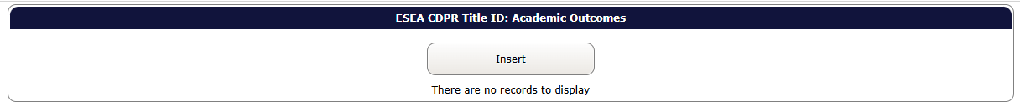

Once the first step is completed, this screen will appear. Please select YES or NO for each type of facility. If YES is selected, that section will expand. Data must be entered for each data element. If NO is selected, the web application will automatically populate that type of program with ZEROs. More than one type of program may be selected if the district is reporting data for multiple types of facilities.
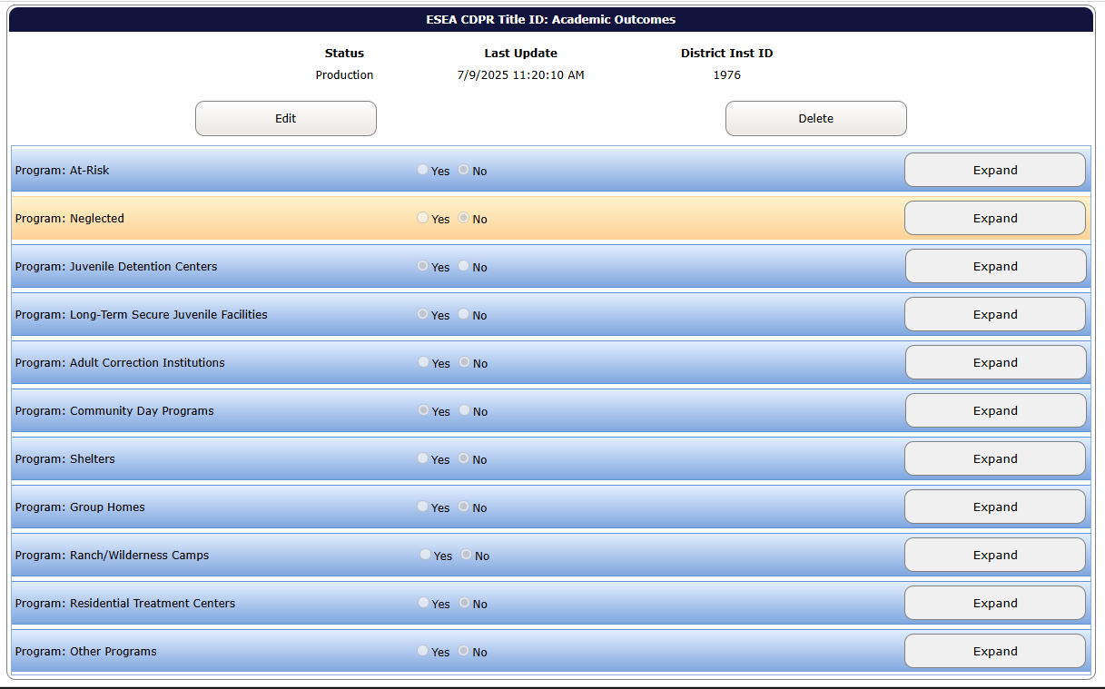

Data may now be entered for each element. No data element within the type of facility chosen can be left blank.
For each program selected, please enter data for the following data elements in the web application.

The table below shows the content for ESEA CDPR Title ID: Academic Outcomes. Note that each data item is required. A number or comment (as appropriate) must be entered into each cell even if the response is “0.”
Item # | Item Description | Long Description | Question to Define Data Needed | Entry Type
1 | High School Credit Student Count | Count of students enrolled in programs who attained High School course credits, while in program | How many students earned High School course credits while in the program? | Numeric
2 | High School Credit Within 90 Days Student Count | Count of students enrolled in programs who attained High School course credits, after program exit, up to 90 days | How many students earned High School course credits within 90 days after exit from the program? | Numeric
3 | General Equivalency Diploma Student Count | Count of students enrolled in programs who enrolled in a General Equivalency Diploma Progam, while in program | How many students enrolled in a General Equivalency Diploma program while in the program | Numeric
4 | General Equivalency Diploma Within 90 Days Student Count | Count of students enrolled in programs who enrolled in a General Equivalency Diploma program after program exit, up to 90 days | How many students enrolled in a General Equivalency Diploma program within 90 days after exit from the program? | Numeric
5 | Enrolled in District Student Count | Count of students enrolled in programs who enrolled in local district, while in program | How many students enrolled in the local district while in the program? | Numeric
6 | Enrolled in District Within 90 Days Student Count | Count of students enrolled in programs who enrolled in local district, after program exit, up to 90 days | How many students enrolled in their local district within 90 days after exit from the program? | Numeric
7 | Earned General Equivalency Diploma Student Count | Count of students enrolled in programs who earned General Equivalency Diploma, while in program | How many students earned a General Equivalency Diploma while in the program? | Numeric
8 | Earned General Equivalency Within 90 Days Student Count | Count of students enrolled in programs who earned a General Equivalency Diploma, after program exit, up to 90 days | How many students earned a General Equivalency Diploma within 90 days after exit from the program? | Numeric
9 | Obtained High School Diploma Student Count | Count of students enrolled in programs who obtained High School diploma, while in program | How many students obtained a High School diploma while in the program? | Numeric
10 | Obtained High School Diploma Within 90 Days Student Count | Count of students enrolled in programs who obtained High School diploma, after program exit, up to 90 days | How many students obtained a High School diploma within 90 days after exit from the program? | Numeric
11 | Accepted/Enrolled in Post-Secondary Education Student Count | Count of students enrolled in programs who were accepted/enrolled into post-secondary education, while in program | How many students were accepted/enrolled into post-secondary education while in the program? | Numeric
12 | Accepted/Enrolled in Post-Secondary Education Within 90 Days Student Count | Count of students enrolled in prgrams accepted/enrolled into post-secondary education, after program exit, up to 90 days | How many students were accepted/enrolled into post-secondary education within 90 days after exit from the program? | Numeric
13 | Enrolled in Job Training Student Count | Count of students enrolled in programs who enrolled in job training courses programs, while in program | How many students were enrolled in job training courses while in the program? | Numeric
14 | Enrolled in Job Training Within 90 Days Student Count | Count of students enrolled in programs who enrolled in job training, after program exit, up to 90 days | How many students were enrolled in job training courses within 90 days after exit from the program? | Numeric
15 | Obtained Employment Student Count | Count of students enrolled in programs who obtained employment, while in program | How many student obtained employment while in the program? | Numeric
16 | Obtained Employment Within 90 Days Student Count | Count of students enrolled in programs who obtained employment, after program exit, up to 90 days | How many students obtained employment within 90 days after exit from the program? | Numeric
17 | Pre-Post Data Reading Student Count | Count of long-term students in programs (enrolled for at least 90 consecutive days within the reporting year) that have completed an initial and follow-up assessment and received a score data in Reading. | How many long-term students in Title I-D program (enrolled for at least 90 consecutive days within the reporting year) have completed an initial and follow-up assessment and received a score data in Reading? | Numeric
18 | Below Grade Level Reading Student Count | Count of long-term students in programs (enrolled for at least 90 consecutive days within reporting year) that tested below their grade level in Reading | How many long-term students in Title ID program (enrolled for at least 90 consecutive days within the reporting year) that tested below their grade level in Reading upon entry? | Numeric
19 | Negative Grade Level Change Reading Student Count | Count of long-term students in programs (enrolled for at least 90 consecutive days within the reporting year) that demonstrated a negative grade level change from an initial and follow-up assessment and received a score in Reading. | How many long-term students in Title I-D program (enrolled for at least 90 consecutive days within the reporting year) that demonstrated a negative grade level change from an initial and follow-up assessment and received a score in Reading? | Numeric
20 | No Grade Level Change Reading Student Count | Count of long-term students in programs (enrolled for at least 90 consecutive days within the reporting year) that demonstrated no change in grade level from an initial and follow-up assessment and received a score in Reading. | How many long-term students in Title I-D program (enrolled for at least 90 consecutive days within the reporting year) that demonstrated no change in grade level from an initial and follow-up assessment and received a score in Reading? | Numeric
21 | Positive Up To Half Grade Level Change Reading Student Count | Count of long-term students in programs (enrolled for at least 90 consecutive days within the reporting year) that demonstrated a positive change in grade level from an initial and follow-up assessment and received a score in Reading, up to one-half of a grade level. | How many long-term students in Title I-D program (enrolled for at least 90 consecutive days within the reporting year) demonstrated a positive change in grade level from an initial and follow-up assessment and received a score in Reading, up to one-half of a grade level? | Numeric
22 | Positive Up To Full Grade Level Change Reading Student Count | Count of long-term students in programs (enrolled for at least 90 consecutive days within the reporting year) that demonstrated a positive change in grade level from an initial and follow-up assessment and received a score in Reading, from one-half a grade level to a full grade level. | How many long-term students in Title I-D program (enrolled for at least 90 consecutive days within the reporting year) demonstrated a positive change in grade level from an initial and follow-up assessment and received a score in Reading, from one-half a grade level to a full grade level? | Numeric
23 | Positive More Than Full Grade Level Change Reading Student Count | Count of long-term students in programs (enrolled for at least 90 consecutive days within the reporting year) that demonstrated a positive change in grade level from an initial and follow-up assessment and received a score in Reading, of more than one full grade level. | How many long-term students in Title I-D program (enrolled for at least 90 consecutive days within the reporting year) demonstrated a positive change in grade level from an initial and follow-up assessment and received a score in Reading, of more than one full grade level? | Numeric
24 | Pre-Post Data Math Student Count | Count of long-term students in programs (enrolled for at least 90 consecutive days within the reporting year) that have completed an initial and follow-up assessment and received a score data in Mathematics. | How many long-term students in Title I-D program (enrolled for at least 90 consecutive days within the reporting year) that have completed an initial and follow-up assessment and received a score data in Mathematics? | Numeric
25 | Below Grade Level Math Student Count | Count of long-term students in programs (enrolled for at least 90 consecutive days within reporting year) that tested below their grade level in Mathematics | How many long-term students in Title ID program (enrolled for at least 90 consecutive days within the reporting year) that tested below their grade level in Mathematics upon entry? | Numeric
26 | Negative Grade Level Change Math Student Count | Count of long-term students in programs (enrolled for at least 90 consecutive days within the reporting year) that demonstrated a negative grade level change from an initial and follow-up assessment and received a score in Mathematics. | How many long-term students in Title I-D program (enrolled for at least 90 consecutive days within the reporting year) that demonstrated a negative grade level change from an initial and follow-up assessment and received a score in Mathematics? | Numeric
27 | No Grade Level Change Math Student Count | Count of long-term students in programs (enrolled for at least 90 consecutive days within the reporting year) that demonstrated no change in grade level from an initial and follow-up assessment and received a score in Mathematics. | How many long-term students in Title I-D program (enrolled for at least 90 consecutive days within the reporting year) that demonstrated no change in grade level from an initial and follow-up assessment and received a score in Mathematics? | Numeric
28 | Positive Up To Half Grade Level Change Math Student Count | Count of long-term students in programs (enrolled for at least 90 consecutive days within the reporting year) that demonstrated a positive change in grade level from an initial and follow-up assessment and received a score in Mathematics, up to one-half of a grade level. | How many long-term students in Title I-D program (enrolled for at least 90 consecutive days within the reporting year) demonstrated a positive change in grade level from an initial and follow-up assessment and received a score in Mathematics, up to one-half of a grade level? | Numeric
29 | Positive Up To Full Grade Level Change Math Student Count | Count of long-term students in programs (enrolled for at least 90 consecutive days within the reporting year) that demonstrated a positive change in grade level from an initial and follow-up assessment and received a score in Mathematics, from one-half a grade level to a full grade level. | How many long-term students in Title I-D program (enrolled for at least 90 consecutive days within the reporting year) that demonstrated a positive change in grade level from an initial and follow-up assessment and received a score in Mathematics, from one-half a grade level to a full grade level? | Numeric
30 | Positive More Than Full Grade Level Change Math Student Count | Count of long-term students inprograms (enrolled for at least 90 consecutive days within the reporting year) that demonstrated a positive change in grade level from an initial and follow-up assessment and received a scores in Mathematics, of more than one full grade level. | How many long-term students in Title I-D program (enrolled for at least 90 consecutive days within the reporting year) demonstrated a positive change in grade level from an initial and follow-up assessment and received a scores in Mathematics, of more than one full grade level? | Numeric
31 | Collect Student Outcomes After Exit | Indicates whether programs are able to track student outcomes after exiting facility | Is the district able to track student outcomes after the student exits the facility? | Text
32 | Receiving Transition Services | Count of students enrolled in programs who received transition services that address further schooling and/or employment | How many students in the facility received transition services that addressed further schooling and/or employment? | Numeric

Data for ESEA CDPR Title ID: Programs and Facilities
This is the first screen that will appear once this data collection is selected. To open the data collection, click “+ Insert Record”.
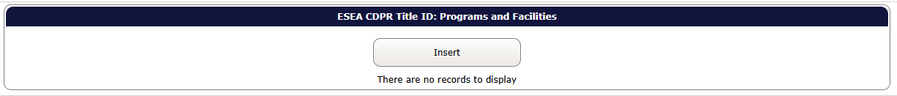

Once the first step is completed, this screen will appear. Please select YES or NO for each type of facility. If YES is selected, that section will expand. Data must be entered for each data element. If NO is selected, the web application will automatically populate that type of program with ZEROs. More than one type of program may be selected if the district is reporting data for multiple types of facilities.
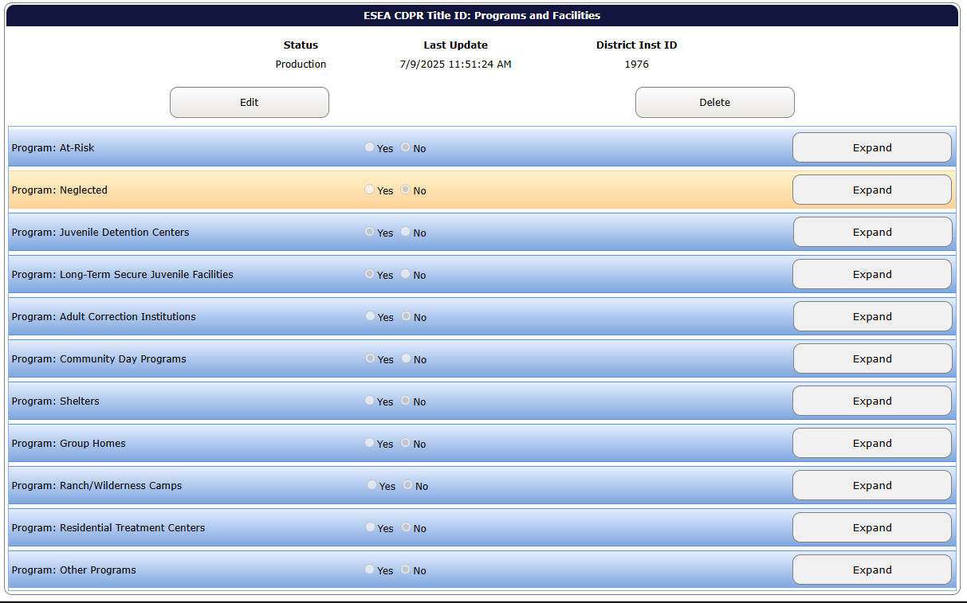

Data may now be entered for each element. No data element within the type of facility chosen can be left blank.
For each program selected, please enter data for the following data elements in the web application.

The table below shows the content for ESEA CDPR Title ID: Programs and Facilities. Note that each data item is required. A number or comment (as appropriate) must be entered into each cell even if the response is “0.”
item # | Item Description | Long Description | Question to Define Data Needed | Entry Type
1 | Title ID Program Count | Number of programs in districts receiving a Title ID subpart 2 allocation | How many programs/facilities in this category in your district receive Title ID funds? | Numeric
2 | Average Stay Days | Average length of stay (number of days) in programs in districts receiving a Title ID allocation | What is the average length of stay (# of days) in this category of program receiving Title ID funds? | Numeric
3 | Unduplicated Student Count | Total number of unduplicated students served in programs in districts receiving a Title ID allocation | How many students were served in Title ID in this category of program in your district? Count each student only once, regardless of number of stays. | Numeric
4 | Long Term Student Count | Total number of long term students served in programs in districts receiving a Title ID allocation | How many long term students were served in Title ID this category of programs in your district? | Numeric
5 | American Indian/Alaskan Native Student Count | Number of American Indian/Alaskan Native receiving Title ID services | How many American Indian/Alaskan Native students were served in the Title ID program in this category at any time during the school year (count each student only once for the entire school year)? | Numeric
6 | Asian Student Count | Number of Asian receiving Title ID services | How many Asian students were served in the Title ID program in this category at any time during the school year (count each student only once for the entire school year)? | Numeric
7 | Pacific Islander Student Count | Number of Pacific Islander receiving Title ID services | How many Pacific Islander students were served in the Title ID program in this category at any time during the school year (count each student only once for the entire school year)? | Numeric
8 | Black Student Count | Number of Black receiving Title ID services | How many Black or African American students were served in the Title ID program in this category at any time during the school year (count each student only once for the entire school year)? | Numeric
9 | Hispanic Student Count | Number of Hispanic receiving Title ID services | How many Hispanic students were served in the Title ID program in this category at any time during the school year (count each student only once for the entire school year)? | Numeric
10 | White Student Count | Number of White receiving Title ID services | How many White students were served in the Title ID program in this category at any time during the school year (count each student only once for the entire school year)? | Numeric
11 | Multi-Racial Student Count | Number of Multi-Racial receiving Title ID services | How many Multi-Racial students were served in the Title ID program in this category at any time during the school year (count each student only once for the entire school year)? | Numeric
12 | Female Student Count | Number of Female receiving Title ID services | How many female students were served in the Title ID program in this category during the school year? | Numeric
13 | Male Student Count | Number of Male receiving Title ID services | How many male students were served in the Title ID program in this category during the school year? | Numeric
14 | Non-Binary Student Count | Number of Non-Binary Students receiving Title ID services | How many Non-Binary students were served in the Title ID program in this category during the school year? | Numeric
15 | 3 – 5 Year Old Student Count | Number of children 3 – 5 receiving Title ID services | How many 3-5 year old students were served in the Title ID program in this category during the school year? | Numeric
16 | 6 Year Old Student Count | Number of children 6 years old receiving Title ID services | How many 6 year old students were served in the Title ID program in this category during the school year? | Numeric
17 | 7 Year Old Student Count | Number of children 7 years old receiving Title ID services | How many 7 year old students were served in the Title ID program in this category during the school year? | Numeric
18 | 8 Year Old Student Count | Number of children 8 years old receiving Title ID services | How many 8 year old students were served in the Title ID program in this category during the school year? | Numeric
19 | 9 Year Old Student Count | Number of children 9 years old receiving Title ID services | How many 9 year old students were served in the Title ID program in this category during the school year? | Numeric
20 | 10 Year Old Student Count | Number of children 10 years old receiving Title ID services | How many 10 year old students were served in the Title ID program in this category during the school year? | Numeric
21 | 11 Year Old Student Count | Number of children 11 years old receiving Title ID services | How many 11 year old students were served in the Title ID program in this category during the school year? | Numeric
22 | 12 Year Old Student Count | Number of children 12 years old receiving Title ID services | How many 12 year old students were served in the Title ID program in this category during the school year? | Numeric
23 | 13 Year Old Student Count | Number of children 13 years old receiving Title ID services | How many 13 year old students were served in the Title ID program in this category during the school year? | Numeric
24 | 14 Year Old Student Count | Number of children 14 years old receiving Title ID services | How many 14 year old students were served in the Title ID program in this category during the school year? | Numeric
25 | 15 Year Old Student Count | Number of children 15 years old receiving Title ID services | How many 15 year old students were served in the Title ID program in this category during the school year? | Numeric
26 | 16 Year Old Student Count | Number of children 16 years old receiving Title ID services | How many 16 year old students were served in the Title ID program in this category during the school year? | Numeric
27 | 17 Year Old Student Count | Number of children 17 years old receiving Title ID services | How many 17 year old students were served in the Title ID program in this category during the school year? | Numeric
28 | 18 Year Old Student Count | Number of children 18 years old receiving Title ID services | How many 18 year old students were served in the Title ID program in this category during the school year? | Numeric
29 | 19 Year Old Student Count | Number of children 19 years old receiving Title ID services | How many 19 year old students were served in the Title ID program in this category during the school year? | Numeric
30 | 20 Year Old Student Count | Number of children 20 years old receiving Title ID services | How many 20 year old students were served in the Title ID program in this category during the school year? | Numeric
31 | 21 Year Old Student Count | Number of children 21 years old receiving Title ID services | How many 21 year old students were served in the Title ID program in this category during the school year? | Numeric
32 | Students with Disabilities Student Count | Number of children with disabilities receiving Title ID services | How many Students with Disabilities students were served in the Title ID program in this category during the school year? | Numeric
33 | Limit English Proficient Student Count | Number of Limited English Proficient children receiving Title ID services | How many Limited English Proficiency students were served in the Title ID program in this category during the school year? | Numeric
34 | Average Number of Days Served | The average number of days that students received Title I-D services. | What were the Average Number of Days that students received Title ID services in this Title ID program? | Numeric

Resources & Tools
- Central Login User Guide
- Institution Lookup Application
- Find District Security Administrator

Revision History
Date | Page | Section | Description
7/9/25 | Pg 10 | Data for ESEA CDPR Title ID: Programs and Facilities | Added “Average Number of Days Served” field.
7/9/25 |  | All Sections | Reviewed and updated revision date & screenshots
8/1/24 |  | All Sections | Reviewed and updated revision date
7/27/23 | Pgs. 4-5 | Data for ESEA CDPR Title ID: Academic Outcomes | Updated Items #17-30 to reflect change in language: “…from an initial and follow-up assessment and received a score…”
7/7/21 |  | All Sections | Reviewed and updated revision date
5/20/20 |  | All Sections | Reviewed and updated revision date
7/9/19 |  | All Sections | Reviewed and updated revision date
6/11/18 |  | All Sections | Reviewed and updated revision date
6/30/17 |  | All Sections | Reviewed and updated revision date
03/24/2016 |  | All Sections | Reviewed and updated revision date
04/30/2015 |  | All Sections | Initial Release of Document to Public

Troubleshooting
If you have problems with any of the processes outlined in this document, please contact the ODE Helpdesk via email at ode.helpdesk@ode.oregon.gov or phone at 503-947-5715.

