CIP Budget NarrativE

User Guide
Updated July 2023

Table of Contents
CIP Budget Narrative 4
Budget Narrative Security 5
The Web Based Application 6
Navigation to Specific Program Sections 13
Program Pages 15
Title I-A Pages 16
Title II-A Pages 24
Title III Regular School Program Pages 29
Title III Immigrant Grant Pages 33
Title IV-A Student Support and Academic Enrichment (SSAE) Pages 37
Other Title Programs 42
Carryover 43
Special Directions for Consortium Members and Institutions: 44
Contacts 45

CIP Budget Narrative

Introduction:
The CIP Budget Narrative (BNSW) is a web based application. This guide has been developed to assist applicants in understanding the format of the application and provide guidance through the submission process. Specific program questions not addressed will need to be directed to the appropriate education specialist.
Action | Date
CIP Budget Narrative Opens | August 11, 2023
Budget Narratives Due  (Application for Funds Due) | November 1, 2023
The application is located at the ODE District Website (see image below).
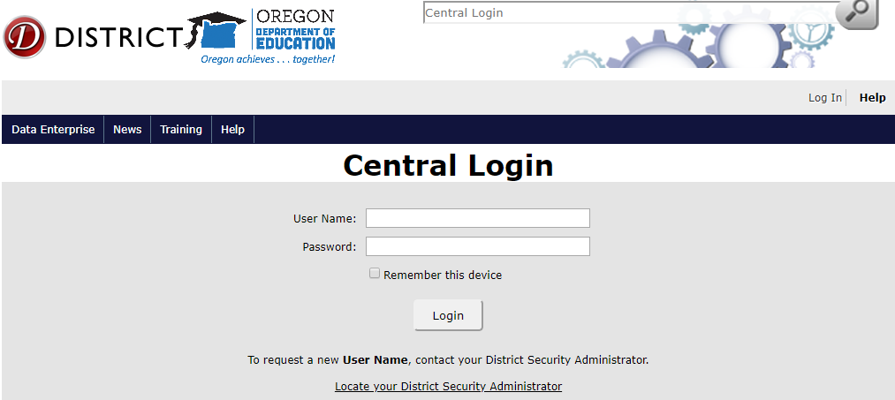
Once you login on the District Secure Site, you will be shown a list of applications that you have rights to access. If CIP Budget Narrative is not listed you will need to contact your District Security Administrator to request the rights to work in the CIP Budget Narrative Application.
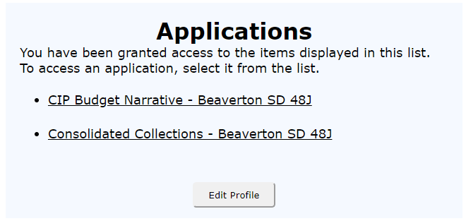

Budget Narrative Security
This application’s security is administered using ODE’s “web security” application, the same web application as other ODE district secure web applications. This is the first application to include role-based security, where a user may have zero or more roles in addition to having access to the application. The district security administrator will be responsible for assigning roles.

User Roles:
Roles that may be granted include the following:
- Submit/Revise
- Edit Everything
- Edit Title I-A, or Edit Title I-C, or Edit. etc. (one for each Title/Program)
The “Submit/Revise” role is for whoever has final authority to submit budget information to ODE. This would most likely be the District Title Coordinator and/or Business Manager. This role authorizes the user to submit budget narratives or revise budget narratives for ALL titles/program. The person assigned this role will see a Submit or Revise button in the far right column on the Summary page.
The “Edit Everything” role is for someone who has authority to edit all of the titles and other screens such as Consolidated Spending and Contacts. A District Title Coordinator or Business Manager typically need this role.
The “Edit Title I-A”, “Edit Title I-C”, etc. are roles which only allow editing for that particular title or program (note, this does not include that title/program’s CarryOver budget narrative). These roles are appropriate for those who specialize in only one or two program areas. For example, a Title III coordinator might just have the “Edit Title III” role.
A user with no roles assigned, but who has access to the application, will have “Read-Only” access to all of the screens. This might be appropriate for an administrative assistant.
For Clarification:
- Those with “Submit/Revise” and “Title ___” can submit and revise for the specific Title they are assigned to, but not the Contacts, Private Schools or Consolidated Spending pages. They will also not be able to revise or submit the CarryOver for that title.
- Those with “Submit/Revise” and “Edit Everything” can submit and revise for all titles, CarryOver, Contacts, Private Schools and Consolidated Spending.
- Maximum access is granted by assigning both the “Submit/Revise” and “Edit Everything” roles
- An individual may be assigned multiple roles or none at all.
- If an individual has been given permissions to edit or submit, but also has been given “Read-Only” permissions, the “Read-Only” permission may negate the edit and submit permissions.
Since this application is on a secure website, it is live for about 2 hours without activity or saving.
Plan on regularly saving your work (every 30 minutes is a good time frame). Another strategy is to write your narratives in Word and copy/paste them into the CIP Budget Narrative application.

The Web Based Application

The Budget Narrative Menu
Note: Please turn to the “Consolidated Spending” page for instructions if you plan to decline all ESEA Funds.
The Budget Narrative Menu provides management tools.
Summary: This is the page you begin on when you open CIP Budget Narrative. This page allows the users to track the progress of each of the pages involved in the submission and revision. Submit Sections/Programs one at a time for review as the sections are completed.
Search: Allows the user to search for key words throughout the application.
Print: Allows user to print all or part of the Budget Narrative/Spending Workbook. Be careful to follow the Printer Setup directions.
E-mail: This feature allows the user to email sections of the BNSW to others within your system for review.
Archive: The user can review previously submitted documents using this feature.
Budget Year Selection: This section allows the user to switch between budget years. The program will automatically default to the most current budget year. The current budget year is displayed in the upper right corner of the screen. For consortium leads (community colleges, ESD’s and districts) who apply directly as well as a consortium, this is also used to switch between those two modes (consortium vs. direct).

Prerequisites
This information is located on the CIP Budget Narrative “Summary” screen. The Summary screen is the first page you open to when you enter CIP Budget Narrative. All prerequisites must be met prior to being able to submit other sections in CIP Budget Narrative.
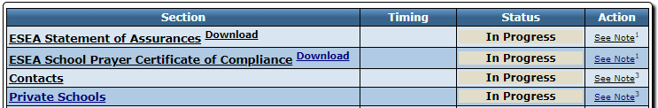
These are the first steps in the application process; all prerequisites must be submitted and approved prior to any program section being able to be submitted. The following information will help in getting your prerequisite requirements completed.
Please note – Complete ALL of these as soon as possible after the specific program allocations are in CIP Budget Narrative.

Items to submit to ODE either by Smartsheet, email, or mail:
The items to be turned in to ODE are listed below. Once they are turned in and approved, ODE staff will indicate their acceptance on the summary screen via the Status column which will change to “Approved”.
Item | How to Submit | Note
Continuous Improvement Plan | N/A | The Continuous Improvement Plan requirement for the 2023-2024 school year for the CIP Budget Narrative is fulfilled by the submission and approval of a district’s Integrated Guidance Application.
2023-24 ESEA Statement of Assurances | Submit via the Prerequisites Submission Form. | Due June 30, 2023. They must be submitted and recorded prior to ability to submit any application for funds.
2023-24 School Prayer Certification | Submit via the Prerequisites Submission Form. | Due June 30, 2023. They must be submitted and recorded prior to ability to submit any application for funds.

Description of items to submit to ODE:

Continuous Improvement Plan:
The Continuous Improvement Plan requirement for the 2023-2024 school year for the CIP Budget Narrative is fulfilled by the submission and approval of a district’s Integrated Guidance Application.

ESEA Statement of Assurances:
A new assurance form is signed by the superintendent every year. It is the superintendent’s responsibility to read and implement the items in the assurances. The signature on the form indicates the district has these requirements in place. Each year’s ESEA Statement of Assurance form is posted within the CIP Budget Narrative Application and can be found on the Oregon Department of Education’s CIP Budget Narrative – Spending Workbook webpage.
The form needs to be signed and submitted electronically or by hard copy by June 30, 2023 each year. See the bottom of each assurances form for specific submission information.

ESEA School Prayer Certificate of Compliance:
A new school prayer certificate of compliance is signed by the superintendent every year. This certifies that the requirements in the compliance are being met. Each year’s ESEA School Prayer Certificate of Compliance form is posted within the CIP Budget Narrative Application and can be found on the Oregon Department of Education’s CIP Budget Narrative – Spending Workbook webpage.
The form needs to be signed and submitted electronically or by hard copy by June 30th each year. See bottom of assurances form for specific submission information.

Attention Consortiums
Districts within the consortia must have the above prerequisites completed and also have the following done prior to the consortium being allowed to submit an application.
Please turn to the “Special Directions for Consortium Members” page for more Consortium information for the CIP Budget Narrative.

Title I-C Consortium:
Districts participating in a Title IC consortium must contact their consortium lead if they have not signed a "Member of a Consortium Certification.” Consortium leads will provide the certification form to each consortium member and mail them to Leslie Casebeer.

Title III Regular School Program Consortium:
Districts participating in a Title III consortium must contact their consortium lead if they have not signed a "Member of a Consortium Certification.” Consortium leads will provide the certification form to each consortium member and mail them to Kim Miller.

Prerequisites entered in the application:
The following sections are also considered prerequisites and must be completed before submitting any program section. These prerequisites must be submitted and approved because they supply data to program sections of the application.
Note for consortia member districts, all districts must have these prerequisites completed before your consortia can submit the consortium budget.

Contacts:
District will enter contacts for general district personnel and for specific Title programs. Contacts will be needed when the district receives an allocation in a specific Title program. Please click on “Contacts” from the Summary page and enter information into all fields and double check for accuracy. This is the information that will be entered into EGMS and is extremely important. Throughout the year if contacts change, you need to change the information on this page and then resubmit. This will notify EGMS and the update can then take place.
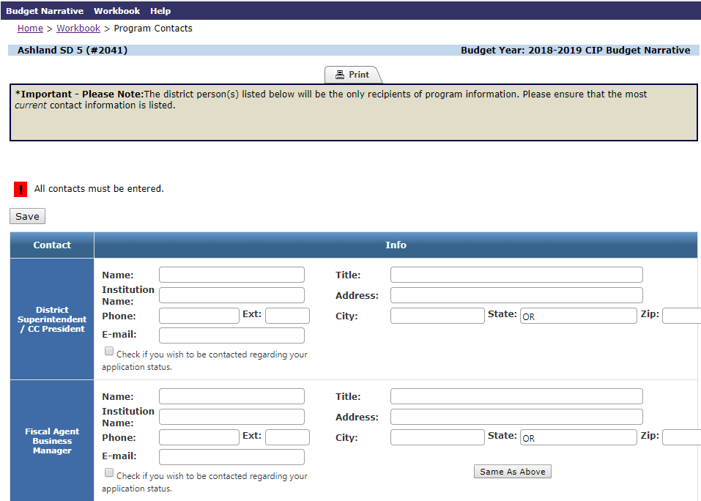
Please notice the SAVE button!
You may use the “Same As Above” button to copy the exact information from the contact above. This will facilitate filling out contact information when the same person is responsible for several areas.
At times there is more than one contact for a program area. “Additional Contacts” provides the applicant an opportunity to enter that information. These contacts will not be added to EGMS but will be added to the email notification process for CIP Budget Narrative. Clicking on the link at the bottom of the Contacts page will take you to the page for entering additional contact information.
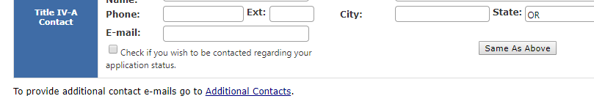

Private Schools
Private schools are eligible to participate in many ESEA Title programs. It is required that each year districts consult with private schools – ideally in the spring of the previous year – to determine their participation in the ESEA programs. Districts must maintain written proof of this consultation process each year. The Affirmation of Consultation with Private Schools form must be filled out and submitted to Janette Newton for each Private School participating in ESEA Equitable Services.

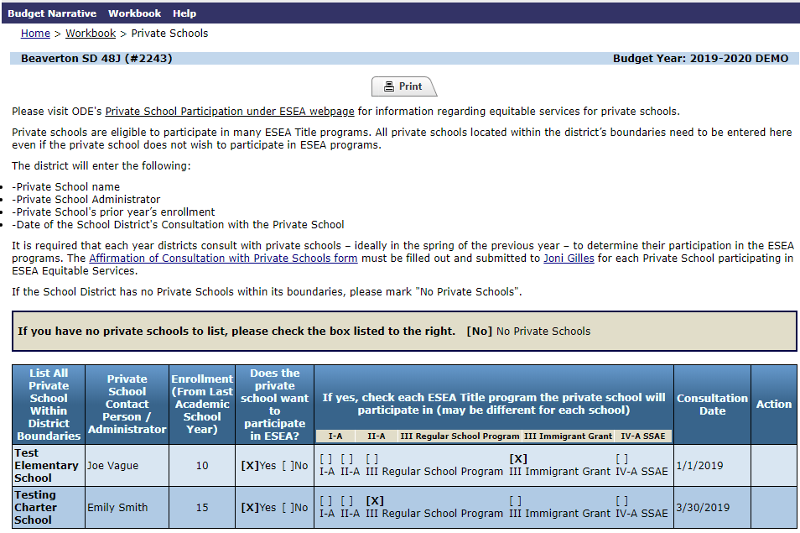
All private schools located within the district’s boundaries need to be entered here even if the private school does not wish to participate in ESEA programs. The district will enter the Private School name, administrator, prior year’s enrollment and the date of the district’s consultation with the private school. When the Budget Narrative opens, click on “Private Schools” from the Summary page and enter this information.
The ESEA programs do not appear until the district has an allocation for that specific ESEA program. A district may complete the private school name, contact and enrollment prior to allocations being loaded but will not be able to complete the participation portion until August when the allocations are in the system.

Consolidated Spending:
All titles for which you receive an allocation will appear after CIP Budget Narrative when the ESEA allocations are loaded into CIP Budget Narrative during August and September.
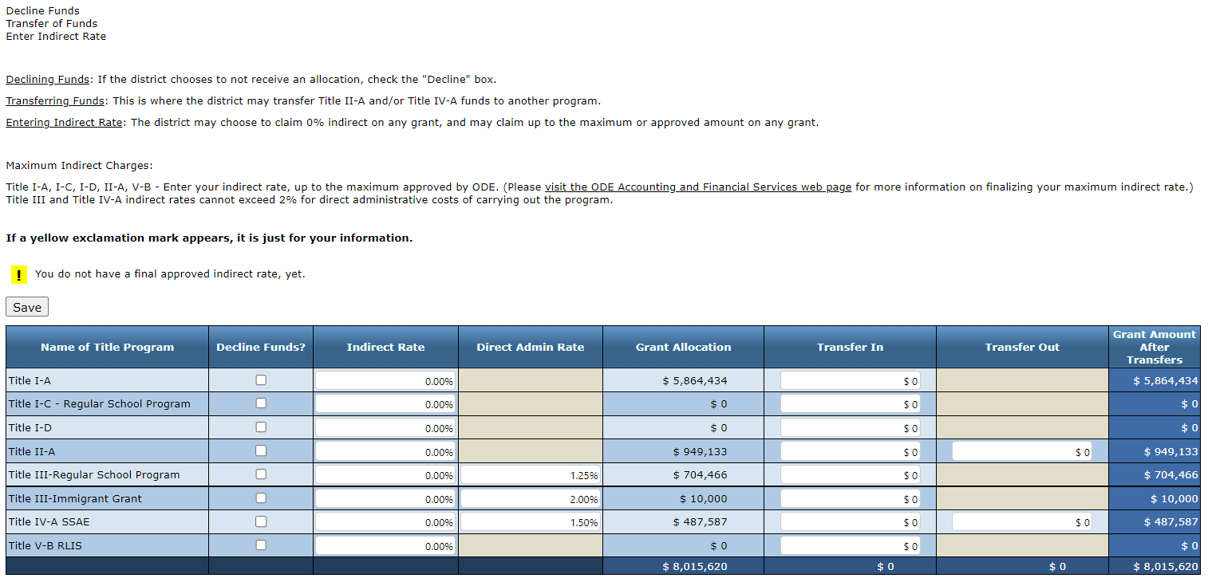
Please notice the SAVE button!
DECLINING FUNDS: If districts are choosing to decline ANY or ALL ESEA funds, districts need to log in, check “Decline Funds” for each line, SAVE, then go back to the Summary Screen and click Submit for Consolidated Spending. This notifies ODE that you are declining funds.
PLEASE NOTE: If a district declines Title I-A funds, this will make the district ineligible for Title IV-A funds in the next year. Title IV-A allocations are based on the applied for and approved Title I-A allocations of the previous year.

Indirect Rate
Indirect Rate: The district annually gets an approved indirect rate from ODE. The district does not have to claim indirect on any grant. The district may claim up to the maximum allowable or approved indirect amount on any grant. Note that Title III Regular School Program has specific directions about indirect rates.
It is of VITAL importance that your business office negotiate and get an approved indirect rate for applicable programs as soon as possible after July 1st each year, as the application will not allow you to submit with any indirect amounts until the indirect rate has been approved for the current year.
After entering in any indirect rates or declining funds check boxes, the district will click the Save button and then navigate back to the Summary page and submit the Consolidated Spending page.
Please visit the Accounting Financial Services webpage for the Indirect Rate Approval Process. The ODE contact for School District Indirect Rate approval is Julie Hansen (Julie.b.hansen@state.or.us, (503) 947-5680).

Direct Admin Rate
Direct administrative costs: are those costs that are specific to a particular grant. For federal programs this is often costs for personnel to administer the program, but can also include costs for materials, travel or other expenses that cannot be charged to another program. Some programs have limits on administrative costs while others do not.
For Title III, Title III Immigrant, and Title IV-A: The district/consortium can enter up to 2% in the Direct Admin Rate column for direct administrative costs. For indirect administrative costs, the district/consortium can enter up to the maximum approved indirect rate in the Indirect Rate column.
NOTE: Districts that choose to claim direct administrative costs up to 2% must reduce the amount entered in the indirect rate column so that the total claimed in administrative costs does not exceed the district’s approved indirect rate.
For example, if the district’s indirect rate is 4.2% and the district claims 2% in direct administrative costs, the maximum that can be entered in the indirect rate column is 2.2%.
For more information on the difference between Indirect & Direct Admin Rate, please review the Administrative Costs brief.

Navigation to Specific Program Sections
There are two ways to navigate to a specific program section:
- From the Summary page click on the program name
- From the Workbook menu select from the drop down menu
Summary page navigation
Click on the underlined program you wish to go to.
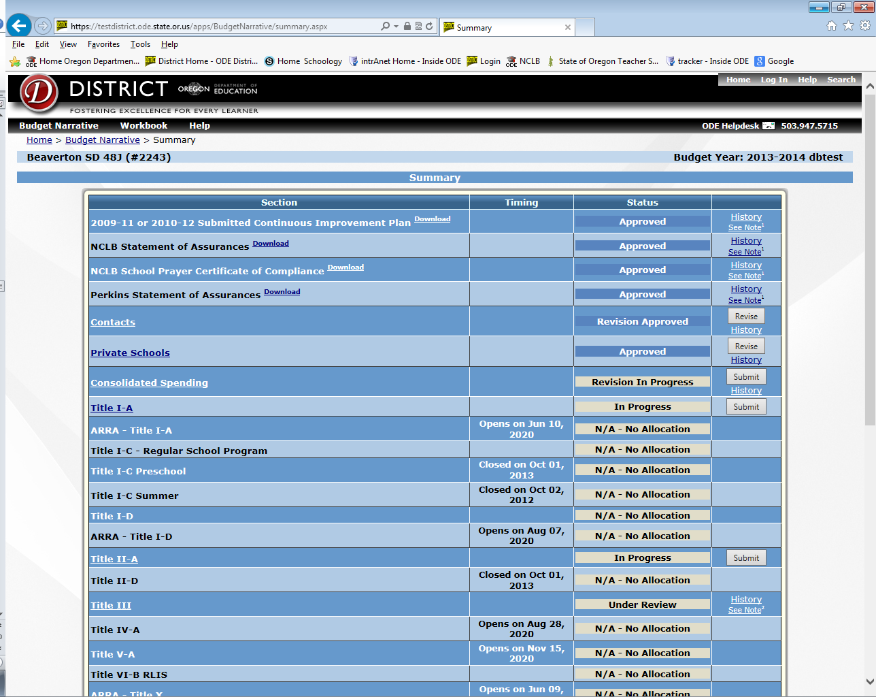
Workbook Menu navigation
This Menu provides instant navigation to all areas of the budget narrative application.
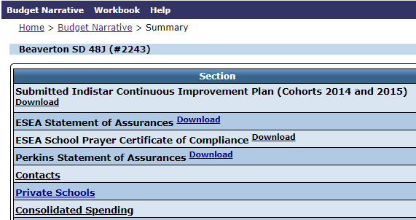

Eligibility and Submission Status:
By looking on the Summary Page applicants can determine their program eligibility and submission status. If the district has an allocation for a specific program, then the submission status will display.
If the district is not eligible for a specific program then N/A-No Allocation will display.
Submission Status:
- In Progress: The applicant is working on the application and it has yet to be submitted to ODE.
- Under Review: The applicant has submitted the program application and it is now under review by ODE specialists.
- Response Required: ODE has reviewed the application and applicant revisions are required prior to approval. The applicant must make the revisions and resubmit the application. Once resubmitted, the user will see the status change to “Under Review.”
- Approved: This message indicates that the application has been submitted and approved.

Program Pages
Common Program section pages
There are three common sections in each program area:
- Overview: In this section, general information, links and resources are provided regarding the grant program.
- Budget Narrative: In this section, applicants will enter program activities and expenditures for these activities to match the allocation available.
- Spending Worksheet: In this section, the system will take the function and object codes from the Budget Narrative page and fill in the Spending page. Districts will not need to enter any information on this page.
Additionally, some program sections contain additional pages that are required for the grant application process.
The next section will go into specific detail on select Title Programs.

Title I-A Pages
When you go to the Title I-A section of the CIP Budget Narrative, you will land on the Overview page. From this page you will use the navigation tabs in the middle to go to the other pages that need to be filled out for Title I-A. The tab will highlight when you are on the specific page.
The other pages are:
- Targeting
- Set-Asides
- Budget Narrative
- Spending

Overview Page
The Overview page will describe the purpose of Title I-A.
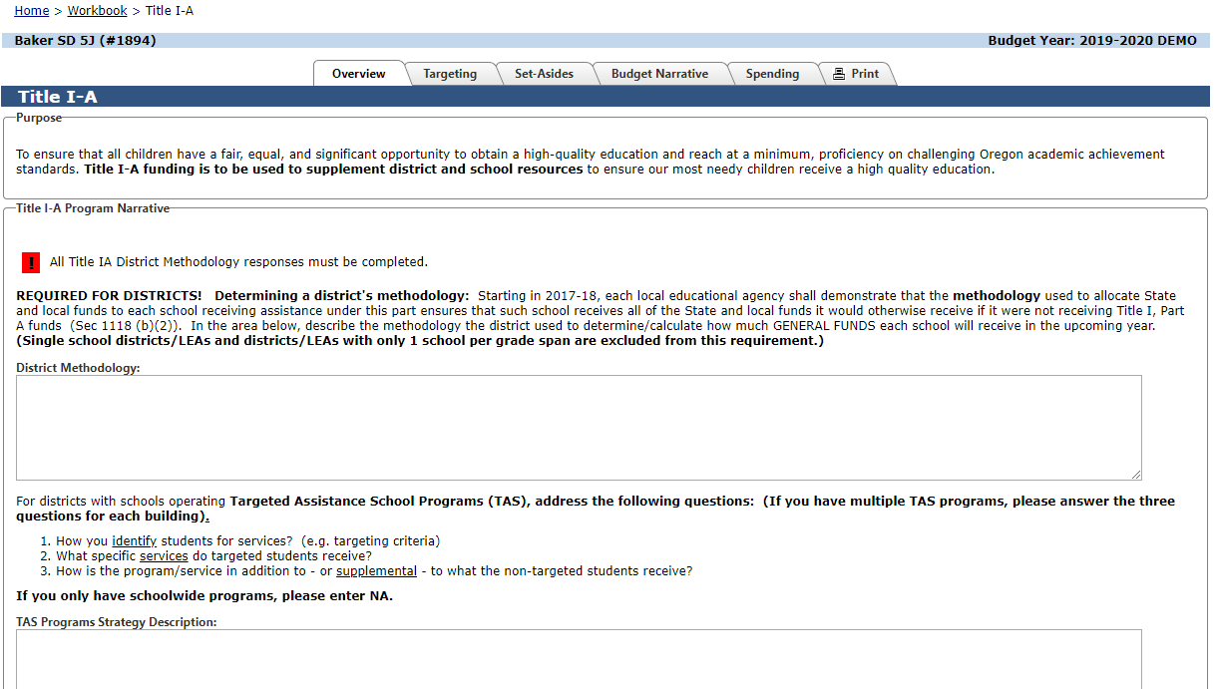
The Overview page also asks for District Methodology. Determining a district's methodology: Starting in 2017-18, each local educational agency shall demonstrate that the methodology used to allocate State and local funds to each school receiving assistance under this part ensures that such school receives all of the State and local funds it would otherwise receive if it were not receiving Title I, Part A funds (Sec 1118 (b)(2)). In other words, a LEAs methodology must be “Title I neutral” in that it allocates state and local funds to schools without regard for Title I-A status.
For this section you will describe the methodology the district used to determine/calculate how much GENERAL FUNDS each school will receive in the upcoming year. (Single school districts/LEAs and districts/LEAs with only 1 school per grade span are excluded from this requirement.) Please see the Supplement not Supplant Methodology Guidance from the U.S Department of Education for specific methodology examples (pp.12-13).

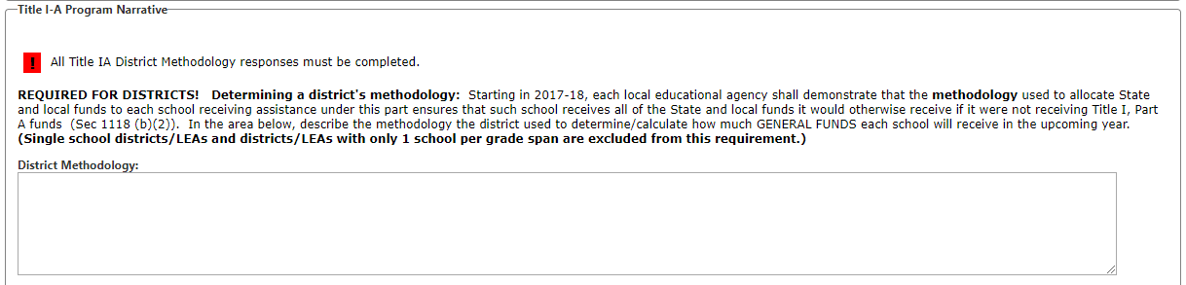
In addition, the Overview Page will ask for specific information on any Targeted Assistance Schools (TAS) that the district may be operating. The district will need to answer all three questions for each TAS funded building within the district. If all Title I-A funded schools are operating as Schoolwide schools (SWP), then the district will fill in NA in the box.
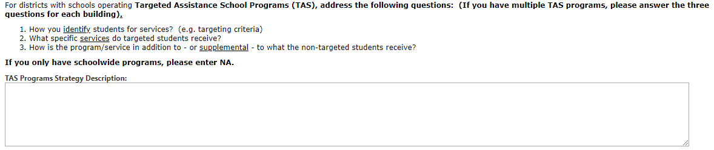

Targeting Page
The Targeting page is where the district indicates which schools will be served under Title I-A. This process is often referred to as “Rank and Serve”. The Targeting Page will list all the schools in your district with their grade spans. Please check the list to make sure all schools including Charter Schools are listed and that the grade spans are accurate. This data is pulled from the Institution Data Base. To make corrections and update the school data, please fill out the “Institution Request Form” found on the Institution Identification - School Names web page.
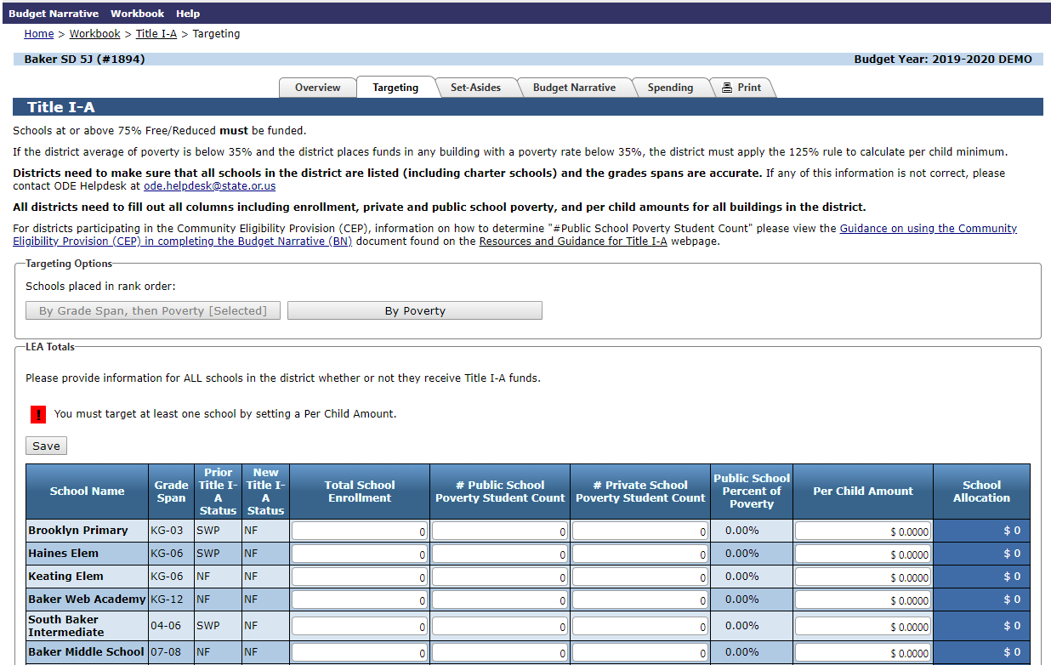
Total School Enrollment: This is where the district will enter enrollment for each of the schools in the district. The enrollment can be taken from the last official student count of the previous year, or the first official student count from the current year. The district shall select a single point in time and use that same point in time for calculating the enrollment count for each school. Many districts use the October enrollment data they submit to ODE.
Public School Poverty Student Count: The district will enter the number of public school students in poverty based on the Free and Reduced Lunch Program, Parent Income Survey, or the Community Eligibility Provision (CEP) Calculation. The district shall select a single point in time and use that same point in time for calculating the enrollment count and poverty count for each school. All schools, even those not being served with Title I-A funds, including public charter schools, must have both enrollment and poverty numbers entered.
Private School Poverty Student Count: The district will enter the number of private school students in poverty who would be attending a Title I-A funded school. The poverty count is determined by the Free and Reduced Lunch Program or Parent Income Survey. The private school students are entered on the line of the public school that the students would be attending if they did not attend the private school.
The system will calculate the Public School Percent of poverty from the Enrollment and Public School Poverty Student Count.
After the grade span column, the page will show the Prior Title I-A Status of the school. This reflects whether the school was Title I-A funded in the prior year and what type of Title I-A program the school operated under (SWP, TAS or NF).
The new Title I-A status will not change until the district enters a per child amount for that specific school. When the district enters a per child amount, this means that the school will be funded as a Title I-A school in the current year.
The Per Child Amount: This is figured by the district with the highest poverty schools per grade span having the highest per child amount or equal per child amount for all funded buildings within a grade span.
If a school has 75% or greater poverty, then the district must fund that school.
After the Per Child Amount is entered, the system will then calculate the School Allocation and if applicable the Private School reserve. The School Allocation amount will be what the district uses on the Budget Narrative page when the district is creating a budget narrative line for each school.
At the bottom of the page, the system will calculate the percentage of private school students in poverty. This percentage is what the district will use on the Set-aside page for equitable services.
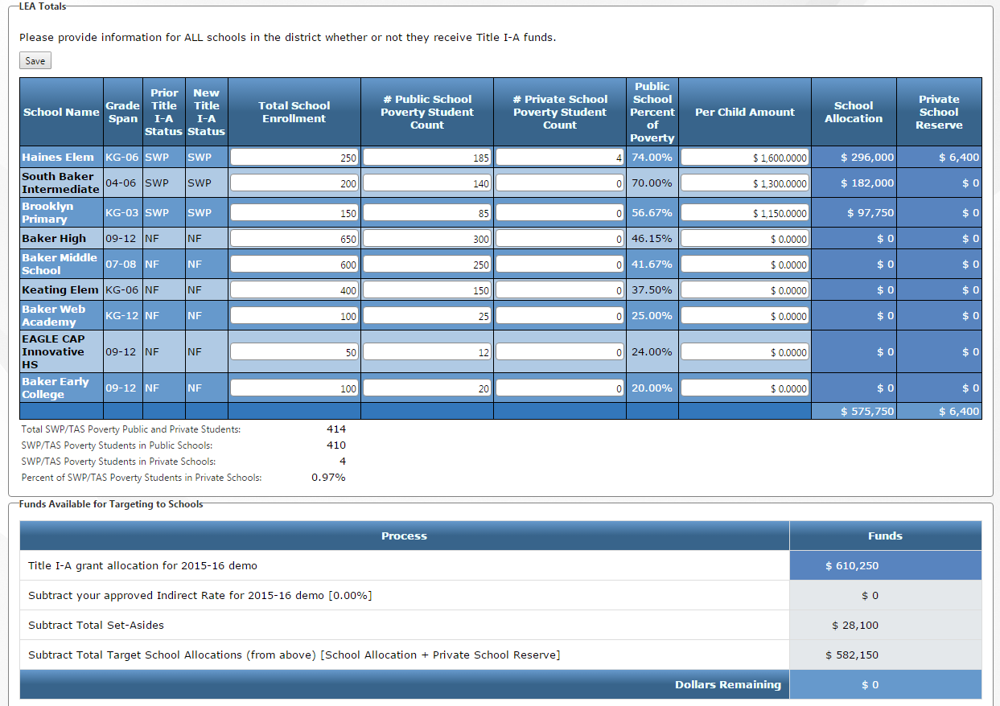
The Dollars Remaining line at the bottom of the page must equal zero. If the balance is not zero, check your Per Child Amount or the Set Asides page to make the necessary adjustments. The allocation for each school on the Targeting Page must equal each school’s allocation on the Budget Narrative Page.
The last box will take the total allocation the district receives and subtracts the district indirect costs (if applicable), the total set-aside and the sum of the school allocations.

Set-Asides Page
The Set-Asides page is for district level set-asides which are taken before any money is allocated to buildings.
Requirements:
- Homeless: The Homeless set-aside is required for all districts and can be used for all students experiencing homelessness, regardless of Title I-A school attendance.
- Parent/Family Involvement: This is required for districts with Title I-A allocations of more than $500,000. Funds from this Set Aside must be used in Title I-A schools.
- Neglected Students: Section 1112(b)(5) requires that districts who receive funds for serving neglected students describe the activities and/or supports provided for this population. This applies to districts who report a neglected facility and population count on the October Caseload Count for Title I-D. Neglected funds are allocated to districts under Title I-A. (Activities to support delinquent students are allocated under Title I-D). If you are not sure if your district receives these funds, please contact Jen Engberg.
- Equitable Services for Private School Students: If the district has participating private schools, the percent of poverty students in private schools from the Targeting Page is applied to the total Title I-A allocation to determine the private school equitable share.
- The remaining set-asides are optional and must be used for activities in Title I-A funded buildings:
  - District Administration
  - Salary Equalization
  - Extended Time
  - Professional Development
  - Other (pre-school programs, delinquent or at-risk programs, etc.)
Each set-aside will have a text box to describe what the district is spending funds on and a Funds in Reserve box for the dollar amount being set-aside for the specific purpose.
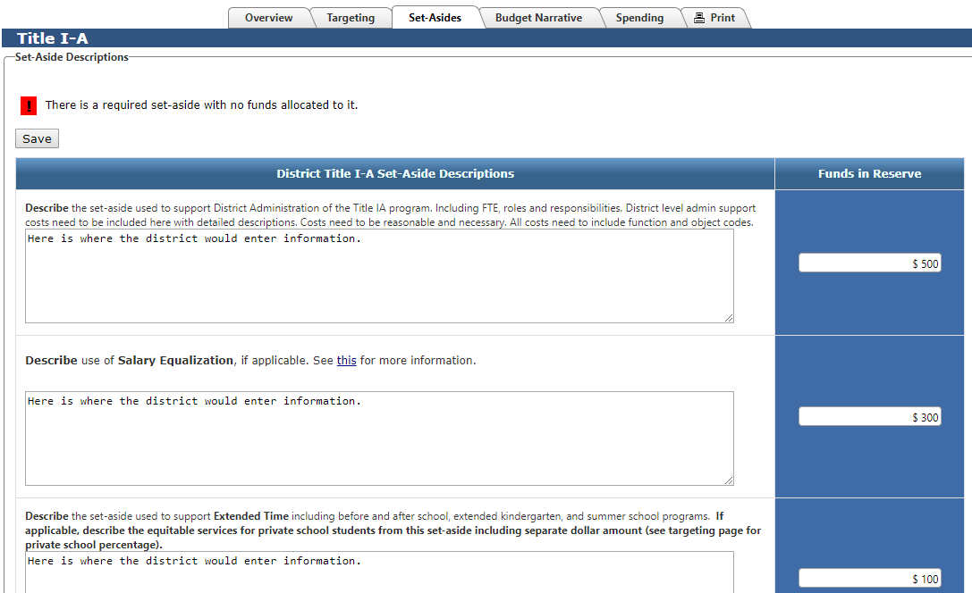
The total amount from the set-aside page will then be deducted from the total district allocation before the district can complete the targeting page.
Messages:
- Red error messages will appear on the top of the page when the required set-aside is not completed.
- Yellow error messages remind the district that they need to complete certain set-asides.

Budget Narrative Page
The Budget Narrative page is where the district describes what the funds for each Title I-A funded school will be used for. Each funded school needs to have a separate narrative line. The district can add narrative lines by using the Add Narrative Line button.
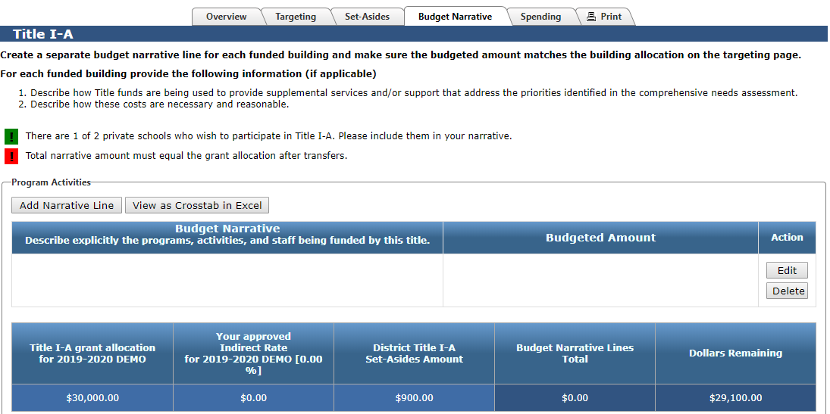
Messages:
- The green message reminds districts that they have private schools wishing to participate in Title I-A services.
- The red error message indicates that the narrative total does not add up to the total of the grant.
The district finds the dollar amount on the targeting page for each funded school and then creates a narrative line for each school.
In each funded school’s narrative line, the district provides the FTE of both certified and classified staff paid out of Title I-A funds. Please only provide the specific FTE funded out of Title I-A funds and not the full FTE of the staff if funded out of multiple sources. If the school spends any Title I-A funds on professional development, family engagement or supplies and materials, these costs are described, itemized and costs are listed in the school’s narrative line.
If the district has private schools participating in Title I-A equitable services, the district will add a narrative line to describe the equitable services that the private school(s) will receive.
After you have added a narrative line you will see an Edit button on the right.
The Edit button opens another screen where you can enter in the specific information about the expenditures for each school. The text box will include the description of the expenditure and function and object codes. The right Budgeted Amount boxes will give a drop down menu for Function Codes and Object codes. The district will enter the dollar amounts for that specific function and object code. Please list salary and benefits for certified staff as two lines (object 111 and object 2xx) and list classified salary and benefits as two different lines (object 112 and object 2xx).
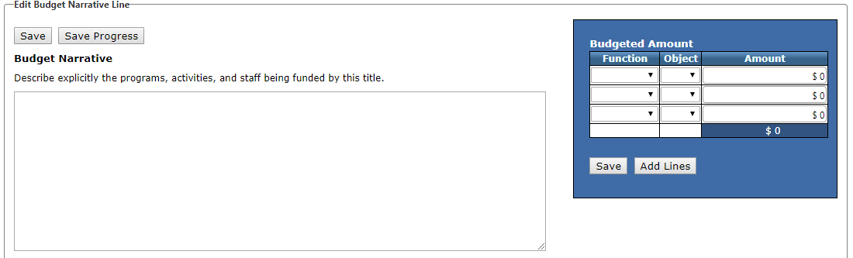
Don’t forget to Save!
There are two different Save buttons. The Save Progress button will save what you have entered on this page and keep you on this page. The Save button will save what you have entered but take you back out to the Budget Narrative page. This item will then be added to the Budget Narrative. For additional schools, just repeat the process.

Function Codes:
Further down on this screen, the applicant will find a list of function codes that are allowable for Title I-A activities to use as a resource. These are the only codes available in the drop down menu.

Object Codes
Further down on this screen, the applicant will find a list of Object codes that are allowable for Title I-A activities to use as a resource. These are the only codes available in the drop down menu.
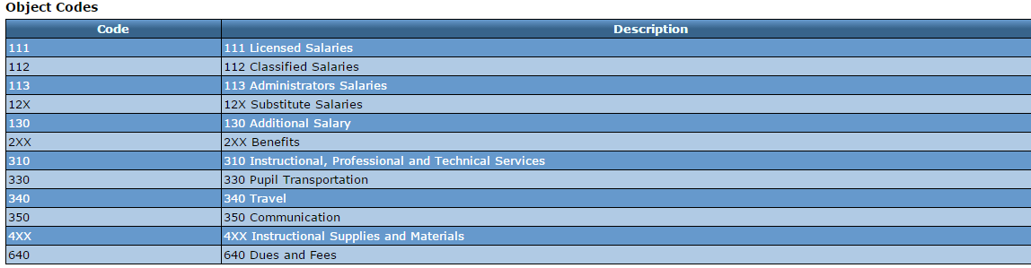

Spending Page
The Spending page is prefilled from the function and object codes that were entered on the Budget Narrative page. The Title I-A allocation is in the upper right corner of this page.
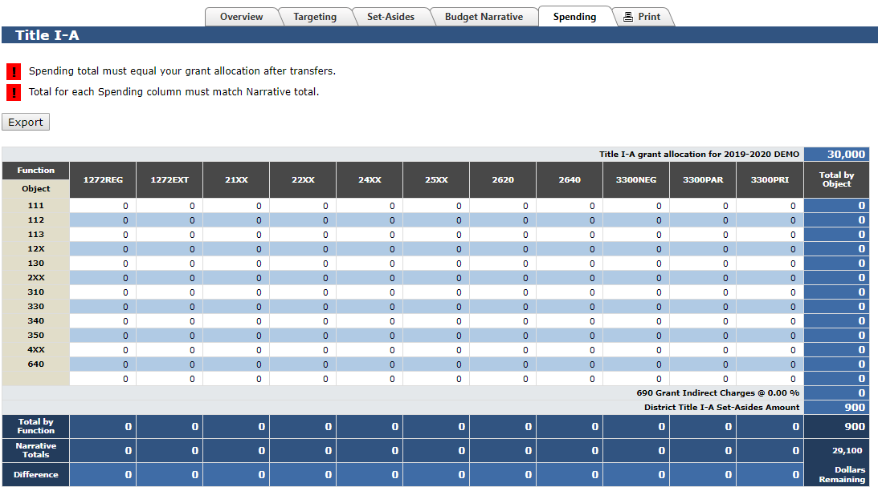
Note: The Set-aside total and the indirect charges are already subtracted on this page.
If the user hovers the cursor over either a function or object code, the application will display a long description of the item. The object and function codes are pulled from the “Oregon Program Budgeting and Accounting Manual (PBAM)” found on the Oregon Department of Education’s Finance web page.
The district can export the spending page as an Excel workbook and fill it out on their own computer, outside the CIP Budget Narrative system. Once the spending page is exported as an Excel worksheet, the district can add tabs in the workbook for each school and then have Excel sum each worksheet to the original worksheet. The district cannot import the Excel Workbook into the Spending page but can use the information to help fill out the individual school budget narrative lines with the correct function and object codes.

Title II-A Pages
When you go to the Title II-A section of the CIP Budget Narrative, you will land on the Overview page. From this page you will use the tabs in the center to go to the other pages that need to be filled out for Title II-A.
The Title II-A pages are:
- Overview
- Needs Assessment
- Equitable Services Worksheet (if applicable)
- Budget Narrative
- Spending

Overview Page
The Overview page gives guidance on the purpose of Title II-A, the program priorities and required Needs Assessment.
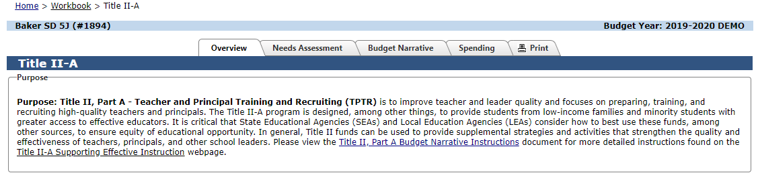

Needs Assessment Page
In the Needs Assessment section, the district will answer the questions in the boxes available. Please note that the questions included on the Needs Assessment page are aligned with the questions included in the Comprehensive Needs Assessment Summary section of Oregon’s District Continuous Improvement Plan Template. NOTE: The content of this section can reflect the district’s larger needs assessment process and results. Districts are not required to engage in a separate needs assessment for Title II-A.
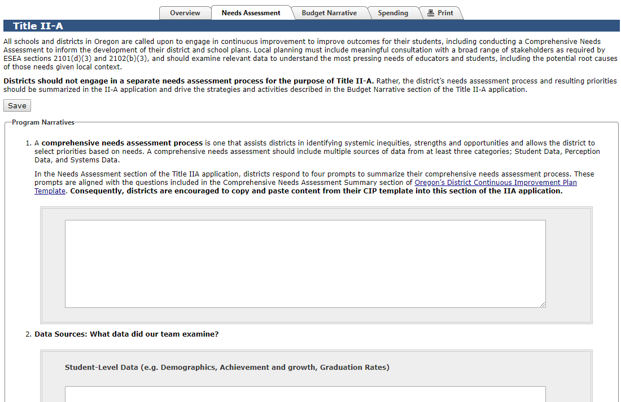
In order to enter information in the box, click in the box, type and make sure to hit the Save button. Once this information is entered and saved, the red error message will go away.

Equitable Services Worksheet Page
The Equitable Services Worksheet page is where the district enters enrollment and allocation data to calculate the amount of Title II-A funds that an LEA must make available for equitable services to private schools. The amount a LEA must reserve to provide equitable services for private school teachers and other educational personnel for Title II, Part A services is based on the LEA’s total Title II, Part A allocation, less administrative costs. The amount deducted for administrative costs prior to calculating equitable service amounts cannot exceed the district’s negotiated indirect rate.

Budget Narrative Page:
The Budget Narrative Page is where the district describes each allowable expenditure linked to a prioritized need from the Needs Assessment information. Each allowable expenditure needs to have a separate narrative line. The district can add narrative lines by using the Add Narrative Line button.
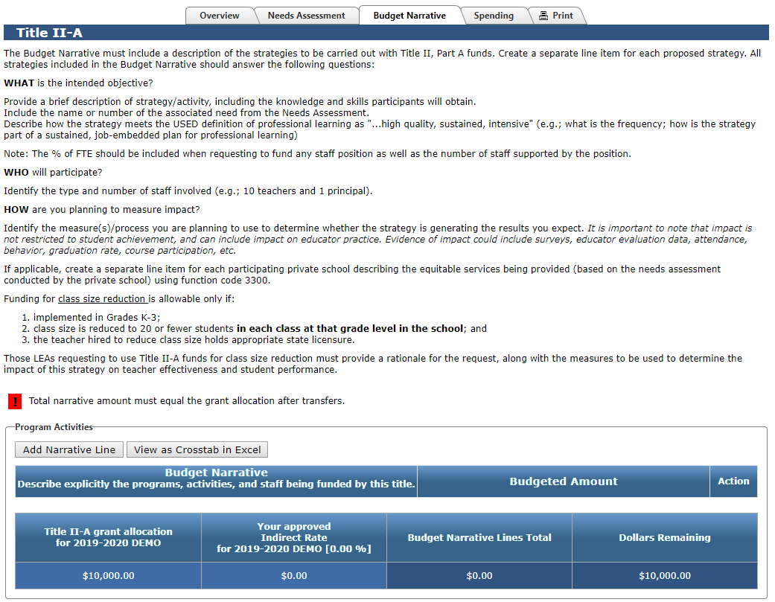
Messages:
- The green message reminds districts that they have private schools wishing to participate in Title II-A services.
- The red error message indicates that the narrative total does not add up to the total of the grant.
Each allowable expenditure needs a separate narrative line. Each narrative line should include:
- Prioritized need from Needs Assessment page (Either use the prioritized need number or name)
- Description of the strategies (WHAT)
- Number of staff involved (WHO)
- How impact of strategies will be measured (HOW)
The district should also create a separate line item for each participating private school that includes the name of the school and date of first contact as well as a description of how the private school is planning to use its equitable share.
After you have added a narrative line you will see an Edit button on the right.
The Edit button opens another screen where you can enter in the specific information for each expenditure tied to a prioritized need. The text box is for the description of the expenditure. The right Budgeted Amount boxes will give a drop down menu for Function and Object Codes and the district will enter the dollar amounts for each specific Function and Object code. There can be more than one code and dollar amount per activity.
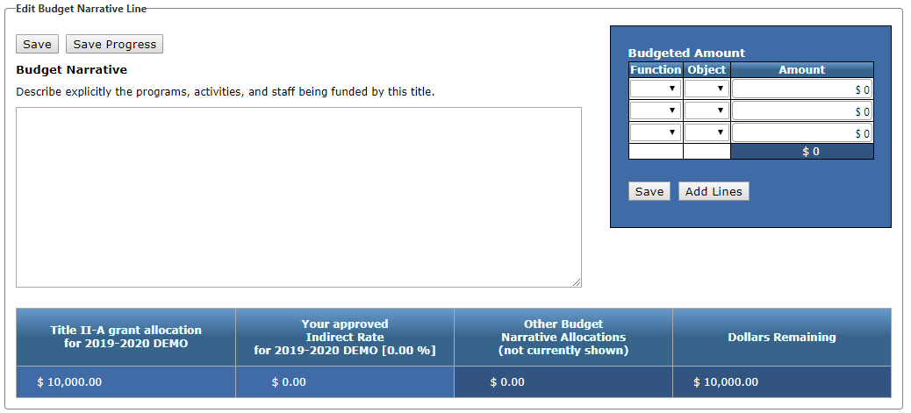
Don’t forget to Save!
There are two different Save buttons. The Save Progress button will save what you have entered on this page and keep you on this page. The Save button will save what you have entered but take you back out to the Budget Narrative page.

Function Codes:
Further down on this screen, the applicant will find a list of function codes that are allowable for Title II-A activities to use as a resource. These are the only codes available in the drop down menu.
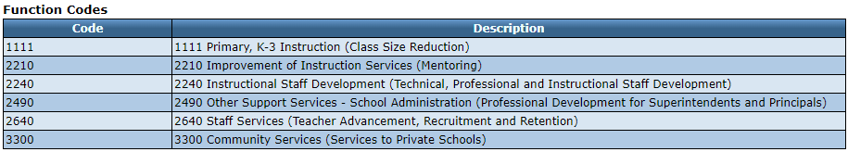

Object Codes
Further down on this screen, the applicant will find a list of Object codes that are allowable for Title II-A activities to use as a resource. These are the only codes available in the drop down menu.
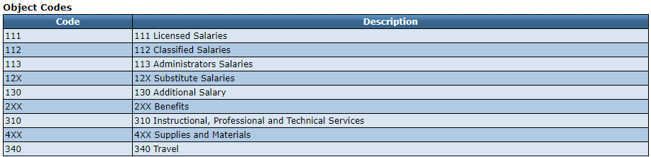

Spending Page:
The Spending page is prefilled from the function and object codes that were entered on the Budget Narrative page. The Title II-A allocation is in the upper right corner of this page.
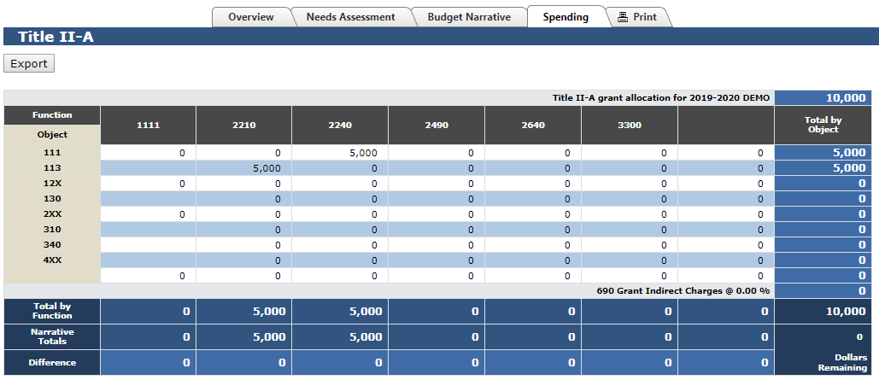
Note: The indirect charges are already subtracted on this page.
If the user hovers the cursor over either a function or object code, the application will display a long description of the item. The object and function codes are pulled from the “Oregon Program Budgeting and Accounting Manual (PBAM)” found on the Oregon Department of Education’s Finance web page.
The district can export the spending page as an Excel workbook and fill it out on their own computer, outside the CIP Budget Narrative system. The district cannot import the Excel workbook into the Spending page but can use the information to help fill out the individual narrative lines with the correct function and object codes.
Don’t forget to Save on a regular basis.

Title III Regular School Program Pages
When you go to the Title III Regular School Program section of the CIP Budget Narrative, you will land on the Overview page. From this page you will use the tabs in the center to go to the other pages that need to be filled out for Title III Regular School Program.
The Title III Regular School Program pages are:
- Overview
- Detailed Narrative
- Budget Narrative
- Spending

Overview Page
The Overview page gives guidance on the purpose of Title III Regular School Program and the program priorities.
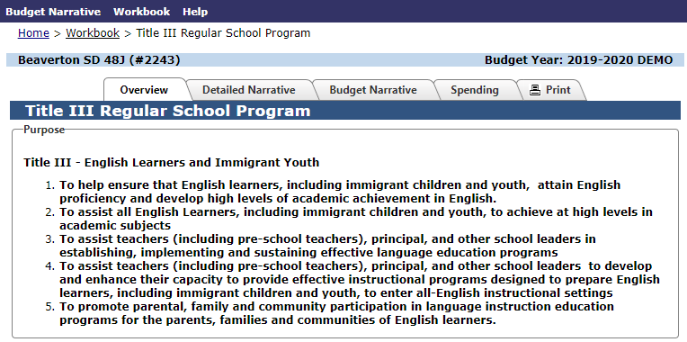

Detailed Narrative Page
For reporting purposes, there are a number of required text boxes that all grant recipients must clearly respond to. In order to enter information in the box, click in the box, type and make sure to hit the Save button. Once this information is entered and saved, the red error message will go away.
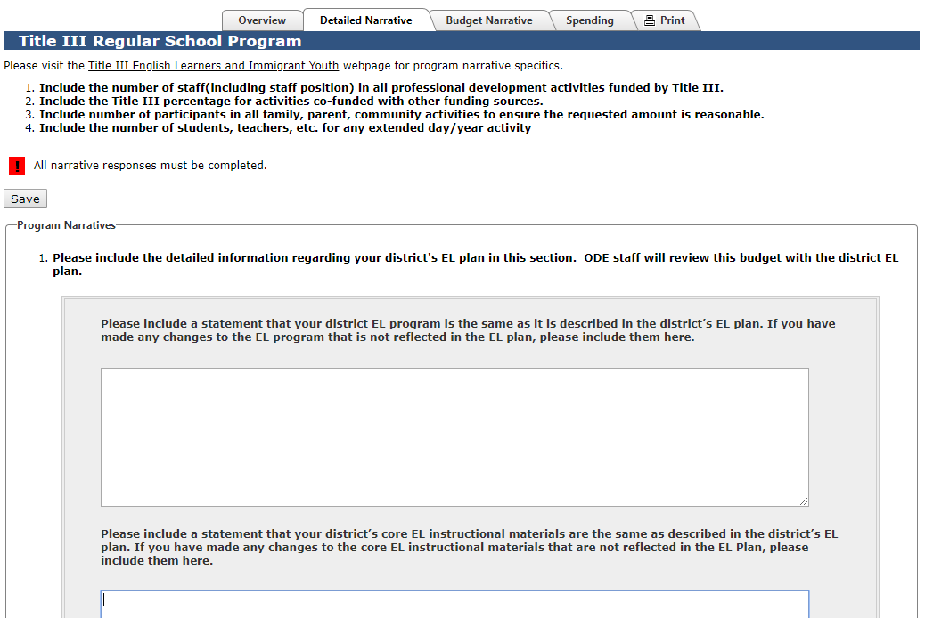

Budget Narrative Page:
The Budget Narrative Page is where the district describes each expenditure according to each applicable Narrative Line including function and object codes.
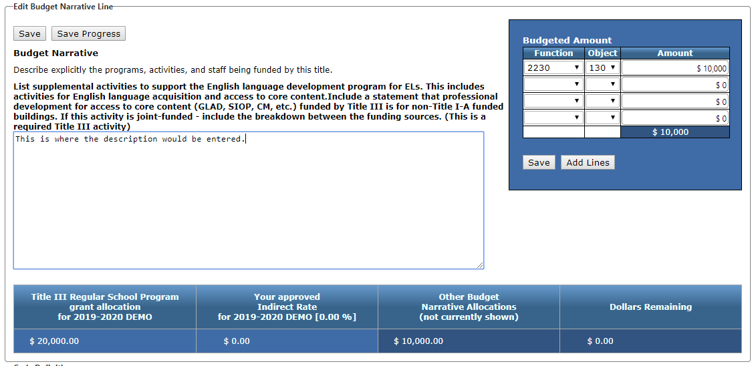
Messages:
- The green message reminds districts that they have private schools wishing to participate in Title III Regular School Program services.
- The red error message indicates that the narrative total does not add up to the total of the grant.
For each applicable Narrative Line you will need to click the Edit button which opens another screen where you can enter in the specific information about the expenditures for that specific Narrative Line. The text box will include the description of the expenditure and function and object codes. The right Budgeted Amount boxes will give a drop down menu for Function Codes and Object codes. The district will enter the dollar amounts for the specific functions and object codes. There can be more than one Function code and dollar amount per Narrative Line.
Don’t forget to Save!
There are two different Save buttons. The Save Progress button will save what you have entered on this page and keep you on this page. The Save button will save what you have entered but take you back out to the Budget Narrative page.

Function Codes:
Further down on this screen, the applicant will find a list of function codes that are allowable for Title III Regular School Program activities to use as a resource. These are the only codes available in the drop down menu.
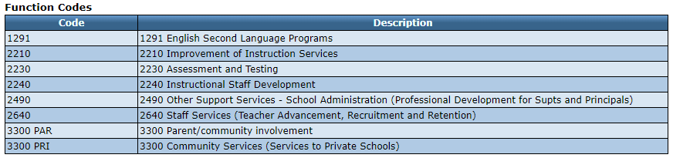

Object Codes
Further down on this screen, the applicant will find a list of Object codes that are allowable for Title III Regular School Program to use as a resource. These are the only codes available in the drop down menu.
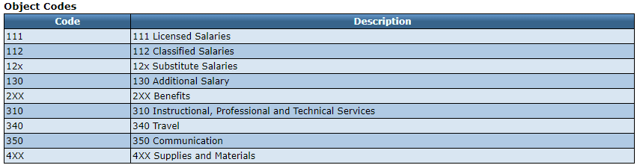

Spending Page:
The Spending page is prefilled from the function and object codes that were entered on the Budget Narrative page. The Title III Regular School Program allocation is in the upper right corner of this page.
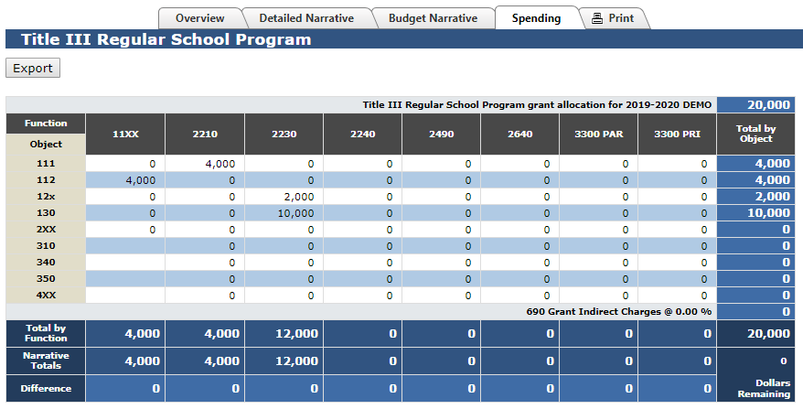
If the user hovers the cursor over either a function or object code, the application will display a long description of the item. The object and function codes are pulled from the “Oregon Program Budgeting and Accounting Manual (PBAM)” found on the Oregon Department of Education’s Finance web page.
The district can export the spending page as an Excel workbook and fill it out on their own computer, outside the CIP Budget Narrative system. The district cannot import the Excel Workbook into the Spending page but can use the information to help fill out the individual school budget narrative lines with the correct function and object codes.

Title III Immigrant Grant Pages
When you go to the Title III Immigrant Grant section of the CIP Budget Narrative, you will land on the Overview page. From this page you will use the tabs in the center to go to the other pages that need to be filled out for Title III Immigrant Grant.
The Title III Immigrant Grant pages are:
- Overview
- Budget Narrative
- Spending

Overview Page
The Overview page gives guidance on the purpose of Title III Immigrant Grant and the program priorities.
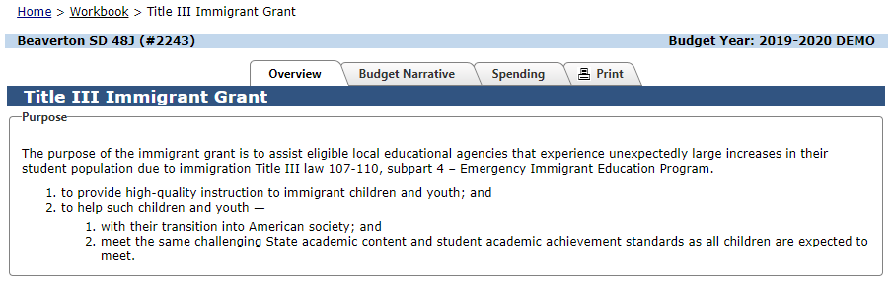

Budget Narrative Page:
The Budget Narrative Page is where the district describes each allowable expenditure. Each allowable expenditure needs to have a separate narrative line. The district can add narrative lines by using the Add Narrative Line button.
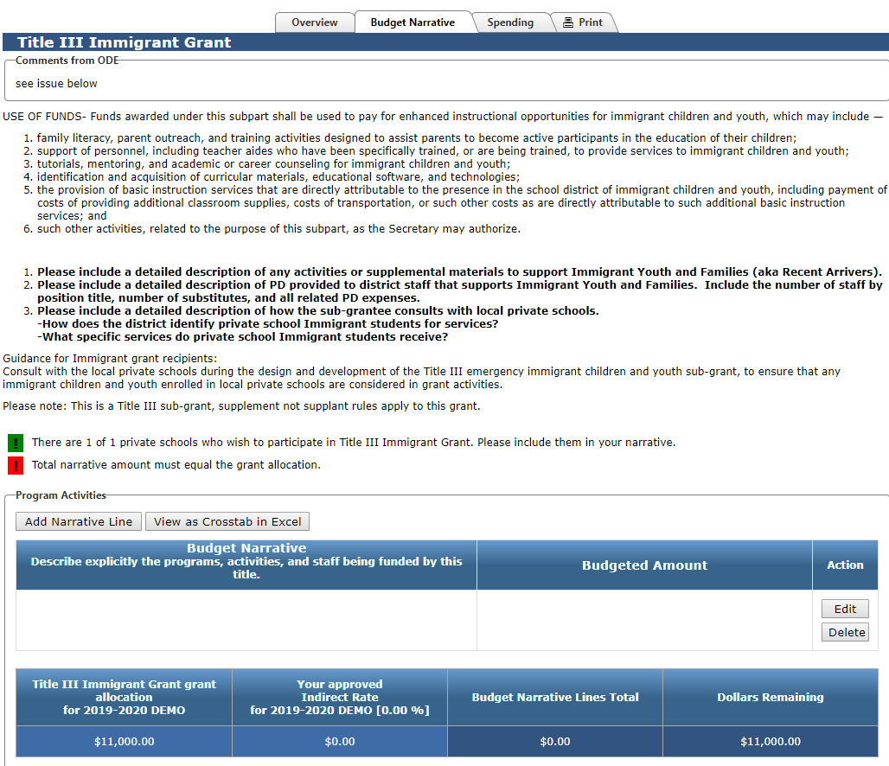
Messages:
- The green message reminds districts that they have private schools wishing to participate in Title III Immigrant Grant services.
- The red error message indicates that the narrative total does not add up to the total of the grant.
After you have added a narrative line you will see an Edit button on the right
The Edit button opens another screen where you can enter in the specific information for each expenditure. The text box will include the description of the expenditure and object codes. The right Budgeted Amount boxes will give a drop down menu for Function Codes and the district will enter the dollar amounts for that specific function code. There can be more than one Function code and dollar amount per activity.
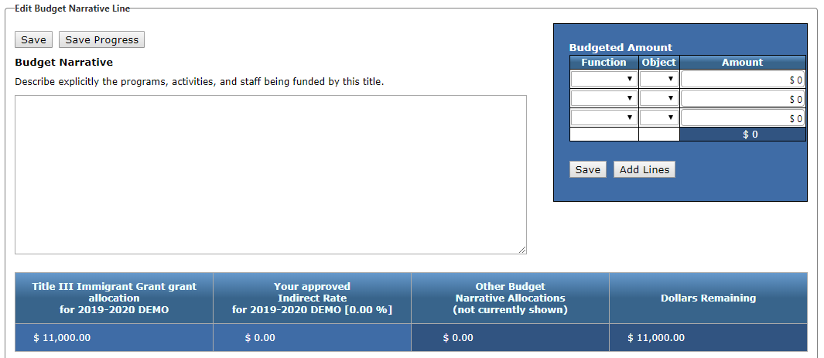
Please notice the SAVE button!
When the applicant is finished entering information for that activity, use the SAVE button. This item will then be added to the Budget Narrative. For additional activities, just repeat the process.

Function Codes:
Further down on this screen, the applicant will find a list of function codes that are allowable for Title III Immigrant Grant activities to use as a resource. These are the only codes available in the drop down menu.

Object Codes
Further down on this screen, the applicant will find a list of Object codes that are allowable for Title III Immigrant Grant to use as a resource. These are the only codes available in the drop down menu.

Spending Page:
The Spending page is prefilled from the function and object codes that were entered on the Budget Narrative page. The Title III Immigrant Grant allocation is in the upper right corner of this page.
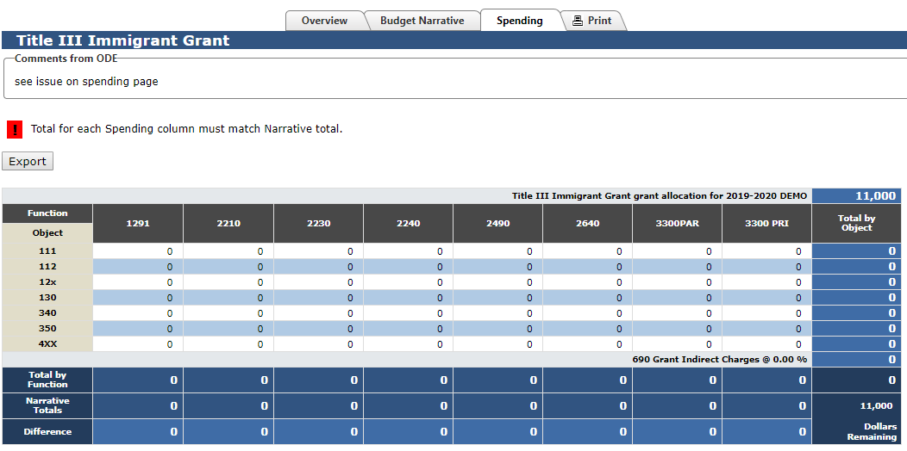
If the user hovers the cursor over either a function or object code, the application will display a long description of the item. The object and function codes are pulled from the “Oregon Program Budgeting and Accounting Manual (PBAM)” found on the Oregon Department of Education’s Finance web page.
The district can export the spending page as an Excel workbook and fill it out on their own computer, outside the CIP Budget Narrative system. The district cannot import the Excel Workbook into the Spending page but can use the information to help fill out the individual school budget narrative lines with the correct function and object codes.

Title IV-A Student Support and Academic Enrichment (SSAE) Pages
When you go to the Title IV-A section of the CIP Budget Narrative, you will land on the Overview page. From this page you will use the tabs in the center to go to the other pages that need to be filled out for Title IV-A.
The Title IV-A pages are:
- Overview
- Equitable Services Worksheet (if applicable)
- Needs Assessment
- Budget Narrative
- Spending

Overview Page
The Overview page gives guidance on the purpose of Title IV-A, how the funds may be spent and eligibility for the program.
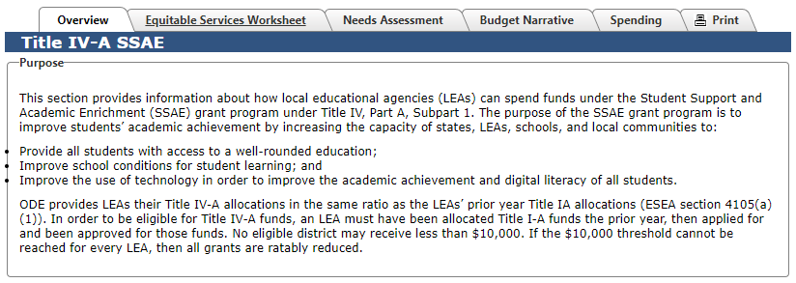

Equitable Services Worksheet Page
The Equitable Services Worksheet page is where the district enters enrollment and allocation data to calculate the amount of Title IV-A funds that an LEA must make available for equitable services to private schools.

Needs Assessment Page
An LEA or consortium that receives $30,000 or more Title IV-A funds must conduct a comprehensive needs assessment once every three years, whether the district is transferring these funds or not. A comprehensive needs assessment should examine access and opportunities to the three focus areas.
LEAs are encouraged to identify needs and plan the use of these funds as part of their continuous improvement plan. The LEA will identify priorities and include objectives that address the district’s prioritized needs. SSAE funds should support LEA priorities and can be leveraged with other federal, state, or local resources. The CIP budget narrative can then be completed to include budgeted activities to support the plan objectives.
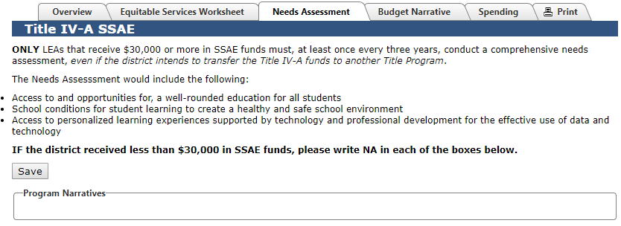
In order to enter information in the box, click in the box, type and make sure to hit the Save button.

Budget Narrative Page:
The Budget Narrative Page is where the district explicitly describes the programs, activities, and staff being funded by this title. Each allowable expenditure needs to have a separate narrative line. The district can add narrative lines by using the Add Narrative Line button.
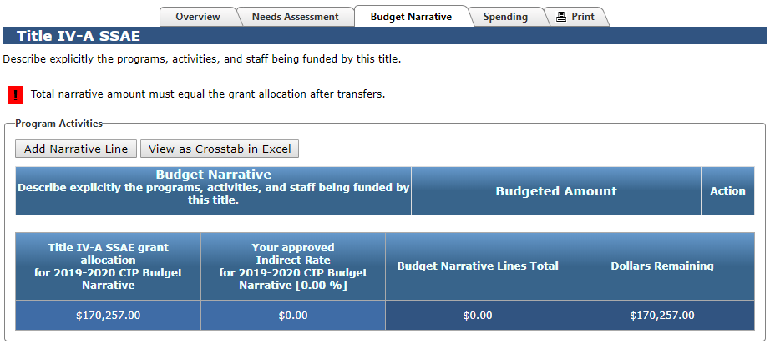
Districts should create a separate line item for each proposed strategy. All strategies included in the Budget Narrative should include:
- The related need from the Needs Assessment (WHY did you choose this strategy?);
- A brief description of the strategy/activity (WHAT is the objective?);
- The audience for the activity (WHO is impacted?); and
- The measure(s) used to determine whether the strategy is generating the result you expect. (HOW will you measure impact?)
Messages:
- The green message reminds districts that they have private schools wishing to participate in Title II-A services.
- The red error message indicates that the narrative total does not add up to the total of the grant.
Each allowable expenditure needs a separate narrative line. After you have added a narrative line you will see an Edit button on the right
The Edit button opens another screen where you can enter in the specific information for each expenditure tied to a prioritized need. The text box is for the description of the expenditure. The right Budgeted Amount boxes will give a drop down menu for Function and Object Codes and the district will enter the dollar amounts for each specific Function and Object code. There can be more than one code and dollar amount per activity.
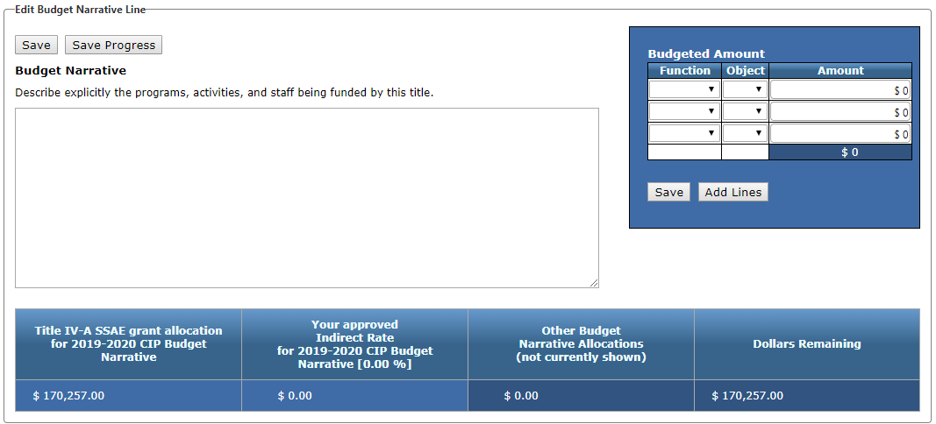
Don’t forget to Save!
There are two different Save buttons. The Save Progress button will save what you have entered on this page and keep you on this page. The Save button will save what you have entered but take you back out to the Budget Narrative page.

Function Codes:
Further down on this screen, the applicant will find a list of function codes that are allowable for Title IV-A activities to use as a resource. These are the only codes available in the drop down menu.
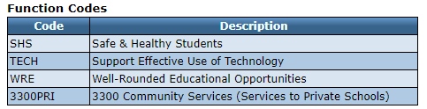

Object Codes
Further down on this screen, the applicant will find a list of Object codes that are allowable for Title II-A activities to use as a resource. These are the only codes available in the drop down menu.
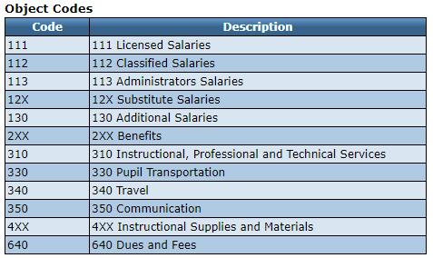

Spending Page:
The Spending page is prefilled from the function and object codes that were entered on the Budget Narrative page. The Title II-A allocation is in the upper right corner of this page.
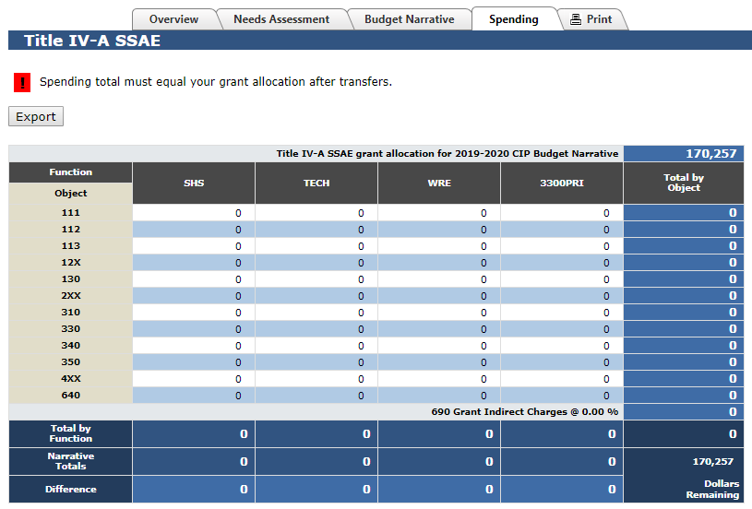
Note: The indirect charges are already subtracted on this page.
If the user hovers the cursor over either a function or object code, the application will display a long description of the item. The object and function codes are pulled from the “Oregon Program Budgeting and Accounting Manual (PBAM)” found on the Oregon Department of Education’s Finance web page.
The district can export the spending page as an Excel workbook and fill it out on their own computer, outside the CIP Budget Narrative system. The district cannot import the Excel Workbook into the Spending page but can use the information to help fill out the individual narrative lines with the correct function and object codes.
Don’t forget to Save on a regular basis.

Other Title Programs
Most programs contained in the application follow the same general use principles. Applicants will find similarity between the pages, but specific questions and requirements are tailored to each page.

Title I-C Regular School Program:

Priority for Service Page:
On this page the applicant will indicate which schools will be participating in the project and the number and types of students that have been identified.

Title V-B REAP:
REAP districts have different rules for use of funds. Districts eligible for REAP will find their allocation at the bottom of the V-B REAP Budget Narrative page. REAP districts can then choose how to spend those total dollars based on allowable activities.

Carryover
For programs that allow carryover, the carryover pages are on the Summary Screen.
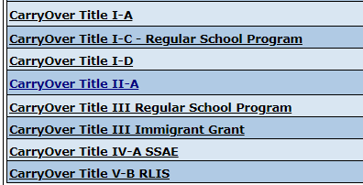
The Carryover sections interface with current expenditure claims in EGMS and will open after Nov. 15th.
Remember, all expenditures through Sept 30th need to be claimed through EGMS no later than Nov. 14th.
Each Carryover Page will list the total original grant allocation, maximum carryover allowed and the balance remaining in EGMS. Once submitted and approved, the Carryover Page cannot be revised within the CIP Budget Narrative Application. The district must contact the program’s specialist for revisions.
Steps on the Carryover Page:
- The district will enter the requested amount of carryover—generally the district can request the total balance remaining.
- The district will explain the reason funds were not expended.
- The district will have a Budget Narrative box to describe the allowable activities the carryover will be used for.
- The district will enter a Function Code and Budgeted Amount.
- Don’t forget to Save.
After the information has been saved, the district will go back to the Summary Page and hit the Submit button. This will inform ODE Specialists that a review is necessary. Once the ODE specialist reviews the request they will either:
- Approve – This will immediately notify EGMS and the district that carryover has been approved.
- Response Required – This will immediately notify the applicant that there is attention needed prior to approval.

Special Directions for Consortium Members and Institutions:

Title I-C Consortium:
Applicants for a Title I-C Consortium will see the following screens:
- Prerequisites
  - All member districts will need to fulfill prerequisites. The status of their progress is shown when the consortium lead selects “Details” in the Action column for that prerequisite.
- Contacts
- Consolidated Spending
  - When opened all member allocations will be included in the consortium allocation shown here.
  - Make sure indirect has been negotiated.
- Title I-C
  - Overview
  - Priority for Service
    - The consortium must enter this information for each district in the consortium
    - Use the UP arrow to move from one district to the next.
  - Budget Narrative
  - Spending
- Title I-C Carryover

Title III Regular School Program Consortium:
Applicants for a Title III Regular School Program Consortium will see the following screens:
- Prerequisites
  - All member districts will need to fulfill prerequisites. The status of their progress is shown when the consortium lead selects “Details” in the Action column for that prerequisite.
- Contacts
- Consolidated Spending
  - When opened all member allocations will be included in the consortium allocation shown here.
  - Indirect rate is set at 2% maximum.
- Title III Regular School Program
  - Overview
  - Detailed Narrative
  - Budget Narrative
- Title III Regular School Program Carryover

Contacts
Section | Contact | Phone | Email
CIP Budget Narrative Tool questions | Kyle Walker | 503-689-0479 | kyle.walker@ode.oregon.gov
Prerequisites | Kyle Walker | 503-689-0479 | kyle.walker@ode.oregon.gov
Contacts | Kyle Walker | 503-689-0479 | kyle.walker@ode.oregon.gov
Consolidated Spending | Lisa Plumb  Jen Engberg | 503-947-5749  503-947-0339 | lisa.plumb@ode.oregon.gov  jennifer.engberg@ode.oregon.gov
Title I-A Program Questions | Amy Tidwell  Lisa Plumb  Jen Engberg  Sarah Martin | 503-580-0078  503-947-5749  503-947-0339  503-947-5668 | amy.tidwell@ode.oregon.gov  lisa.plumb@ode.oregon.gov  jennifer.engberg@ode.oregon.gov  sarah.martin@ode.oregon.gov
Title I-C Program Questions | Yuliana Kenfield | 503-400 1991  503-428-0608 | yuliana.kenfield@ode.oregon.gov
Title I-D Program Questions | Jen Engberg | 503-947-0339 | jennifer.engberg@ode.oregon.gov
Title II-A Program Questions | Sarah Martin | 503-947-5668 | sarah.martin@ode.oregon.gov
Title III Program Questions | Kim Miller | 971-239-9681  971-720-3444 | kim.a.miller@ode.oregon.gov
Title IV-A Program Questions | Lisa Plumb | 503-947-5749 | lisa.plumb@ode.oregon.gov
Title V-B RLIS Program questions | Amy Tidwell | 503-580-0078 | amy.tidwell@ode.oregon.gov
Title V-B REAP Program Questions | Amy Tidwell | 503-580-0078 | amy.tidwell@ode.oregon.gov

