Funding Guide: Services & Supports for Homeless Students

This tool is designed to help McKinney-Vento Liaisons determine which funding sources can be used to support the needs of students experiencing homelessness. The table of contents corresponds to each legal responsibility of the McKinney-Vento liaison, and are intended to help LEAs robustly fulfill those responsibilities and provide comprehensive support. It includes a pre-filled matrix showing allowable uses of key federal funds and provides space for you to add other federal, local and community-based funding sources. There are a variety of federal, state, tribal and local funds that can be woven together to meet the various needs of students experiencing homelessness. NOTE: This file has been modified to meet the Oregon Department of Education website accessibility requirements. Source: SHC Funding Guide: Services & Supports for Homeless Students

Step-by-Step Instructions

 | Review the Pre-Filled Funding Columns  - Check the first two columns: Title I, Part A, and McKinney-Vento Act (EHCY funds)  - Each row (or student need) has an “X” if that funding source can be used to meet the need
 | Consult with Your LEA’s Federal Programs Officer  - Talk with your LEA’s federal programs officer to learn:  - Which title programs are available in your school  - How these funds can be used  - Complete the “Other Federal Funding Sources” column as applicable
 | Assess Local Availability  - Talk with your tribal, state, local education agencies, and community-based organizations to learn:  - What funds are already available  - How funds are currently being used  - What gaps exist
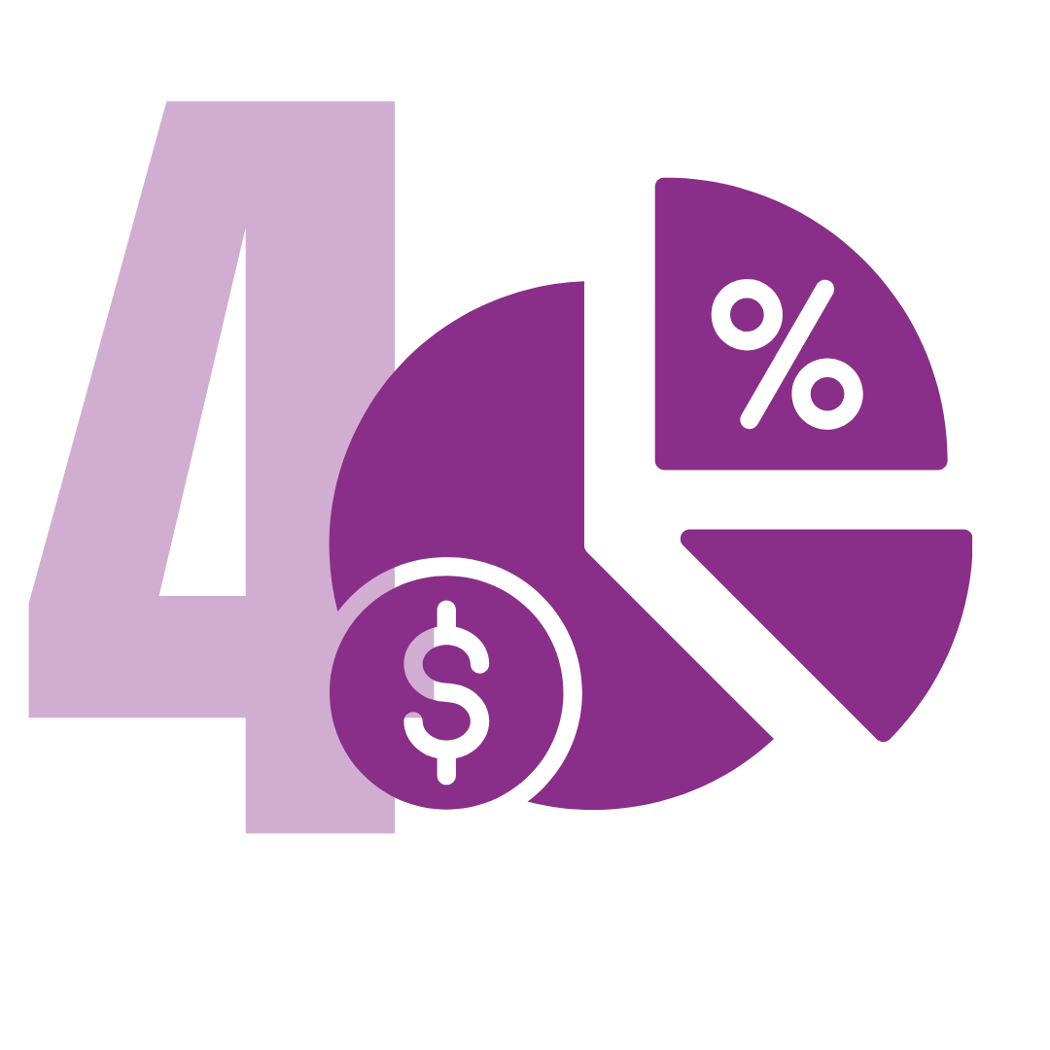 | Complete the Final Three Columns (This step helps you localize the tool and plan for additional supports outside of Title I and McKinney-Vento funds.)  - Use your findings to complete:  - Other Federal Funding Sources  - State, Tribal, and Local Funds  - Community Partnerships and Donations
 | Use the Tool for Strategic Planning  - Use the completed tool to:  - Advocate for resource allocation  - Coordinate with partners  - Plan budgets and grant applications  - Train school staff on allowable uses of funds
 | Contact Your State Coordinator if you’re unsure about specific allowable uses or funding rules:  - Title I Part A: All schools must reserve Title I Part A funds to serve homeless students (20 U.S.C. §6313(c)(3)(A)). Title I funds reserved for homeless children and youth may be used for services not ordinarily provided by Title I, including funding local liaisons’ salary and transportation to the school of origin (20 U.S.C. §6313(c)(3)(C)(ii)). Two principles govern the use of Title I, Part A funds to provide such services to homeless students.
  - First, the services must be reasonable and necessary to assist homeless students to take advantage of educational opportunities. (2 CFR § 200.403(a)).
  - Second, Title I, Part A funds must be used only as a last resort when funds or services are not available from other public or private sources. (See ESEA section 1115(e)(2)).
- McKinney-Vento Act Education for Homeless Children and Youth Funds: McKinney-Vento subgrant funds are awarded through a competitive grant process and must be used for the purpose of facilitating the identification, enrollment, attendance, and success in school of homeless children and youth.
- Other Federal Funding Sources: Title I, Title II, Title IV, Part A, Rural Low Income Schools, Title IV, Part B, CLSD, IDEA, Part B, ISEP, FACE, Indian Education (Title VI, Part A).
- Tribal, State and Local Funds: Liaisons can modify this column to include any funding available to their school either through State funds or other local (including Tribal) funds.
- Community Partnerships and Donations: Liaisons can build on this resource list as they identify additional funding partners, resource providers, etc. These resources can be local, state or national.

Designate Liaison
The local educational agencies will designate an appropriate staff person, able to carry out the duties described in the law, who may also be a coordinator for other Federal programs, as a local educational agency liaison for homeless children and youths. 42 USC §11432(g)(1)(J)(ii)

 | Title I Part A | McKinney-Vento Act Education for Homeless Children and Youth Funds | Other Federal Funding Sources | State and Local Funds | Community Partnerships and Donation
 |  |  | Liaisons: Finish filling in these three columns for your school
Liaison Salary (Note: Title I Part A allows “all or part,” whereas McKinney-Vento allows a “portion”) | X | X

Identification
Associated Liaison Duty: Identify children and youth experiencing homelessness through outreach and coordination with other entities and agencies. 42 USC §11432(g)(6)(A)(i)

Specific Need | Title I Part A | McKinney-Vento Act Education for Homeless Children and Youth Funds | Other Federal Funding Sources | State and Local Funds | Community Partnerships and Donation
 |  |  | Liaisons: Finish filling in these three columns for your school
Outreach services to students living in shelters, motels, and other temporary residences | X | X
Services and assistance to attract, engage, and retain homeless children and youths, particularly homeless children and youths who are not enrolled in school, in public school programs and services provided to non-homeless children and youths. (Section 723(d)(7)) | X | X

Enrollment & School Success
Associated Liaison Duty: Ensure that children and youth experiencing homelessness are enrolled in, and have a full and equal opportunity to succeed in school. Additionally, ensure that children and youth experiencing homelessness who meet the relevant eligibility criteria do not face barriers to accessing academic and extracurricular activities, including magnet school, summer school, career and technical education, advanced placement, online learning, and charter school programs. 42 USC §11432(g)(6)(A)(ii)

Specific Need for Enrollment & School Success | Title I Part A | McKinney-Vento Act Education for Homeless Children and Youth Funds | Other Federal Funding Sources | State and Local Funds | Community Partnerships and Donation
 |  |  | Liaisons: Finish filling in these three columns for your school
Costs Associated With Removing Barriers To Participation, Retention And Success In School. Examples include extracurricular fees, test fees (IB/ACT/SAT etc.), co-curricular (ASB cards, cap and gown, traditional eagle feather for cap), materials and fees for educational programs/courses (i.e., fees associated with music, art, STEM, CTE, etc.), alternative education programs, Running Start, credit retrieval, GED assistance and GED testing for school-age students | X | X
Tutoring, supplemental instruction, and other educational services that help homeless children and youths reach the same challenging State academic standards the State establishes for other children and youths. (Section 723(d)(1)) | X | X
Assistance with high school graduation fees, college examination, or application costs when the school’s policy is not to provide this support for any of its students for these purposes | X | X
Fines. Examples include lost/damaged materials, uniforms, books, etc |  | X
Payment of fees and costs associated with tracking, obtaining, and transferring records necessary to enroll homeless children and youths in school. The records may include birth certificates, immunization or other required health records, academic records, guardianship records, and evaluations for special programs and services |  | X
Tutoring services, especially in shelters or other locations where homeless students live | X | X
Extended learning time (before and after school, Saturday classes, summer school) to compensate for lack of quiet time for homework in shelters or other overcrowded living conditions | X | X
Before- and after-school, mentoring, and summer programs for homeless children and youths in which a teacher or other qualified individual provides tutoring, homework assistance, and supervision of educational activities | X | X
Expedited Evaluations: Gifted & Talented; Special Education; Section 504; early intervention services for eligible infants and toddlers with disabilities under Part C of the IDEA; programs for English learners; career and technical education; meals through the National School Lunch Program and School Breakfast Program |  | X
Remedy or assist with removal of barriers that prevent children and youth who are homeless from having a fair opportunity to attend school, including assistance with medical needs (eye glasses, hearing aids, doctor and dental appointments) and other emergency needs | X | X
Develop coordination between schools and agencies to provide services |  | X
Activities to address the particular needs of homeless children and youths that may arise from domestic violence and parental mental health or substance abuse problems |  | X
Providing school supplies, including those to be distributed at shelters or temporary housing facilities, or other appropriate locations | X | X
Purchase of supplementary instructional materials such as books, school supplies, homework tools, and calculators | X | X
Specialized instructional support services, including violence prevention counseling, and referrals for such services |  | X
Providing extraordinary or emergency services needed to enable homeless children and youths to attend school and participate fully in school activities |  | X
Barriers to learning that may occur while living in domestic abuse and emergency shelters | X | X
Printed materials that are needed to support and expand literacy development | X | X

Early Care & Education
Associated Liaison Duty: Ensure that children and youth experiencing homelessness have access to and receive educational services for which such families, children and youths are eligible, including services through Early Head Start, Head Start programs and other preschool programs administered by the school.
42 USC §11432(g)(6)(A)(iii)

Specific Need | Title I Part A | McKinney-Vento Act Education for Homeless Children and Youth Funds | Other Federal Funding Sources | State and Local Funds | Community Partnerships and Donation
 |  |  | Liaisons: Finish filling in these three columns for your school
Healthy Relationships for Expecting and Parenting Youth |  | X
Developmentally appropriate early childhood education programs for preschool-aged homeless children that are not provided through other Federal, State, or local funds | X | X
Early intervention services for eligible infants and toddlers with disabilities under Part C of the IDEA |  | X
Printed materials that are needed to support and expand literacy development | X | X

Referrals
Associated Liaison Duty: Ensure that children and youth experiencing homelessness receive referrals to health care, dental, mental health, substance abuse, housing, and other appropriate services.
42 USC §11432(g)(6)(A)(iv)

Specific Need | Title I Part A | McKinney-Vento Act Education for Homeless Children and Youth Funds | Other Federal Funding Sources | State and Local Funds | Community Partnerships and Donation
 |  |  | Liaisons: Finish filling in these three columns for your school
Referrals of eligible students to medical, dental, mental, and other health services (Section 723(d)(4)) |  | X
Referrals to counseling services to address anxiety related to homelessness that is impeding learning | X | X
Coordination between schools and agencies providing services to homeless children and youths in order to expand and enhance such services. Coordination with programs funded under the Runaway and Homeless Youth Act must be included in this effort. |  | X

Family Engagement
Associated Liaison Duty: Ensure that the parents or guardians of children and youth experiencing homelessness are informed of the educational and related opportunities available to their children, and are provided with meaningful opportunities to participate in the education of their children.
42 USC §11432(g)(6)(A)(v)

Specific Need | Title I Part A | McKinney-Vento Act Education for Homeless Children and Youth Funds | Other Federal Funding Sources | State and Local Funds | Community Partnerships and Donation
 |  |  | Liaisons: Finish filling in these three columns for your school
Provide education and training to parents/guardians of HCY regarding rights and resources |  | X
Parental involvement specifically oriented to reaching out to parents of homeless students |  | X
Other activities designed to increase the meaningful involvement of parents and guardians of homeless children or youths in the education of such children or youth | X | X
Interpretation and translations of materials for ELL students and their parents for educational and educational rights and responsibilities purposes | X | X

Public Notice of Rights
Associated Liaison Duty: Ensure that public notice of the educational rights of children and youth experiencing homelessness is disseminated in locations frequented by families and youth experiencing homelessness, including schools, shelters, public libraries, and soup kitchens, in a manner and form understandable to parents, guardians, and unaccompanied youth.
42 USC §11432(g)(6)(A)(vi)

Specific Need | Title I Part A | McKinney-Vento Act Education for Homeless Children and Youth Funds | Other Federal Funding Sources | State and Local Funds | Community Partnerships and Donation
 |  |  | Liaisons: Finish filling in these three columns for your school
Printing, disseminating materials |  | X
Development of social media awareness campaign |  | X

Enrollment Disputes
Associated Liaison Duty: Ensure that enrollment disputes are mediated in accordance with the provisions of the Act. 42 USC §11432(g)(6)(A)(vii)

Specific Need | Title I Part A | McKinney-Vento Act Education for Homeless Children and Youth Funds | Other Federal Funding Sources | State and Local Funds | Community Partnerships and Donation
 |  |  | Liaisons: Finish filling in these three columns for your school
Printing dispute resolution materials |  | X

Transportation
Associated Liaison Duty: Ensure that parents, guardians, and unaccompanied youth experiencing homelessness are fully informed of all transportation services available to McKinney-Vento students, including transportation to the school of origin, and are assisted in accessing transportation to the school deemed in the best interest of the student. 42 USC §11432(g)(6)(A)(viii)

Specific Need for Transportation | Title I Part A | McKinney-Vento Act Education for Homeless Children and Youth Funds | Other Federal Funding Sources | State and Local Funds | Community Partnerships and Donation
 |  |  | Liaisons: Finish filling in these three columns for your school
Bus service to and from the school of origin | X | X
Gas cards or reimbursement to families | X | X
Cost of providing public transit passes (bus, train) | X | X
Taxi or rideshare (Zum, Uber, Lyft, etc.) | X | X
Extracurricular activities (tutoring, athletic practice, etc.) | X | X
Cost of attending school-sponsored field trips and college visits |  | X
To a work study program, internship, etc. |  | X
Cost of transporting parents of young children/students who must accompany their child to school | X | X
Car repairs for a family or youth experiencing homelessness when the car is the student’s only mode of transportation to and from school | X | X
Purchasing a vehicle for transporting students experiencing homelessness | X | X
Hiring a district or regional transportation coordinator for students experiencing homelessness | X | X
Assistance with excess cost to pay for transportation to a student’s school of origin for the remainder of the academic year after a formerly homeless student becomes permanently housed | X
Bus service to and from school (i.e. regular transportation offered to all children and youth)

Professional Development
Associated Liaison Duty: Liaisons and other school personnel providing services receive professional development and other support. 42 USC §11432(g)(6)(A)(ix)

Specific Need | Title I Part A | McKinney-Vento Act Education for Homeless Children and Youth Funds | Other Federal Funding Sources | State and Local Funds | Community Partnerships and Donation
 |  |  | Liaisons: Finish filling in these three columns for your school
Professional development and other activities designed to heighten the understanding and sensitivity of such personnel to the needs of homeless children and youths, the rights of such children and youths under the McKinney Vento Act, and the specific educational needs of runaway and homeless youths | X | X

Unaccompanied Homeless Youth
Associated Liaison Duty: Regarding unaccompanied homeless youth: Ensure that youth are enrolled in school and have opportunities to meet the same challenging State academic standards as other children and youth, as well as are informed of their status as independent students under the Higher Education Act of 1965 (20 U.S.C. § 1087vv), and receive assistance verifying this status for purposes of the Free Application for Federal Student Aid (FAFSA). Additionally, ensure that unaccompanied homeless youth and other youths separated from public schools are identified and accorded equal access to appropriate secondary education and support services, including by identifying and removing barriers that prevent youths described in this clause from receiving appropriate credit for full or partial coursework satisfactorily completed while attending a prior school, in accordance with State, local, and school policies. 42 USC §11432(g)(6)(A)(x)

Specific Need | Title I Part A | McKinney-Vento Act Education for Homeless Children and Youth Funds | Other Federal Funding Sources | State and Local Funds | Community Partnerships and Donation
 |  |  | Liaisons: Finish filling in these three columns for your school
Providing extraordinary or emergency services needed to enable homeless children and youths to attend school and participate fully in school activities (Section 723(d)(16)) |  | X
Remedy or assist with removal of barriers that prevent children and youth who are homeless from having a fair opportunity to attend school, including assistance with medical needs (eye glasses, doctor and dental appointments) and other emergency needs | X | X
Food to meet need during weekend | X | X

Other Commonly Requested Costs
Associated Liaison Duty: Regarding unaccompanied homeless youth: Ensure that youth are enrolled in school and have opportunities to meet the same challenging State academic standards as other children and youth, as well as are informed of their status as independent students under the Higher Education Act of 1965 (20 U.S.C. § 1087vv), and receive assistance verifying this status for purposes of the Free Application for Federal Student Aid (FAFSA). Additionally, ensure that unaccompanied homeless youth and other youths separated from public schools are identified and accorded equal access to appropriate secondary education and support services, including by identifying and removing barriers that prevent youths described in this clause from receiving appropriate credit for full or partial coursework satisfactorily completed while attending a prior school, in accordance with State, local, and school policies. 42 USC §11432(g)(6)(A)(x)

Specific Need – Other Commonly Requested Costs | Title I Part A | McKinney-Vento Act Education for Homeless Children and Youth Funds | Other Federal Funding Sources | State and Local Funds | Community Partnerships and Donation
 |  |  | Liaisons: Finish filling in these three columns for your school
Air mattresses, bedding for students |  | X
Rental or mortgage assistance
Utility bills
Motel/hotel vouchers
Yearbooks
Entertainment such as tickets for sporting events, concerts, or shows
Prom expenses
Food to meet need during instructional time or activities | X
Items of clothing, particularly if necessary, to meet a school’s dress or uniform requirement; Clothing and shoes necessary to participate in physical education or CTE classes | X | X
Washer/Dryer and laundry soap for student use to eliminate hygiene concerns resulting in absences, or being bullied |  | X
Baby-related items (e.g. diapers, car seats, formula, breast-feeding supplies) |  | X

