Mentor Observation Tool
Verbal Flow
Verbal flow is a data gathering strategy that provides information about who talks with whom. It requires that the observer be given a seating chart labeled with students’ names so the observer can accurately record information about the flow of verbal communication between teacher and students, students and teacher, and students and students
Teacher: ____________________________ Mentor:__________________________________
Area of Instruction: _________________ Standard:___________________________________
Observation Focus: _____________________________________________________________
- Involvement of students in the lesson
- What is happening with a certain group of students
- Gender or other bias (which students are
called on, how often, in what order)

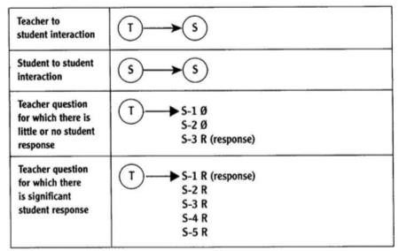
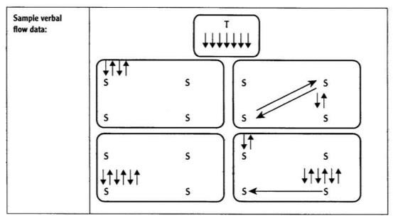
Ask teacher to be observed for a seating chart prior to this observation.

