Connector: Map Your Cultural Reference Points
Purpose: To begin understanding aspects of surface, shallow, and deep culture for clues about our own culture. Think of it as a treasure hunt or archeological dig.

SURFACE Culture
- How did your family identify ethnically or racially?
- Where did you live – urban, suburban, or rural community?
- What is the story of your family in America? Has your family been here for generations, a few decades or just a few years?
- How would you describe your family’s economic status – middle class, upper class, working class, or low income? What did it mean in terms of quality of life?
- What is the typical education level of your family?
- What family folklore or stories did you regularly hear growing up?
- What are some of your family traditions – holidays, foods, or rituals?
- Who were the heroes celebrated in your family or community? Why? Who were the antiheroes? Who were the “bad guys”?
SHALLOW Culture
- What metaphors, analogies, parables, or “witty” sayings do you remember from parents?
- What family stories are regularly told or referenced? What message do they communicate about core values?
- What did parents, neighbors, and other authority figures tell you respect looked like? Disrespect?
- How were you trained to respond to different emotional displays – crying, anger, and happiness?
- What physical, social, or cultural attributes were praised in your community? Which ones were you taught to avoid?
- How were you expected to interact with authority figures? Was authority of teachers and other elders assumed or did it have to be earned?
- As a child, did you call adults by their first name?
- What got you shunned or shamed in your family?
- What earned your praise as a child?
- Were you allowed to question, or talk back to, adults? Was it okay to call adults by their first name?
- What is your family/community’s relationship with time?
A few questions exploring DEEP Culture
- How do you believe students should behave at school? What behaviors should students exhibit – talk and discourse patterns, volume of interaction, time on task, collaboration or individual work, seat time versus interaction? Why do you believe this?
- What messages did you get about why other racial or ethnic groups succeeded or not?
- What did your culture teach about intelligence? Did you believe it was set at birth? Did you believe it was genetic? Did you believe some groups were smarter than others?

- With a partner, take time to think about and answer a few key questions listed above.
- Next steps might be to continue this exercise on your own. You might:

  - Pull out some old photo albums or journals to trigger memories of your family’s culture;
  - Interview family members about cultural practices or views.
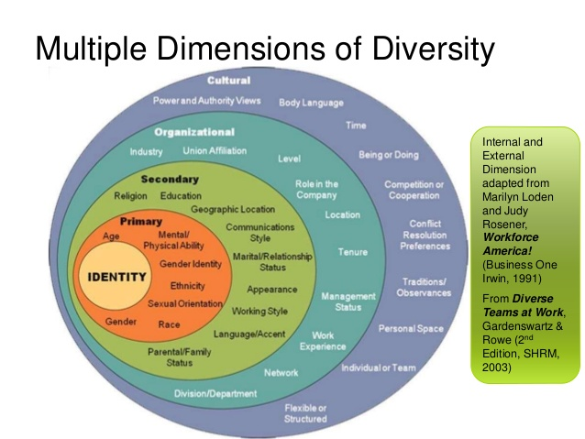
Describe a few dimensions of culture that impact your life and work.
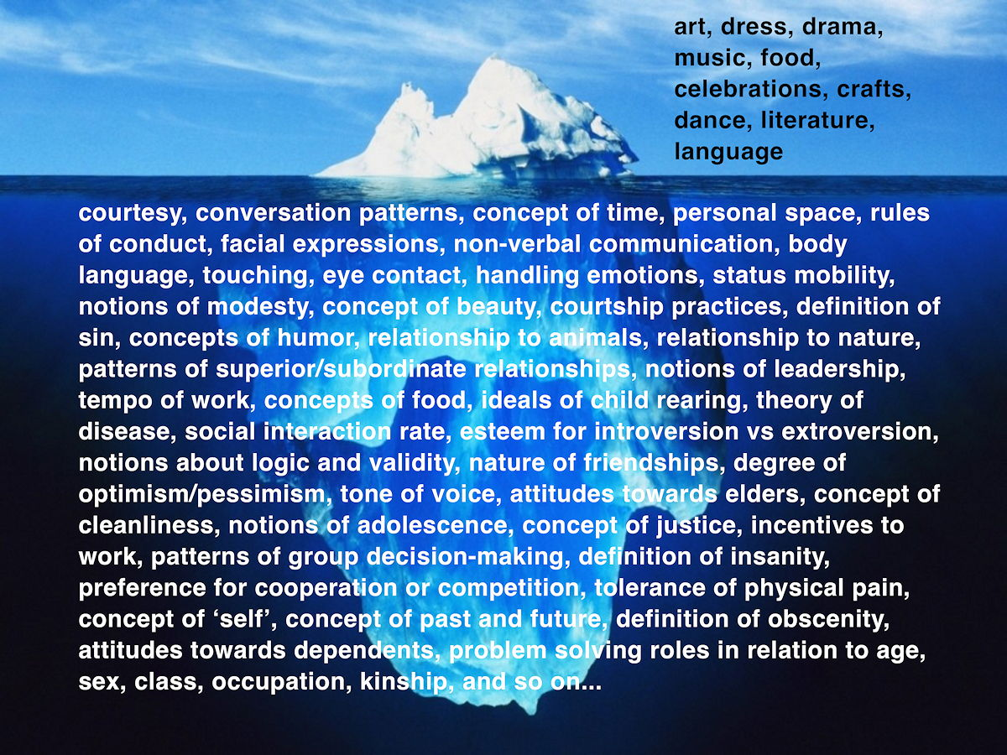

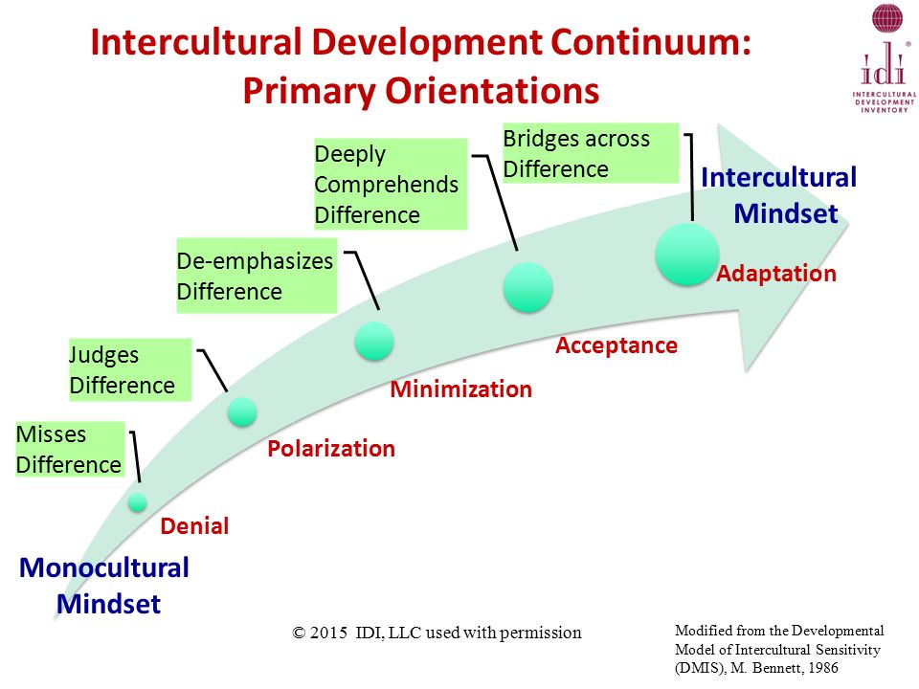AN EXAMPLE OF MINDSETS AT DIFFERENT LEVELS OF DEVELOPMENT
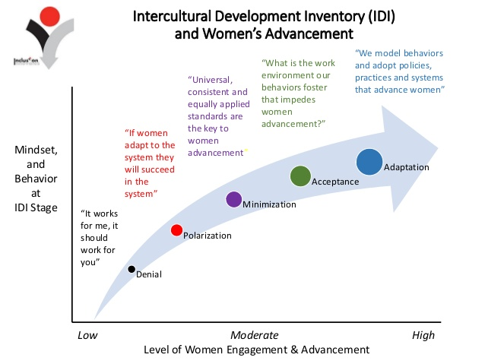

In your context, think about the kinds of comments you might hear from people in each stage of intercultural development.

