EI/ECSE SPR&I Procedural Compliance:

File Review User Guide

This User Guide provides guidance on the submission of data for the annual Performance Compliance Review (PCR) and evidence of corrections of any noncompliance, including additional file reviews and interventions. | Documentation of Compliance & Corrections

EI/ECSE SPR&I Procedural Compliance: File Review User Guide

Table of Contents

Welcome to EI/ECSE SPR&I | 3
Procedural Compliance Review Corrections | 4
A Note about “Lights” | 5
Procedural Compliance Review (PCR)
- Step 1: Updating Your Contact Information | 6
- Step 2: Logging In | 7
- Step 3: Selecting Your Files | 8
- Step 4: Locking in Your Files | 10
- Step 5: The PCR Review Form | 12
- Step 6: Entering Your Data into the System | 13
- Step 7: Double Checking Your PCR Entries | 17
- Step 8: Submitting Your PCR Data to ODE | 18
- Step 9: ODE Verification | 20
- Step 10: Correcting PCR Noncompliance | 21
Additional File Reviews | 22
- Step 1: How Many Files Will You Need to Review? | 24
- Step 2: Selecting Your File(s) | 25
- Step 3: Entering Your Data | 26
Systemic Issues | 27
- Step 1: Wrapping Up Individual File Corrections | 29
- Step 2: Completing Interventions for Specific Standards | 30
- Step 3: Corrective File Review(s) | 32
SPR&I Reports | 34
Addendum: EI/ECSE SPR&I Flow Chart | 36

Welcome to the EI/ECSE SPR&I Procedural Compliance Review!

This manual provides guidance to complete your EI/ECSE SPR&I Procedural Compliance Review (PCR). Completing the SPR&I process can be an experience that allows programs to not only identify and correct program noncompliance, but to:

- Create a team-building opportunity;
- Identify staff development needs;
- Analyze the efficiency of program systems;
- Provide a link between compliance in child files with progress in indicators;
Most importantly:
- Ensure that children who are entitled to FAPE are receiving it.
County Contact Information:

Your ODE County Contacts are available to assist you with your questions regarding SPR&I:

County Contact | Email | Phone #
Alan Garland: | alan.garland@ode.state.or.us | (503) 947-5759
Holly Reed-Schindler: | holly.reed.schindler@ode.state.or.us | (503) 947-5820
Bruce Sheppard: | bruce.sheppard@ode.state.or.us | (503) 947-5612
Mandy Stanley: | mandy.stanley@ode.state.or.us | (503) 947-5662
Meredith Villines | Meredith.Villines@ode.state.or.us | (503) 947-0795

Your Procedural Compliance Review Corrections
from last year’s review are due as soon as possible
but no later than April 14 of the following year.

EVIDENCE OF CORRECTION: Any non-compliance found during your Procedural Compliance Review (PCR), must be corrected by:
- Correcting all non-compliance in all standards in individual files (if possible);
- Completing additional file reviews for each standard with non-compliance; and
- If systemic Issues were identified during your PCR process, complete interventions and additional file reviews for each standard with systemic non-compliance.

You must submit all evidence of correction for 100% of your program’s noncompliance (corrections, additional file reviews, and interventions) as soon as possible, but no later than April 14 of the following year. For example, PCR reviews submitted on 2/3/20 must be completed no later than 4/14/21

Reader’s Note: Screen shots are used for illustration purposes and do not reflect the current dates

It is the policy of the State Board of Education and a priority of the Oregon Department of Education that there will be no discrimination or harassment on the grounds of race, color, sex, marital status, religion, nation origin, age, sexual orientation, or disability in any educational programs, activities or employment. Persons having question about equal opportunity and nondiscrimination should contact the Deputy Superintendent of Public Instruction at the Oregon Department of Education, 255 Capitol Street NE, Salem, Oregon 97310; phone 503-947-5740; or fax 503-378-4772.

A Note about “Lights”
The lights on your dashboard indicate where your program is in any given process. Generally:
A red light means something needs your attention. If you have started on a task, but have not yet finished it, the light will remain red.

A yellow light means ODE staff needs to review or approve your work so you can move into the next phase of your PCR Indicator work.

A green light means you have done as much as you can do right now on this task. It does not necessarily mean you are completely finished with the task.

No light means the task is not ready.

Check your dashboard frequently during SPR&I “season” for updates, changes in lights, and other information.

Procedural Compliance Review (PCR)

Step 1: Updating your Contact Information
Before you begin, please be sure your program contact information is up- to-date. SPR&I notifications go to the email addresses listed in the Program Staff section.
ODE county contacts do not receive “bounce” notices from the system, so they do not know if you are not receiving updates. Notifications go to every contact listed. Please make sure the people on this list are the ones you want to receive SPR&I updates.
Updating your contact information is simple. First, double click on the area below the gray box on the right side of your dashboard page that says “Program Staff”.
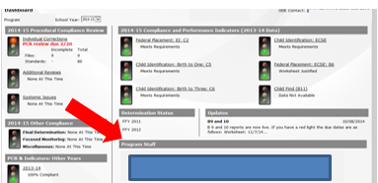

This will bring up your Program Staff editing box.

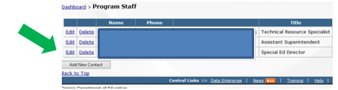
To change information, click on Edit, Delete, or Add New Contact. After you make your updates, click on “Save” (not shown.)

Step 2: Logging In
Using your secure password, login to the system via the ODE District Website at https://district.ode.state.or.us. Access is obtained through your program, not through ODE.
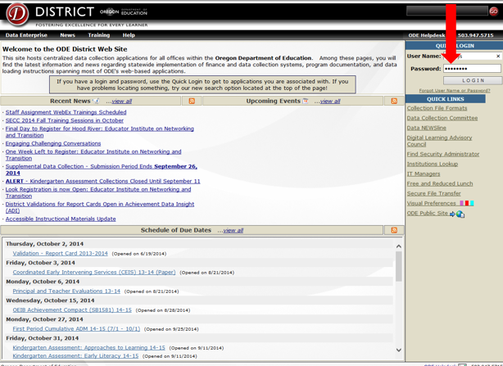
After you click on “LOGIN”, the SPR&I dashboard will appear.
Step 2: Logging-In (continued)
When your dashboard appears, check for any updates. Always check to make sure you are working in the correct school year.
Please note: “PCR due date” indicates the date the final PCR for the current year.
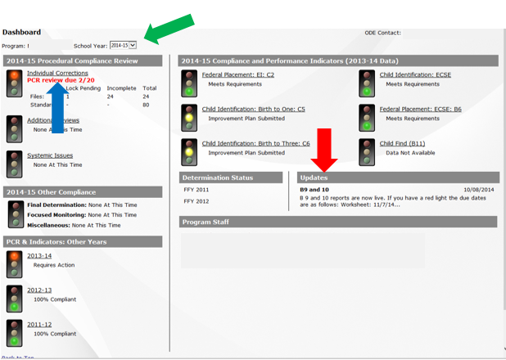

Step 3: Selecting Your Files
The system will automatically provide the required number of slots to enter file information for each category for your program (EI, ECSE, and EI Transition). Use the ecWeb file selection process to generate a representative list of files from your program. If your program had fewer children in a category than the number of slots appearing on your dashboard, please contact your ODE County Contact for assistance.
Note: Files listed in bold print require action.
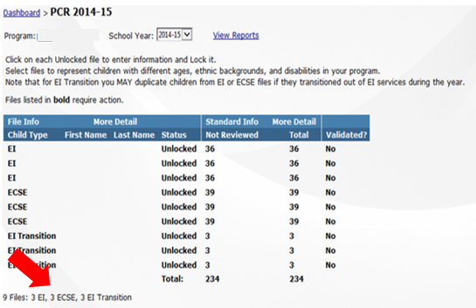
Step 3: Selecting Your Files (continued)
Select and lock in only the files of children who meet the criteria below under Eligibility and Census Verification.

Eligibility and Census Verification
The child file being reviewed includes:
- Documentation that the child was enrolled in the program on December 1st of the census review year whenever possible; and
- A statement of eligibility signed by an Eligibility Team which was in effect by the child’s enrollment in the program; and,
- An Individualized Family Service Plan (IFSP) which was in by the child’s enrollment in the program; and
- The ISFP contained specially designed instruction.
If the child was in the program prior to 12/1 but had a lapsed IFSP on 12/1, the file should not be reviewed – an alternate file should be selected for review. Also, please email your ODE County Contact as soon as possible so that any necessary corrections to the SECC can be made.

Step 4: Locking in Your Files
To lock in your files, first check to make sure that you are using the current year in the “School Year” box at the top of the page. Then click on Individual Corrections next to the red light under Procedural Compliance Review”.

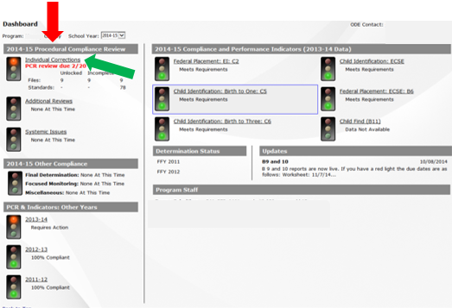

When you arrive at current PCR screen, click on a line under “Child Type” to begin entering an individual child file. When you enter a child’s information, be sure to enter only information relevant to the category of the file you have selected (EI, ECSE or EI Transition.)

Once the information has been entered, click on “Save” and then “Lock” to lock in the file for the PCR review process. ODE staff will review and approve your file selections.

Note: ODE staff cannot approve files for your review until you lock them.

A Note about Timing: To ensure the child continues to meet all criteria for file review, complete the lock-in process close to the time the file is reviewed.

If the child no longer meets all criteria at the time of the PCR review process (e.g., the child is no longer eligible or has transferred to a different program), the file should be unlocked and a new child file selected. If a file needs to be unlocked, contact your ODE County Contact.
Step 4: Locking in your files (continued)
To view demographic information for all files at once, click on More Detail located in the File Info box. Information is based on the December SECC data collection.
The More Detail section located in the Standard Info box provides a quick summary of the compliance status for individual files, including the number of applicable standards and compliance status for each file and verification of any necessary corrections. An additional column indicates ODE verification of the submitted data. Click on “Less Detail” to remove all demographic information except for the child’s name and file category.
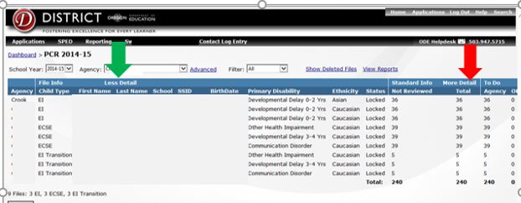

Step 5: The PCR Review Form
After your files have been locked in, print a copy of the PCR Review Form for each child by double clicking on the child’s name and then on Print Blank Form in the information box.
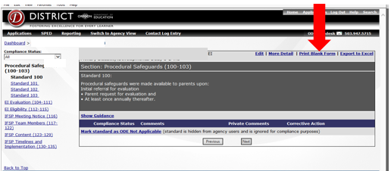

The PCR form will show the Agency name, the child’s SSID number, and the applicable category of standards for the child (EI, ECSE, or EI Transition).
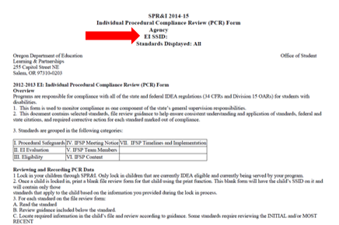

Step 5: The PCR Review Form (continued)
ODE recommends completion of file reviews using the printed PCR form (above) for entering the data into the system. Each Individual standard on the printed PCR form includes ODE guidance and the required corrective actions if the standard is not in compliance.
We also recommend that you retain copies of any printed PCR review forms or materials you use in to complete your correction process. This will assist in facilitating ODE’s review during any verification monitoring activities.

Step 6: Entering Your Data into the System
Select “Not Entered” in the Display Standards box to initiate the data entry process. The Compliance Status box lists the various compliance areas, followed by the standards that apply to the selected file. The drop down menu allows sorting by other criteria (e.g., “All” or by compliance status). In the Compliance Status box in the individual standard, click on “Not Reviewed” and then select the appropriate response from the drop-down menu (e.g. yes, no, NA, or corrected).
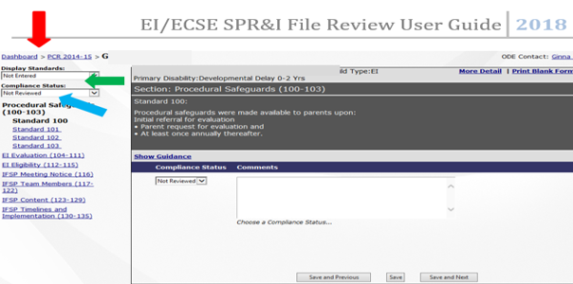

Step 6: Entering Your Data into the System (continued)
Select the appropriate Compliance Status for the standard you are reviewing, add a comment if required or to explain the circumstances, and then click on one of the “Save” options. “Save and Previous” will save your work and then display the previous standard; “Save and Next” will save your work and then display the next standard that requires review.
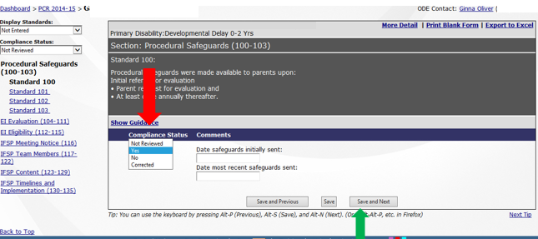

Note We strongly recommend that you correct as you go. It is not necessary to wait for ODE verification to begin making corrections on individual standards. See page 21 for information about making corrections.
Step 6: Entering Your Data into the System (continued)
You may add comments to any standard, but if you entered No or N/A, a comment must be included that describes what was out of compliance or why the standard was not applicable. To simplify the process, the SPR&I system may automatically insert a typical response. You can edit this response or replace it with a different comment if you wish.
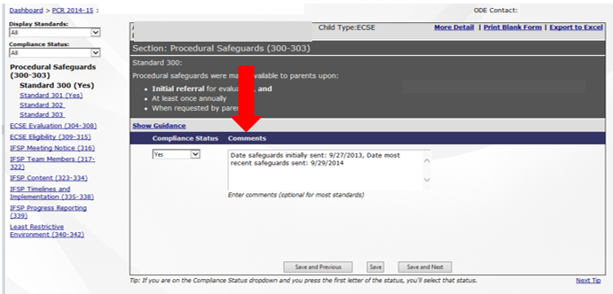Note: ODE County Contacts closely review these comments, so please explain any unusual circumstances, provide specific details, and be concise.
Step 7: Double Checking Your PCR Entries
To check on progress or to double check your data before submitting to ODE, look in the Standard Info column that shows the number of standards that were not reviewed. Click on “More Detail” in the Standard Info box to show more information, including the number of standards marked No, Yes, NA, and Corrected. In the example below, “More Detail” for Standard Info was clicked and is therefore not visible in the screen (it would be where “Less Detail” is, which you can click on to return to the screen without standard information detail.)
ODE completes the “Correction Verified” column. We may mark a standard “Pending” if further information is needed from you.

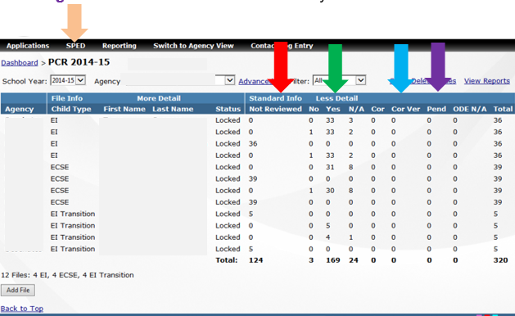

Step 8: Submitting Your PCR Data to ODE
Once you have entered all of the information for all of your files, you can submit your data to ODE for verification. At this point a “Submit All PCR Files” button will appear.
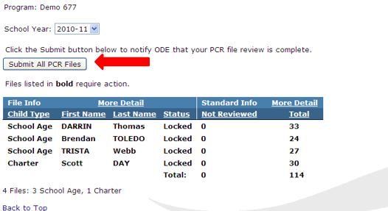

Don’t forget to click on the “Submit” button!

Step 9: ODE Verification
ODE staff will begin our verification process after the PCR submission due date.
If ODE staff agrees with your compliance rating, they will verify your rating by selecting “Yes” under Compliance Status.

If staff disagree with your rating, or have questions for clarification, they may mark the standard with a different rating than you used, such as “No” or “Pending”. These responses generally require more work by your program in order to finish the PCR process.
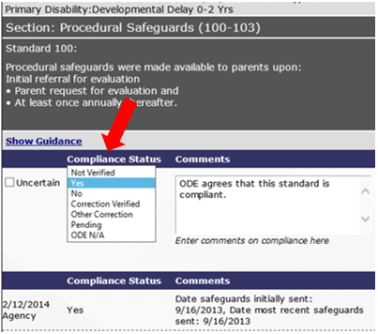

ODE tracks and reports all noncompliance through to 100% correction in our Annual Performance Review (APR), which we submit to the US Dept. of Education, Office of Special Education Programs (OSEP).

Step 10: Correction of Any PCR Noncompliance
All noncompliance resulting from your PCR is corrected through individual file corrections and/or additional file reviews. Specific instructions for correction of each indicator appear in the review screen in the window labeled “Corrective Action”. Further Guidance is available on the PCR review form.
Once you have completed your correction, choose “Corrected” from the drop down menu into the Compliance Status box. You will also need to enter information under Comments in the data entry box(es). You must complete these boxes in order for ODE staff to verify your correction.
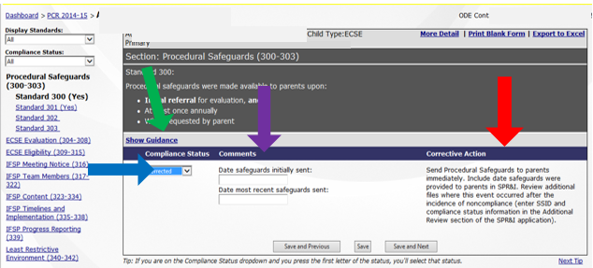
Note: It is not necessary to wait for ODE staff to complete verification of your initial file review in order to begin making corrections on individual standards.
Step 10: Correction of PCR Noncompliance (continued)

Complete corrections as soon as possible, but in any case no later than one year from written notification from ODE of a finding (April 14) ODE recommends that you complete your corrections quickly because:

- Corrections take time. For example, correction of a standard that requires an IFSP meeting (and then additional file reviews) may take longer to complete than one that requires mailing a form.

- If Systemic Issues occur, you will need to complete the individual correction a systemic intervention, and additional file reviews.
Most importantly...
- Noncompliance in certain ECSE standards may mean that a child is not receiving FAPE. These standards must be corrected quickly to assure that the child receives his or her educational entitlements.

Once ODE’s verification process is completed and all of your necessary individual file corrections are complete, the light on your dashboard for “Individual [file] Corrections” will change to green. Now it is time to move on to Additional [file] Reviews.

Additional File Reviews
After you have corrected each standard that was out of compliance, the SPR&I system will require you to complete Additional File Review(s) to determine whether this instance of noncompliance was an isolated one. Some standards require only additional file review(s) for correction. We recommend that you complete all of your individual corrections before you begin reviewing additional files.
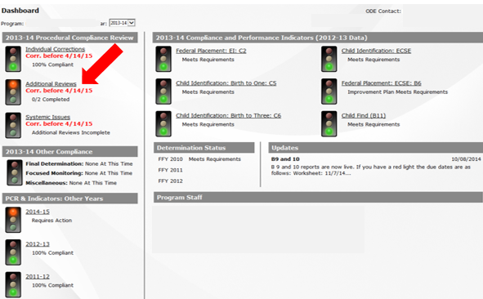

Note: This screen is an example based on a previous year’s Procedural Compliance Review. The due dates above do not apply to the current review.

Additional File Reviews (continued)

Step 1: How Many Files Will You Need to Review?
The number of files that you need to select for additional file reviews will depend on the number you reviewed during your PCR. This number is generated automatically by the system, and you will need to review the required number for each missed standard.
Program Size | Required # of files for initial PCR | Required # of files for Additional File Review
Very Small (1-99 SECC) | 9  (3 for each category) | 2
Small (100-499 SECC) | 12  (4 for each category) | 2
Medium (500-999 SECC) | 24  (8 for each category) | 4
Large (1000+ SECC) | 30  (10 for each category) | 6

NOTE: If the child you entered into the system is no longer enrolled in your program, contact your ODE County Contact for guidance.

Additional File Reviews

Step 2: Selecting Your Files

Select files in which the information you are reviewing occurred after the date of noncompliance in your initial review of the standard (s).
You may select files for each standard you need to review, but we strongly recommend that you use the SSID Master Summary. Find this by clicking on Additional Reviews on your dashboard.
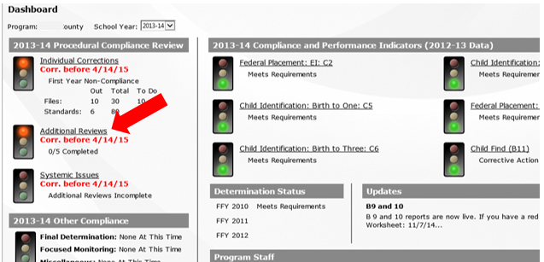

Note: This screen is an example based on a previous year’s Procedural Compliance Review. The due dates above do not apply to the current review.
Using the Master SSID Summary list is optional, but it can help reduce the amount of time required to complete your additional file reviews, especially if you have more than one standard out of compliance.
When using the Master SSID list, select files that cover the majority of noncompliant standards. The Master SSID Summary will automatically give you the correct number of file spaces for your additional file review(s).
If a standard you need to do additional reviews for does not apply to a file on the Master SSID Summary, do not change the Master SSID summary. Instead, when you click on an individual standard in the additional review list, after you have completed interventions a corrective file review tab will open. Click on “Add SSID” and enter the SSID number for a file in which the standard is applicable.
Note: You can print a blank form from this page for your additional file reviews by clicking on Print Blank Form (for EI or ECSE.) You do not have to use the entire form; just use the standards that need additional reviews.
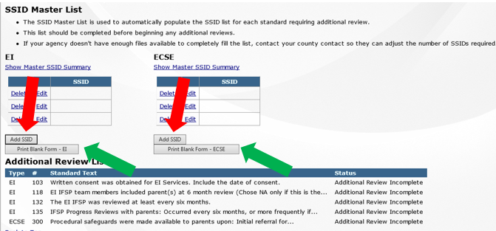

Additional File Reviews

Step 3: Entering Your Data

When you are ready to enter the results of your additional file review, there will be two choices for the compliance status for your correction (Yes or No.) You may also enter a Comment for clarification.

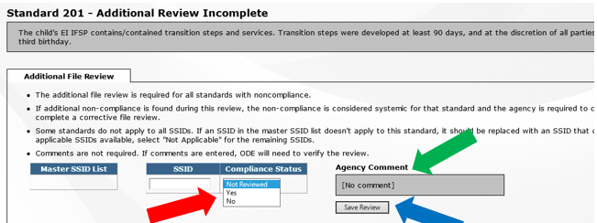
Note: In rare cases, an N/A can be used during this step only if N/A was an acceptable response for that standard in the initial review and there are no other files available to review for this standard.

Click on the “Save Review” button after you have entered your information!

If during your additional file reviews, you find that any of the standards you are reviewing are noncompliant, this standard becomes a Systemic Issue. The next step will be to complete interventions and subsequent corrective file reviews to demonstrate compliance.

Systemic Issues

Systemic Issues are triggered in the SPR&I system when...

- More than 33% of your files are out of compliance for a specific standard during the initial Procedural Compliance Review; and/or

- You report noncompliance of a standard during the Additional File Review process.

To correct a Systemic Issue, you must complete at least one intervention and a corrective review (additional file review) for each standard that is out of compliance.
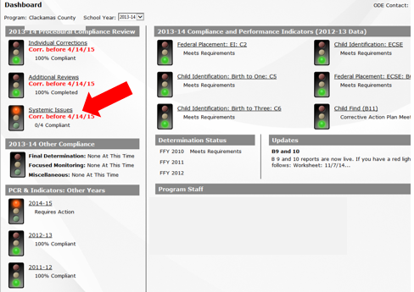

You will not be able to begin to work on your Systemic Issues until your Systemic Issues light is red.

Note: This screen is an example based on a previous year’s Procedural Compliance Review. The due dates above do not apply to the current review.
Systemic Issues (continued)

To correct Systemic Issues (noncompliance) in the system, you will need to:
- Complete individual file corrections as needed;
- Complete interventions for specific standards;
- Complete “Corrective” (additional) file reviews after you complete the intervention(s).

Clicking on the Systemic Issues light on your dashboard will take you to the Systemic Issue List.

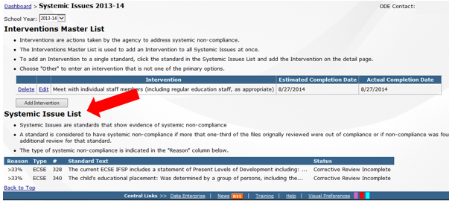

Step 1: Wrapping Up Individual File Corrections
You will need to complete any remaining individual file corrections before you proceed to identifying and completing interventions for Systemic Issues. The procedure for completing corrections is the same as that described in Step 10 of the 2018-19 Procedural Compliance Review entitled, “Correction of PCR Non-compliance. See page 22 for this procedure.

Systemic Issues (continued)

Step 2: Completing Interventions for Specific Standards

“Interventions” are actions taken by your program to address Systemic Issues (non-compliance.) The Interventions Master List applies an Intervention to all Systemic Issues at the same time. Click on one of the listed standards under the Standard Text heading in the Systemic Issues List...

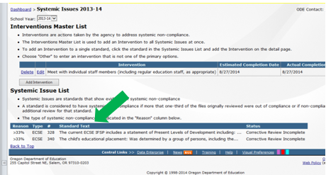

...and select “Add Intervention” to reach a list of suggested interventions for that standard (see next page for example.)

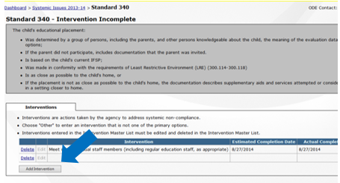
Systemic Issues (continued)

Step 2: Completing Interventions for Specific Standards (continued)

Example: Suggested Interventions for ECSE standard 328:

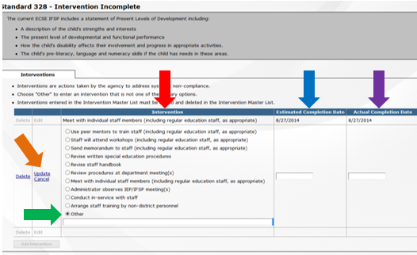

Single standard interventions - If you want to add an Intervention for one single standard only, click on “Other” and manually add the intervention.

In either case, be sure to enter the Estimated Completion Date. When you have completed your intervention, be sure to enter the Actual Completion Date.

Be sure that the Estimated Completion Date of your intervention allows sufficient time within the one year correction period to complete all the required steps (for example, completing the intervention and corrective file reviews to verify compliance post-intervention. )

Note: Make sure to click Update when you have finished your work.
Systemic Issues (continued)

Step 3: Corrective File Review(s)

After the intervention(s) for your Systemic Issue(s) are completed, you will need to verify the effectiveness of your intervention(s) through a Corrective File Review in which the activity in the standard occurred after the date you completed your intervention(s). The Corrective File Review tab will become available to enter SSID numbers and indicate compliance status during your Corrective File Review.

For your Corrective File Review, select only those files in which the action in the standard occurred after the intervention completion date. In the example below, the program completed the intervention and needed to review the Family Outcomes page from three files with IFSPs dated after the actual completion date of the intervention.

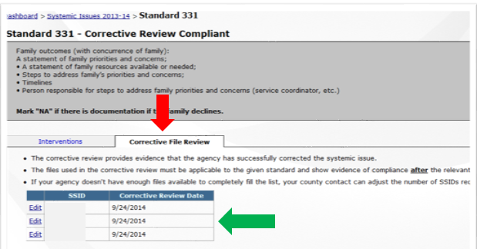

Note: The end/due date for the completion of this process is one year from your notice of findings (April 14th the year following the February PCR submission. For example, corrections for the 2/1/19 PCR submission are due no later than4/14/20).

Systemic Issues (continued)

Step 3: Corrective File Review (continued)

When you have indicated in the system that your corrective file reviews were completed and in compliance, the light on your dashboard for Systemic Issues will turn green.

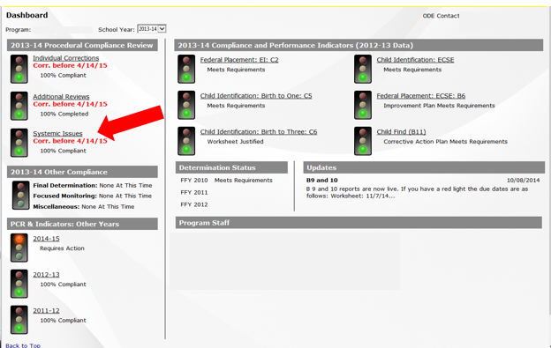

This completes the PCR process!

SPR&I Reports
You can print a number of reports using the SPR&I database. In addition to extensive data provided for each indicator under their reports tab, you can access the multi-year database and other reports by clicking on SPED.
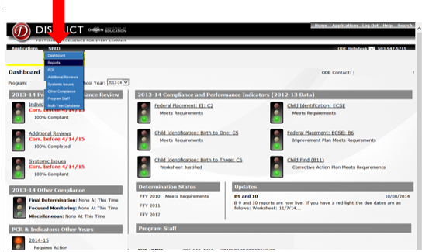
When you click on “Reports” in the drop down menu, you will arrive at the screen below. Click on any of the reports to open them for your program. Note that some of the reports are for Indicators, and will give you information about their status.

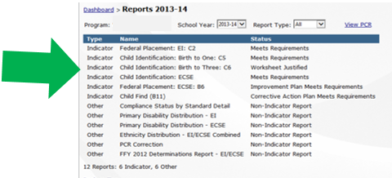

If you have any questions, please call your ODE County Contact. ODE staff welcomes the opportunity to provide you with assistance!

May all your lights be green!

Addendum:

EI/ECSE SPR&I Flow Chart

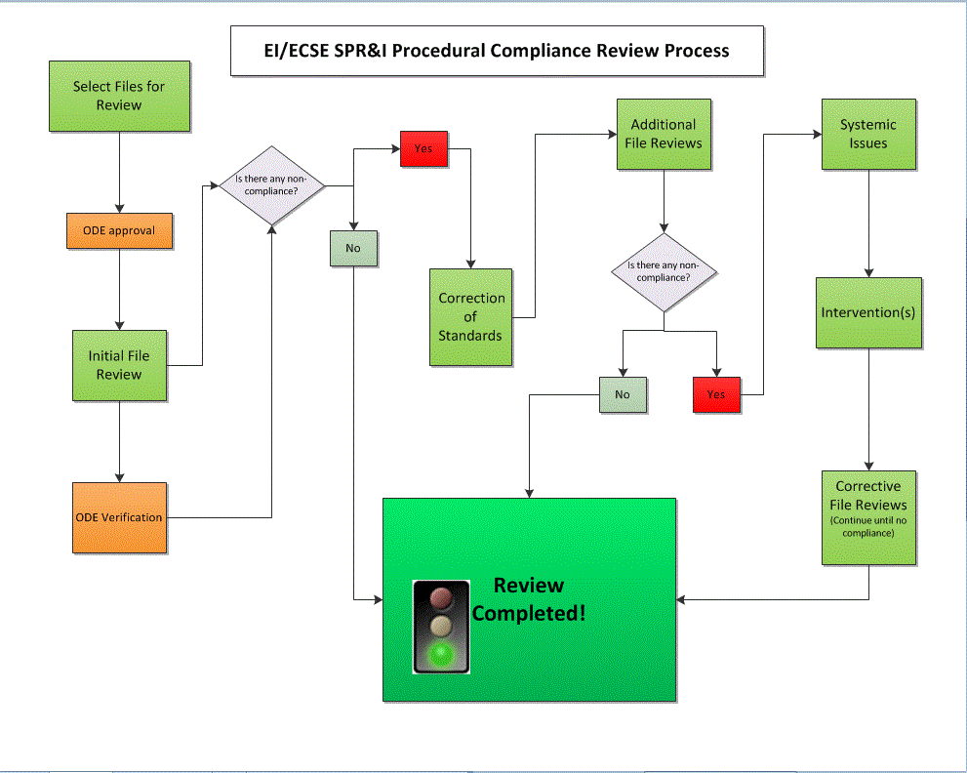

Verification monitoring is an additional process that ODE uses to confirm validity of data in the PCR self-evaluation process.
Student names used in this example are fictitious.
See page 22 for more information about additional file reviews.
See page 27 for information about Systemic Issues.
See page 21 for more information about PCR corrections.
See MEMO 09-02, US Dept. of Education, Office of Special Education Programs
See “Systemic Issues” on page 27 for more information.
See page 31 for information regarding Corrective File Reviews.
To see where Actual Completion Dates are located in the system, refer to Completing Interventions for Specific Standards on page 30.

