Authorization Submission Process 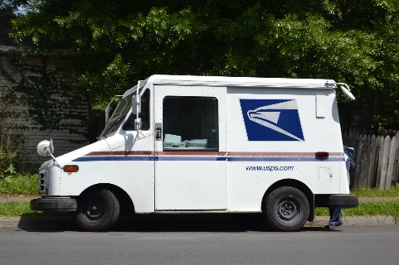
- Authorization portfolios are reviewed twice a year - in March and August.
- Contact Holly Reed Schindler (holly.reed.schindler@state.or.us) for specific March and August due dates for the current year.
- Email Holly Reed Schindler for directions on where to mail your portfolio for submission.
- The review process should take approximately 2 weeks and Holly will email your status after the completion of your portfolio review.
- For directions on what to do if your portfolio is denied, click on the next link on the webpage, “Portfolio Review.”

