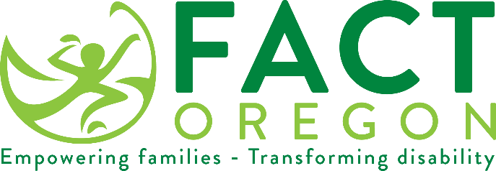

WE VALUE YOUR OPINION!

The Oregon Department of Education (ODE) will soon be asking families living in [insert Educational Service Districts] with children receiving special education services to respond to the Family Involvement Survey.
If you receive a survey, please take a few minutes to complete and return it in the self-addressed, stamped envelope or complete the online version by going to the stated web address.
You are an important member of our team. Your participation in this survey will help us plan improvements in our special education system.
Mandy Stanley
mandy.stanley@ode.oregon.gov
503-510-1364

