

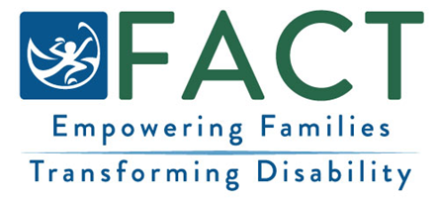

KAPASEIS FANITEN FAMINI
Sia mochen eusening ngeni porousen omwe famini nupwen an fifiti [pachenong iten ewe programun Early Intervention / Early Childhood Special Education EI/ECSE ].
What to Know About the Survey
- Ekei kapaseis e eisini famini porouser nupwen ar fifiti Early Intervention me Early Childhood Special Education (EI/ECSE).
- Ponuwen ekei kapaseis mei monomonono.

Ifa esin om kopwe Ponuweni
- Sipwe invitei ekewe famini ar repwe ponuweni ekewe kapaseis non text ika taropwe non posto.
- Nupwen a tour ngonuk ekewe kapaseis, kose mochen awora fitu minich om kopwe amasouwa.
Mwirin om Awesi ekewe Kapaseis
- Menapen ponuwan meren omwe famini ina epwe nom non ewe report ekan tou ew me ew ier. Esapw pwan afatetiw iten aramas me porouser minne repwe tongeni sineno ren.

- Sipwe nounou porousen ei report ach sipwe tongeni eochuweno angangen aninisin EI/ECSE.
Kapaseis?
Porous ngeni [pachenong ian repwe tongeni tour ngeni ewe Programun EI/ECSE Program me ia].
FACT Oregon: (503) 786-6082 factoregon.org

