YouTube Basics

Training Videos
Uploading Videos to YouTube
Editing Closed Captions in YouTube

Organization
- The ODE YouTube channel will be administered by a representative from IT (as of March 1, 2024, this is Stu Mayberry), the Single Point of Contact (SPOC) for the ODE website (as of March 1, 2024, this is Peter Rudy) and YouTube managers throughout the agency.
- Each office’s Web Content Council representative(s) will serve as a YouTube manager. Offices can decide to have more than one YouTube manager, depending on the office’s needs. A Director or Assistant Superintendent must notify the SPOC via email to request additional managers.
- The channel administrator from IT will be in charge of giving permissions to new managers.
- Each office will determine a process for approval of YouTube content for their office. Please utilize the content best practices (below) as you review content.
- The SPOC will train new managers on how to post content and uphold content guidelines.
- You Tube Managers will upload videos to the channel using the procedures outlined below.
- Offices can add or remove staff members from the list of YouTube managers at their discretion by notifying the SPOC via email. The SPOC will work with the channel administrator from IT on adding and deleting managers.

Activating YouTube Permissions
- The channel administrator from IT will send the invite to the oregonlearning.org email account of the manager to be added.
- The manager to be added will receive an email from “google-my-business-noreply@google.com” with a link to “Accept Invitation.”
- Click on the link which should take you to a screen to accept the invitation (go to Step 5).
- If you get the error message below, please contact the SPOC to let them know the invite failed and the SPOC will work with IT on a fix for you:
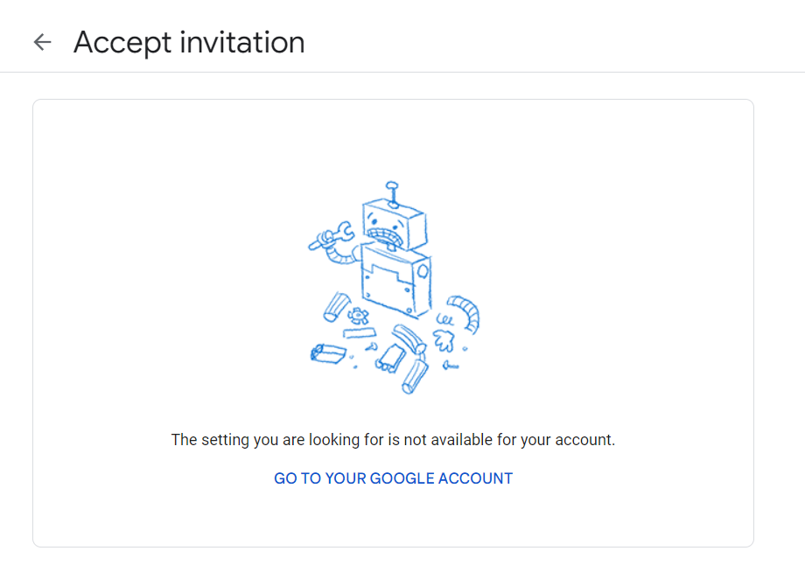

- Click on the nine dot box next to your avatar and select “YouTube.”
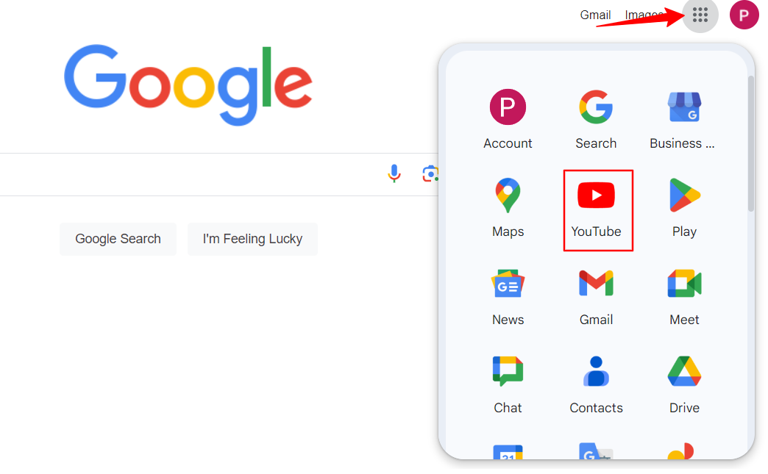
- The first time, you may be asked which channel to use. Select Oregon Department of Education and your avatar should switch to the ODE logo. This is how you know you are in the right place. If you do not get that question, click on your avatar and switch the account to ODE.
- Continue with the procedures below to upload and manage content.

Procedure

Best practice is to give yourself two full workdays to complete the following steps:
- Make sure your video is saved in a format supported by Youtube. MP4 is the safest choice.
  - Create a folder in your 30-Day Share Drive called “Videos” (offices should keep original MP4 files for their own records as YouTube is not a substitute for archiving).
  - Save the video you want uploaded into the Videos folder on your shared drive.
  - The video will need both a title and a description (see below).
    - Video Title:
      - YouTube requires a title for every video.
      - 100 character limit.
      - Short but descriptive is best:
        - “Training Video” is too vague of a title.
        - “March 2024 Training On YouTube Uploads” is much better.
    - Video Description:
      - Descriptions are a short explanation of what the video contains.
      - 5,000 character limit.
      - Short and descriptive is still best:
        - If the video is a webinar recording, please include the date of the webinar in the description.
        - Can include a call to action and URL (although it won’t be hyperlinked) like “For more information, visit www.oregon.gov/ode.”

- Determine which staff member will be responsible for editing the closed captions for accuracy.
  - All videos have to include closed captioning in order to comply with the ODE accessibility policy.
  - While YouTube generates automatic closed captioning, this is not sufficient to meet accessibility guidelines.
  - Closed captions must include proper punctuation and capitalization and indicate when different people are speaking.
  - Plan on setting aside five to 10 minutes of staff time for every minute of the video’s length to review and edit closed captions. A five minute video will require approximately 30-60 minutes to properly edit closed captions and an hour long video could take a full work day of staff time.

- Determine which of YouTube’s three levels of privacy you desire for the video:
  - Public: The video is visible on the ODE YouTube page and can be found via YouTube’s search feature.
  - Unlisted: Anyone with the URL of the video can watch it, but it is not visible on ODE’s YouTube page and would not come up in a search.
  - Private: The video is not visible on ODE’s YouTube page, would not come up in a search and requires a password to view it even if you have the link.

- The video can now be uploaded to YouTube using the instructions provided during training
  - Ensure that the video is given a title and description.
  - Set the level of privacy for the video to Unlisted when first uploading. Do not change to Public until edited captions are complete.

- Closed Captioning:
  - YouTube managers can enter corrected subtitles immediately after uploading the video using the editing environment within YouTube Studio. This is best when the video used a script that can be copied and pasted in.
  - YouTube managers can also correct the automated captions within YouTube Studio (see training video for more details).
  - Once the closed captions are automatically generated by YouTube, they can be downloaded and provided to the designated staff member for editing.
  - The designated staff member can then open the file (looks like plain text in Notepad with the text and the timing of when the text is displayed) and make the necessary changes to the closed captioning. All edits must be made in Notepad:
    - Do not change the times in the file, just the text.
    - Add proper punctuation and capitalization.
    - If there is a change in who is speaking, that needs to be identified in the captions
      - Peter: Welcome to the training video.
Colt: Thank you very much.
      - If a speaker is not known (like in a Q&A on a webinar), you still need to note the change in who is speaking. Use “Question from Audience” or “Unknown Speaker” to denote the change.
  - It’s a good idea to play the video while making corrections. Even if you have the script that was used to make the video, it’s possible the speaker did not say everything exactly as scripted.
  - Acronyms (ESSER, LEA) should be in all caps.
  - If you can’t tell what is being said (like in a webinar Q&A), that should be noted in the captions with something like “[unintelligible speaking]”.
  - If there is music in the video, you should put [Music] in the captions.
  - If there are extended periods (more than a couple seconds) where no one is speaking, put ellipses [...] in the captions.
  - Once the edited captions are complete, save the file in the same format.
  - The YouTube manager can then upload the corrected file.
- The video can now be linked on the website.
  - Due to accessibility considerations we do not embed videos on our webpages. If you want, you can take a screenshot of the video and put that image on the webpage and have it link to the video which will come up in a new window.

Content Best Practices
Please use the same professional considerations for videos as you use for memos, newsletters, webinars, conference presentations, website updates and other external communications.

When posting videos to ODE’s YouTube channel:

1. Ensure accessibility. We are committed to creating an online environment that is accessible to everyone. This includes proper use of closed captions.

2. Review the footage prior to posting. Use the ODE Style Guide, apply ODE’s Equity Stance, and utilize the following list of questions to ensure that the video aligns with the Oregon Department of Education’s core values of equity and partnership with school districts:
- Is the video content accurate, clear, professional, partnership-oriented and inclusive?
- Does the video contain any information that might be confusing or misleading? (For instance, references to information that is no longer relevant.)
- Is the content appropriate for a wide audience?
- Have you previewed the content with your supervisor?
- Are you prepared to respond to questions, appreciations or concerns about the content?

For more communication tips and best practices please visit Inside ODE’s Communications page or contact ODE Communications.

