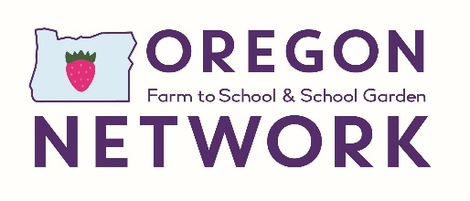

MOI Outcomes for Education
CORE MEASURES related to education

- Number or percentage of schools in Oregon that have an edible garden
- Number or percentage of schools that have an edible garden that is actively used for educational activities.
- Number of counties in Oregon with at least one school garden
- Number or percentage of school districts that have farm to school activities in pre-K settings.
- Number or percent of school districts that utilize promotional activities related to local foods:
  - in the school environment
  - in the community
- Number of school districts offering farm to school educational activities (such as school gardening, farm field trips, Future Farmers of America, cooking, nutrition and food-based lessons).

SUPPLEMENTAL and WISH LIST MEASURES related to education

- Number or percentage students participating in, or exposed to, farm to school educational activities, such as school gardening, farm field trips, Future Farmers of America, cooking, nutrition and food-based lessons
- Number and type of nutrition, food-based or agriculture-based learning materials sent home or shared with other community adults
- Number of parents or care-giver participants participating in farm to school activities, such as after-school programs, garden volunteers, field trips, nutrition and food-based learning, etc.
- The number of training and support opportunities for students and their families to grow and prepare their own food
- Number of families that begin gardening at home or in a community garden after participation in farm to school activities
- Number of families who report purchasing local foods after involvement in farm to school activities
- Increase in student and family awareness and knowledge about food and nutrition’s impact on health
- Increase in student and family willingness to try new local, healthy foods
- Amount of local fruits and vegetables students and families report eating
- Number and type of food-related businesses (i.e., farmers, ranchers, distributors, retailers) partnering with the school district to support farm to school through education, gardening and procurement efforts (i.e., field trips, site visits)
- Number of participating in farm to school and school garden activities aligned to Early Learning Framework, Common Core or state-adopted content standards
- The subjects (i.e., nutrition, science), grade levels, number of classes and type of activities (i.e., taste tests, hands-on learning, gardening) where farm to school activities and curriculum are aligned to Early Learning Framework, Common Core or state-adopted content standards
- Learning opportunities in each subject area that are aligned with Early Learning Framework, Common Core or state-adopted content areas, measured by:
  - Number of hours,
  - frequency and
  - type
- Number or percentage of school gardens that have a designated, funded School Garden staff position (School Garden Coordinator or Educator).
- Number of school districts that are using Oregon Harvest for Schools materials.
- Number of students who are receiving educational activities that are able to demonstrate knowledge of where their food comes from and how it is grown.
- Knowledge of at least one element of food heritage, such as foods unique to different cultures, and including food histories native to the region/community/their own family
- Number of students receiving educational activities who are able to demonstrate knowledge, skills and motivation to make responsible food choices and how they impact their health, the environment and their community.
- Number of children, at what grades, for what length of time, visit local farmers to learn about sustainable food production methods
- Number of school-based composting programs that are part of existing waste reduction programs or are stand-alone

