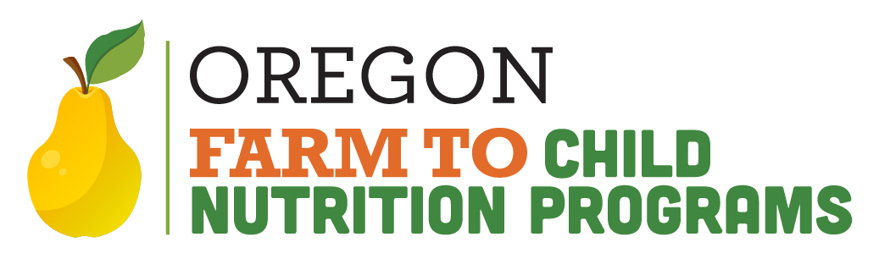
Farm to CNP Reimbursement Grant
Item Eligibility Guidance

The intention of the Farm to CNP Reimbursement Grant is to empower Grantees to increase their purchasing capacity of Oregon grown, produced and processed foods, as well as benefit the local economy, job market and environment by cycling State dollars back into communities around Oregon.
We encourage Grantees to seek out products that they may not have had the resources to purchase before, and to cultivate new relationships with Oregon producers and processors.
Below are descriptions of reimbursable and non-reimbursable items, as well as some examples of items that are commonly misinterpreted as reimbursable.
Eligible for Reimbursement:
- Produced in Oregon
  - Products that are grown, raised or caught in Oregon
    - Oregon-grown fruits, vegetables, legumes, grains, etc.
      - For minimally processed* frozen items, at least SOME of the product must be Oregon produced.
      - Example: Norpac foods uses 100% Willamette Valley produce during the summer; but maybe as low as 0% during the winter months.
      - *minimally processed means that the food product was processed in a manner that does not fundamentally alter the product and the product retains its inherent character. The term includes, but is not limited to, butchering livestock and poultry, cleaning fish, dicing meats, slicing produce, forming ground food products into patties, grinding meats, drying or dehydrating food products, and washing produce.
    - Oregon-raised meats
    - Oregon-caught seafood
- Produced AND Processed in Oregon
  - Items grown, caught or raised in Oregon and processed in Oregon.
    - Example: Dairy products produced in Oregon using milk from Oregon-raised dairy cows.
    - Example: Tofu processed in Oregon from Oregon-grown soy.
    - Example: Flours processed in Oregon from Oregon-grown grains.
- (Fully) Processed in Oregon
  - Products that are more than minimally processed* in Oregon
  - Definition of “processed” = foods/ingredients added together, cooked, canned, etc.
    - Items could be grown, caught or raised out of state, but processed into a usable product in Oregon.
    - Flours, noodles, tamales, salsa, tofu, sauces, etc.
***Starting in the 2025-2027 biennium grant cycle, pizza products, tortillas, and tortilla chips will no longer be eligible for reimbursement through the Farm to CNP Reimbursement Grant***
- Pizza products include, but are not limited to:
  - Pizza (whole or slices), pockets, sticks, bites, crust, dough, etc.
- Tortilla products include, but are not limited to:
  - Hard and soft shells, wraps, chips, etc.

Ineligible for Reimbursement:
- Items routinely served in food service programs
  - Milk in half pints or bulk milk for drinking
    - Alternative milks for drinking to cater to special dietary needs are allowable
  - Bread, buns, rolls
    - Sandwich bread, Hot dog buns, hamburger buns, dinner rolls, hoagie rolls.

- Fruits and vegetables grown outside of Oregon but only minimally processed* in Oregon
  - *”minimally processed” means that the food product was processed in a manner that does not fundamentally alter the product and the product retains its inherent character. The term includes, but is not limited to, butchering livestock and poultry, cleaning fish, dicing meats, slicing produce, forming ground food products into patties, grinding meats, drying or dehydrating food products, and washing produce.
    - Jicama grown out of state, but chopped in Oregon
    - Carrot coins sliced in Oregon, but grown out of state

- Other ineligible items
  - Oil
  - Pan spray
  - Butter/margarine
  - Salad dressings

Ineligible items commonly found on claims (not an exhaustive list):
- Rainier Fruit - They do not currently partner with any Oregon growers.
- Tropical fruits - Pineapple, mango, bananas, jicama, avocado
- Citrus - Oranges, lemons, limes, grapefruit
- Papetti products, produced by Michael Foods, distributed by Sysco. They no longer use Willamette Valley Egg Farms eggs.

***Starting in the 2025-2027 biennium grant cycle, pizza products, tortillas, and tortilla chips will no longer be eligible for reimbursement through the Farm to CNP Reimbursement Grant***
- Pizza products include, but are not limited to:
  - Pizza (whole or slices), pockets, sticks, bites, crust, dough, etc.
- Tortilla products include, but are not limited to:
  - Hard and soft shells, wraps, chips, etc.

Reminder:
Grantees must use at least 75% of the award for food purchases. 25% of the award may be used for other reasonable costs incurred for growing, harvesting, transporting, procuring or processing foods served in your food service programs.

