For immediate release

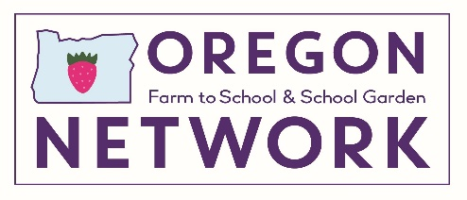
Contact:
Megan Kemple, Director
Oregon Farm to School and School Garden Network
megan@oregonfarmtoschool.org
541-344-4329 (office) 541-225-8807 (cell)

OREGON LEGISLATURE UNANIMOUSLY APPROVES INCREASE FOR FARM TO SCHOOL
- $15M Program a “Win-Win-Win” for Oregon Kids, Farmers, and Communities -

SALEM, Ore. -- July 2, 2019 -- Late Saturday evening, the Oregon Legislature produced a “win-win-win”, passing Oregon’s Farm to School Bill (HB 2579) with unanimous, bipartisan support. The bill renews funding for the Oregon Department of Education (ODE) Farm to School Grant Program and grants a historic increase for the program from the current $4.5 million to $15 million for the 2019-21 biennium.

Representative Brian Clem and partners in the Oregon Farm to School & School Garden Network (OFSSGN) championed the increase for the Oregon Farm to School Grant Program which, since 2011, has provided a total $10.4 million in funding for schools to purchase Oregon foods, and for schools and partner organizations to educate children about food, gardens, nutrition, and agriculture.

“At a time when the state is politically divided, bi-partisan efforts like this bring Republicans and Democrats together and bridge the urban/ rural divide,” said Megan Kemple, director of the Oregon Farm to School & School Garden Network. “Farm to school is a win, win, win, supporting kids, farmers and communities. We are thrilled about the legislature’s commitment to supporting and expanding this valuable program and thank Representative Clem for his leadership.”

“We should always be using tax dollars to buy local,” Representative Clem said. “It never made sense to me to buy apples from anywhere else than right here in Oregon. This program connects our schools and children to our most important industry: agriculture. It’s Oregon farmers feeding Oregon’s children.”

Growing the Farm to School Grant Program from $4.5 million to $15 million annually allows for significant expansion of the program, making Head Start and other early childcare and education sites eligible, including new summer meal sites and adding new funding for summer meals, and adding infrastructure and equipment grants for producers who are ready to sell to schools.

Research from OFSSGN partner Ecotrust (linked here) has shown for every $1 schools spend on local food, $2 are returned to Oregon’s economy. And the new funding provides support to Oregon producers who are ready to sell to schools but need infrastructure or equipment to do so.

###
About Oregon Farm to School and School Garden Network
The Oregon Farm to School and School Garden Network supports members of Oregon’s farm to school and school garden community in their work to incorporate healthy, local food into school meals and implement farm and garden-based education. The Network is made up of over 1200 participants including school districts, food producers, non-profit organizations, and other stakeholders involved with farm to school and school garden programs in Oregon.

