USDA Local Food for Schools
Allowable and Unallowable items
Allowable items:
- Fluid milk half pints from State of Oregon or 400 miles outside of Oregon border.
  - All milk including flavored milk
- Unprocessed or minimally processed items only
- Local items from 400 miles outside of Oregon border; items must be grown, raised, caught from that state (WA, ID, MT, NV, CA).
For reference, look at this map. 300 miles from Medford is Sacramento.. Bend reaches to Boise.. Ontario would reach to Butte, MT. Some Eastern Oregon could reach to Reno or SLC, UT. Items have to come from USA as Portland to Vancouver BC is only 315 miles away..
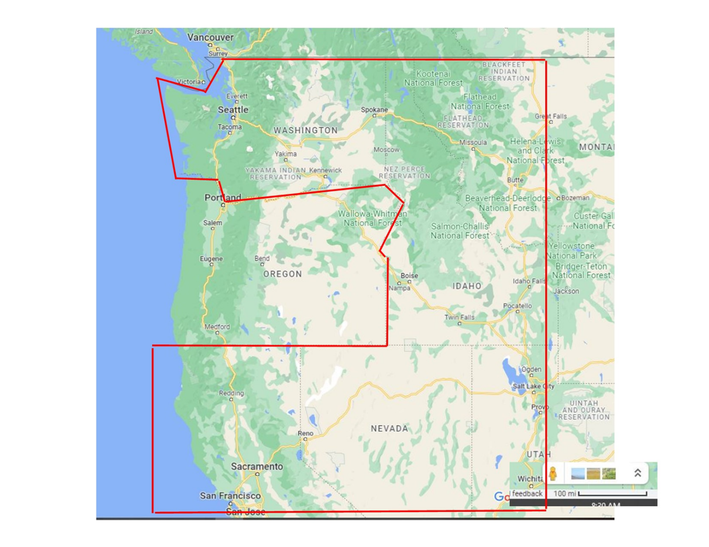

- The Sponsor would have to state where the item came from on their excel claim form
Unallowable items
- Items simply from an operation that packs/distributes; the item has to be grown/caught or raised from that area.
- Items from an operation greater than 400 miles away
- Processed food. No canned, items that are multi-ingredient.
- USDA Says: Local and regional food is raised, produced, aggregated, stored, processed, and distributed in the locality or region where the final product is marketed to consumers, so that the total distance that the product travels between the farm or ranch where the product originates and the point of sale to the end consumer is at most 400 miles, or both the final market and the origin of the product are within the same State or territory. So, it says “and” here – not “or.” This means that the item must originate within the region, and not come from outside the region and simply minimally processed in the region.

