Tranquil Farms
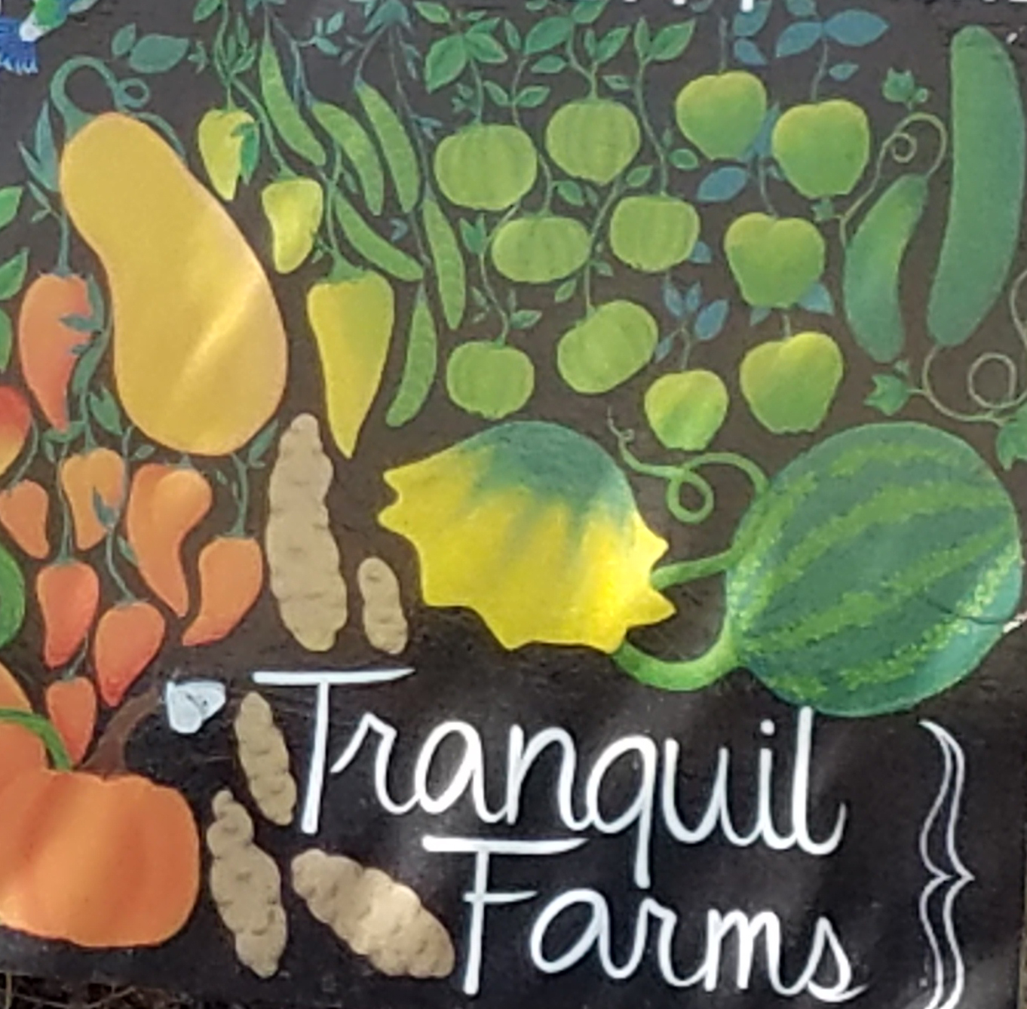

Product: Makah Ozette Fingerling Potatoes

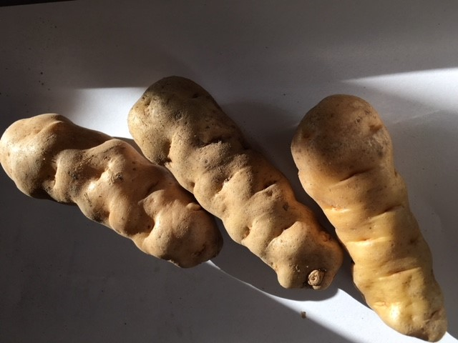
History:
- Heritage, endangered potato on Slow Food’s Ark of Taste and Presidia
- Brought to North America from Peru by the Conquistadors
- Staple food in the diet of Pacific Coast Native Americans of the Makah Nation
- Not until the late 1980’s was this potato grown outside the Makah Nation
- Tranquil Farms is currently the only commercial grower in the Portland area
Characteristics:
- Thin-skinned fingerling potato
- Firm flesh
- Creamy texture
- Unique nutty, earthy flavor
- Great for boiling, roasting, sautéing, and deep frying
- Holds well raw and cooked
Availability
- SEASONAL AVAILABILITY – SEPTEMBER THROUGH APRIL

About the Farmer:
Joann Reckling is a Farmer, Chef and Caterer with a unique interest in growing heritage and indigenous foods. She moved to Oregon from Nevada where she grew mainly perennial herbs and hops. When not in the fields, Joann is continually in pursuit of odd and exciting heirloom vegetables in danger of extinction such as the Makah Ozette, her primary crop, along with her current crop of specialty garlic.

About TRANQUIL FARMS
In operation since 2016, Tranquil Farms is an 11-acre farm and forest located on the Clackamas River. The farm specializes in growing vegetables and fruit that are in demand for their uniqueness as well as those native and indigenous foods at risk of disappearing. All products are grown naturally without pesticides or chemicals. The farm is currently applying for Organic Certification.

Contact:
Joann Reckling, Farmer/Owner
Tranquil Farms
ph# (702) 328-5348
tranquilfarmsoregon@gmail.com

What people are saying about the Makah Ozette

“Customers have returned multiple times to repurchase. they are one of our most popular potatoes, creamy and buttery!” Rubinette Produce

“People love the texture and particularly the flavor. They do have a unique shape that looks great when the potatoes are served whole.” Pascal Chureau, Chef/Proprietor, Allium

“All that taste and hear the story of the Makah Ozette are twinkly eyed and deeply satisfied. Our patients appreciate that we’ve gone to so much effort. Kids think they are fun to look at, adults say they are beautiful.” Fernando Divina, Executive Chef, OHSU Hospital, Author of Foods of the America’s: Native Recipes and Traditions

