Oregon Department of Education (ODE)
New Grantee Frequently Asked Questions (FAQs)

- Where might I need to register before I receive grant funding from ODE?
Make sure your information is complete and consistent with each of these entities: inconsistent data causes delays in processing ODE grants.
  - Internal Revenue Service (IRS): Apply for an Employer Identification Number (EIN) Online | Internal Revenue Service (irs.gov)
You will need either an Employer Identification Number (EIN) or a Social Security Number (SSN, for sole proprietor businesses) --- this is your Taxpayer Identification Number (TIN).
  - Oregon Secretary of State (SOS): State of Oregon: Business - Register a Business
Register your entity with the Secretary of State (if applicable) --- this is your Registry Number.
  - Dun & Bradstreet: Dun & Bradstreet
Currently, grantees receiving federal funding need to register with Dun & Bradstreet --- this is your DUNS number.

[Please note, future grantees receiving federal funds will be required to get a Unique Entity Identifier (UEI) instead of a DUNS number. This process is in transition. More about the UEI may be found here.]
  - OPTIONAL Bank: Establish an account
The Oregon Department of Administrative Services processes requests for ACH (electronic) payments. More about this request process can be found here. Having a bank account set up for ACH payments will speed up the payment process.
  - OPTIONAL OregonBuys: Establish an account
The State of Oregon has a new eProcurement system called OregonBuys. This system replaces the Oregon Procurement Information Network (ORPIN) and provides access to ODE’s solicited grant opportunities. To register, go to OregonBuys and click the blue “Register” button in the top right corner. If you need help, contact suppliersupport@periscopeholdings.com.
- Who can I contact?
- Your ODE Grant Manager should be your first point of contact for any questions about your grant agreement.
- For specific grant database set-up questions and the related forms, start by contacting ode.egms@state.or.us, from which your question will be routed to the most appropriate person.
- Direct deposit/ACH questions need to go to the Department of Administrative Services (DAS): ACH.Coordinator@oregon.gov

- How does the ODE grant-making process work?
  - Selection of Grantees
For a competitive grant— A Request for Applications (RFA) is issued, applicants submit applications, and grantees are selected based on program criteria.
[Some ODE grants are non-competitive—selected directly by the ODE Program Office, or issued based on “formula”, or demographic, data.]
  - Establishment of Grant Agreements and Funding in the Electronic Grant Management System (EGMS)
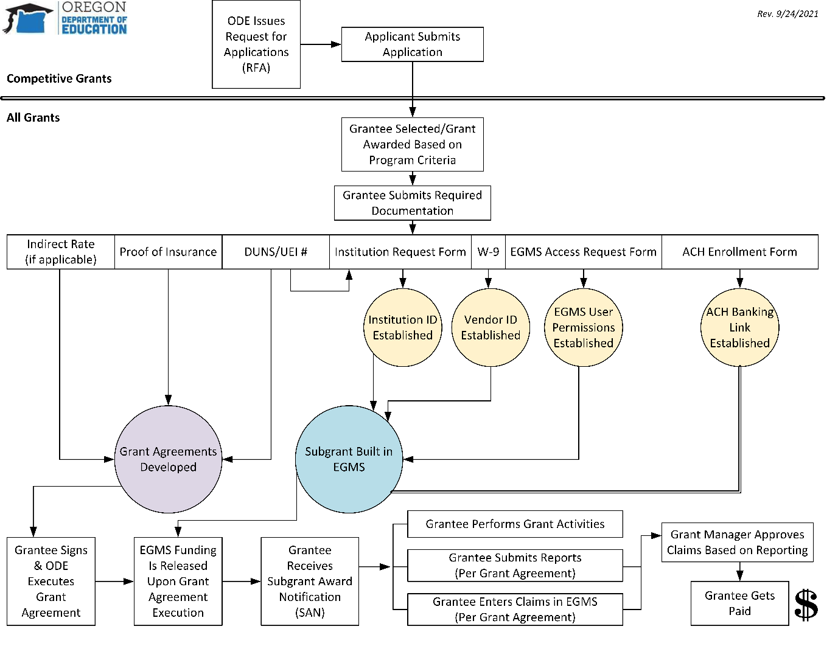
Grant Agreement Language is Started—The Grant Manager from the ODE Program Office and the Contracting Officer from the ODE Procurement Unit work together to develop grant agreement language, identifying all details that need to be legally agreed upon between ODE and the grantee.
New Grantees Provide ODE with Documentation—Each grantee needs to be set up in a number of databases to receive funds. The Grant Manager should notify new grantees of the documentation they need to provide (see table below) and grantees need to submit the necessary forms to prevent delays in their awarded funding. As forms are received, state staff in various offices establish accounts and/or build records in databases and will contact grantee for more information or clarification as needed. The grantee will end up with a vendor ID, an Institution Number, and a user login and password for EGMS.
Grant Agreement Details and Funding Records Are Finalized—Contracting Officers in the ODE Procurement Unit send an individual grant agreement to each grantee and the EGMS Team establishes subgrant funding in the EGMS system, based on documentation provided by the Grant Manager from the ODE Program Office.
Grant Agreement Is Executed and Funding Is Released—An authorized representative of the grantee entity signs the grant agreement and returns it to ODE for execution. All parties receive a fully executed copy. The funds in EGMS are committed in the accounting system and made available for claiming. Grantees receive an email that a Subgrant Award Notification (SAN) is available in EGMS. Please note, the grant agreement number will not match the EGMS subgrant number.
  - Performance of Grant Activities and Submission of Claims for Reimbursement in EGMS
Grant Activities Happen—The grantee performs the grant activities listed in the grant agreement.
Reporting May Be Requested—Depending on the grant and the language in the grant agreement, specific reporting may need to be submitted to the ODE Grant Manager by particular dates. Grant Managers and grantees should refer to their grant agreements for details and communicate with each other about reporting.
Reimbursement Requests (“Claims”) Are Submitted in EGMS—A day after the original Subgrant Award Notification (SAN) is issued, grantees may enter claims in EGMS (all SAN PDFs must be opened/read and all holds must be lifted before claims may be entered). Grantees enter their claims according to grant agreement terms and conditions. Claims gets reviewed by the ODE Grant Manager for approval (and are often compared against the reporting submitted) prior to payment.
If the requested reporting/backup documentation has not been submitted or does not match the EGMS claim, the ODE Grant Manager or the EGMS Team may put the grant on hold to prevent further claims and/or might reject the claim. (Rejected claims may be resubmitted once concerns have been addressed.) This can delay grantee payments, so please check with your ODE Grant Manager if you have questions about a claim that was submitted but not paid.
Claims Are Paid—Approved claims are sent to the accounting system and paid in a few days, either via check (“warrant”) or direct deposit. For a brand new grant, payment might be delayed up to a week.
- What forms do I need to complete and to whom do I send them?
Make sure your information is complete and consistent on each form: incomplete or inconsistent data causes delays in processing ODE grants.

Form/Information Requested | Details Needed | Who Gets It
PREPARATORY INFORMATION FOR GRANT AGREEMENT
- Proof of Insurance Coverage (meeting requirements in grant agreement)  - DUNS or UEI #  - Indirect Rate (if applicable/allowable) | These might be collected through a grant application, by your ODE Grant Manager (or other contact from the ODE Program Office), or by your Contracting Officer in the ODE Procurement Unit. | Send to the requestor.
COMPLETED GRANT AGREEMENT
- Signed grant agreement | Grantee’s authorized representative should read and sign the grant agreement, as well as grantee’s Project Manager. | Return the grant agreement, signed by your entity’s authorized representative, to the requestor.
REGISTRATION AS A VENDOR WITH THE STATE OF OREGON
- Completed W-9 Form (Request for Taxpayer Identification Number and Certification) | If your entity is not already established in the state accounting system, you might need to provide a W-9 through a grant application, to an ODE Contracting Officer, or to a Financial Services staff member. | Send to the requestor.  HOWEVER, if you use a Social Security Number for your Taxpayer Identification Number, submit your W-9 through secure transfer to connie.flowers@state.or.us.
REGISTRATION AS AN ODE INSTITUTION
- Institution Request Form | Complete sections A, C, E, F, K, N, and O. This form requests your Taxpayer Identification Number, DUNS number, and the form needs a physical signature. If you use a Social Security Number for your Taxpayer Identification Number, DO NOT WRITE IT ON THIS FORM (instead write “Using SSN” in the U.S. Employer ID# (Federal Tax ID#): field). | Scan and return to the Institutions Team: ode.institutions-request@ode.state.or.us  PLEASE DO NOT WRITE YOUR SOCIAL SECURITY NUMBER ON THIS FORM.
USER PERMISSIONS IN ODE’S ELECTRONIC GRANT MANAGEMENT SYSTEM (EGMS)
- EGMS Access Request Form (also available in Spanish) | There are 2 levels of user permissions in EGMS: Claim Administrator (able to enter grant claims) and Read Only. You must have at least one Claim Administrator to claim your funding. Request all EGMS user permissions on the EGMS Access Request Form. The form requires a signature from your organization head or a Board member. | Scan and return to the EGMS Team: ode.egms@state.or.us
ENROLLMENT IN DIRECT DEPOSIT
- ACH Enrollment Form | Form needs Taxpayer Identification Number, banking information, and a signature from your financial institution. | This should NEVER be emailed to any person but instead sent by MAIL (via U.S. Postal Service) to:  Department of Administrative Services (DAS)  EGS FBS SFMS / ACH Coordinator  155 Cottage Street NE U60  Salem, OR 97301-3963  ODE staff do not have access to view or change banking information.
- Who needs to know if my information changes?
 | - Changes to Grant Contacts | - Changes to Institution Name or Address | - Changes to Business Structure (i.e. sole proprietor to LLC or other change in Taxpayer Identification Number) | - Changes to EGMS User Permissions | - Changes to Bank Info  - (SEND BY MAIL)
- Grant Manager  - (Email/call) | - X | - X | - X
- EGMS Team | - X  - EGMS Access Request Form |  | - X  - Email ode.egms@state.or.us about this | - X  - EGMS Access Request Form
- ODE Financial Services Unit |  | - X  - W-9 | - X  - W-9
- ODE Institutions Team |  | - X  - Institution Request Form
- Secretary of State (SOS) |  | - X  - State of Oregon: Business - Update Registration | - X  - State of Oregon: Business - Update Registration
- Department of Administrative Services (DAS) |  |  | - X  - ACH Enrollment Form |  | - X  - ACH Enrollment Form

