Oregon’s Farm to School and School Garden Resource People

Topic (not in any particular order) | Who to contact  (see next pages for contact info)
Getting started with or expanding local purchasing | Melina Barker
Finding farmers, Farmers selling to schools | Amy Gilroy
Food safety for school gardens | Rick Sherman
Food safety for farms | Amy Gilroy
School gardens & chickens/pollinators | Rick Sherman
Regional Education and Procurement Hubs | Melina Barker
Farm based education, farm field trips | Melina Barker
Starting and maintaining school gardens | Sarah Wheeler, Anna Garwood,  Rick Sherman, Maureen Hosty
School garden curriculum | Amoreena Guerrero  Anna Garwood, Maureen Hosty, Lucy Miner
Garden-based after school programs | Amoreena Guerrero  Anna Garwood, Maureen Hosty, Lucy Miner
Oregon’s Farm to School and School Garden Grants | Rick Sherman, Amy Jean Williams, Emily Griffith
Oregon Harvest for Schools | Rick Sherman, Amy Jean Williams, Emily Griffith
Farm to early care and education | Angela Hedstrom
Higher Ed. And Extension | Michelle Markesteyn
Farm to Summer | Rick Sherman, Amy Jean Williams, Emily Griffith
ODE’s Fresh Fruit & Veggie Program | Rick Sherman, Amy Jean Williams, Emily Griffith
Geographic preference rules | Rick Sherman
Advocating for state policies | Megan Kemple
Research and evaluation | Michelle Markesteyn
Media, communications & marketing | Michelle Markesteyn
Oregon Farm to School Producer Awards  Oregon Farm to School Infrastructure Grant | Amy Gilroy
FoodCorps | Aaron Poplack
Oregon Farm to School and School Garden Network | Melina Barker
National Farm to School Network | Rick Sherman
Farm to School with Oregon Dairy  Fuel Up to Play 60 grant funding opportunities | Crista Hawkins, Erin Hirte
Oregon Agriculture in the Classroom | Jessica Jansen
Future Farmers of America | Reynold Gardner
4H | Maureen Hosty
Adopt-a-Farmer | Mallory Phelan
USDA Farm to School Program | Position Open
Other questions? | Melina Barker

Contact Information for Resource People
Melina Barker 541-890-7004
Program Manager, Oregon Farm to School and School Garden Network
melina@oregonfarmtoschool.org www.oregonfarmtoschool.org
Amy Gilroy  Farm to School Program Manager  Oregon Department of Agriculture  agilroy@oda.state.or.us 503-709-5360 | 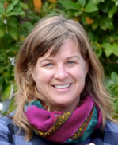
Megan Kemple
Director, Oregon Farm to School and School Garden Network
megan@oregonfarmtoschool.org 541-344-4329
www.oregonfarmtoschool.org
Michelle Markesteyn, PhD
Farm to School Coordinator
Oregon State University Extension
Founder, Rootopia
michelle.markesteyn@oregonstate.edu 503-476-6080 https://extension.oregonstate.edu/farmtoschool
Rick Sherman  Farm to School Analyst  Oregon Department of Education  Rick.Sherman@state.or.us 503-947-5863 bit.ly/f2sor | 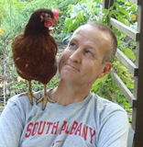
Wren Huff
Admin Support, Oregon Farm to School and School Garden Network
wren@oregonfarmtoschool.org www.oregonfarmtoschool.org

Amy Jean Williams
Farm to School Administrative Assistant,
Oregon Department of Education
amy.williams@state.or.us 503.947.5940 bit.ly/f2sor
Emily Griffith
Farm to School Administrative Assistant,
Oregon Department of Education
Emily.griffith@state.or.us 503.947.5938 bit.ly/f2sor
Angela Hedstrom
Farm to School Coordinator
Ecotrust
ahedstrom@ecotrust.org 503.467.0790 www.ecotrust.org
Position Open
Farm to School Regional Lead, USDA Food and Nutrition Services
Western Regional Office, San Francisco CA
https://www.fns.usda.gov/farmtoschool/farm-school
Anna Garwood
Youth Grow Director, Growing Gardens
anna@growing-gardens.org 503-284-8420
www.growing-gardens.org
Reynold Gardner
(FFA Advisor) Agricultural Education - Natural Resource Education Specialist Oregon Department of Education
Reynold.gardener@state.or.us 503.947.5615
Amoreena Guerrero
Youth Grow Manager, Growing Gardens
amoreena@growing-gardens.org 503-284-8420
www.growing-gardens.org
Lucy Miner  Program Director, School Garden Project of Lane County  lucy@schoolgardenproject.org 541.284.1001  https://www.schoolgardenproject.org/ | 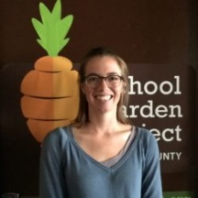
Crista Hawkins
Director of School Programs, Oregon Dairy & Nutrition Council
chawkins@odncouncil.org 503.229.5033
https://odncouncil.org/
Erin Hirte
Manager of School Programs, Oregon Dairy & Nutrition Council
ehirte@odncouncil.org 503.229.5033
https://odncouncil.org/
Maureen Hosty
OSU Extension Faculty, 4-H Youth Development
maureen.hosty@oregonstate.edu 503-916-6075
Jessica Jansen  Executive Director, Oregon Ag in the Classroom  Jessica.jansen@oregonstate.edu 541.737.8629  https://oregonaitc.org/ | 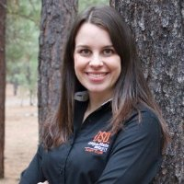
Mallory Phelan
Director of Community Outreach, Oregon Adopt a Farmer
info@aglink.org (503)595-9121 http://www.aglink.org/
Aaron Poplack  Oregon Program Manager, FoodCorps  aaron.poplack@foodcorps.org  503-558-6374  https://foodcorps.org/ | 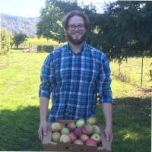
Sarah Wheeler  Garden Educator, School Garden Project of Lane county  sarah@schoolgardenproject.org 541.284.1001  www.schoolgardenproject.org | 