2025-2027 ODE Farm to CNP Education Grant: OregonBuys Instructions

Application Materials: How to Access

- Follow this link to OregonBuys (https://oregonbuys.gov/)

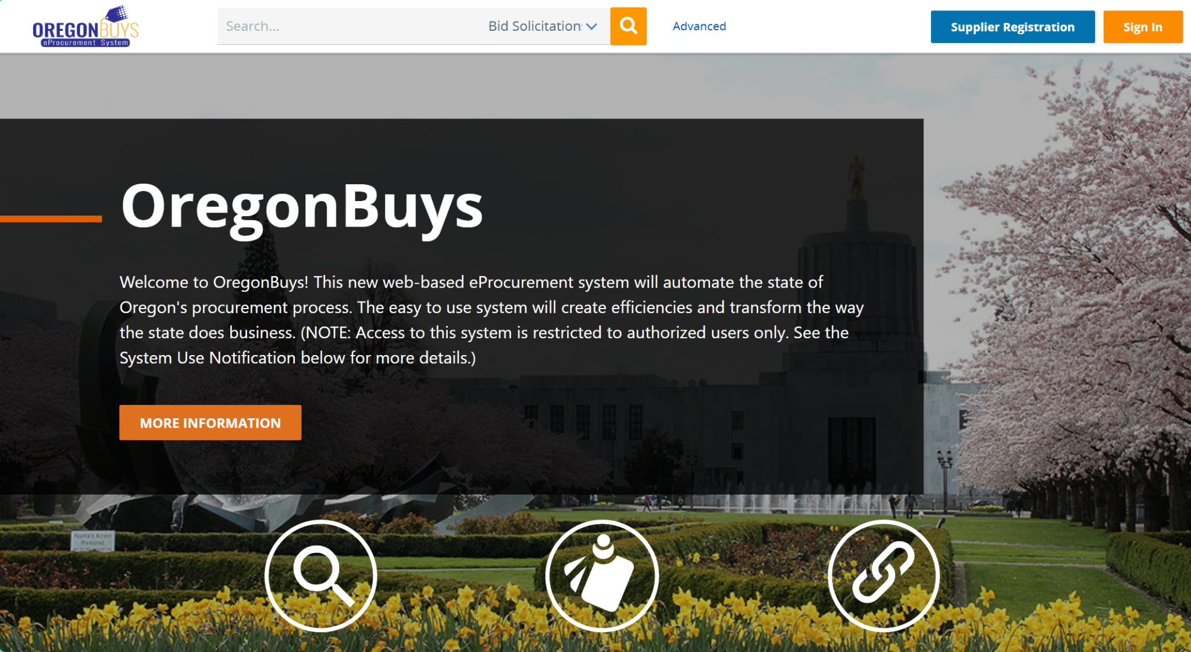

- At the top of the screen in the search bar search “Farm to CNP”:
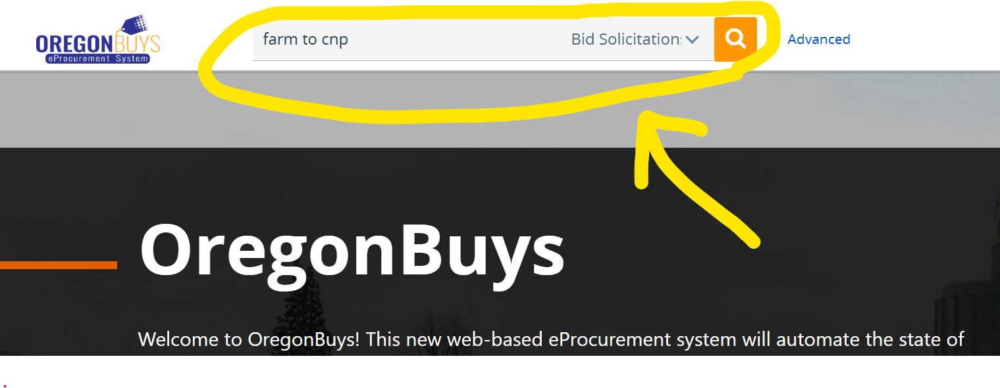
- You will be led to the ODE Farm to CNP Grant listing in OregonBuys (below).
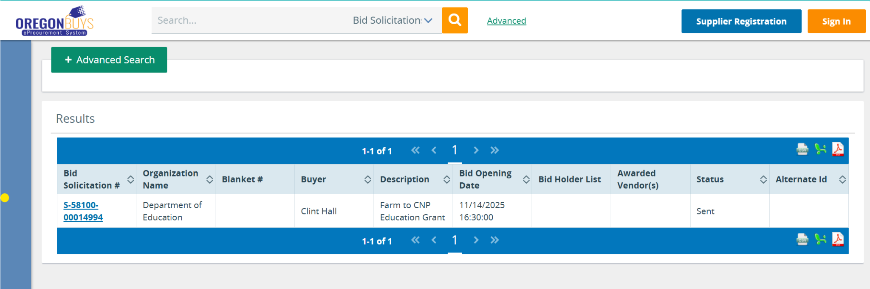
- Click on the Bid Solicitation number “S-58100-00014994” (in blue) to see the application materials, listed under “File Attachments.”

To Apply for the Education Grant

To apply for the Education Grant, you will need to register for OregonBuys. 1. On the OregonBuys homepage (https://oregonbuys.gov/) click “Supplier Registration” in the top right corner.

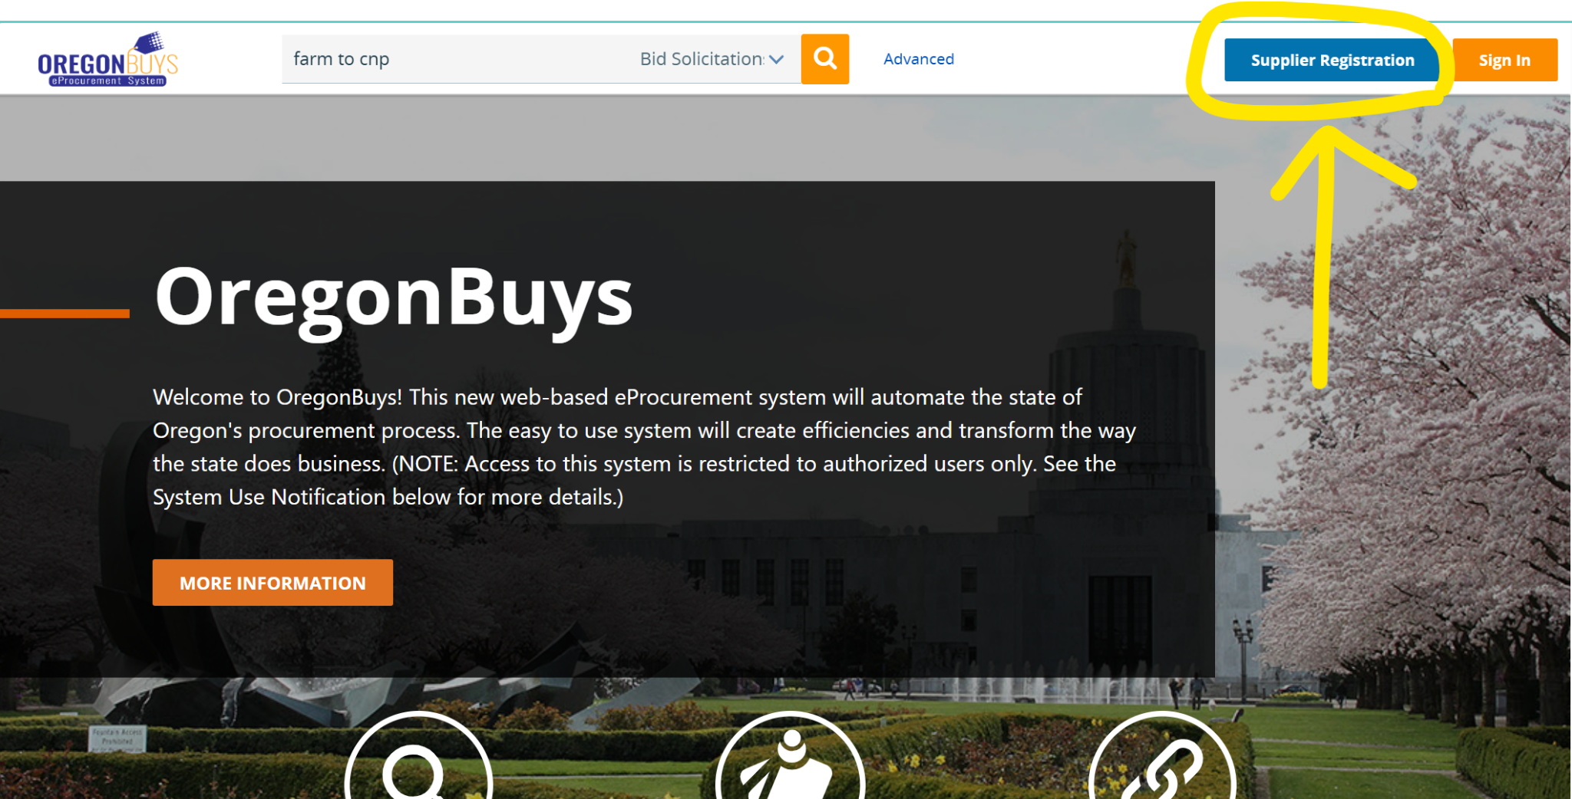
2. Utilize the resources on OregonBuys under “Register for a Supplier Account” to complete your registration and create your account to log in.

For assistance with OregonBuys registration, contact OregonBuys Supplier Support:
1-855-800-5046
support.oregonbuys@das.oregon.gov

