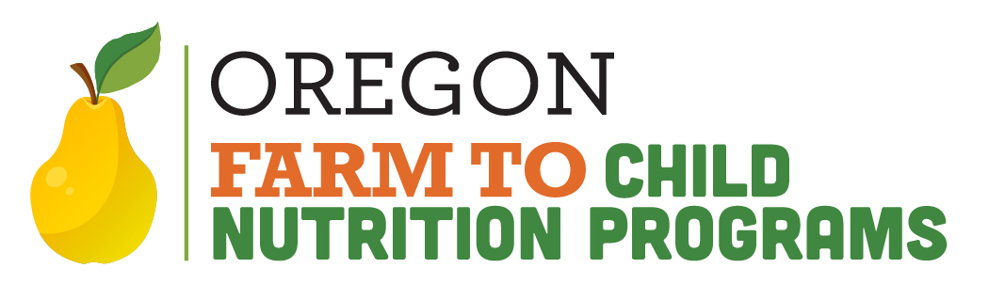
Farm to School Reimbursement Grant (RG):
Processing claims with second parties or vended meal contracts
About 80% of the time, a CNP Sponsor purchases Farm to CNP RG food directly from vendors like farmers, ranchers, processors, etc. and submits a claim to ODE, in which no other parties are involved.
However, there are situations where a Sponsor does not purchase the food themselves; in these cases a Food Service Management Company (FSMC) or Vended Meal Contract is involved. Below are the different situations that occur when a sponsor submits a claim:
1. Self-operated Sponsor (most common): The Sponsor produces their own food and/or purchases food directly from suppliers such as farmer/rancher/distributor/etc. and submits a claim to the ODE F2CNP team.
2. Food Service Management Company:
a. The FSMC has a vended meal agreement with a Sponsor. The vended meal agreement is a contract where the Sponsor pays the FSMC a fixed price per meal.
b. This fixed price has to include ALL costs associated with a meal. The FSMC figures out their cost and goes through a bid process where the Sponsor and FSMC agree on this fixed price. Therefore, no other additional costs (such as the NCRG) can be recouped by the FSMC.
c. Since the FSMC who orders and prepares the meals are the ones that are in charge of the food, they are the ones that keep the records and submit the claims.
d. All claim reimbursements from the NCRG must go to the Sponsor, not the FSMC. It is recommended that the FSMC should figure in the costs associated with purchasing food for this grant when figuring out their fixed price per meal solicitations.
e. Only the Sponsor (School district or CACFP operation) is eligible to receive funds, and the FSMC can not claim the funds.

3. Sponsor Providing Meals to Another School District or Sponsor: Sometimes we have a situation where one entity contracts to another entity to provide meals.
a. Example: Forest Grove School District supplies to Banks and Gaston.
b. Example: OSU Child Development Center (CACFP operation) contracts with Corvallis School District.
c. These cases are also Vended Meal Contracts, so these situations would be handled the same way as #2.
d. The entity that orders food and provides the meals would submit the claim for the Sponsor, all reimbursements would go to the Sponsor that receives the meals.
e. NOTE: Sometimes this is confusing as some school districts hire out their food service department to the same Director as another school district and the NSD runs both, separately. This would be like Corvallis/Philomath/Alsea, for example. When confused, or to confirm, check with the appropriate team or Richard Williams richard.williams@ode.oregon.gov

4. Sponsors have entered into an agreement with a manufacturer of food to provide meals, like Fresh N’ Local (FNL).
a. Technically, these are also Vended Meal Contracts, however FnL would be considered a food manufacturer for the Sponsor. The best way to manage this situation is to have the SPONSOR submit the claim.
b. The main difference in this situation is that the vendor is simply selling a meal and has no oversight or management of the program whatsoever.
c. FnL supplies meals to the sponsor, with a detailed receipt that would have any items for the RG broken out on it, like entrees processed in Oregon, and any fruit or veg grown in Oregon. The total price of the invoice would also have any subtotals for these items broken out on the invoice for documentation.

