Oregon Department of Education Honors Leaders in Farm to School at Inaugural Oregon Harvest for Schools Awards

CLACKAMAS, Ore. – The Oregon Department of Education (ODE) Child Nutrition Programs celebrated outstanding leaders advancing Farm to School efforts across Oregon during the inaugural Oregon Harvest for Schools Awards ceremony, held October 9 at the Oregon School Nutrition Association (OSNA) Industry Seminar at Camp Withycombe. The awards recognize individuals, schools, organizations, and producers whose work strengthens connections between Oregon students and Oregon agriculture.
The Oregon Harvest for Schools Awards highlight excellence across ODE's Farm to Child Nutrition Program and recognize contributions that advance the program's statewide goals:
- Food Education for All
- Local Food Access for All
- School Food Culture & Environment
- Leadership & Professional Development
- Market Access for Oregon Producers
The awards drew a highly competitive pool of nominations from across the state, demonstrating the growing impact of Farm to School programs in Oregon. Future award ceremonies will alternate between the Oregon Farm to School Conference and the Oregon School Nutrition Association Conference.
Applications for the SY 2026-2027 Oregon Harvest for Schools Awards are now open! Learn more and submit your nominations on the Oregon Harvest for Schools Awards webpage. Join the next awards ceremony at the bi-annual Oregon Farm to School Conference: January or February 2028.

School Garden of the Year
Goal(s): Food Education for All; School Food Culture & Environment
This year's School Garden of the Year is a place where learning comes alive. Students explore science, nutrition, agriculture, sustainability, and healthy living through hands-on experiences in the garden. Supported by an incredible network of educators, families, volunteers, and community partners, this garden has become a centerpiece of the school community and a powerful connection between students and the food they eat. The Oregon Harvest for Schools School Garden of the Year is Sauvie Island School.
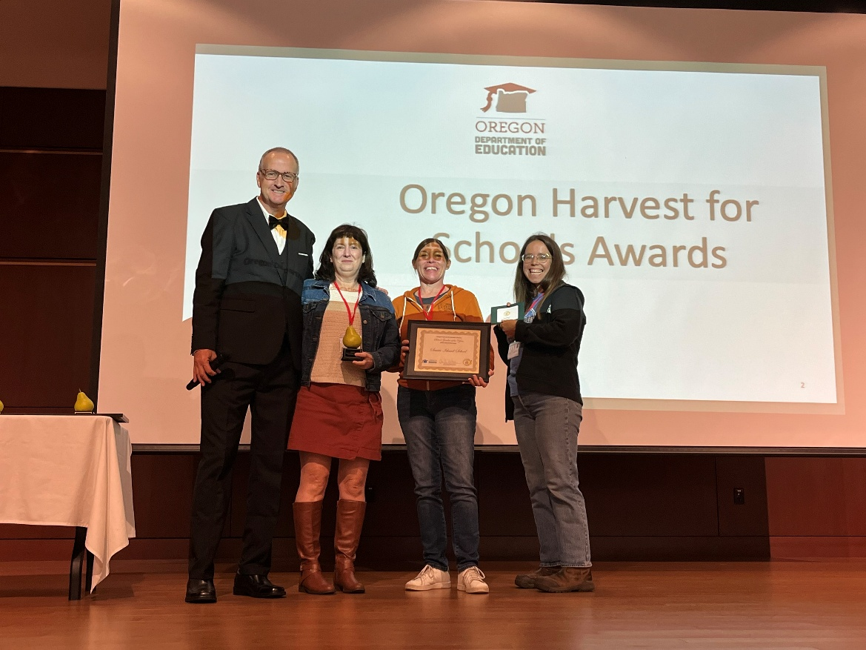
Photo courtesy D Sanchez
Accepting the award for the SG of the year are Director Darla Meeuwsen; Office Manager Ann Pavia; and School Garden Coordinator Zoe Mendez.

School Garden Coordinator of the Year
Goal(s): Food Education for All; School Food Culture & Environment
Great school gardens don't happen by accident. They are built by dedicated leaders who inspire students, bring people together, and create opportunities for hands-on learning. The School Garden Coordinator of the Year is someone who demonstrates that a garden can be far more than a place to grow food. Under this individual's leadership, the garden has become a place where students build skills, develop confidence, connect with their community, and learn firsthand about Oregon agriculture and natural resources. Through innovative partnerships, year-round learning opportunities, and a strong focus on student ownership, this coordinator has created a program that will continue to thrive for years to come. The School Garden Coordinator of the Year is Chris Martin of Newport Middle School
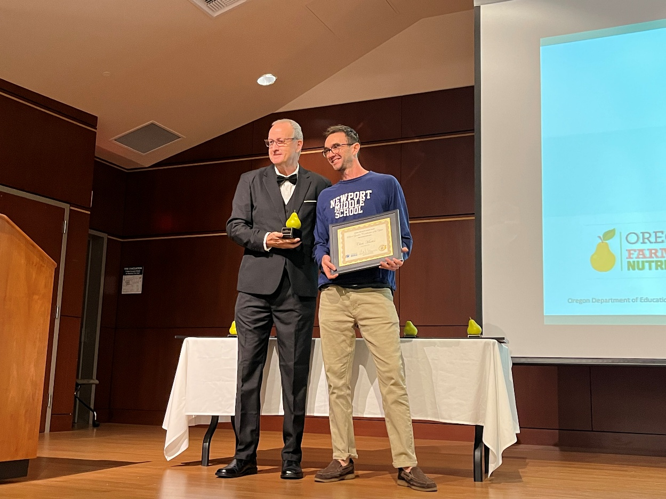
Photo courtesy D Sanchez

Oregon Food Producer of the Year
Goal: Market Access for Oregon Producers
The Oregon Food Producer of the Year Award, presented in partnership with the Oregon Department of Agriculture, honors an Oregon producer whose passion, dedication, and leadership have strengthened Farm to School efforts throughout Oregon. This year's recipient has worked tirelessly to make Oregon-produced foods more accessible to schools, forging lasting partnerships with nutrition professionals, supporting food education efforts, and helping students make meaningful connections to the people who produce their food. Through a commitment to quality, service, and collaboration, this producer has become a trusted partner to schools across the state and a shining example of what Farm to School can accomplish. The 2026 Oregon Food Producer of the Year goes to Patrick Roelle of Fishpatrick’s Seafood
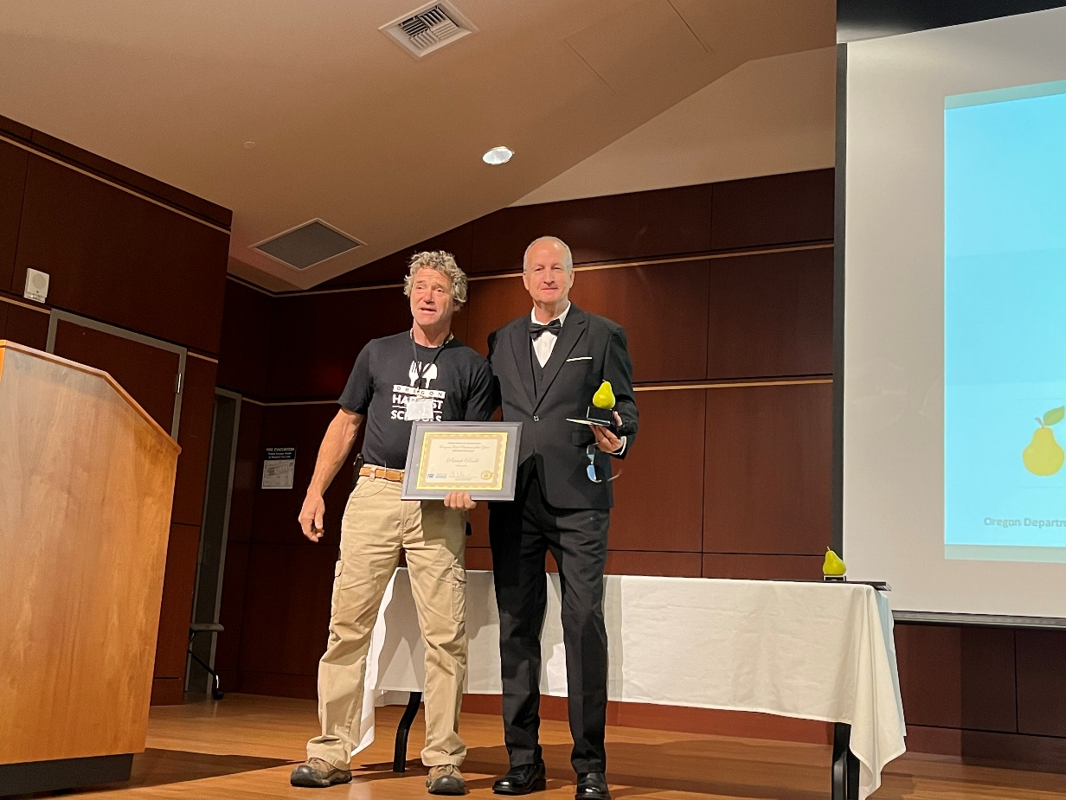
Photo courtesy D Sanchez

Community Partner of the Year
Goal: School Food Culture & Environment
The Community Partner of the Year award recognizes a person whose impact reaches far beyond any one school or community. Behind every successful farm to school program are people who bring others together, solve problems, and turn big ideas into lasting results. This year's recipient has done exactly that, helping schools connect with local producers, strengthening regional partnerships, supporting equitable access to local foods, and building systems that will benefit students and communities for years to come. This year’s Community Partner of the Year Award goes to Patrick Newson of The Oregon Farm to School Network.
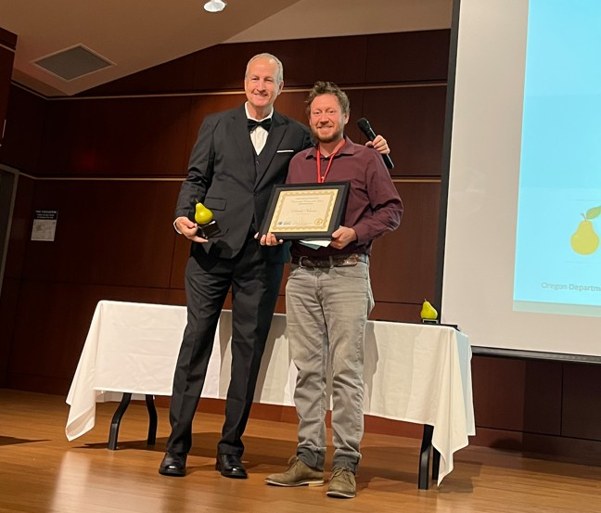
Photo courtesy D Sanchez

Nutrition Service Professional of the Year
Goal: Local Food Access for All; Leadership & Professional Development
This award goes to the Nutrition Service individual (Director, Manager or frontline staff) who best exemplifies Farm to School practices in Oregon. Farm to School is at its best when local food purchasing, nutrition education, community partnerships, and student engagement all come together. This year's recipient embodies that vision. Through leadership, innovation, and an unwavering commitment to children and families, this individual has strengthened connections to Oregon agriculture, elevated culturally relevant local foods, expanded hands-on learning opportunities, and inspired others across the state through collaboration and service. This year’s Oregon Harvest for Schools Nutrition Service Professional of the Year is Francia Yera, Adelante Mujeres, Forest Grove.
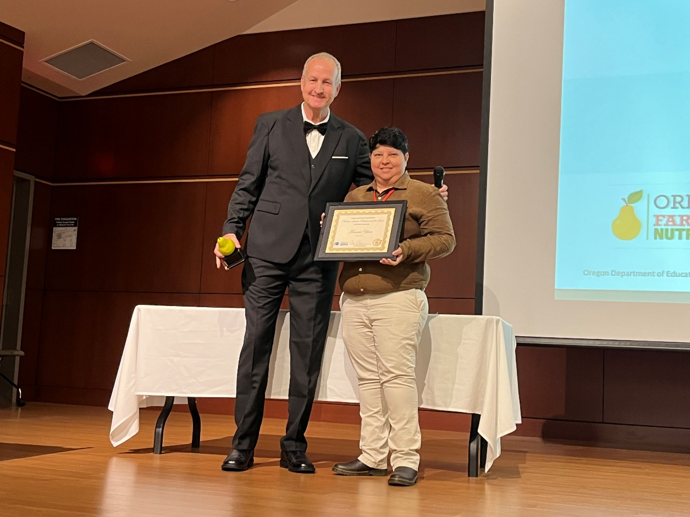
Photo courtesy D Sanchez

Oregon Farm to School Hall of Fame
When the opportunity presents itself, we hand out Lifetime Achievement Awards on an engraved plaque in the shape of the state of Oregon. Here are the past award winners for our Lifetime Achievement Awards:
Claire Columbus, Gervais SD NSD, 2015
Oregon Representative Brian Clem, 2015
Oregon Representative Vic Gilliam, 2015
Oregon Speaker of the House Tina Kotek 2015
Joyce Dougherty, ODE NCP Director, 2017
Megan Kemple, Oregon Farm to School Network Director, 2019

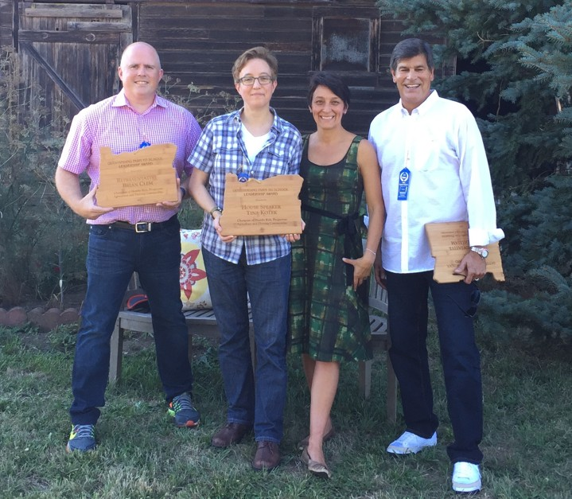
Photo courtesy of Michelle Markesteyn

