May 3, 2021

To: Sponsors of the National School Lunch Program (NSLP) to include Sponsors that have operated under the Summer Food Service Programs (SFSP) for school year 2020-2021, which would normally operate under the NSLP if not for waivers due to COVID-19, and Sponsors which have not operated in the 2020-2021 school year due to COVID-19
RE: Excess Operating Balance Reporting (EOB) – Action Required – Submit (EOB) by June 15, 2021
This memo is to notify sponsors of the National School Lunch Program (NSLP) that the Oregon Department of Education Child Nutrition Program’s (ODE CNP) will be collecting information regarding each Sponsor’s net cash resource balance of the non-profit food service account for school year 2019-2020.
ODE CNP is responsible for ensuring that schools, districts, and other entities participating in the National School Lunch and School Breakfast Programs comply with federal regulations regarding the financial management of their nonprofit food service accounts. This includes a requirement that program sponsors limit their net cash resources (i.e., year-end balance) to an amount that does not exceed three months average expenditures for their nonprofit food service programs. 7 CFR 210.9(b)(2) and 7 CFR 220.7(e)(1)(iv).
All program sponsors will be required to calculate their year-end nonprofit food service account balance and provide one of the following certifications using the Excess Operating Balance Certification Form:
- Certification by the financial manager listed in CNPweb that the year-end balance of the nonprofit food service account for the 2019-2020 school year is not in excess of three months average expenditures OR
- Certification by the financial manager listed in CNPweb that the year-end balance of the nonprofit food service account is in excess of three months average expenditure, but due to increase operating expenses related to COVID-19, sponsor is requesting state agency approval to retain the excess funds (approval or denial of the request will be communicated via email to the financial manager as listed in CNPweb) OR
- Certify that the year-end balance of the non-profit food service account is in excess of three months average expenditures and sponsor will spend the amount down (making allowable expenditures) and attach the spend down plan the EOB Certification Form for state agency approval (approval or denial of the plan will be communicated via email to the financial manager as listed in CNPweb)
Sponsors of the (NSLP) to include (SFSP) operated under SY 2020-2021
Excess Operating Balance Reporting (EOB)
Page 2

Your organization’s business officer, accountant, or financial Manager should be the person to complete the EOB certification form. Please ensure that person receives this memo. The Excess Operating Balance Certification form must be submitted to the state agency by June 15, 2021.
If you have any questions regarding the Excess Operating Balance requirement or the EOB Certification Form, please contact your Assigned Nutrition Specialist.

Sincerely,
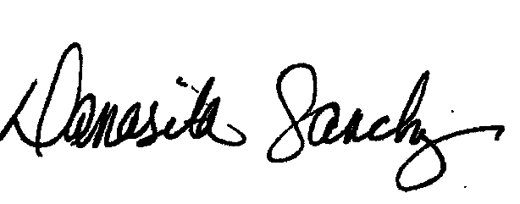
Damasita Sanchez
Manager, School Nutrition
Child Nutrition Programs
Office of Child Nutrition, Research, Accountability, Fingerprinting and Transportation

K:\~Memos\_SNP Memos-Unnumbered\2021-22\EOB Memo 2021.docx

