July 28, 2017

TO: Sponsors of Family Day Care Home Providers

RE: Family Day Care Home CACFP Reimbursement Rates for 2017-2018
Effective July 1, 2017 - June 30, 2018

The Oregon Department of Education Child Nutrition Programs (ODE CNP) announces the annual adjustment to the national average payment rates for meals served in day care homes and the administrative reimbursement rates for sponsors of the day care homes, effective
July 1, 2017- June 30, 2018.

Reimbursement Rates: (all amounts expressed in dollars or fractions of dollars)

Breakfast |  | Lunch & Supper |  | Supplement (snack)
TIER 1 | TIER 2 | TIER 1 | TIER 2 | TIER 1 | TIER 2
$1.31 | 0.48 ¢ | $ 2.46 | $ 1.48 | 0.73 ¢ | 0.20 ¢

Administrative Reimbursement: (per home/per month)

Initial 50 day care homes . . . . . . . . . . . . . | $114
51 – 200 day care homes . . . . . . . . . . . . | $ 87
201 – 1,000 day care homes . . . . . . . . . . | $ 68
Each home over 1,000 . . . . . . . . . . . . . . | $ 60

If you have questions concerning the reimbursement rates, please contact your assigned Child Nutrition Specialist.

Sincerely,
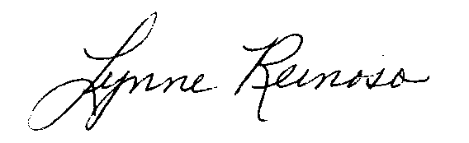
Lynne Reinoso, Manager, Community Nutrition
Child Nutrition Programs
Office of Student Services

K:\~Memos\_CACFP Memos-Unnumbered\2017-18\FDCH\Memo 7-28-17.docx

