October 1, 2021

TO: Sponsors of the National School Lunch Program, including those operating the Seamless Summer Option throughout school year 2021-2022

SUBJECT: School Year 2021/22 Verification

RE: Verification Process for School Year 2021-2022

ACTION REQUIRED: Complete Verification Process October 1 – November 15, 2021
Complete Verification Collection Report November 1 - February 1, 2022

The Oregon Department of Education Child Nutrition Programs (ODE CNP) is releasing guidance that all sponsors operating the National School Lunch Program (NSLP), School Breakfast Program (SBP) or the Seamless Summer Option (SSO) will be required, at a minimum, to complete the FNS 742 Verification Collection Report in CNPweb.

Federal regulations at 7 CFR 245.6a require that all Local Education Agencies (LEAs) collecting free and reduced meal applications in School Year 2021-22 select and verify a sample of their approved free and reduced price meal applications on file as of October 1 by November 15 of each year.

All sponsors that have collected Free and Reduced applications for any reason, to include for purposes of qualifying for Pandemic Electronic Benefit Transfer (P-EBT), must conduct the verification process.
Sponsors who do not collect free and reduced meal applications, such as:
- District-wide Community Eligibility Provision (CEP) or
- Provision 2 for all meals district-wide and are in a non-base year or
- Residential child care institutions (RCCI) without day students
do not complete the verification process. However, completion of the FNS – 742 Verification Collection Report is required for all sponsors.

All sponsors that have collected Free and Reduced applications for any reason must conduct the verification process and are required to use the Standard - 3% Error-Prone method for the 2021-22 school year and must submit the FNS-742 Verification Collection Report. Verification materials describing this method are available on the School Nutrition Programs Verification web page

The verification process begins October 1, 2021 and must be completed by November 15, 2021.

Upon completion of the verification process, sponsors must complete the Verification Collection Report (FNS 742) located on the claims tab in CNPweb and submit it to the ODE CNP by Tuesday, February 1, 2022. If the completed FNS 742 Verification Collection Report is not entered into CNPweb by Wednesday, February 2, 2022 Claims for Reimbursement will be withheld until it is completed.

Sponsors may request an extension of the November 15th deadline, by writing to School Nutrition Programs, due to natural disaster, civil disorder, strike or other circumstances that prevent the timely completion of verification activities. An extension must be requested no later than Friday, October 29, 2021. Please send extension requests to ode.schoolnutrition@ode.state.or.us.

If you have any questions, please email your school or school district’s Assigned Specialist.

Sincerely,
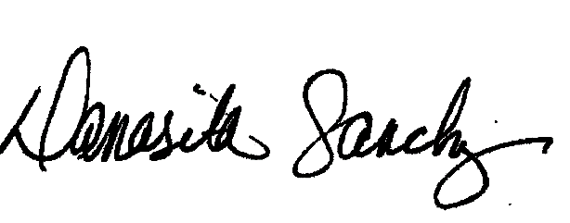
Damasita Sanchez
Manager, School Nutrition
Child Nutrition Programs

K:\_SNP\Verification\2021-22\Communication to Sponsors\Memo-Verification Notification SY21-22.docx

