To OPEN Renewal ~ Important First Task: Log in to CNPweb, 2020
Select Applications tab
Click Add for the Sponsor Information Sheet
Click Submit at the bottom of the page.
This will enable both the sponsor and ODE CNP to track any progress in the renewal, e.g. off-line form submissions. Please do this upon receipt of these instructions.

To COMPLETE Renewal ~
Renewal has four areas:
- 2018-19 Civil Rights training date entered on the Packet tab for 2020(CNPweb)
- Off-line forms - details below (Send to ODE SNP, ode.schoolnutrition@ode.state.or.us)
- Updated Sponsor Information Sheet for 2020 (CNPweb)
- Updated Site Information Sheets for all operating sites in 2020 (CNPweb)
The sponsor part of renewal is not complete without sending in Off-line forms.
The order of tasks can vary.

Helpful Hint #1: Plan ahead to meet the due date of April 30, 2018. Look back to the previous year as a guide for exceptions that will need updating. Update the exceptions and send them in to allow time for your specialist to review, ask questions and approve them. CNPweb keeps track of the entire renewal process: Update the Sponsor Information Sheet, all Site Information Sheets, enter the Civil Rights training date, and date sent for any off-line forms. Most information will roll over when you activate your renewal, however, you need to review, verify and update all information and certify that it is true and accurate.
Entering Off-line information:
Scroll to bottom of Packet Tab screen. At the bottom of the page, click here to enter dates for required tasks and forms sent to ODE CNP.
Fill in “Date Sent” column as described below for each item as needed
Click Submit at bottom of Packet Tab
ODE will fill in the “Date Received” and “Date Approved” columns.

Civil Rights – ALL SPONSORS Enter the date staff were trained for the 2018-19 school year, between July 2018 and June 2019. Do not send any additional information for Civil Rights training.

Off-Line Forms
Submit Off-line Forms to ODE.schoolnutrition@ode.state.or.us
This is a list and explanation of the various off-line forms your organization may need to submit:

- Additional Eligibility Officials – As needed if CNPweb doesn’t have enough space for multiple eligibility officials in each site. The form is available on the packet tab. Complete, submit, and enter date sent.

- Eligibility Effective Date Exception – Notification to ODE CNP that a sponsor will be using the available Flexibility in Determining Effective Date of Eligibility to an earlier date than the SFA determination for each method of certifying students for free/reduced meals. CNPweb Executive Contact or CNP Program Manager must sign. FSMC staff signatures are not accepted. The form is available on the packet tab. Complete, submit, and enter date sent.

On-line Renewal
Helpful Hint #2: CNPweb identifies every information area with a number, like this (55). These instructions will reference a specific information area by its number. Error messages in CNPweb will, too. Being able to identify the exact area when you have questions is also helpful.
After selecting the SNP Purple Puzzle Piece and reviewing the splash page message:

Select the Program year 2020, and Sponsor, if responsible for applications for more than one Sponsor
- Select Applications Tab
- Click Edit for the Sponsor Information Sheet
Most information from SY 2019 will roll over into SY 2020. Review the form for accuracy; revise and fill in all missing information. Correct spelling, check email addresses and phone numbers. Capitalize first letters of names, streets, etc. This information is used to develop mailing lists. Please ensure at least two different people are in these four contact areas
Sponsor Information Sheet Reminders:
- (34)Executive Contact: The Superintendent or CFO, who is legally responsible for entering into contracts for the sponsor.
- (42)CNP Program Manager: A sponsor employee responsible for the nutrition program.
- (50)Nutrition Services Contact: For self-operated sponsors this may be the same person as CNP Program Manager. For Sponsors with FSMC contracts, this can be the FSMC employee who oversees the program.
- (58)Business Manager/Claim Contact: Staff who submits the monthly claim.
- (75)Free and Reduced Price Hearing Officer: A person not involved in the Eligibility determination process. They will be the impartial staff parents can contact.
- (all) Be sure every information area (numbered) is complete and current
- When the Sponsor Information Sheet is complete and correct, click Submit at the bottom of the page.
- If in error status, correct any errors and resubmit the form.
- CNPweb will display a list of all active sites.
- Click Add for each Site Information Sheet
Most information from SY 2019 will roll over into SY 2020. Review the entire form for accuracy; revise and fill in all missing information. Correct spelling, check email addresses and phone numbers.

Site Information Sheet Reminders:
(39) Eligibility Official: the person who collects and processes eligibility applications for this site. Use the Eligibility Officials form on the Packet Tab if additional space is needed.
(52),(53) If meals are delivered through an agreement with another organization, indicate here and enter the name of the organization. This may be a school, a caterer, etc.
(55) Attendance Factor may be 100%. The Milk Program does not limit one per student per day.
(56)-(58) and (62)-(64) will be filled in automatically, using data from previous years.
(65), (75) Participation: Select “Not Participating”.
(66)-(73), (76)-(82) leave blank
(84) Participation: Select “Participating”
(85) Months Meals Served: Select each month milk is served to students
(92), (98) Participation: Select “Not Participating”.
(93) - (97), (99) – (108) Leave blank
(109), (111) Food Safety Inspections are not required for Special Milk Program.
(119) – (130) School Garden: Answer as it applies to the site.
(131) - (142) Take the time to explain each site’s Accountability Procedures. Conflicting information in this area will delay approval of your renewal. Send in a POS Exception Request for each site as needed

- Click Submit at the bottom of the page
- If in error status, correct any errors and resubmit the form
- Repeat steps 6 – 8 for each Site

When the “Status” column says “Pending Submission” for all forms on the Applications tab
- Select Packet Tab
- REFER TO PAGES 1-3 OF THESE INSTRUCTIONS FOR COMPLETING THE PACKET TAB
- Confirm all required Off-line forms are submitted with “Date Sent” column completed

13. Scroll to bottom of Packet tab. Check the box “Submit to the State for Approval”.
Click on submit button.
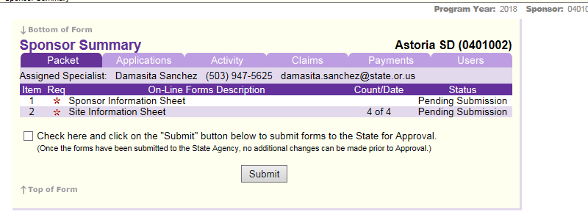

The Packet status will now state “Pending Approval”. Return to the Sponsor Summary Application tab - You are done!

The school nutrition team will review the CNPweb information and required offline forms. The renewal will either be approved or ODE CNP will contact you.
Helpful Hint #3: Every authorized user of CNPweb is electronically signing documents when they complete them online. Staff members with access should be using their own login information to ensure accountability. This is a great time to make sure that only current employees have access to CNPweb in the areas needed to do their jobs. Please use these forms available on the packet tab to update access and program information as needed:

- User Authorization Request & Certification
- Request to Terminate CNPweb User Authorization
- Add Site/Modify Site Information
- Inactivate Site Programs

