September 11, 2023

To: Sponsors of the National School Lunch Program (NSLP)
RE: Excess Operating Balance Reporting (EOB) – Action Required – Submit EOB report by October 13, 2023

This memo is to notify sponsors of the National School Lunch Program (NSLP) that the Oregon Department of Education Child Nutrition Program (ODE CNP) will be collecting information regarding each sponsor’s net cash resource balance of the non-profit food service account for the 2022/23 school year.
ODE CNP is responsible for ensuring that schools, districts, and other entities participating in the National School Lunch and School Breakfast Programs comply with federal regulations regarding financial management of their non-profit food service accounts. This includes a requirement that program sponsors limit their net cash resources (i.e. year-end balance) to an amount that does not exceed three months’ average expenditures for their nonprofit food service programs. Refer to 7 CFR 210.9(b)(2) and 7 CFR 220.7(e)(1)(iv).
ODE CNP will be hosting a live informational webinar focused on reporting the balance of the non-profit food service account. The webinar will take place on September 19, 2023 at 9:00 am. Please register here: Webinar registration

All program sponsors are required to limit their net cash resources to an amount that does not exceed three months average expenditures. ODE CNP requires sponsors to evaluate the balance of their non-profit food service account as of June 30, 2023 and provide one of the following reports using the Excess Operating Balance SY 2022 -2023 Reporting Form: (Note: Your organizations business or financial office should be the person(s) completing the EOB reporting.)
- Report and certification that the year-end balance of the nonprofit food service account for the 2022/23 school year was not in excess of three months’ average expenses OR
- Report that the year-end balance of the nonprofit food service account was in excess of three months’ average expenses. This will require submission of a spend-down plan (making allowable expenditures). Note: The spend-down plan must be submitted as a separate document. See instructions below.
Prior to submitting the EOB reporting, please work with your organizations business/financial office to ensure that the EOB reporting is accurate.

The Excess Operating Balance Report, and if applicable, the spend-down plan, must be submitted to the state agency by October 13, 2023.

Once approved, your school or school district will receive a separate notification of compliance with the EOB requirement to retain for your records.

Should you have any questions regarding the EOB requirement or the EOB reporting Form, please contact your assigned Child Nutrition Specialist.

Instructions for reporting

Sponsors must first:
- Review the ending balance in the non-profit food service account as of June 30, 2023
- Review total expenditures/operating expenses from the account in school year 2022/23
- Divide the total expenditures by the number of months that you operated the NSLP (to include SSO) this will give you your average monthly operating expenses.
- Multiply the average monthly operating expenses by three (Monthly expenses X three = Three months’ average operating expenses)
- Determine if the balance as of June 30, 2023 exceeds three months’ operating expenses.

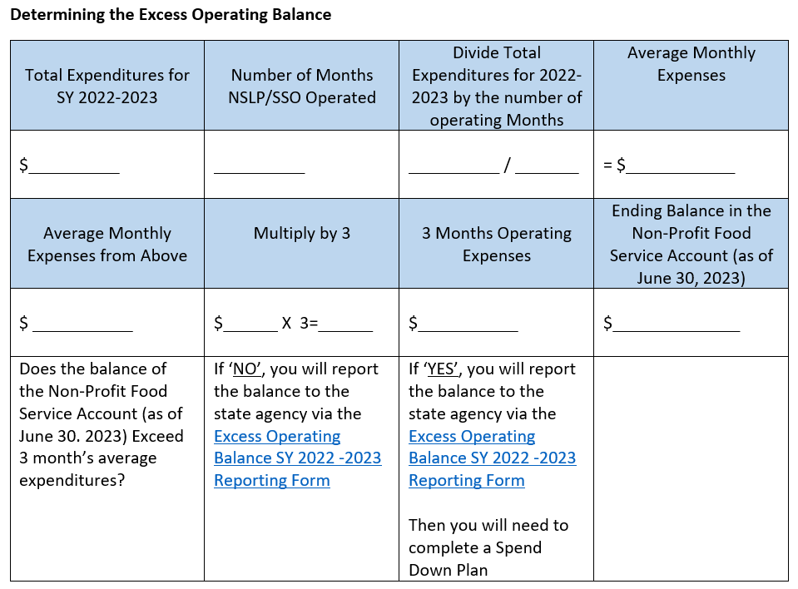

Now, that you have the numbers needed for accurate reporting, the next step is to:
- Access the Reporting Tool:
- Less than three months’: If your balance was under three months’ operating expenses, you will enter the balance information, the average monthly operating expense and attest that the balance is less than three months’ operating expenses, then submit the form
- In excess of three months’: If your balance in excess of three months’ operating expenses, you will report the balance and the average monthly operating expenses. An email will be sent to you separately, which will include the spend-down plan template with instructions as well as the due date to submit the completed template for approval to the state agency.

- Submit the reporting form. Note you will receive a separate approval notification when your submission has been approved, however, it is a best practice to request a copy of your reporting response by checking the ‘send me a copy of my response’ box prior to submitting the reporting form.

The Oregon Department of Education Child Nutrition Programs appreciates all you do in regard to feeding Oregon’s students.

Regards,

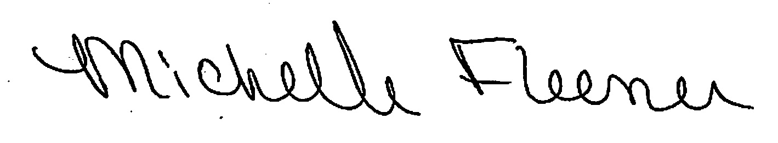
Michelle Fleener
Manager, School Nutrition
Child Nutrition Programs
Office of Child Nutrition, Research, Accountability, Fingerprinting and Transportation
Michelle.fleener@ode.oregon.gov

K:\_SNP\Financial Mgt\Excess Operating Balance Report\FY 2024\EOB Memo

