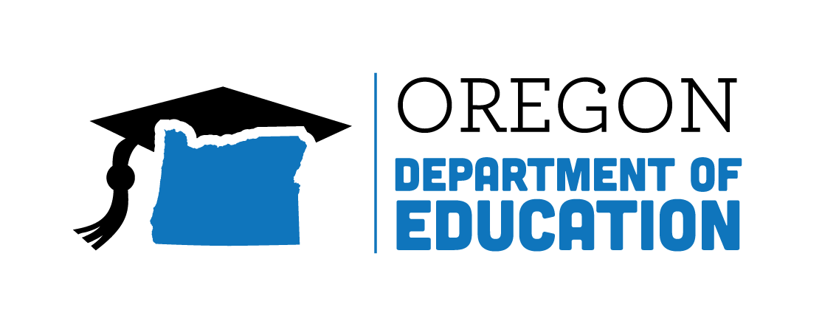
Colt Gill
Director of Public Instruction
Oregon achieves . . . together!

March 18, 2019

TO: Sponsors of the National School Lunch Program, School Breakfast Program and Special Milk Program

RE: 2019-2020 Renewal Information for State Agency-Sponsor Permanent Agreement
All Sponsors Due Date: Tuesday, April 30, 2019
Action Required

Sponsors participating in the National School Lunch Program and School Breakfast Program are required to complete the 2019-2020 Program Agreement Renewal with the Oregon Department of Education Child Nutrition Programs (ODE CNP).

To complete the 2019-2020 renewal multi-step process, go to CNPweb at: https://cnp.ode.state.or.us and submit off-line forms to the School Nutrition central mailbox ode.schoolnutrition@state.or.us. Access to the 2020 Program Year section of CNPweb and the renewal forms is available beginning
March 16, 2019.

Helpful Hint #1: Plan ahead to meet the due date of April 30, 2019. Look back to the previous year as a guide for exceptions that will need updating. Update the exceptions and send them in to allow time for your specialist to review, ask questions and approve them. CNPweb keeps track of the entire renewal process: Update the Sponsor Information Sheet, all Site Information Sheets, and enter the dates you submitted off-line forms. Most information will roll over when you activate your renewal, however, you need to verify and update all information and certify that it is true and accurate.

Attached are detailed renewal step-by-step instructions. The important first task is to go into CNPweb, School Year 2020 and “Add” your organization’s sponsor sheet. This opens up the packet tab so ODE CNP can track your off-line forms submissions.

A completed renewal packet will include updated Sponsor and Site information sheets in CNPweb and Off-line forms. When CNPweb information is updated and submitted to your assigned Child Nutrition Specialist for review, the Packet status will be ‘Pending Approval’.

Completed renewal packet materials must be submitted by Tuesday, April 30, 2019.

Annual training is no longer part of the renewal process. This requirement is now addressed under the requirements of Professional Standards and monitored during program Administrative Reviews.

In an effort to help Sponsors complete the renewal process in a timely manner, notices will be sent via the SNP newsletter, email reminders, and phone.

If you have questions, please contact your assigned Child Nutrition Specialist.

Sincerely,
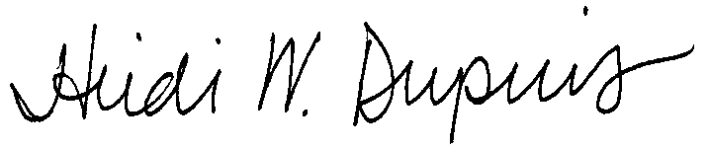
Heidi Dupuis, Manager, School Nutrition
Child Nutrition Programs
Office of Student Services

K:\_SNP\Agreement Renewal Pkts\2019-2020\Renewal Memo\SNP Renewal Memo_PY2020.docx

Enclosure: Sponsor Renewal Step by Step Instructions
CNPweb Quick Reference
Sponsor Specialist List

255 Capitol St NE, Salem, OR 97310 | Voice: 503-947-5600 | Fax: 503-378-5156 | www.oregon.gov/ode

