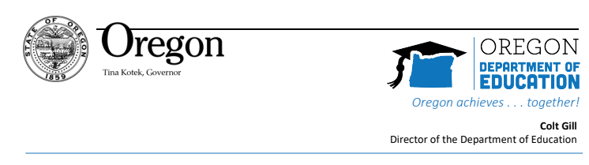
TO: National School Lunch School Food Authorities operating Seamless Summer Options (SSO) in June 2023
RE: SSO June 2023 Instructions

ACTION REQUIRED
Due 4/28/2023

School Food Authorities (SFA’s) that plan to operate the Seamless Summer Option (SSO) in June of 2023, must complete three steps to ensure timely approval and accurate renewal information for the next school year 2024 (SY 2024).

Since SSO operations frequently cross school years (June being school year 23 and July-September being School Year 24) it is imperative that the steps below are completed. The National School Lunch renewal application for SY 2024 will open in CNPweb on May 1, 2023. To ensure program information transfers to SY 2024, please complete the following steps by April 28, 2023.

Sponsors that plan to operate SSO in the month of June 2023 MUST:

- Determine site eligibility to operate SSO.
Open, Closed Enrolled (area eligible), and Migrant sites are required to submit eligibility documentation:
  - Census Data: Must submit screenshot of map, showing census number, if using Census to determine eligibility. Census data can be found using the USDA FNS Area Eligibility Mapper.
  - School Data: Must submit a screenshot of map, which shows a site, is located within the attendance boundaries of an eligible school, if applicable. Use the Free and Reduced Price Eligibility List – October 2022 for current school data.

- Sponsors applying to serve non-congregate meals in eligible rural areas must:
- Complete the Non-Congregate Summer Meals in Rural Areas training.
Certification statement is included on the Meal Distribution Plan. Sponsors must complete the training before checking the “I certify” statement on the Meal Distribution Plan.
- Submit a snip of the site address in a qualifying area using the SFSP Rural Designation Tool or the Rural Development Eligibility Tool
  - Complete and submit the Meal Distribution Plan.
Sponsors who are located in eligible rural areas may apply to serve non-congregate meals by completing a Meal Distribution Plan. Instructions for completing the Meal Distribution Plan are included in the document.

Please Note: If sites are approved to serve non-congregate meals in eligible rural areas. Sponsors will be required to submit additional claim information to Oregon Department of Education Child Nutrition Program for reporting purposes to USDA. More information will be provided upon approval.

- Sponsors must update SSO section CNPweb lines 120-130.
(120) Line 120 select Participation method from the dropdown menu. Note: All sites must meet area eligibility requirements. Sponsors must submit supporting documentation.
(121) Select months of operation. Note: Seamless Summer Option is only available during the summer months.
(122) If this site is classified as "Non-school (46) or "Not Eligible for Seamless Summer Option”, select an eligible site that includes this site's attendance area.
(123) Select site type from the drop down box
(129 -130) Select options that are closest to your method of advertisement. ODE CNP recognizes the methods currently listed may be out of date.

Sponsors must submit all documentation to the School Nutrition email address: ode.schoolnutrition@ode.oregon.gov

If you have questions, please contact your assigned Child Nutrition Specialist.

Thank you in advance for your prompt action.

Michelle Fleener, Manager School Nutrition Program
Child Nutrition Programs
Office Learning/Student Services

