Direct Verification Medicaid Data Instructions

Medicaid data is available ONLY for Direct Verification purposes during the Direct Verification window (October 1-November 15).

Getting Started
If you do not have access, contact your System Administrator to gain access to Student Collections Direct Certifications.

- Go to the Direct Certification Login page
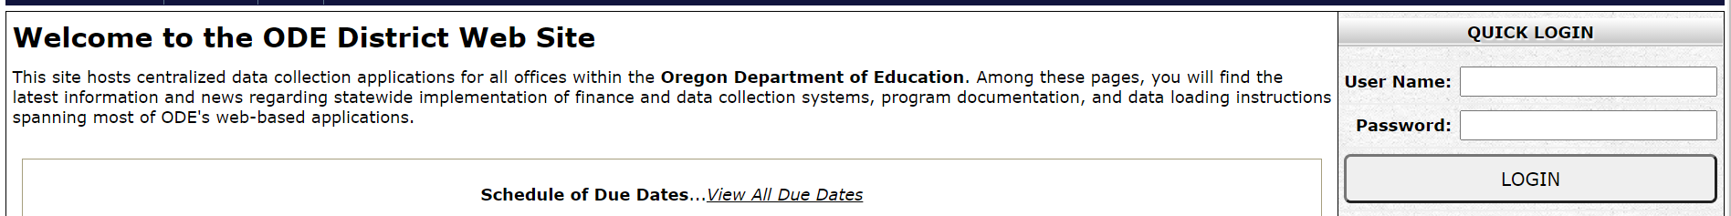

- Log on using your assigned user name and password.

- Click on Consolidated Collections
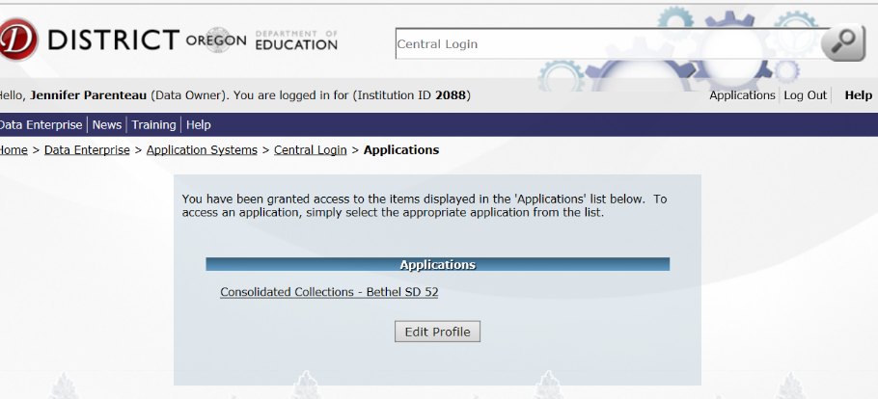

- Click on “Student Collections”
Click on “Child Nutrition - Direct Certification Match (NSLP) –> Direct Verification (Medicaid data)”
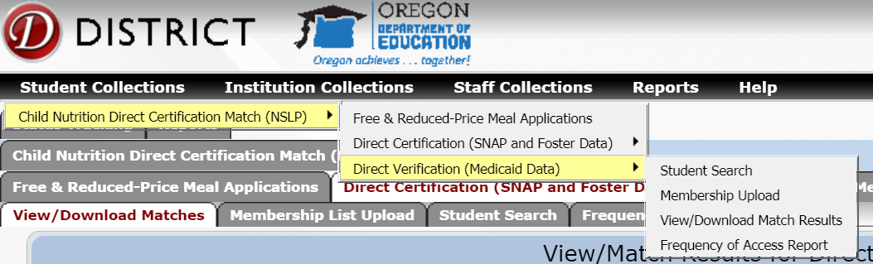

There are three ways to search this file:

- Choose “Student Search” and search by putting in an individual student’s SSID or name and/or birth date
- Choose “Membership Upload” and upload your entire student body
- Choose “View/Download Match Results”. There is a choice of “Matches” for your district, or “Non Matches” for the entire state

Student Search
- Select the “Student Search” tab to find individual students.
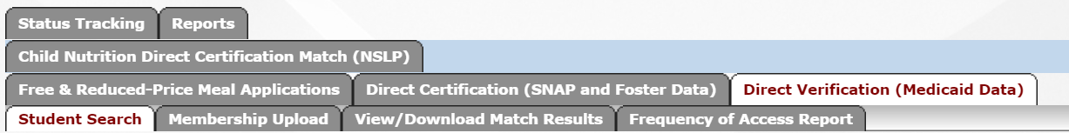

- Select Filter options. “Matches” only will return students matched to the school (district) chosen. “Non Matches” will return students on the non-match list throughout the state.
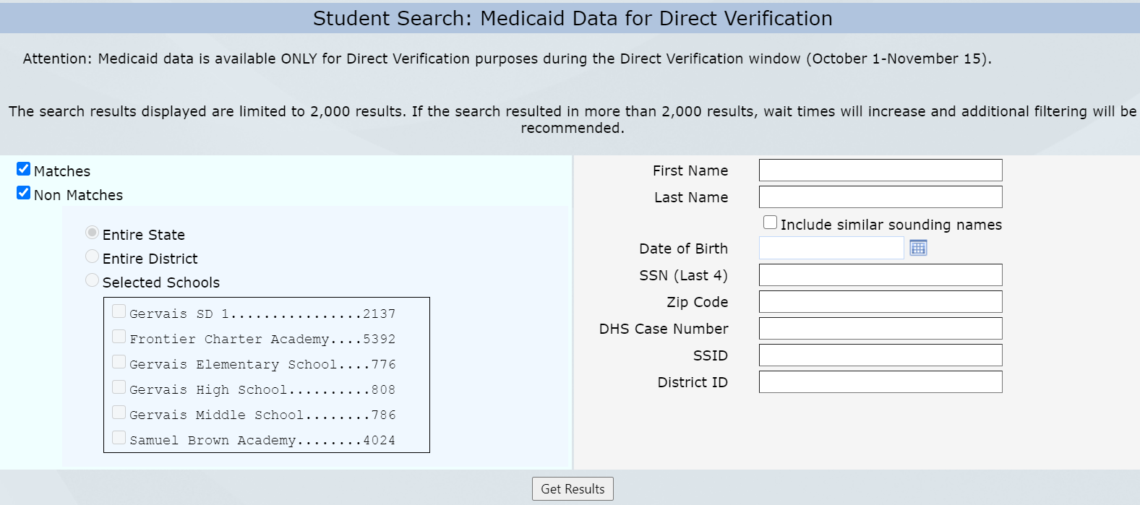

- Search by any available information. More information that is added will provide better results.
- By checking “Include similar sounding names” box all students with similar names will be displayed
- If a student(s) is found, they will be displayed with the option to view available information under the headers by scrolling across the page, or a .pdf can be downloaded and/or saved by clicking on the “PDF Export”. There may be multiple students listed depending on the search criteria that was provided. If a student is off of the “Non Match” list, there will not be any data for the “Match Source”, “Match Code”, or “Institution Information”.
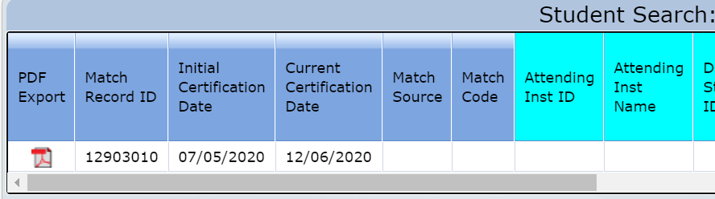

Membership Upload
- Select “Membership List Upload”
- Click “Choose File” to search and select your formatted enrollment list
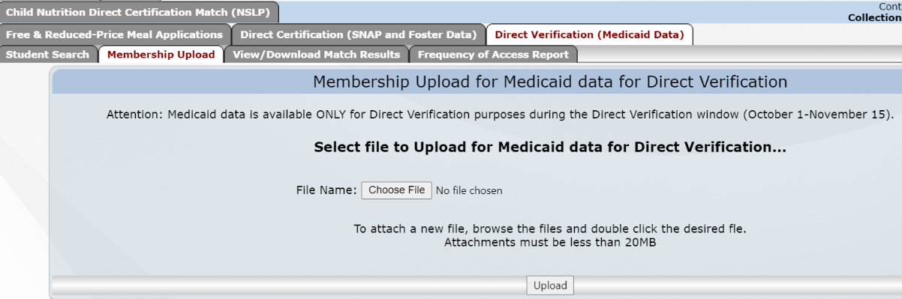

- Click “Upload”. The system will make sure the file meets the formatting requirements and if it passes, the following message will be displayed.
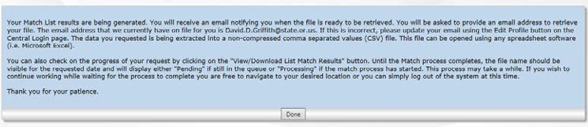
- If the file does not meet the formatting requirements, an error message will be displayed and will provide a reason for the fail on the screen or will tell you that an email is being sent with a link to a document that will provide more details on why the upload attempt has failed.

- If the information provided above looks good and you wish to go ahead and generate the Match results, select the date (defaults to the current date) that you want to run the Match for and click on the “Match” button:

- Click “Done”. A file to download will be sent to the email address on file.

View/Download Matches
- Choose “Matches” to return students matched to your school. Choose “Non Matches” to choose students throughout the state not matched to a specific school.
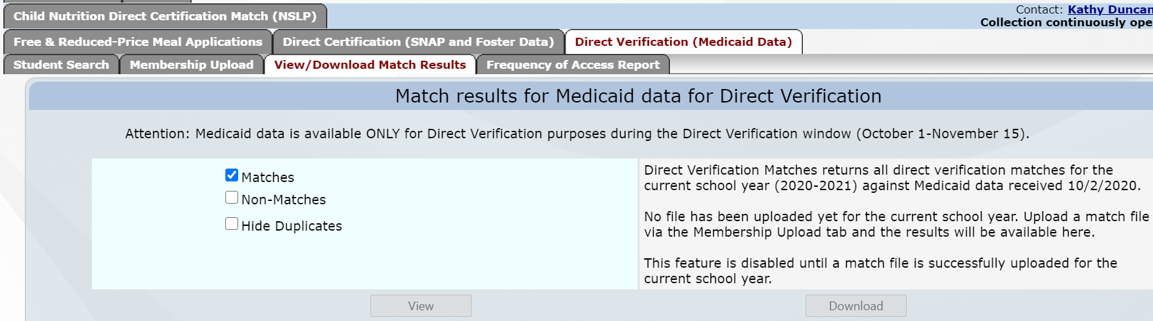

Retrieve the Downloaded File

- A dialog box appears that states, “The file you requested is being generated.”

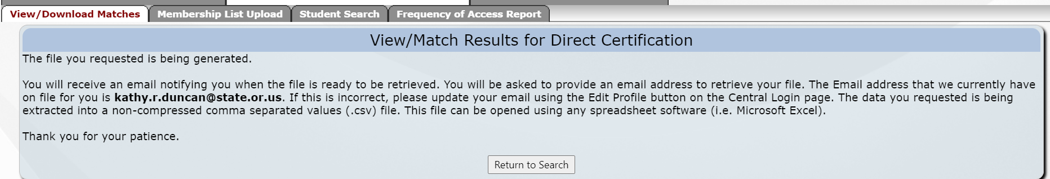

- Go to your email Inbox and open the email from the ODE Helpdesk.
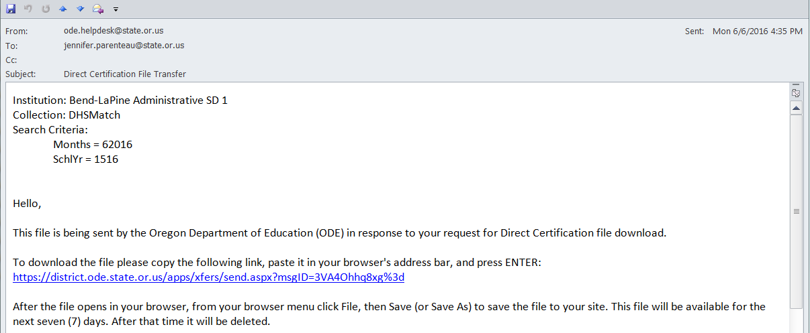

- Click on the blue underlined web address as shown in the email or copy and paste the address in the email into your web browser

- Type in your email address exactly as it is on file for the student collections, and click on the “Submit Email Address”

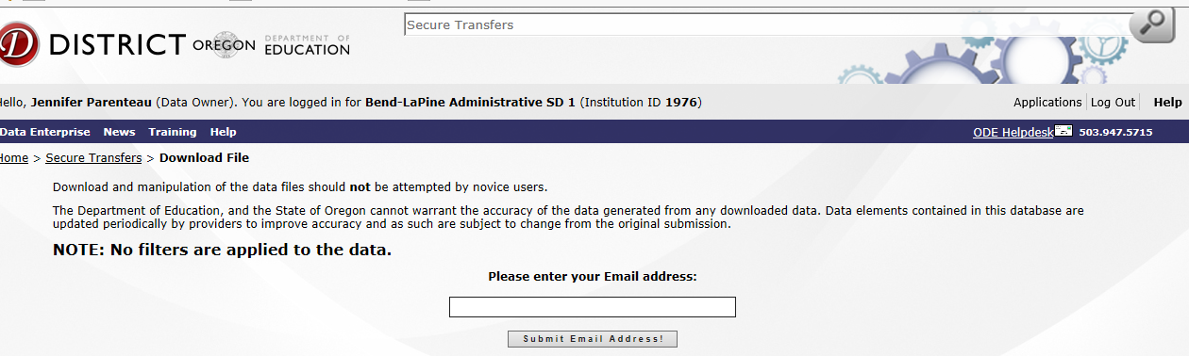

- Click on “Download”. 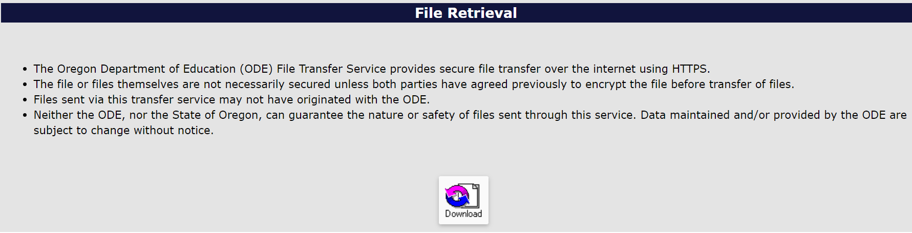
- A dialog box will appear that gives the option to “open” or “save (as)”.

